Statistical Inference Course Project

RogierGit

# 1 Overview

We will investigate the exponential distribution using lambda = 0.2.

# 2. Setup

## Setting up environment

# Set the seed  
set.seed(1234)  
  
# Packages  
library(knitr)

# 3. Simulations

# The theoretical mean of the exp distribution

The theoretical mean of the exponential distribution is 1/lamba. For our analysis in which we use lambda = 0.2, this means that the theoretical mean is:

# Theoretical mean:  
theoreticalmean <- 1/0.2

# The theoretical standard deviation of exp distribution

The theoretical standard deviation of the exponential distribution is 1/lambda. Here we also use lambda = 0.2, which gives us a theoretical sd of:

# Theoretical standard deviation:  
theoreticalsd <- 1/0.2  
  
# The theoretical variance:  
theoreticalsd^2

## [1] 25

# A distribution of single set of 40 random exponentials

# Create a vector with 40 random exponentials  
single_exp <- rexp(40, 0.2) #0.2 = lambda  
  
# Mean of the exponentials  
(single_exp_mean <- mean(single_exp))

## [1] 4.969024

# Variance of the exponentials to the mean  
(single_exp_var <- var(single_exp))

## [1] 25.99297

# Standard deviation for the single sample  
# Variance of the exponentials to the mean  
(single_exp_sd <- sd(single_exp))

## [1] 5.09833

# Running 1000 simulations

# Run 1000 simulations of a vector of 40 random exponentials and store the mean  
sim_exp_means = NULL  
  
for (i in 1 : 1000) sim_exp_means = c(sim_exp_means, mean(rexp(40, 0.2)))  
  
# Mean of the means from the 1000 exponential simulations  
(mean_of_sim_exp_means <- mean(sim_exp_means))

## [1] 4.973641

# 4. Sample Mean versus Theoretical Mean

We start by comparing the results of the single sample to the theoretical mean

hist(single_exp, xlab="Exponentials", main=NULL, breaks=10)  
abline(v = theoreticalmean, lwd = 2, col="green")  
abline(v = single_exp_mean, lwd = 2, col="blue")  
legend("topright", pch=1, col=c("green", "blue"), legend=c("Theoretical mean", "Single sample mean"))  
title("Single sample of 40 exponentials")

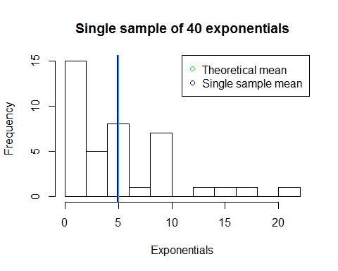

We compare the sample means from the 1000 simulations

hist(sim_exp_means, xlab="Simulation means", main=NULL, breaks=40)  
abline(v = theoreticalmean, lwd = 2, col="green")  
abline(v = mean_of_sim_exp_means, lwd = 2, col="blue")  
legend("topright", pch=1, col=c("green", "blue"), legend=c("Theoretical mean", "Simulation mean"))  
title("Means of 1000 simulations")

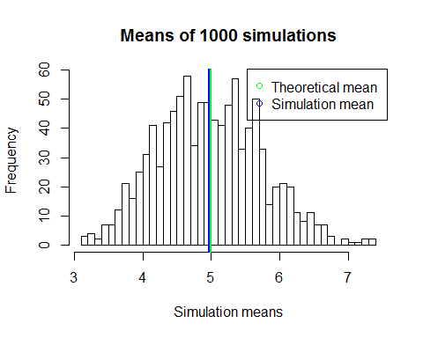

From the plot we cannot distinquish the theoretical and the simulation mean. The simulation means is approaching the theoretical mean.

#Theoretical mean  
theoreticalmean

## [1] 5

#Simulation mean  
mean_of_sim_exp_means

## [1] 4.973641

# 5. Sample Variance versus Theoretical Variance

Variance is the square distance from the mean

# 6. Distribution

Explain how one can tell the distribution is approximately normal.