MBA Course Business Economics

Naam: Rogier Nitschelm

Adres: Noteboom 59

Postcode en woonplaats: 4101 WS Culemborg (Nederland)

Inschrijfnummer: 805605

Modulecode: MAS0600N

Inzendcode: MMAS0600NI3

Datum: 7 juli 2015

Appendice

Chapters Page

1. Question 1: development and outlook 2 - 6
2. Question 2: analysis of the frozen vegetable industry 7 - 10
3. Question 3: analysis of relational assets 11 - 12
4. Question 4: transforming technologies 12
5. Question 5: factor disadvantages and advantages 12 - 13
6. Literature 13

**Question 1:**

**Michael Porter (Dicken, page 199-202) has developed his Diamond Model to explain why industries in particular countries prosper. Although his book was titled the Competitive Advantage of Nations, the most frequent use of the model is indeed at explaining the success of industries.**

**From the information in the case, summarize the development, the maintenance and the current outlook of the frozen vegetable industry in West Flanders.**

Answer 1:

Emergence of the frozen vegetables industry

The region originated as one of the largest flax producers in the world, at least until the introduction of synthetic fibers around 1950. As South-West Flanders was struck by the consequences of the emerging technology, its farmers gradually replaced producing flax with the production of vegetables. At the time this new production method emerged, most of the vegetables were sold to cannery factories for conservation and later use by the end-consumer.

This regional economic revolution would spark innovation, as a vegetable trader by the name of André Dejonghe discovered a new technique of conserving vegetables. And with it, the region was on the brink of a new era. One of economic success. As Dejonghe founded his company Pinguin, specialized in the freezing of food, so did competitors arise in close proximity. First Westfro and Unifrost, later on another multitude of companies emerged. Supported by European subsidies the sector could expand their investments and further grow its industry.

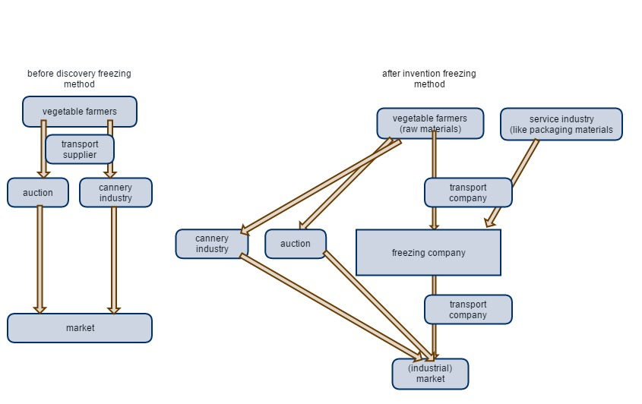

*A simplified drawing of the supply chain (from a vegetable farmer’s perspective!) before invention of the vegetable freezing technique and after. The market for raw materials (vegetables) increased in the number of customers for these vegetables. Unfortunately for them, their margins remain low still.*

The technique involved freezing vegetables for preservation and later use. As an alternative of canned vegetables. Its advantages over the latter were the (by customers) perceived superior nutritional values as well as a more modern image of the product. And whereas frozen food was becoming a booming business, the market for canned food went into (relative) decline.

Expansion of distribution

Belgium gained lots of success in the field of export of frozen vegetables. Even though not having a large domestic market for its products, as one of the largest exporters of frozen food its production accounted for nearly half of Europe’s total export of frozen vegetables. However, its Belgian producers would also import frozen vegetables themselves. Especially the kinds of vegetables that couldn’t be effectively grown on Belgium soil. Another motivation was maintaining the ability to supply its markets in times of scarcity. Even though harvest won’t every year be as successful as the last, people’s demand persists, and so does the market for frozen vegetables.

One of the key features of Flanders’ frozen vegetables industry is its distribution channels, which would extend its market from retail sector, to industrial kitchens and the food industry. Due to the specialization of the companies in certain markets, its cannibalization would be reduced to a minimum. However, due to the concentration of distribution channels, competition between players would persist in a degree and possibly grow.

Another aspect of the West Flanders industries in frozen vegetables, were the focus on private labeled products, which allowed them to supply food industries and catering. These branches were considerably less interested in brands, and more so in a low price and good quality of the vegetables. In which the Flemish vegetable industry happened to excel.

As the larger multinationals like Unilever transformed into marketing organizations with powerful brands, so did they ask a higher price for their products. As consumers’ experience of the brand would enable these multinationals to raise their prices in contrast to smaller businesses. This did however prove to be productive for the West Flemish industry, as the multinationals began outsourcing a large part of their production. A major portion of its production was outsourced to the West Flemish industries, turning them into the main suppliers of both Unilever and Bonduelle.

Even though some leaders of the industry questioned the usefulness of branding their products, others did see uses for branding. Especially using these B-brands in addition to distribution brands.

With the coming of outsourcing by large brands, another distribution channel is added. A brand-channel and a non-brand channel.

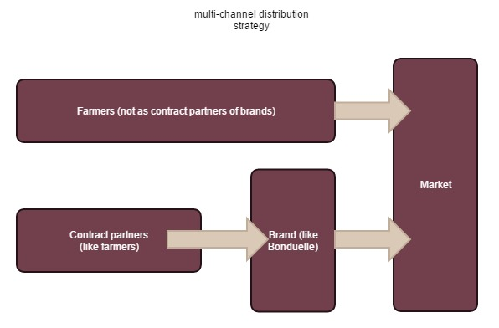

Considering the impact the frozen vegetable industry has on marketing foreign markets, its consideration of opportunities abroad, the outsourcing of production by transnationals (like Unilever), I believe we can speak of a global production network (GPN). Perhaps not as extensive as to cover the entire globe, but it sure does have its roots and influences spread across a large part of Europe. As well as the international influences that impact the sector itself. Most businesses within this network operate a global organization-model, as a family ran business often centralizes responsibilities. Among a flat organizational structure, family businesses often operate with tight management control. And last but not least, export is a key factor to the success of the companies, as the domestic market is limited in size.

I have depicted the place an average company within the frozen vegetable branch in West Flanders within the global-local framework.

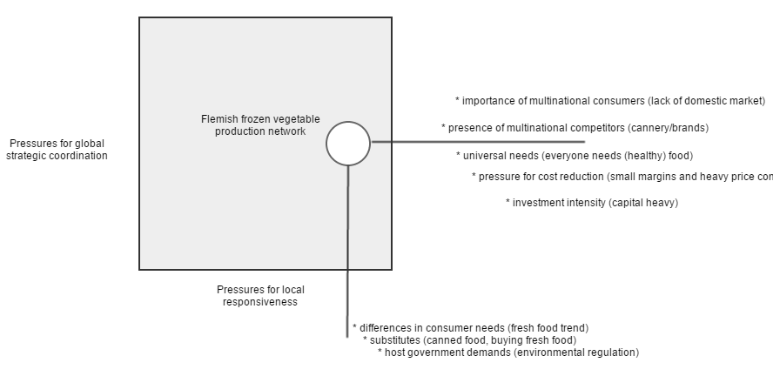

Regulation (within the frozen vegetables industry)

In 1980 the VEGEBE was founded in order to conclude labor agreements, as well as enforcing a uniform purchasing policy. This would regulate quality, price fixing and reception standards. In later years more themes would rise, like environmental protection, hygiene and technology. In 1995 the Flemish knowledge center BAT was founded to further encourage environmental friendly production. Companies producing frozen vegetables had to pay additional costs when not complying to regulation. Which would cause severe dents on its balance sheets, and thus its ratio’s. A good method of enforcing regulation.

Another development was the creation of the Provincial Center. The creation of this center would further increase competitiveness in the agricultural sector in West Flanders. Furthermore, large-scale distributors would increase pressure on verification of the source of its frozen vegetables. As customers became more demanding in regards to the environmental hazards , the industry had to comply in order to maintain their customer base. Eventually, in 1997, all producers of frozen vegetables would have to be equipped with a HACCP system, monitoring the quality of production. Both distributors (through demands of their customers) as well as the government would demand such a monitoring system. But as more environmental issues rose, so did the regulation, enforcing, for example, a more efficient use of water. This isn’t only of negative financial impact. When operating with responsibility, a company can gain a superior reputation in comparison to companies that do not take their corporate (social) responsibility

Another issue in the agricultural sector is the employment problem. Both seasonal bounds and an increase in technology (and therefore technical personnel), would cause some serious problems in obtaining and maintaining a sufficient workforce. This would result in a European program to further encourage maintaining employment in the agricultural sector, through discouraging stockbreeding and motivating vegetable culture. West Flanders also had several education institutions supplying the region with schooling. Offering a large variety of education and training.

The future

Even though there has been extensive growth within the region, the future is not without trouble. There are considerable obstacles to overcome. Among these are soil exhaustion, attracting technical skilled personnel, smaller margins, and so on.

One of the major problems is the soil exhaustion that is beginning to occur. As fertilization would damage the soil, other techniques will have to be applied to be able to continue to produce vegetables. For example farmers will have to use natural compost rather than chemical compounds. But even these more natural fertilization products will cause damage to the soil. A better and more sustainable alternative is crop rotation, cycling through various crops to maintain a useful soil.

However, not everyone perceives the risk of soil exhaustion equally as important. As problems concerning the soil arise, producers (of frozen vegetables) begin looking for alternative physical resources to provide them with vegetables. Like farmers in France and Southern Holland. But do they also consider the additional cost of transport? And the possible competition that might arise in these specific regions, when import from those regions grows? Producers should consider the option of direct investment in companies in these territories, in order to obtain a stable base of operations, rather than just contracting suppliers.

Another problem is the concentration of distribution channel, further lowering margins (and thus profit), due to the (negotiation) power the growing distributors possess. Globalizing is perhaps the only way to avoid powerlessness to the will of distributors.

And lost but not least, automation is increasing. The lack of labor can be partially compensated, yet still the automated factories will need operators. And skilled operators become more and more scarce. The demand in quantity of simple laborers dropped, but the region is still lacking educated personnel to operate the processes.

All of these problems will cause substantial challenges to the industry, but considering the flexibility that the industry has shown in past decades, it will be more than equipped to counter most of these problems. Of course the future also brings opportunities. One of the opportunities is the large market that is present in Europe and the continuous globalization of the world, reducing the physical distance (not in kilometers/miles but in time to transport, due to faster means of transportation). Combining this with the large agricultural trade deficits in close proximity, it ensures of a fairly stable demand for food among which likely frozen vegetables. Also, with the world population continuously growing, so will the demand for food. However, due to further urbanizations other risks arise, as farmlands will be more and more rare. Possibly forcing more investment into technological advances to grow more vegetables in smaller plots.

**Question 2:**

**The Diamond Model consists of four primary competitive determinants, and two secondary components.**

**Analyze, in detail, the industry in terms of:**

**\* Factor conditions (as a primary factor)  
* Related and supporting industries (as a primary factor)  
* The role of the government (as a secondary factor)**

Answer 2:

Several especially regional factors appear to be vital to the competitiveness of Flanders as an industry in an international context. Both currently and in the future. I will describe both present and future outlook considering the factors.

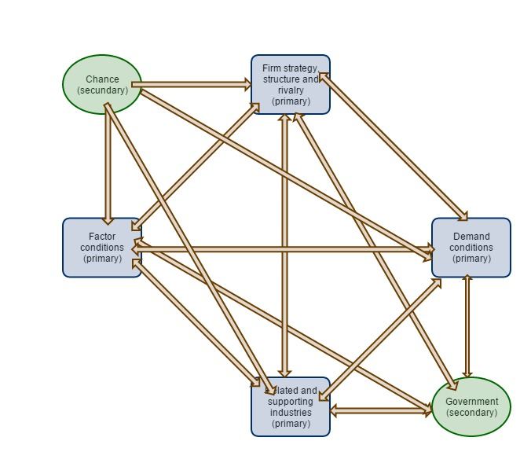

*The Diamond-model (Porter)*

Factor conditions:

* Physical resources;
* Infrastructure;
* Human resources;
* Knowledge resources;
* Capital resources.

Physical resources

Even though not literally named in the literature at the given page (Dicken’s, chapter 9, page 200), but clearly one of the factors that is relevant for the industry are the natural resources. In fact these are vital. As soil is one of the major factors of importance responsible for the development of any agricultural sector. Without a diverse and fertile soil, the vegetable culture in West Flanders would never have existed. Among physical resources I do consider the environmental factors like a calm climate and stable temperatures during the seasons. But what is just as important is its soil variety and fertility, resulting in production capacity of 10 months per year. The soil is also the reason for the relatively fixedness of the raw materials industry, as the assets (farms and soils) aren’t very flexible.

In the past there used to be a mix of an intensive and extensive vegetable culture. However, due to a drop in the margins caused by distribution concentration, the extensive culture had been forced onto large plots of agricultural land in order to maintain a positive financial result of operations. Lack of these plots forced the extensive cultivation of several types of vegetables to the Walloon provinces of Belgium and Northern France. Whereas the West Flemish farmers were forced into intensive cultivation, due to not having the means of obtaining these larger farm plots. The case doesn’t clearly specify why the Flemish lack the means, as language is not an obstacle for them.

Even though I consider the close proximity of vegetable farmers to the producers of frozen food a physical resource to the agricultural sector (a concentration of industry is in my humble opinion a physical resource). As its the clustering of raw material suppliers (farmers), producers and suppliers of additional services, like freezing equipment, that increases the value of the region and encourages industry to even further concentrate. Also reducing transportation costs, reducing the cost of supplies. This concentration also results in an increase in attractiveness for locations to use for schools and colleges.

Risks within the factor of physical resources are the exhaustion of soil. When the soil becomes non-harvestable, part of the industry will probably move to alternative locations. And it could well be a reason for industry to spark innovation into a new field of industry. Which indicates an asset orientation for the farmers, as the asset of fertile soil is the primary requirement for their production. The food processing part of the vegetable industry is less dependent on local physical resources, yet is still indirectly benefited by the presence of raw materials producers clustering on and around the region with fertile soil.

Infrastructure

Due to the central location of Flanders in Europe and its extensive road network, the frozen vegetable industry was ensured a vast and stable distribution network with its roots leading into every direction. Add on top of that the close proximity of a large industrial port (Antwerp), this together allowed the industry to export enormous amounts of products to other countries. Which is, considering the lack of a domestic market and the size of the total external demand, a profitable alternative to market.

Another issue of interest is the ability for the industry of frozen vegetables to obtain alternative supply routes through import from South Holland and Northern France, in the situation that soil exhaustion would disable crop harvesting in the local region. The infrastructure would allow such a switch in suppliers because of the quality of the infrastructure. However, costs do come with it, like longer physical transport and time to supply.

Also, it’s worth to notice that only relatively cheap means of transport are attractive for this industry. Considering the weight and small margins, the cost of aerial transport is of course in no way attractive for transporting frozen vegetables.

Human resources

One of the factors involved in the industry is the employment of staff. As the region was originally orientated around the production and distribution of flax, a switch to processing (frozen) vegetables is of course a smaller step than entirely abandoning one industry for another.

As in recent years the unemployment was extremely low, around 2%. This caused a structural problem in employment of staff. Seasonal peaks in demand could not be answered due to the fact that laborers were already fully employed. Also tighter regulation by the government diminished the alternatives to obtain a decent workforce.

When considering laborers from other regions, the industry discovered that a large part of the potential workforce weren’t flexible enough to move to West Flanders, which ensured the persistence of the worker shortage.

Another problem is the high labor costs, as labor costs are among the highest in Belgium. This logically resulted in an increase in investment in automation by the industry, in an attempt to obtain economies of scale and reduce labor intensity of its processes. This did however give the industry a heads up in technology in comparison to foreign competitors.

However, even an automated plant requires operators and engineers to keep the processes running. These too cost money, and these too are scarce.

Knowledge resources

Most of the intangible resources I consider knowledge resources. Perhaps the most important of these intangible resources is the proficiency in innovation. The introduction by Dejonghe of the freezing of vegetables was keen to the industry’s successes nowadays, an example of technological progression and resourcefulness of the Flemish entrepreneur. The know-how to either obtain information or create knowledge (through innovation) and then apply to further enhance an industry prove to be well rewarding in the case of food preservation.

Another form of knowledge present in the Flanders industry, or even Flanders altogether is the multilingual ability. The ability to communicate in multiple languages. As Belgium has two native tongues (being French and Dutch), it would make trade partnerships easier, which gave the industry a competitive advantage. Without the barrier of language, contracting partners internationally would prove far easier to accomplish than rivals could do without. This is reflected in exhibit 5, picture C. as can be seen in the amount of Belgian import in the Netherlands and France, respectively 22% and 32%.

Besides the already present knowledge within the sector, education is being supplied by a large amount of schools and educational institutes, offering both basic and professional education as well as extra training.

Capital resources

Among the capital resources are largely family investments, but also investments from external providers, like governmental subsidies, and quite likely the common industrial loans from regular financial institutions. Due to going public, some companies obtained a large pool of possible capital. As being able to publically offer stocks on the primary market will allow for better flexibility in strengthening or altering the balance sheet.

The family businesses, run by family members on the other hand, have other pros. However, naming these would involve mere speculation. Closer ties to the company might allow for easier persuasion of family members to invest. However, again, this would only be speculation.

Considering the sheet (exhibit 6) the financial costs are minimal, under 1%. This is most likely explained due to the fact that most funding is done by family and considering the relatively high equity to total assets, which is common in capital intensive industries, the amount of interest on loans is relatively small, at least partially explaining the low financial costs.

Related and supporting industries

Due to its internationally competitive frozen vegetable industry, supporting industries would settle within the region, to service the main industry and lift upon its success. The service industries would become well-known internationally for the production of machinery like cutting machines and refrigeration. One company in specific is the Bruynooghe company that specialized in pre-processing machines to clean up vegetable (before freezing them).

There are two types of supporting industries, one being the supplier of freezing tunnels, the other the machinery, among which the cutting machines. These were used to cut up the vegetables in acceptable quantities (for packaging). Of course the equipment did require maintenance, especially the freezing tunnels. Which was another reason for the industry to remain close to their customer base of frozen vegetable producers. This would however not be a solution for subsidiaries, but due to the coming of the internet, assistance could be given from range.

Also, the transport sector benefitted from the industriousness, as new kinds of demand rose. Like transport of frozen vegetables, requiring refrigeration equipment installed in transportation. Even though the auction of fruit and vegetables wasn’t a direct competitor, it’s close proximity did of course improve the attractiveness for industries to locate their plants in the region.

Role of the government

Even though the European and Belgium government did prove of substantial use, with it did came regulations. These would also threaten the margins made by the industry. The pros that did help the industry were the financial subsidies to increase development of the vegetable culture in the region. Having the industry thrive on government-aid, would make for cheap investments.

But as consumer awareness of the environment increased, so did government regulation. Quality monitoring, hygienic regulation and restriction to water use would dampen the profits of the industry. But considering the fines that were imposed for not complying to the authority’s demands, the industry was forced to make the required investments. To decrease the use of water to grow vegetables for example. Such measures do require new kinds of equipment, resulting in an increase in research and development, allowing the supportive industries to thrive even more, at the cost of, to some extent, the main industry. This regulation would perhaps be of a net negative effect on the short-term for the main players, but it would benefit the economic environment of the region, with its increasing demand for more efficient processes and machines.

Another governmental pro to the industry was the presence of Belgium within the economic union of the EU. This would mean the absence of trade barriers and export tariffs to other EU-countries, expanding the benefits of growth and export into foreign regions within the union.

**Question 3:**

**Besides the factors that are part of Porter’s model, the case lists factors that do not fit easily in the model.**

**Analyze from the case how relational assets (e.g. historical and family relationships) have impacted the success of the industry.**

Answer 3:

Historical relations

Originally South-West Flanders was known for its extensive flax industry. However the majority of the industry became obsolete due to technological progression, resulting in the emergence of synthetic fibers.

As presumably the demand for flax dropped, farmers were literally forced into other fields. Such as growing vegetables. The flax industry altogether had to adapt in order to maintain a market. A market of servicing and distributing the production of these new ‘types’ of farmers. Preserving food was one of the more obvious alternatives to service the new industry.

Family relationships

Some of the successes in the region can be explained by the relational production networks. As these differ majorly from the multinationals like Bonduelle and Unilever. Even though I did name family investments specifically under the topic ‘capital factor’, I will further describe the family relationships and how they influenced the growth of the region as a major industry.

As one of the more rewarding features of the industry, the Belgian companies operated a flat organizational structure, resulting in a financially attractive depth of control. Fewer layers of management were present, nor required, due to family members running the businesses. This would lead to lower administration cost allowing for cheaper production and in turn attractive margins on sales. Of course whenever a company grows substantially one would eventually be forced into an alternative management structure. As nominal capital intensity would increase, and so would the demand to fund the additional facilities. This would require additional means for funding, like the primary markets for stocks and bonds. Also, due to the depth and span of control being physically limited, even the family businesses would eventually have to increase management in order to oversee operations.

Yet, altogether one can claim the family relationships, resulting in a ‘natural’ source for leadership, were of a major positive influence to the development of the sector. I believe that, especially, the start and growth of these industries were severely carried by these family relationships.

Business relationships

Along with family relationships, there were close ties between management of competitor businesses. Stirring production and innovation within each company to obtain an advantage over its rivals. Due to the close proximity of one another, information would more easily flow throughout the industry. Which would in turn lead to faster development of the industry. However, as competition increased, so did the margins drop. Which was the downside. As (most) price fixing is regarded as illegal, there aren’t a lot of alternatives left to obtain a stable profitable margin. Extensive rivalry with competitor businesses would mean a further necessity for increasing efficiency. As operational excellence (cost leadership) is currently the only mean of competition. This is a downside of the industry altogether. At least as long as companies reject branding of products as an alternative to obtain a competitive advantage.

Summarized, the pros of the close ties of businesses is the innovation and increase in production efficiency, but the downside is the drop in margins. Eventually smaller competition might be driven out of the market, or become subject of take-overs. Others might decide to merge. These developments could herald a shift of the market towards an (homogenous) oligopoly, of which the well-known effect of price competition is indeed killing. Another reason to, in my opinion consider branding as a (partial) solution to differentiate products that are homogenous in nature.

**Question 4:**

**Global food industries (cf. Dicken, chapter 9, page 270-300) are characterized by three sets of changes: transforming technologies; the role of the state; and corporate strategies.**

**Analyze to what extent Dicken’s observations on transforming technologies can be applied to the West Flanders frozen vegetables industry.**

Answer 4:

A noteworthy observation is where Dicken regards the presence of a “permanent global summertime (PGST)” (p 271) to consumers. As vegetables and fruits are available every day of the year in the supermarket, due to the ability for retailers to import them from different areas of the world (where the seasons differ from the seasons in local markets). This enables a maximum availability of vegetables and fruits. The local season is no longer relevant. It is also underlined when further studying the chapter (The Agro-Food Industries). Dicken (p. 282) describes the development of ‘global cool chains’ – having transformed the availability of agricultural goods.

In a way the freezing of food attempts to achieve the same result. The availability of certain seasonal bound vegetables at any given time in the year. However, the downside is of course that fresh vegetables are likely preferred by the customer base. In this regard, the PGST can be considered a threat to the conservation of food. Yet, frozen food offers another benefit. Not having to travel (other than to the fridge) to obtain vegetables at any given time.

It would be an assumption, but I do consider it highly likely that in current times, the ability to obtain certain vegetables without a lot of effort (walking to the fridge) might be one of the main reasons for people to still buy conserved vegetables. As visiting the supermarket offers fresh vegetables at the cost of more effort.

Another topic of interest is the question ‘who owns nature?’ as Dicken describes (p. 271). As the extensive use of soil results in infertile soil. Is the food industry entitled to destroy the soil? Simply because they might own or rent the land? I believe, especially considering the present attention for nature within Western society, that regulation is the only right thing to further prevent destruction of natural (limited) resources. I actually consider the irreversibility of soil exhaustion a scary thought. However, with the pace in which technology advances, perhaps they will find a way of partially undoing the damage to the soil.

Like Dicken describes in the literature (p. 283), capital intensity increases, whereas labor intensity decreases. When considering the production of vegetables in West Flanders, this is indeed the case. This hadn’t been possible without the technological progression. Dicken’s observations can also be applied here.

**Question 5:**

**Which factor disadvantages have contributed, and still can contribute to the competitive advantage and in what manner? In which respect has the absence of a large domestic demand in a way reinforced the competitive advantage?**

Answer 5:

One of the problems that the Flanders region experiences is the high cost of labor and shortage of qualified personnel. This obvious disadvantage encouraged have investment in automation, which after the initial investment, resulted in an advantage in the form of a larger production capacity and more efficiency. A disadvantage turned into an advantage.

Another regionally specific disadvantage was the lack of a domestic market for frozen vegetables. This forced the producers into exporting their products to foreign regions. Regions with a variety of demands. However, due to being forced into different markets, the industry had to adapt its operations, which would encourage flexibility and resilience to altering demands. Especially since the majority of the Belgian population is multilingual, trading in both France and the Netherlands reduced their (informal) entrance barriers, allowing for a more smooth penetration of these international markets.

Also, having interdependencies within the supply chain, caused for synergetic proficiencies. For example, a larger variety in demand of frozen vegetables, would not only cause for additional or alternative purchases from farmers, but would also cause a demand for alternative freezing (and other) equipment which the suppliers of additional services could provide. A joint benefit of the competitiveness of the Flanders vegetable industry. This in turn would explain the clustering in this region, as businesses lift upon each other competitive successes and strengthened its position in the international markets.

One disadvantage (from a business’ point of view) is the influence by the government through regulation. However, this disadvantage can be partially altered into an advantage. As meeting the requirements set by government agencies, producers can obtain subsidies, relieving some capital expenses. This doesn’t undo the disadvantages from a business’ perspective (not taking into account CSR), but it does soften the ‘pain’ of complying to regulations.

Literature

* Dicken, P. (2011) *Global Shift* Sage Publications