MBA Course Strategic Management

Naam: Rogier Nitschelm  
Adres: Noteboom 59  
Postcode en plaats: 4101 WS Culemborg (Nederland)  
Inschrijfnummer: 1727840  
Modulecode: MAS0100N  
Inzendcode: MAS0100NI3  
Docent: Q. Truong P hd

Date: march 22, 2015

Appendice

Chapters Page

1. A Profile of Alstom 3

1.1 What is Alstom? 3

1.2 History of Alstom 4 - 5

2. Situation at Alstom pre-Kron 5

2.1 A summary 6 - 7

2.2 The problems 8 - 9

3. New approach 9

3.1 Kron’s new approach 9

3.2 Alstom recovers 9 - 10

3.3 New core values 10

4. Judging Kron’s rescue plan 10

4.1 From my perspective 11

4.2 Strategy development 11 - 12

4.3 Strategy execution 12

5. My recommendations 13

5.1 People 13 - 14

5.2 Corporate cultures 14

5.3 Processes 14 - 15

5.4 Technology 15

5.5 Finances 16

5.6 Strategy 16 - 17

5.7 International markets 17

1. A profile of Alstom

*Provide a brief description of the company’s profile*

1.1 What is Alstom?

Alstom is a multinational manufacturer of power generation equipment and rail transport equipment (trains and railways) with its roots in France. Due to it’s diversified fields of operation and plants in multiple countries it can be considered a conglomerate.

1.2 History of Alstom

In 1928 Alsthom was founded in France through the merging of two industrial companies. Initially it centered it’s activities solely on energy generation equipment but expanded to the production of railway transportation equipment a few years later (1932).

In 1987 Alsthom was assimilated by CGE and in 1991 CGE was renamed Alcatel Alsthom. It’s name was later shortened to Alcatel. With the coming of Bilger the venture was individualized and renamed Alstom (SA) and brought to the stock markets. The new independant company’s IPO (initial public offering) turned out to be the largest of the year.

In the period the demands for power generation equipment peaked (the late ninetees), a new joint-venture was formed. In 1999 ABB and Alstom formed a strategic alliance. One year later Alstom purchased ABB’s stakes and Alstom Power was born. But not without difficulties. Alstom had failed to analyze critical information about several of ABB’s assets and facets. Some more notable than others. One of them were performance and efficiency minimums that were part of ABB’s service level agreements with contract partners. Combined with technical problems concerning gas turbines. It turned out the assets obtained by Alstom were duely overpriced. In spite of these problems Alstom would continue it’s debt financed expansion.

Another event of importance in 2000 was the acquisition of a majority of shares of Fiat Ferrovaria. In 2001 it turned out that Alstom was the largest supplier of power generation equipment and second largest in transport equipment. Later that year Marconi and Alcatel sold most of their shares to Alstom and Patrick Kron became a member of the board of executives.

1.2.1 Crisis

A terrible event happened in september that year, as the financial center of the globe, the World Trade Center was under attack by terrorists, hijacking planes to destroy some of the largest and most important buildings in the world. The terrorists succeeded destroying both the towers. The world was ashock, and Alstom was too. As transportation being one of Alstoms markets, it was unfortunate but not a surprise. The value of it’s stock dropped rapidly and other bad news was on the horizon. As Renaissance Cruises, which was a large customer of Alstom went bankrupt. It’s bankruptcy caused Alstom severe financial damage, because of loans that Alstom covered. It’s exposure was approximately 648 million. Alstoms value however, dropped even more rapidly and by september 29th there had been a loss of 2 billion in value. Its course continued downwards after. Another notable event occured in the United States when energy company Enron filed for bankruptcy after the discovery of accounting fraud of biblical scale.

1.2.2 Restore value plan

In 2002 Philippe Jaffre joined as an advisor to Bilger. In 2002 Jaffre became CFO and a mission to restore Alstom’ value was issued. Among the objectives were the sell of 750 million of real estate, with the intention of renting/leasing the real estate back from the new owners. This would put ALSTOM in the position of reducing the size of its debts and increasing its solvency and liquidity. Another objective was the disposition of 12 businesses worth approximately 900 million. Furthermore the company would link employee incentives to cash generation.

In addition to these objectives Alstom wanted to raise funds through loans and rights issues offering existing holders of shares the option to buy additional shares (at a reduced price).

Financial analysts were optimistic about the Restore Value program, but soon discovered that it wasn’t producing the results they had hoped for. Later (2003) Bilger would step down as CEO and Kron would take his place. In 2004 Kron also obtained the role of chairman.

1.2.3 Kron in charge

At the start of his duty as CEO Kron was plunged into problems. The Restore Value program didn’t go as planned, there was a debt-to-equity ratio of 500%. The interest payment would beat a huge dent in Alstoms cashflow, causing it to go 300 million negative. Soon Alstom would no longer be capable of paying the rent to investors of the loans.

It was obvious the company’s course had to change. Along with a change of management (style), a change of organizational structure and better management of human resources. The latter because of the mixed corporate cultures that persisted through the merger of companies and divisions in the past.

Alstom had to obtain additional financial resources to be able to sustain. However, investors needed to be persuaded into investing more. This would be a difficult task, due to Alstoms history of bad results and news. Kron had to find a way to save Alstom from the brink of bankruptcy.

2. Situation of Alstom pre-Kron

*What is the situation of Alstom and the problems facing the company before the take-over of the new CEO, as described in the case?*

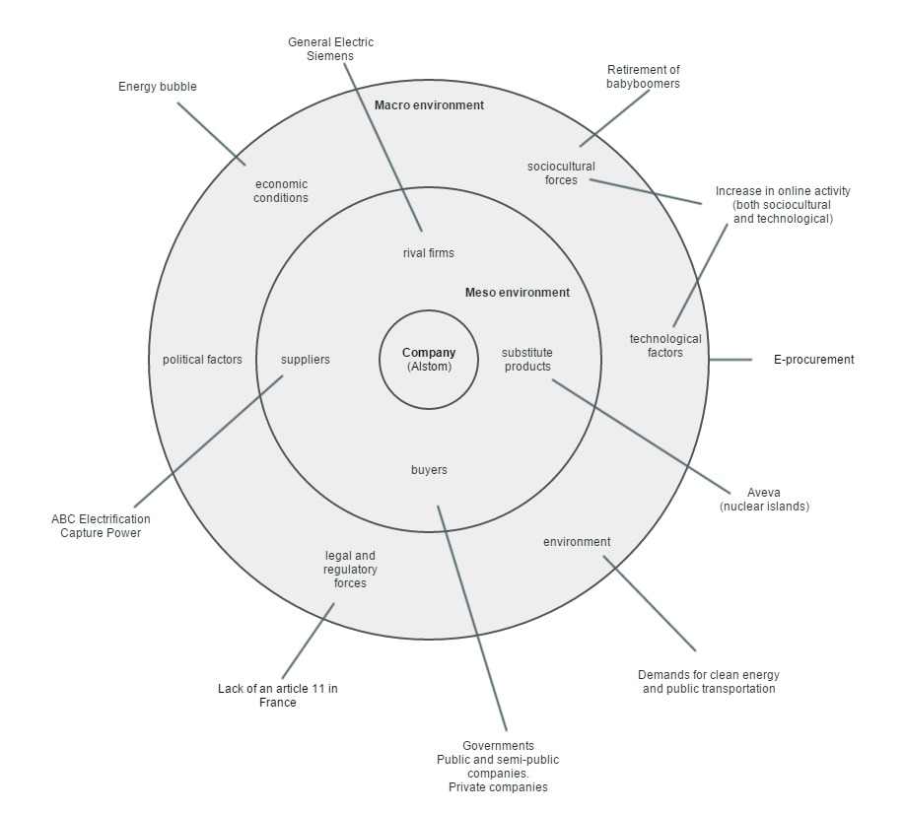

2.1 A summary (SWOT)

Potential internal strengths and competitive abilities:

* Strong energy division;
* Strong transport division;
* Powerful production capabilities;
* Well-known and powerful brand name;
* International coverage;
* Full-service to customers;
* Innovative minds;
* Potential high income in times of hausse.

Potential internal weaknesses:

* Weak balance sheet (high debt-to-equity ratio);
* Unproductive R&D department;
* Lacking due diligence;
* Unfit assets (obtained through acquisition);
* Narrow product line in comparison to primary rivals;
* Large difference in sizes of businesses;
* Reputation dropped last few years;
* Contracts with legal penalties;
* Covering liabilities for contract partners;
* Low margins;

Market opportunities:

* Increase in a demand for clean energy;
* Availability of internet and e-procurement;
* Increase in population (more demands for public transportation).

Market threats:

* Exposure to unfavorable industry driving forces;
* Heavy competition (Siemens and GE);
* Energy bubble;
* Retirement of post-War employees (knowledge).

2.1.1 Core businesses and strengths

The core businesses of Alstom were (and still are) producing and services of energy generation equipment and transport equipment. Its transport business focused on rail transport equipment with a minor focus on maritime equipment. The power division is and was responsible for the largest amount of sales. It generated approximately 50% of Alstoms total sales. Transport division was responsible for less than a quarter of Alstoms total sales. A famous production of Alstoms transport division is the TGV, which is a high-speed train for public transportation.

Alstoms core competences consisted mainly of technical knowhow, present in both businesses. It produces equipment, delivers and installs it. In other words, Alstom fully services the process of implementing new equipment for its customers. It also has its own production plants that allow for rapid production of equipment. Its long and succesful history turned Alstom into a strong brand with a good reputation. Ofcourse its reputation was damaged during the crisis.

In addition to these strengths the personnel of Alstom is very innovation-minded.

2.1.2 Weaknesses

Even though Alstom has alot of strengths, there were also quite some weaknesses present. The research and development department is lacking, which is a very bad feature for a company with lots of innovative minds present. The underperforming research and development department (among other departments, like legal and finance), failed in collecting the right and adequate information prior to business acquisitions. Acquiring risky and complex assets.

Another weakness was the way Alstom operated its organization. Alstom was based on a matrix structure, making it unnecessary complex to handle.

And if that weren’t enough, the mixed corporate cultures turned out hard to unite.

2.1.3 External (macro) situation

Technology is advancing rapidly and e-procurement allows businesses to more efficiëntly operate their processes. Consumers start using the internet more frequently and social media begin to rise, like Myspace. E-procurement could reduce the costs of operations of Alstom. Also Alstom could gain valuable information more easily through using the net.

Demographically there are also some changes on the horizon. Babyboomers start to retire, retreating into their post-productive lifetime. The pros are that the way will be clear for younger generation to populate businesses and plants, but the cons are that valuable experience will be lost.

Demands for social responsibility is starting to arise. People demand companies to consider the environment when operating their processes. The demand for clean energy increases. Which could be both a threat or an opportunity. A threat when it comes to the production of coal and gas turbines, but an opportunity for investing in clean energy equipment. Like equipment for solar power and wind mills.

2.1.4 External (meso) situation

The primary competition to Alstoms activities are General Electric and Siemens. They were the primary competition back in the days of Alstoms crisis but still are. But threats come not only from rivals, but also from the markets itself. Substitute products were and still are a danger, especially now technological inventions pop up more rapidly.

Among substitute products for Alstoms power division could be Aveva supplying different forms of power equipment. The transport division could suffer from substitute products of Volvo, producing trucks, which like trains are another means of cheap transportation. More flexible, but with less maximum capacity.

Among buyers are all sorts of businesses. Like public and semi-public organizations. Private organizations, and so on.

Suppliers and partnerships can be found at ABC Electrification and Capture Power.

2.2 The problems

2.2.1 Operations management

There was a wide range of causes for the problems at Alstom. One of them was a result of the several mergers and alliances that Alstom sustained. Alstom rapidly increased in size and might not have dealt with the problems that came with the expansion.

Also the change of the company’s composition caused a mix of corporate cultures to be present within the company. The difference between the cultures within these businesses were apparently hard to unite. The different cultures were still clinging on to old habits and values. Alstom had failed to merge the corporate cultures as they had merged the multiple companies into one. Cooperation among personnel is required to maximize operational efficiency. I cannot find a direct connection between the clash of pre-IPO centered corporate cultures and the low margins on energy equipment as described in the case. But it is highly likely to be one of the causes of the low margins (compared to its largest competitors), as a result of lacking efficiency.

2.2.2 Financial situation

Another problem could be found in Alstoms balance sheets. Alstoms operations and expansion was mostly financed through liabilities like bonds and loans, causing a potential high return on equity but also a dangerously high interest to be paid to its investors (lenders). Funding it’s durable assets through emitting equity capital would’ve been potentially wiser. One of the basics of business economics is to maintain a relatively high solvency ratio when operating a manufacturing company. This due the higher amounts of durable assets in comparison to other companies, like trade companies. The possibility to seize payments of dividend to free more money for operations in times of crisis might’ve helped solve some of Alstoms problems.

The presence of large competition by General Electrics and Siemens could be a possible reason for Alstoms situation. Even though Alstom had obtained and maintained a market leadership, it’s return on investments were low in comparison to its competition. Alstoms margins (3.2%) were only a fraction of the margins that GE and Siemens made. Thus Alstom was the biggest, but far from the most efficient.

It’s strategic moves were also occasionally questionable. For example Alstom obtained the shares of ABB, while not knowing exactly what they had acquired. They were funded through debt, rather than equity.

2.2.3 Technical problems

Because of minimal due diligence Alstom wasn’t well-informed of its future assets, having obtained a(n overpriced) ticking timebomb. And while the ticking continued and technical problems arose, Alstom failed to assess the problems, like the ones called ‘sequential combustion’. But also failing to properly test its products before installing them. The troubles arising would cause Alstom to incur penalties for not meeting the service levels agreed upon with its contract partners. These penalties were both higher and partners were more unforgivable. Unlike British Railways in the past. Even though Alstom would eventually attempt to fix the problems, new ones would occur throughout the technical updates.

Another problem that occurred when British Railways was nationalized, was the way contracts were managed. Contracts with the state-owned company would be technical-based. Contracts with private companies, however, were based on performance outcomes. And thus came the penalties of underperformance.

Especially when Alstom failed to meet the contracted demands concerning heavy turbines. It had to negotiate with its customers to ease the consequences of meeting performance requirements.

When in 2001 Renaissance Cruises went bankrupt the risks of exposure became more evident. Apparently both legal and accounting departments within Alstom had failed to setup contracts with acceptable risks, having agreed upon guarantees given by Alstom in case of a default. This guarantee caused Alstom to pay in the stead of Renaissance Cruises, causing additional financial damage.

2.2.4 Collapse of markets

The market for power generation equipment collapsed and apparently Alstom had failed to expand to potential profitable other markets, remaining conservative.

Cash flows turned negative (300 million), the size labor forces had to be reduced, of course not without (financial) consequences due to legal issues involved.

And last but not least, most of Alstoms executives knew little of the real underlying problems. Possibly due to the highly sophisticated organizational structure, being a matrix organization.

3. New approach

*What is the new strategic approach/focus, strategic options and future vision of the new CEO to turn around the company from the brink of bankruptcy?*

3.1 Kron’s new approach

One of the firsts aspects of the new approach by Patrick Kron was to narrow down its field of operations. As the company grew too large and complex, Alstom had to reduce the amount of divisions, and focus on its key businesses. This would in turn reduce the complexity of the company which would make it more easilier manageable. This was clearly different from the previous strategy, where expansion and acquisitions knew no limits.

Another key in saving Alstom was to increase the performance of operations. Considering its margins on sales, in comparison to GE and Siemens, its rentability was obviously lacking. Alstom was the largest but also the most inefficiënt of the three rivals. The average margin of 3,2% proves this.

Last but not least the balance sheet was in desperate need of consolidation. Especially the high debt-to-equity ratio would. Kron got in contact with investors and had to convice them to invest in equity capital. An enormous amount of shares were issued since Kron’s arrival, approximately 5.5 billion. The price per share had however dropped to less than half a euro. Fortunately 3 billion euro’s in equity capital had been collected, allowing Alstom to decrease its debt-to-equity ratio. Alstoms debt would be refinanced and the French government aided Alstom with another capital injection.

3.2 Alstom recovers

Orders increased and in 2008 Alstoms cash flow had grown to approximately 1 billion euros. The price per share had gone sky high. Investors would foresee a great future for Alstom. The ones who put their faith in Alstom were rewarded accordingly by the increase in value of the shares.

With a new healthy balance and positive results, Alstom got back on its feet. It started investing in innovation and new facilities in the USA and China. Production efficiency would be further improved and personnel got the attention they needed through improved human resource management.

Instead of blindingly adding new businesses to the fold, Alstom would now only consider acquiring financially healthy businesses that truly add synergetic pros to Alstoms current businesses. This is a wise approach duet o the fact that investors could just as well invest in new businesses seperately from Alstom.

When it comes to operational performances, Alstom has switched from a focus on products, to a focus on projects delegating major responsibilities to the project managers. These were in direct contact with clients and could well oversee the demands and translate them into products to fulfill those demands. Another change in operations was standardizing a large part of the production processes, saving on production costs wherever and whenever it is possible.

3.3 New core values

Among the changes were also a change of core values. Transparancy was essential to Krons new approach. To be able to make good decisions, one needs information. But not only transparancy would solve problems. One has to carefully but rapidly assess the problems that (are to) occur. In the past transparancy was limited. Alstom also failed in effective due diligence, which proved out to be a catastrophy after acquiring the ticking timebomb named ABB.

But the internal transparancy also had to be extended to financial stakeholders. This to further restore the trust in management and Alstom alltogether. One needs the financial markets for capital, and they will only lend or inject financial resources when there is trust in the organizations management. Transparancy helped restore that trust.

4. Judging Kron’s rescue plan

*Your judgment on the effectiveness of Patrick Kron’s rescue plan in terms of strategy development vs. strategy implementation/execution. Use table/matrix to present your analysis for each item.*

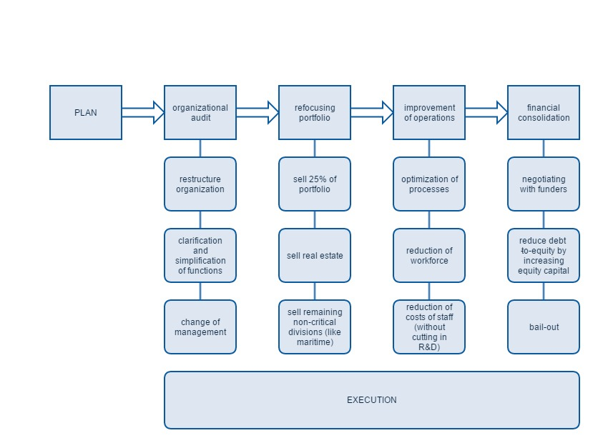

4.1 From my perspective

I am about to judge the development and implementation of Kron’s rescue plan. I am not an authority when it comes to saving organizations from their downfall. From my perspective, everything Kron did is a great accomplishment. To be able to judge someone like Kron, I believe I should compare his actions to that of a common multinational’s CEO. Because if I actually compared him to how I would perform in his situation, then he would have gotten an A+ at every turn.

|  |  |  |
| --- | --- | --- |
| Development |  |  |
| Focus | | + |
| Short term objectives | | ++ |
| Long term objectives | | ++ |
| Survivability | | ++ |
| Sustainability | | -/+ |

|  |
| --- |
| Scores |
| ++ excellent |
| + good |
| -/+ average/unknown |
| - bad |
| -- terrible |

4.2 Strategy development

Patrick Kron decided that survival would only be possible when focusing on core businesses and selling all other expendable assets. I believe it was the right choice of strategy at the moment. I also believe he did take a risk by doing so, as narrowing your scope does increase your exposure to conjunctural fluctuations in one market. I however do not think a company on the edge of bankruptcy can be saved without risks. Its already too late to avert the dangers. You’re in the middle of them. All together I believe he did a good job with going back to the core businesses of Alstom.

Kron did well to plan the sales of 40% of Alstoms portfolio to free up liquidity as well as show the determination that Alstom lacked, regaining a portion of the lost trust among investors. I think Kron did an excellent job.

In the long run, Alstom would have to significantly reduce the costs of production. He therefore had to find the cost drivers in which to cut. Even though a very painful decision for the employees and their families, cutting in the workforce was, in my humble opinion, the only possible outcome. Kron planned to reduce the workforce at the short-term costs of legal penalties. He managed to reduce the workforce by 50%, suffer the penalties… And survive. I consider that an excellent achievement.

To be able to sustain in the future, one first has to survive the present. He did an excellent job at developing a way for Alstom to survive. Kron did a great job of figuring out the way to regain the trust of investors, allowing Alstom to maintain its connections with the financial markets now and in the future. Kron also maintained investments in the research and development department. A good decision, however I believe it would be wise to allocate more resources to R&D in the future. As innovation is extremely important, in my humble opinion. I believe he did a good job in preserving a good future for Alstom.

|  |  |
| --- | --- |
| Execution |  |
| Leadership | ++ |
| Organizational structure | -/+ |
| HRM | ++ |
| Corporate culture | ++ |
| Diplomacy | ++ |

|  |
| --- |
| Scores |
| ++ excellent |
| + good |
| -/+ average/unknown |
| - bad |
| -- terrible |

4.3 Strategy execution

Kron’s leadership is exceptional. How else could someone succesfully implement a rescue plan to avert Alstoms default. I do not know much about Alstoms organizational structure after Patrick Kron seized control. I know it used to have a complex and matrix organizational structure. But I do not know if that has changed.

Another great method of binding personnel to Alstoms cause was the implementation of employee shareholding plans. A great incentive to increase commitment. Besides, he doesn’t let himself be persuaded into hiring back the employees who had to leave Alstom. Doing so would’ve been well received by the population, however it would also be a sign of weakness by investors. His actions concerning human resources management are an example. I believe he did an excellent job.

Another great achievement is the way Alstom actively participated in creating a new corporate culture. He figured out, by inviting a few hundred employees and simply asked them: which values do you consider important? He then, together with his executives, defined the common shared values. And forged with them a new corporate identity, shared by all. This is exactly the way I would do it myself.

Kron also engaged into diplomacy with several investors, the French government and so on. He restored trust, managed to obtain funds for operations and managed to reduce the debt-to-equity ratio extremely well. He finally managed to raise the price per share from 40 cents to nearly thirty euros as of today. That’s a positive interest that makes any equity investor drool.

5. My recommendations

*In your opinion, what should Patrick Kron do further to help Alstom survive, grow and sustain, based on your practical experience and the theories on Strategic Management that you have learned from the course.*

5.1 People

5.1.1 Personalities

I consider the human aspects a very important part of management. Not the common ‘tea party management’, but rather taking into consideration the personalities of personnel. For example, from a common extravert and social manager’s perspective, the suggested solution to most personnel problems is, as I have observed during my career, the use of team-building events, parties and other social events. But take a minute and think. Involved personnel with a social personality might appreciate these initiatives. But what about shy and introvert personnel? Do they enjoy these social events as much as the rest? Does it truly help this minority in becoming more involved in a company’s objectives? I sincerely doubt it. Throwing an introvert into a lion’s den doesn’t really make him or her happy. Nor would it make anyone else happy, residing in a situation one isn’t comfortable with. And I don’t believe unhappy personnel add much to success.

I decided to take the introvert as an example when it comes to failing people management. Introverts are considered a (less popular) minority. Even though recent studies show that introverts could potentially make up half the population, they are still seen as minority.

They are implicitly less-popular in the mind of many managers. Neglecting the positive features that this minority possesses. Like the average greater tendency to possess analytical skills, creativity and so on. One of course can’t entirely avoid social situations in present days’ society, even as an introvert. But a manager can attempt to make the situations more sustainable to people less social or shy. Allowing them to take a place in the company’s community that they feel comfortable with. And with that increase their happiness and in turn their productivity. It may seem like a proposition of minor magnitude, but I think increasing the happiness of half your workforce must do some good to the results of your company.

Managers often are characterized as socials and will consider, on average, a person with a distant or introvert personality to be ‘boring’. Which is in a way understandable due to a difference in personality. But excluding certain personalities might negatively influence both a company’s efficiency and effectiveness. For example, a social person might improve a departments vividness. It is rumored that socials perform better in sales tasks. Whereas introverts usually excel in research and analytics.

In my career I’m yet to find a job posting where a company was looking for an introvert. On the contrary, I’ve seen quite a few job postings where the company in specific, did not want a ‘boring’ introvert. I’ve seen several job postings meant for people where they did ask for extravert people to apply.

I believe there can be gains in actually using peoples personalities to improve results throughout a company.

5.1.2 Compensation plans

Another part of human resource management that I think could use some attention, is the way of rewarding employees. Currently there is a lot of societal opposition to incentives related to profits, like bonuses. As a lot of people consider those are an incentive to unethical behavior, pointing at the recent financial crises. As a supporter of rational egoism, I consider every person motivated by pursuing his or her own happiness. I believe they can be a great tool to motivate personnel. They should however be linked to more ethical accepted objectives. Sales personnel could be rewarded for an increase in customer happiness, rather than pure sales. Reducing hit-and-run tactics. Administrative personnel could be rewarded for results in superb data integrity.

I suggest not to reduce personnel compensation just because of societal demands.. As most critics come from spite and jealousy. How many of the people that actually criticize those that generate high income, would decline a raise in salary or a financial incentive? Again, I believe compensation should be in relation to results and other long-term objectives such as sustainability.

5.1.3 Rewarding in all phases of economical conjuncture

On top of function-related rewarding I believe it is good to reward personnel even in times of crises. Just because profit drops, doesn’t mean one can no longer reward personnel. If motivated personnel manages to reduce an expected drop in profit by 25%, then it should be rewarded for its efforts. Keeping personnel motivated even in times of crisis, might not lead directly to profit, but a reduction in losses is just as important.

5.2 Corporate cultures

As a mix of corporate cultures are one of the key problems within Alstom, a good way of avoiding great levels of tension between subcultures, could be to continuously monitor values and possibly adapt visions and vision statements and the means of achieving your visions.

For example if a shared value within one half of a company subculture isn’t shared by the other half, one might be better off choosing to focus on another value. One that is shared by the majority of both subcultures. Pick the best of both worlds, and pull your eyes away from conflicting values.

After I wrote this, I found out that Patrick Kron already did the same thing to forge a unified corporate identity.

5.3 Processes

I am not a great fan of Lean manufacturing. To be able to understand my view I will give some examples on how Lean has had a negative impact on the environment where I work. I do understand some parts of Lean Six Sigma can be of use in an industrial context. However, I do not think the philosophy of production efficiency in a Japanese car factory is fit for a Dutch consumer bank.

5.3.1 Lean desk policy

Whenever I see a recycle bin in the center of an office with 50+ personnel, I know something is wrong. Lean Six Sigma was here. The pros of investing in research, development, marketing activities and so on, do not immediately produce their profits. They come with some delay. Due to the nature of process optimization and business redesign through a hype named Lean manufacturing, anything that does not add to short-term profits is being eradicated by these ‘Lean’ experts in my working environment. This means cutting in marketing divisions, research and so on.

I believe innovation is required to sustain in markets of heavy competition. Which is about any market. Therefore I consider Lean a bad choice when attempting to improve operations.

Not only does it seem to focus on means rather than results, at least in my environment, it ignores the human aspect all together. Especially now financial institutions start copying the Lean-hype it becomes obvious. Personnel is subject to increasing work pressures due to a focus on costs putting severe dents in their well-being. Often leading to burn-outs and so on. Focusing only on costs will not get you any unique advantage. Perhaps only a slight reduction in costs.

But I even doubt the cost reduction is always met. I work for a large international consumer bank. What surprises me is that in any department, any office, there are no bins to be found. No trash cans. None. It seemed the ‘Lean experts’ had decided that bins are excessive in costs to maintain. So all bins were removed, only 1 was being put in the center of the office. This way the cleaner no longer had to clean up 10 bins, but only 1. They were convinced it would reduce the costs of operating the specific department.

5.3.2 An example

But what these ‘experts’ fail to understand is, the price per hour for a detached actuary goes into the 3 digits per hour. 40 actuaries and actuarial analysts having to walk to a bin 3 times a day for say an average of 100 euros per hour. Let’s say they are away from their desks for 1 a minute. This means 40 / 60 x 100 x 3 = EUR 200. While all together it takes the cleaner 20 minutes to clean the department. The cleaning company costs 40 euros per hour per cleaner. 40 euros / 3 = 14 euros saved. So to reduce 14 euros a day on cleaning costs one has to accept an increase in personnel costs of EUR 200 per day. Then what is the point of removing all these bins? And what about all these ‘Lean’ experts? What do they cost?

No, I’m convinced Lean Six Sigma or anything related to scientific management has no place in any non-industrial or non-trade company. One could improve processes by merely using logics, rather than some fancy dummy’s guide or framework. Besides, one could reduce costs (or increase profits) by focusing on results, rather than means and the processes needing to lead to these results.

5.3.3 People are not rational

But opposed to what the doctrine of Lean might suggest, personnel is, in my opinion, like it is with scientific management, being considered rational beings. But they aren’t. People have emotions, and you can’t just get an engineer to come over and fix a human being. Institute interactive control, let the people working in operations have a say in what they can offer their customers. They talk to their customers every day, surely they know what their customers want? Cooperation between multiple echelons of management and operational personnel could create some fantastic initiatives.

That said, Alstom is, unlike my employer an industrial company. Technical processes make up a large part. Efficiency is important and operational excellence might be key to obtaining a satisfying degree of efficiency. But still I believe it is wrong to just blindly cut and alter processes without thinking of the big picture. If your business model hangs by cost reduction alone, you’re swimming in a red ocean (I think). I prefer operating in blue oceans and staying ahead of rivals. A certain proficiency in innovation is required to stay ahead of these rivals. I only believe a sustainable competitive advantage can be gained when you innovate and evolve faster than your competitors do. So it is not about a single lucky strike, but continuous innovation and evolution.

Alter processes with the long term-results in mind. Reward process optimization only when long-term goals are met. Let logics and innovation persist. And by logic I also mean taking into account that people are emotional beings, not machinery. Don’t treat them like machines.

5.4 Technology

Lots of banks found out the problems of lacking due diligence throughout the last years. Through securitization of subprime and alt-A mortgages for decennia, large banks, dangled upon the precipices of bankruptcy. Not knowing what exactly they had invested their money in. It even lead to the fall of Goldman Sachs in 2007.

Like these banks, Alstom wasn’t entirely aware of what it had stepped into when merging into ABB. Even though on the surface all seemed well, but below problems were brooding. Implementing the turbines straight away without testing then in a safe test-environment, turned out to be very dangerous. The technical (and contractual) problems that occurred after were a prove of that. Causing huge financial problems to Alstom.

Therefore installing a test environment for structured testing of products before putting them into use would be a good way to start. This way the amount of problems occurring from using Alstoms turbines during operations would be reduced. Reducing (financial) consequences and risks. It will increase production costs at first glance, but on a long-term there will be a reward in reputation. Reputation as a contract partner and a producer of reliable energy and transport equipment.

5.5 Finances

One of the problems of Alstom was funding most acquisitions with debts, rather than through equity capital. Unlike trade companies and for example banks, industrial organizations require more equity capital due to the illiquidity of many of the assets that can be found within the company. Like structures, machinery and so on.

One way of slightly increasing the equity capital in future comparable situations, would be to reward faithful and good personnel with incentives paid in shares. It is a long-term solution, but also one that motivates employees. You, as an employee, receive payment in shares and the better you do your job, the more you will earn from selling your shares in the future. It is also a means to empower employees, rallying them to better fulfill your company’s objectives.

Also it might be an idea to reduce the impact of assets on the balance by leasing machinery rather than buying them. The increase in technological advantage might be a good reason for this. The faster business needs change, the faster machinery becomes economically inferior. So operational leasing could prove a better way to avoid drops in value to technological breakthroughs.

Another flexible use of funds would be to emit (reverse) convertible bonds*. Reverse convertibles can be converted on the discretion of the emitting company. If the price per share is too low to obtain a satisfying composition and amount of funds, Alstom could’ve emitted convertibles and allow investors to use their rights to convert their bonds to shares when the time is right. Therefore also reducing the amount of rent to be paid. Both during the existence of the non-converted bonds and after. It would of course depend if anyone would ever use their right to convert, but if a company doesn’t believe in its own survival and worth on the secondary capital market, than why even bother with saving Alstom at all?

It is also a sign of trust in one’s own company when issuing convertible bonds. Suggesting a future increase in equity value is very likely.

*\*Convertible bonds, due to the option to trade for equity, have a lower rate of return.*

5.6 Strategy

One of Alstoms problems was the collapse of its primary markets. Considering the problems that occurred after, it might’ve been a better strategic option to broaden or perhaps deepen the range of activities. For example acquiring or starting-up activities in business-to-consumer markets, or focusing on the production of small parts for smaller industries. This to increase the speed of cash flow and reduce exposure to market-related problems, like the energy bubble. By entering consumer markets or markets for small businesses, turnover time of the larger divisions can be compensated due to faster and more frequent sales, increasing the speed of operational cash flows. Alstom could even diversify into unrelated fields, but this would mean a waste to potential synergy pros of diversifying in related fields. Perhaps a mixed strategy?

As reducing debt and increasing equity capital is keen to creating a healthy balance sheet, it is important that potential new activities generate an advantage through synergy. Otherwise investors could just as well invest in the separate shares themselves.

Because Alstoms creates large industrial products, cash flows might be fluctuating, and dropping especially in times of long-term projects or a lack of orders. Siemens and General Electric had and still have a wider scope of products. Reducing the exposure to market specific drop of demands. So I suggest looking to other fields and markets to see where demands might pop up. And perhaps, with a little luck one could find himself his own blue ocean.

I would suggest looking into possible synergies in certain business-to-consumer markets and perhaps smaller businesses that focus on technical equipment. What about the production of 3d-printers? Does Alstom have the competences to gain synergy pros by acquiring or starting up factories in 3d-printers? This of course is just an example. As I do not have the technical know-how to judge the synergies between different technical businesses. But the research and development department could research the potential profits from broadening the company’s scope to other technical equipment.

5.7 International markets

As some markets are still emergent. For example large parts of Africa, India, China and some South-American countries still have the potential to grow rapidly in the near future. Growth leads to more and larger industries and thus larger demands. I would suggest researching which markets are potentially great to supply. And consider starting operations in those markets. As personnel is cheaper and natural resources might also be supplied cheaper, due to shorter supply routes. It is important to monitor expansions in other nations closely from a responsible perspective, due to different cultural ethical norms, values and habits being present. Corporate social responsibility needs to be maintained, else one could damage the reputation in home markets due to, for example, bad working place conditions, bribery and dumping hazardous materials.

The way to ensure the corporate responsibility throughout the world would be to manage a company on the principle of the Integrative Social Contracts Theory. This will make ensure that local cultural ethical norms never take precedence over first-order norms (in this case Western/French cultural norms). I explicitly name Western/French cultural norms, because it’s from the perspective of Western society that these norms are considered first-order. Because of Alstoms roots in Europe. Other companies with their roots in different cultures could very well consider Western norms and values to be inferior to theirs.

A good reputation can be crafted by entering third world markets and assist local businesses in their growth by supplying energy and transport equipment at a reduced cost. This would mean an initial investment, but an improvement of infrastructure would mean a potential higher profit in the long run. As well as a great reputation. Do it responsibly, consider the environment, and one would set a perfect example in terms of corporate sustainability (or the three P’s).