MBA Course Operations Management

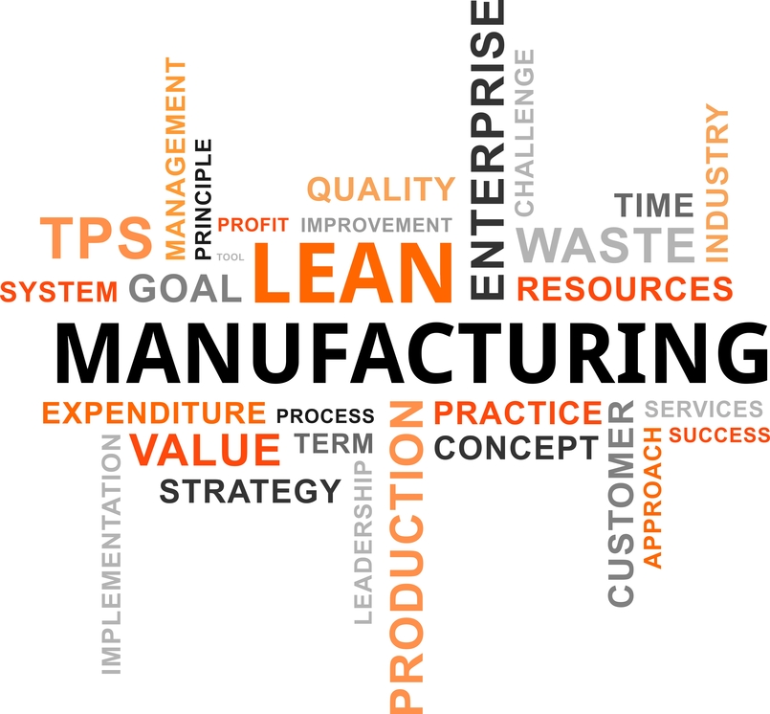

Naam: Rogier Nitschelm

Adres: Noteboom 59

Postcode en woonplaats: 4101 WS Culemborg (Nederland)

Inschrijfnummer: 817397

Modulecode: MAS0450N

Inzendcode: MAS0450NI2

Datum: 13-8-2015

*Explain the circumstances that made Boeing adopt the lean manufacturing practices in the late 1990s. What were the factors that hindered the implementation of the system? What according to you are the pre-requisites for the successful implementation of lean manufacturing in large organizations?*

**Obstacles in implementation**

In the end of the 90s Boeing faced a large amount of problems. First of all the Asian economic crisis had severely dented the outlooks for future revenues in the coming 20 years. On top of this market-related problem, Boeing’s operations were severely outdated, its technology was lacking and there was a large amount of bureaucracy involved in manufacturing, causing further decrease in efficiency.

According to the case, the operations were considered ‘inefficient’ and there were high costs involved as well as long production cycli. In addition to these internal problems was an issue in Boeing’s range of products.. As Boeing offered customers a wide array of extra options and variations, forcing the company to keep track of all the versions, options and so on. This resulted in an excessively large administrative database with an enormous amount of computers to keep track of the information involved.

Even though the operation didn’t cause problems in the past, due to a limited variety in planes being ordered, it now caused a severe obstacle in maintaining proficient operations. Boeing’s reputation stalled, and customers ended up disappointed of which some would seek alternatives in Boeing’s greatest rival, Airbus.

As the problems had to be addressed in order for Boeing to survive, it began implementing Lean manufacturing with the help of a Japanese consultancy firm. In 1994 both DCAC and MRM were implemented, enabling Boeing to simplify its processes. Unfortunately the initiative turned out to be too complex to success.

Despite the efforts made, the lean manufacturing didn’t turn out as well as Boeing had hoped for. One of the problems were related to the company itself. Even though the manufacturing procedures were outdated, Boeings personnel maintained a hostile attitude towards change.

The company did attempt to maintain and increase its market share, yet as its operations lacked, Airbus turned out to be the victor in this battle for the customer. Eventually Boeing had to close down plants and endure an enormous loss of 1.6 billion, while market share would further drop until 2001. As analysts assessed the situation, it was obvious that the corporate culture was the major cause for the failing implementation of operational excellence. People would obstruct organizational change, and thus changes in operations were meant to fail.

**Requirements for change**

I believe the analysts described in the case were right when they explained the corporate culture being the primary factor for the failing of implementing efficient processes. In order to change, a company will have to create a solid ground with all the stakeholders involved. Not only will it reduce protests among workers, it will also reduce work-related stress and through that possibly further increase personnel efficiency. Creating a good foundation to start is to explain ‘why’ one has to change. When promoting improvements, one should address the need for the company to change in order to survive. As no change means no more Boeing its employees should be alerted of its alternative: Boeing no longer able to compete with Airbus, and thus a loss of employment. Through underlining the urge, opposition to the intended changes can be reduced. Training personnel to understanding lean and through that, rally them for the greater good. The implementation of lean manufacturing.

I do believe including (financial) incentives to successful implementation of improvements will increase the likelihood of success. And possibly cause more gains than it costs. Depending on how well the implementation is executed of course. Also, I believe a loosened style of management will encourage change. As employees that are drowned in bureaucracy will not be used to freedom and thus changes in a company.

**Define lean manufacturing and discuss the various tools and techniques that are involved in the successful implementation of the system?**

**Definition of Lean manufacturing**

Originally developed in Japan by Toyota, the Lean philosophy was partially derived from the ideas of Scientific management/Taylorism. Which is a rational method of operations management.

Lean is a philosophy that strives to obtain as a high a customer value as possible. In order to do this, Lean offers the tools to reduce waste, and maximize output.

Lean offers a set of principles that determine how operations should be managed in order to have goods flow smoothly (mura) through to the several stages of a transformation process. Without exposing machinery and men and women to overburdening and stress (muri). This all with as little waste (muda) and minimal variation in order to obtain operational excellence.

Of course it’s essential to determine the definition of waste. Within the Lean philosophy, waste is all that doesn’t add value to a process or product. Research has determined that materials and processes remain idle for 95% of the time, one of the most logical steps is to alter the way inventory and orders are handled. This would result in Just-In-Time delivery.

But even though the muda, mura and muri cause a lot of waste, we also need to determine what can be considered waste.

Lean identifies seven forms of waste. I will sum them up and give an example of a tool to prevent future causes of this type of waste. I will describe some Lean-tools further later on.

**The seven mudas**

*Overproduction*

Producing more than is required is a waste of valuable resources. Both materials wasted as well as end-products that cannot be sold yet, carry the cost of capital in them. There are interests to be paid for capital (or interest lost in case of equity capital used). Produce only exactly the amount that your customer needs will result in no wasted capital and thus more efficiency. One of the answers of Lean to over-production is JIT, or just-in-time.

The traditional means of operations involve holding large amounts of inventory. When operating based on the lean principles inventories are minimalized by building a stable network of suppliers. With open and clear communication, also when concerning the inventories, the supplier will be able to deliver just-in-time and the business will be able to answer customer demands exactly whenever it arises. With as little capital requirements as possible.

Examples of wastes at Boeing:

* Too many copies of manuals regardless of their use;
* Excessive data without the means to analyze this data;

*The traditional push-strategy vs the lean JIT/pull-strategy.*

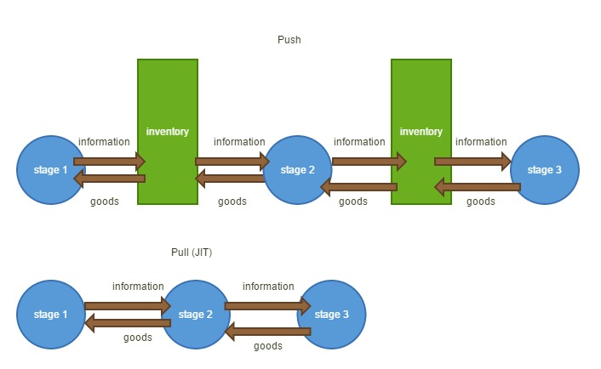

*Waiting time*

Another large source of waste is the time that a person or machine is waiting to operate its activity. A waiting line results in processes not being executed. One can prevent waiting lines by starting the process earlier (and only ordering the amount of materials and manpower that can be active in production at a time. No more).

Some examples of wait:

* Waiting for a process to complete to be able to continue;
* Waiting for specification of the next request;
* Idle machinery.

One answer of Lean to waiting times is continuous flow. Which describes the way materials should flow through a process. In a natural sense, without obstructions or ‘waiting time’. It also helps using quality tools and ensuring standard and clear procedures.

A famous example of when a ‘wait’ is acceptable is the Toyota factory. Whenever an employee detects a defect in the production process it is allowed to completely shut-down the process until the defect is fixed.

Example of waste at Boeing:

* Waiting for parts to be delivered;
* Waiting for information to be delivered.

*Transport*

Operations with lots of moving of resources and handlings are expensive. It is wiser to move related operations close to each other, and ensure the amount of transport is minimal. For example, having a company restaurant on the top floor of skyscraper might give a nice visual, it is not very efficient in terms of transport. It is better to move it to the lowest floor so goods need not be traveled all the way up. However, one should also consider the cost of executives. Putting the least expensive personnel on the highest floor might reduce the amount of costs of senior management having to move between restaurant, their own office and other related locations. An administrative employee having to spend 5 minutes in the elevator is cheaper than members of the board doing the same thing.

Example of wastes at Boeing:

* Pilots carrying too many documents (non-value for the customer)

*Process*

Processes themselves can be a source of waste. When a process contains sub processes with obsolete handlings, it wastes time and money doing something useless. Like having an administrator fill in two separate sheets with identical information. One could just make a macro in for example Excel, so the input of one sheet will be copied on the other. This will reduce time of the sub process with up to 50%. This is a real-life example of a credit revision process that I have had to execute in the past.

Example of waste at Boeing:

* Searching for information in too many manuals;
* Waste from non-optimal takeoff conditions (non-value for customers);
* Schedule interruptions;
* Unfit applications used in the processes.

*Inventory*

Inventory itself is considered a waste. As it is just ‘there’ waiting for a need to arise. Lean suggests JIT to ensure that inventories are minimal and resources are delivered exactly on time. This will save on costs of capital that is required to hold an inventory. Also, one shouldn’t produce ahead. Produce when an order is generated, not ahead of time.

Example of waste at Boeing:

* An inventory based on just-in-case, rather than just-in-time;
* Unused records in Boeing’s database.

*Motion*

Motion is considered activities that do not add value. One can move from one spot to another, yet do nothing useful. Too much searching for items is wasted value. If information is required, then it should be easily accessible. If not it is waste of motion.

Example of waste for Boeing:

* Too much time to find the right parts.

*Defects*

The waste of quality that is supposed to generated but is not. Examples of defects are faulty products, incorrect components in a product, scrap materials, and so on. Lean suggests that it is important to avoid or correct defects, rather than let them occur and correct them afterwards.

Jidoke is one of the solutions to solve defects. These are intelligent machines that are able to detect variation from a standard. So when a faulty product is about to be produced, the system is alerted and corrections can be applied. Preventing the production of a faulty product.

Examples of waste at Boeing:

* Wrong parts removal;
* Missing specification;
* Extra maintenance to correct errors.

**Lean tools**

I will describe a number of tools that is commonly used in lean manufacturing. Along with a few examples of results that Boeing achieved using these tools. These tools will help reduce waste and maximize value in operations.

Some of the Lean tools are:

* Just-in-time;
* Kanban;
* Kaizen;
* Value-stream mapping;
* Key performance indicators;
* PDCA.

*Just-in-time*

Rather than pushing production through projected demands, employing JIT results in basing production exclusively on customer demands. Through this it is possible to reduce inventory and therefore reduce the amount of (quick) liabilities and the interest. It’s important to ensure a stable supply line as problems in supply means one cannot answer the customers’ demands and will result in selling no for an answer. Considering the past in which some customers would trade Boeing for Airbus, it is essential to manage the supply chain accordingly. One should have a select group of dedicated suppliers.

A few tools to ensure the right relation between the core suppliers are:

1. Alignment of vision between the partners
2. A common focus on customer benefits
3. Mutual trust, commitment and dedication

Results of Boeing’s implementation in terms of JIT:

* An information system that sets the right minimum and maximum number of items to be ordered.
* Suppliers using the computerized network to investigate the presence of their supplied materials. When empty they will deliver new ones. Boeing does no longer need to give notice prior to delivery.
* Suppliers have insight in the production forecast up to 3 years ahead.

*(source: Boeing Frontiers at boeing.com)*

*Kanban*

Kanban is a method of improving communication with participants and stakeholders. It does this by visually monitoring the production chain. For example on a Kanban board. It is often executed by using cards, notes and so on. Other philosophies also adopted Kanban, like Agile/Scrum and so on. Visuals often succeed where.

Kanban in Japanese means signboard.

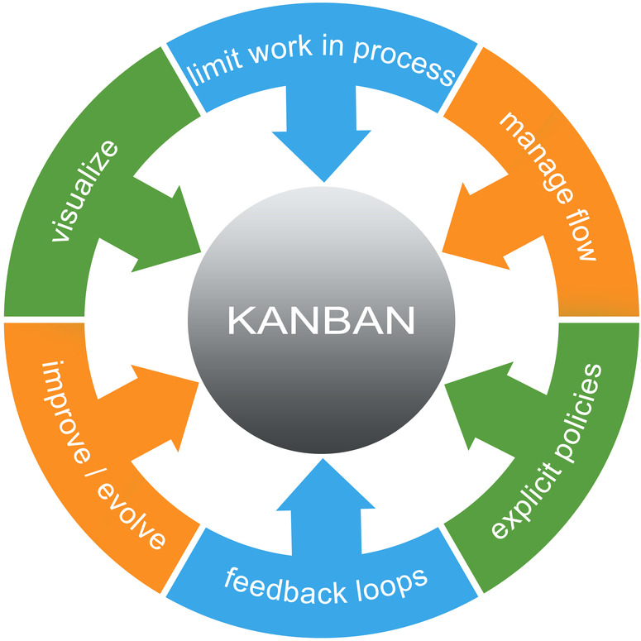

*Kaizen*

Kaizen is a synonym for continuous improvement in business environments. By attempting to improve, one is able to fulfil several goals, like increased production efficiency, eliminating waste and so on. It doesn’t exclusively involve management, but also regular operational personnel are involved in continuous improvement.

The improvements made are usually not very radical. Rather, Kaizen often results in incremental changes, step-by-step improving an operation.

*Value stream mapping*

In order to improve the transformation and information processes, it is necessary to visualize the process itself. VSM is executed by drawing a model of the goods and information streams or flows (mura) within the current state (ist) of a process and describing the activities and other factors involved. This should visualize the current state. After that the future state of a process can be drawn (soll).

Results of Boeing’s implementation of Lean in terms of VSM and Kaizen:

* The Cargo Systems Value Stream Mapping, which improved communication and allowed the assembly team insight in where the parts that are supplied need to be installed. This system is being updated with new improvements continuously.
* A Kaizen newspaper used for reviewing suggested items for improvement.

An example of a Value Stream Map

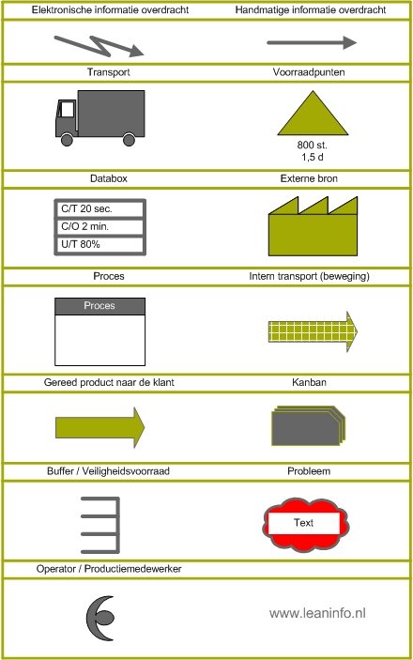

*(source: leaninfo.nl)*

*Key performance indicators (KPI)*

Another tool within the arsenal of Lean is the use of KPIs. Key performance indicators are a way for management to measure the performance of a business by determining the effectiveness in succeeding in the company’s objectives. KPI’s can be determined in various ways. For example one can determine a performance indicator based on the amount of waste produced, the downtime of production processes and so on.

*Plan-do-check-act cycle*

The PDCA is a management tool for controlling and improving processes in a business. The PDCA-cycle or Deming circle consists of four steps which are executed in sequence:

Plan the objectives > Execute the plan > Study the results > Update the process

*Picture: the PDCA-cycle*

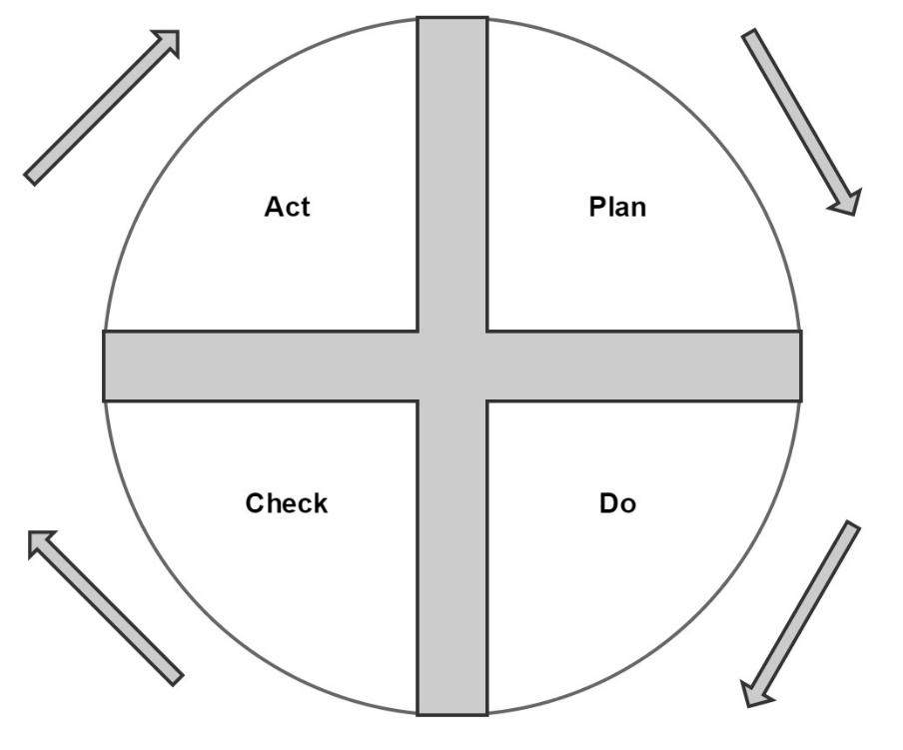

**Implementation of Lean at Boeing**

One cannot simply install Lean without any preparation. Lean implementation has often failed. One of those reasons is attempting to implement Lean in service environments, while applying these through using methods that are only fit for manufacturing industries. For example a service industry (non-trading) often does not have inventories, or not very large ones. An accounting firm does however, have a large amount of very expensive employees. This would mean more focus should be placed on preventing waste of motion and transport, less focus on inventory.

To correctly apply Lean strategies, it is important to:

* Identify waste;
* Eliminate the waste;
* Ensure a continuous and natural flow.

This then translates as follows:

1. Determine value from a customer’s point of view;
2. Identify the value stream (the required actions to deliver the value to the customer);
3. Overcome any obstacles that reduce the flow of value;
4. Have customers request (pull) their products rather than produce ahead;
5. Continuous improvement (Lean is never done).

As the customer is the one determining what is value, it is important to view value from the customers perspective. If the customer doesn’t consider your products of value, he will not buy them. And you will not make profits. When value is determined one needs to get this value to the customer in as little time as possible and deliver it right when the customer needs it.

In this route of value on its way to the customers any obstacles and inefficiencies should be eliminated. As cooperation within the supply chain is one of the foundations of Lean, it is important to have all members of the supply chain and the customer voice communicate their demands on time, so just-in-time delivery is achievable.

Of course Lean will have to adapt to a continuous changing environment with changing demands and necessities. Through continuous improvement one has to ensure to always stay ahead in terms of efficiency and adapt operations to new efficiency rewarding practices.

**Benefits of Lean**

Several researches indicate that Lean manufacturing has led to a reduction in scrap materials and setup time by 90%. Lead-time would be reduced up to 50%, reduction in operating costs and so on. On top of that it would reduce waste and increase quality; in other words ‘value’ (to the customer).

**Explain the lean manufacturing initiatives undertaken by Boeing and explain its approach. Analyze the methodology and the process in implementing it? What are the factos that contributed to its success in the second attempt?**

**Reason for the Lean initiative**

To explain the Lean manufacturing initiatives, one has to look at the problems. The case states that Boeing had severe production problems. Obviously it also lacked credibility on the financial markets, which would translate in problems obtaining funding. On top of that Boeing had a corporate culture unfit for progression.

Lean manufacturing can solve, at least for a great part, most of these problems. Production problems? Waste? A well-implemented Lean approach would solve this. Credibility on the financial markets? Lean might not solve this directly, but in an indirect way, Lean would help regaining investor’s trust. As efficiency and value were lacking, one needed to find a way to obtain the required efficiency and the customer value. Lean would accommodate this, and in turn, financial markets would regain some trust in Boeing. And then the corporate culture. Applied in the right way through the right workshops, could rally personnel in Boeings renewed course.

Thus summarized, Lean would enable Boeing to either directly or indirectly solve most of these major problems. Which makes the initiatives regarding Lean a logical choice.

**Key elements of Lean improvement**

To improve one’s operations based on the lean method one will be focusing on the following key elements:

* Customer centricity;
* Internal customer-supplier relationships;
* Perfection as a goal;
* Synchronized flow;
* Reduction of variation;
* Including all employees;
* Elimination of waste.

But even though these elements are necessary to succeed in improving a company. A stable foundation is required. This stable basis (or philosophy) can be found in the 5-S methodology.

**5-S methodology**

Boeing decided to stick to the Japanese approach and based its implementation methodology on the 5-S. These stand for sort, straighten, shine, standardize and sustain.

This methodology would translate into a successful implementation of Lean.

*Sort (seiri)*

The ‘Sort’, or seiri; describes that one should eliminate all waste and only keep what is required to operate. A great example of Boeing considering this principle in its actions is the reduction of the amount of applications used to keep track of parts.

*Straighten (seiton)*

‘Straighten’ is the term within the 5-S methodology that stands for efficient positioning to allow for a ‘smooth’ flow of operations.

*Shine (seiso)*

The ‘Shine’ principle reflects the necessity to keep a working area clean.

*Standardize (seiketsu)*

By standardizing processes, the amount of problems is reduced. Also, because of a reduced variety in operations, processes are more easier learned and workers can quickly determine when a process is malfunctioning.

*Sustain (shitsuke)*

To sustain means that standard procedures should persist and continuity should always be ensured. To enforce sustainability one could link a key performance indicator to audits which measure the degree in which a division ‘sticks to the plan’.

**Workshops and consultants**

Even though the methodology to base the implementation on was determined. Lean doesn’t implement itself. And there were a lot of obstacles to overcome, of which resistance among personnel was a major factor.

Therefore Boeing ensured its managers would participate in Lean workshops. Also, Boeing would facilitate tours to Japan in order to learn from the masters of efficiency themselves. Executives would be invited to visit local Toyota factories to observe the benefits of standardized Lean production. And the value it would produce. Kaizen tours were accommodated and so on.

Boeing would hire the best advisory available in the form Shingijutsu consultants. Shingijutsu is a well-known consultancy firm in optimizing business processes. These experts would assist Boeing with installing the new Lean way of operations.

In 2000 Boeing would introduce value stream analysis to its commercial division and Boeing would also go corporate-wide with its Lean implementation. Of course continuing Lean training and workshops along its way to regaining its market share.

Eventually the moving line initiative would prove to be one of the best improvements of Boeing’s operations. A car production but for airplanes. Extremely efficient. First its main assemblies would go moving line and its subassemblies after. But the company was aware that in order to further increase efficiency, the supply chain would be required to be synchronized into the Lean way of operating.

**What were the benefits derived by Boeing as a result of adopting lean manufacturing practices? Do you think the company’s decision to implement the moving line technology for aircraft manufacturing was a wise move? Give reason to support your answer.**

**The benefits of Lean**

Boeing obtained a whole lot of benefits from successfully adopting Lean practices. For one Boeing was able to reduce inventories by 1 billion dollars, reduce manufacturing time by 60%. And in addition to this the required floor space for its operations was reduced by half. These are quite some notable improvements in efficiency. Translated, 1 billion dollar savings in funding, 60% less machine and/or man hours. On top of that an increase of potential interest per square meter of floor space. This surely relieved the tight balance of Boeing as well as increase the output of its operations.

In addition to a decreased production time of parts and the reduced assembly time, the flow time of materials and product was reduced from 9,5 days to merely 5 days. This resulted in another benefit, as a second production line was no longer required for Boeing’s operations. Freeing up additional capital for alternative uses.

Mutual dedication of suppliers within the supply chain is one of the principles of Lean. As Boeing improved its inventory and order processes through a digital procurement system, Boeing managed to reduce time to supply as its suppliers were aware and put to action when Boeing would run low on parts. This adaptation would ensure the Just-In-Time deliveries that Boeing needed.

**Benefits of the moving line**

Where traditional manufacturing would involve having workers move towards their tools and the part of the plane they were working on at the specific stage. The moving line would turn this process around. Instead of having the workers move to the right location, the plane is just being moved towards the next workstation allowing to have personnel work more efficiently in the assembly of the plane. These work stations even have their floors painted in a clearly defined color (visual). So at any stage of the manufacturing process it is clear what has to be done and where it has to be done. In addition to this, also the toolkits used by the workers have their own color to define the type of tools that they carry, so they no longer have to waste their time searching for the right set of items.

In addition to the larger moving line moving the plane forward in the production process, Boeing also uses feeder lines. These would allow employees to assemble subassemblies of the planes close to the main product itself.

Last but not least the quality of the products is assured because of errors being both reduced to begin with as well as being clearly visible whenever they occur. So they can be fixed right at the source. This must be a very attractive method of preventing planes with defects move out of the assembly line and flown across the world. Let’s hope this will translate into even fewer plane crashes.

**Non-cyclical growth**

Even in times of crisis its key focus on operational efficiency allowed Boeing to compete. Not only its production was improved, Boeing would also improve its airplanes. Thus using efficiency as a USP not only in terms of cheaper planes. It would mean helping customers obtain their own operational excellence through buying Boeing’s products. In other words both processes and products were the results of efficient operations.

As the financial crises forced customers of Boeing and Airbus, like the US and other governments, to look for ways of reducing costs or increasing output. With its newly adopted Lean tools, moving line production and so on, Boeing was able to supply a considerable share of the increasing demand for fuel-effective airplanes. Allowing profits to be made even during low economic conjuncture and therefore a smaller total market.

The successes made in operational efficiency ensured that Boeing’s Renton plant was able to produce 42 jets per month. Even though this is a reflection of Boeing’s state-of-the-art production efficiency, they plan on even further enhancing its production capabilities, as recently announced improvements could further increase production to around 52 planes a month (source: Boeing.com).

**A smart move?**

Considering the benefits that Boeing obtained and the resistance to conjectural influence instigated by the financial crisis, I believe it was the only choice Boeing had. Introducing the moving line in order to increase efficiency ensured Boeing had a competitive advantage over its rivals. The fact that one strives to sustain continuous improvements, will increase the likelihood of staying ahead on rivals, at least when it comes to operational excellence.

**Do you think Boeing would gain a competitive advantage over Airbus after implementing lean-manufacturing practices at all its locations? Do these practices offer it a potential to regain market share and restore profitability levels?**

**Boeing ensuring it’s future**

What I can tell is that Boeing has done a great job so far, ensuring its own future. It’s now important to get and stay ahead of competition. It must not be forgotten that running a company involves more than just operations management and efficiency. Thanking all the successes merely to Lean isn’t right. It can however, have a large part in the success of obtaining an efficiency edge and of course happier customers. But that part of the total success depends not only on whether or not applying Lean. Because what the case doesn’t specify is that Airbus also applies Lean principles in its production (source: [www.airbus.com](http://www.airbus.com)). One notable success of Airbus was its 100% in-time delivery.

The question, in my humble opinion, shouldn’t be whether or not implementing Lean resulted in a competitive advantage over rivals. But rather the question should be, has the way the Lean techniques are applied given Boeing a competitive advantage? In that case the answer is a possible ‘yes’. Boeing halted the loss of market share and was even able to increase its market share from 2000 to 2001 to a total of 47% where it was 45% before. It has taken 2% of the total at the cost of Airbus. I do not have accurate information on its current state, but Boeing did strengthen its positions and is now more or less equal to Airbus in terms of production and delivery of airplanes. So it is likely that Boeing obtained even a bigger share of the market from 2001 and upwards.

**Bad examples**

As the good examples have been already described I would like to point out some flaws as well. First of all I am one of the people that critically argues some, by colleagues proclaimed Lean-practices that have been going on in my professional environment. It seems like a lot of self-proclaimed Lean specialists focus their goals in operational excellence by cutting in anything that has a measurable cost component. Even if this means the total costs of operation increases.

There is one example in specific that I wish to address. I anonymized the example in order to avoid former employers having their reputation harmed.

**1 bin system**

A large consumer bank hires a handyman 5 days a week. The handyman is a cost that is easily measured. 1 day of cleaning can be done at a total cost of 120 euros. That is 120 euros a day. A small portion of the handyman’s time is used for cleaning trash cans.

Because the company wants to reduce cleaning expenses, it has decided to remove most of the bins from the office. Instead of 20 bins, there now is 1 bin per 40 employees. This results in a cut in the costs of the handyman, as he only has to clean up 1 bin. As instead of 8 hours, it only needs 7.5 hours to clean up the entire office. The total cost is corrected by 7,50 (-) euros per hour per department of 40 employees.

However, in order to throw away trash and keep one’s desk clear, the financial analysts and the actuaries have to move from their desk towards the trash can every time they wish to throw away their trash and empty plastic cups. On average 3 times a day. That means the actuaries, actuarial analysts and financial analysts have to be from their desk 3 x 1 minute of the day. That is 3 minute per employee. An actuary is a very expensive employee, but as we consider other types of employees as well, I have used an average tariff per hour of 50 euros. This means, in order to cut in the expenses of the handyman, it has to accept a cost of 3 minutes x 40 people = 120 minutes = 2 hours. Two hours x 50 euros = 100 euros in extra cost of motion.

So the total loss of cutting in the handyman’s time and using the 1 bin system over having a trash bin at every 2 desk is 100 -/- 7,5 = 92,50. Sure one could state that employees get a health advantage of walking to the trash can. However, that doesn’t seem like a good way of ensuring the health of employees. I’m sure they’d rather have a short walk outside.

**Reason for bad Lean practices**

I believe I do understand the reason for this specific example occurring all over banking offices in the Netherlands. Consultants are hired to reduce expenses. Yet, something is often only considered an expense when it is measurable. Some costs are easier quantifiable than others. In order to ‘prove’ ones’ success, a consultant will have to remove parts with a clearly visible price ticket. Else, even though efficiency is increased, it isn’t measurable at the short term. Which will not do anything for the benefits of the consultant. No measurable success often means no bonus, or other incentives. That said, I do believe there is a significant amount of sheer stupidity involved in these practices. Many consultants probably do not even think of the extra motion office employees have to undertake by removing bins.

Like stated before, this is a real-life example. I have witnessed this being executed by people going about with fancy Lean-titles at two large domestic banks. I have reported this potential costly practice to the head of the division of my current employer, who told me it indeed isn’t lean at all. And it has frustrated this executive that these practices were going on. The downside of Lean in my opinion is that it has an incentive for consultants to cut in the easier measurable components of cost.

Some other common downsides to the implementation of Lean and other practices (Agile and Scrum) is the fact that only “some parts” of the philosophy is integrated, while other parts are not. Companies want lean production, but do not want to delegate responsibilities. They want continuous improvement, but do not want their own employees to have a say in these improvements. In Scrum there is a name for these practices. A Scrum-but:“I’m scrum but XYZ”.

However, like Lean, any management practice or solution has flaws. There is no perfect one.

The moral of my story is that believe it is important to look at the bigger picture, rather than just measurable costs. I baptized this removing of trash cans from office floors as a ‘1 bin system’ in referral to the 2 bin system (p. 392). To me, the 1 bin system remains a synonym for debatable process improvement. My report of the 1 bin example has helped me obtain my new position as process improver at my current employer.

**Literature and references**

* Slack, N.,Brandon-Jones, A., Johnston, R. (2013) *Operations management*
* *Boeing.com and Frontiers at Boeing.com*
* *Airbus.com*
* *Leaninfo.nl*