AI StudyBuddy
AI assistant for smarter learning and study support
Overall Project Documentation
Technical Project Report
Project | AI StudyBuddy
Project ID | SWTID-2026-7764
Source | Current source folders: backend/ and client/
Evidence baseline | Evidence baseline: rebuilt from the selected current backend/ and client/ source folders. Claims are labelled according to evidence. node_modules were not required for source verification.

Description
AI StudyBuddy is a web-based learning assistant that helps students understand, revise, and practise from their own study materials. The verified implementation combines a React and TypeScript client with an Express backend, MongoDB persistence, and Google Gemini generation. A student can authenticate, upload a PDF, TXT, or MD file, save extracted content, and request summaries, flashcards, quizzes, or a study plan.
The client also presents dashboard areas for Materials Hub, AI assistance, quiz practice, study planning, Smart Notes, analytics, settings, and related navigation. Backend-verified behavior is separated from frontend-only behavior and unverified UI claims throughout this report.

Scenario-Based Case Study

Background
A university student receives lecture notes and reference material in different formats. Before an examination, the student needs to identify key concepts, practise recall, and organize a daily revision plan. Manual preparation is slow, especially when the material is long or spread across multiple files.
The project scenario is a simple sequence: authenticate, upload or paste material, process and persist content, call the AI service, save generated learning assets, and present them in the dashboard for revision.

Problem
Students can spend more time preparing study aids than using them. Raw documents do not automatically provide concise notes, self-test questions, or a realistic schedule. Fragmented tools also make it difficult to see which material has been processed and which topics still require practice.
- Manual summarization delays revision.
- Creating flashcards and quizzes is repetitive.
- Students may not know how to divide a large document into a study plan.
- Notes, planner tasks, and analytics may be separate from source materials.
- Administrative visibility requires user and material operations.

Solution
AI StudyBuddy provides an authenticated document-to-learning pipeline. The backend accepts supported material, extracts text, stores a Material document, and uses Gemini 2.5 Flash to generate learning assets. The frontend presents those results through dashboard views and an interactive quiz experience.
Current assessment: material ingestion, AI summary/flashcard/quiz/study-plan endpoints, Material persistence, and backend admin operations are evidenced. Public role escalation, demo authentication fallback, frontend-only notes/planner state, and the requested AdminPanel integration remain security or verification items.

Usage

Student Usage
- Open the web application and use the authentication page.
- Register or log in with the intended student account.
- Open Materials Hub and upload a PDF, TXT, or MD file below 5 MB, or submit direct text.
- Open the saved Material and request a summary, flashcards, quiz, or AI study plan.
- Use QuizPlayer to answer questions and view score/feedback behavior.
- Use planner tasks, Smart Notes, and analytics as available frontend interactions; durable backend persistence is not evidenced.

Administrator Usage
The backend provides protected routes for listing users, reading platform statistics, and deleting a user together with that user's materials. The selected current client source does not contain a verified AdminPanel component or admin-only DashboardLayout integration. That UI claim must be confirmed against the intended source before being documented as implemented.

Outcome
The project demonstrates the core value proposition: a student can move from raw learning material to multiple AI-assisted revision assets in one application. The strongest next outcomes are authorization hardening, executed UAT evidence, clarity about persistence expectations, and confirmation of the intended administrative frontend.

Software Requirements
Area | Verified requirement / technology
Backend runtime | Node.js/CommonJS with Express ^4.22.2
Frontend runtime | React ^19.2.8, TypeScript ~6.0.2, Vite ^8.3.0
Database | MongoDB through Mongoose ^9.7.2 and mongodb ^7.6.0
AI service | @google/generative-ai ^0.24.1 using gemini-2.5-flash
Authentication | jsonwebtoken ^9.0.3 and bcryptjs ^3.0.3
Uploads | multer ^2.2.0 with PDF/TXT/MD filter and 5 MB limit
Extraction | pdf-parse ^2.4.5 plus filesystem text reading
Frontend tools | Tailwind CSS ^4.3.3, Framer Motion ^13.4.1, lucide-react ^1.47.0, canvas-confetti ^1.9.4
Development | nodemon ^3.1.14 and oxlint ^1.81.0

Hardware Requirements
The source does not define a formal minimum hardware specification. A practical development environment requires a computer capable of running Node.js, a browser, the frontend server, and the backend server. Database and Gemini access are external service requirements. Performance, concurrency, storage growth, and deployment sizing remain unverified.

Epic 1: Project Architecture

Architecture Overview
The application uses a client, API, persistence, and AI architecture. The client sends authentication and material requests to Express. Middleware validates Bearer tokens, controllers implement behavior, Mongoose models map data to MongoDB, and the Gemini utility generates learning content.
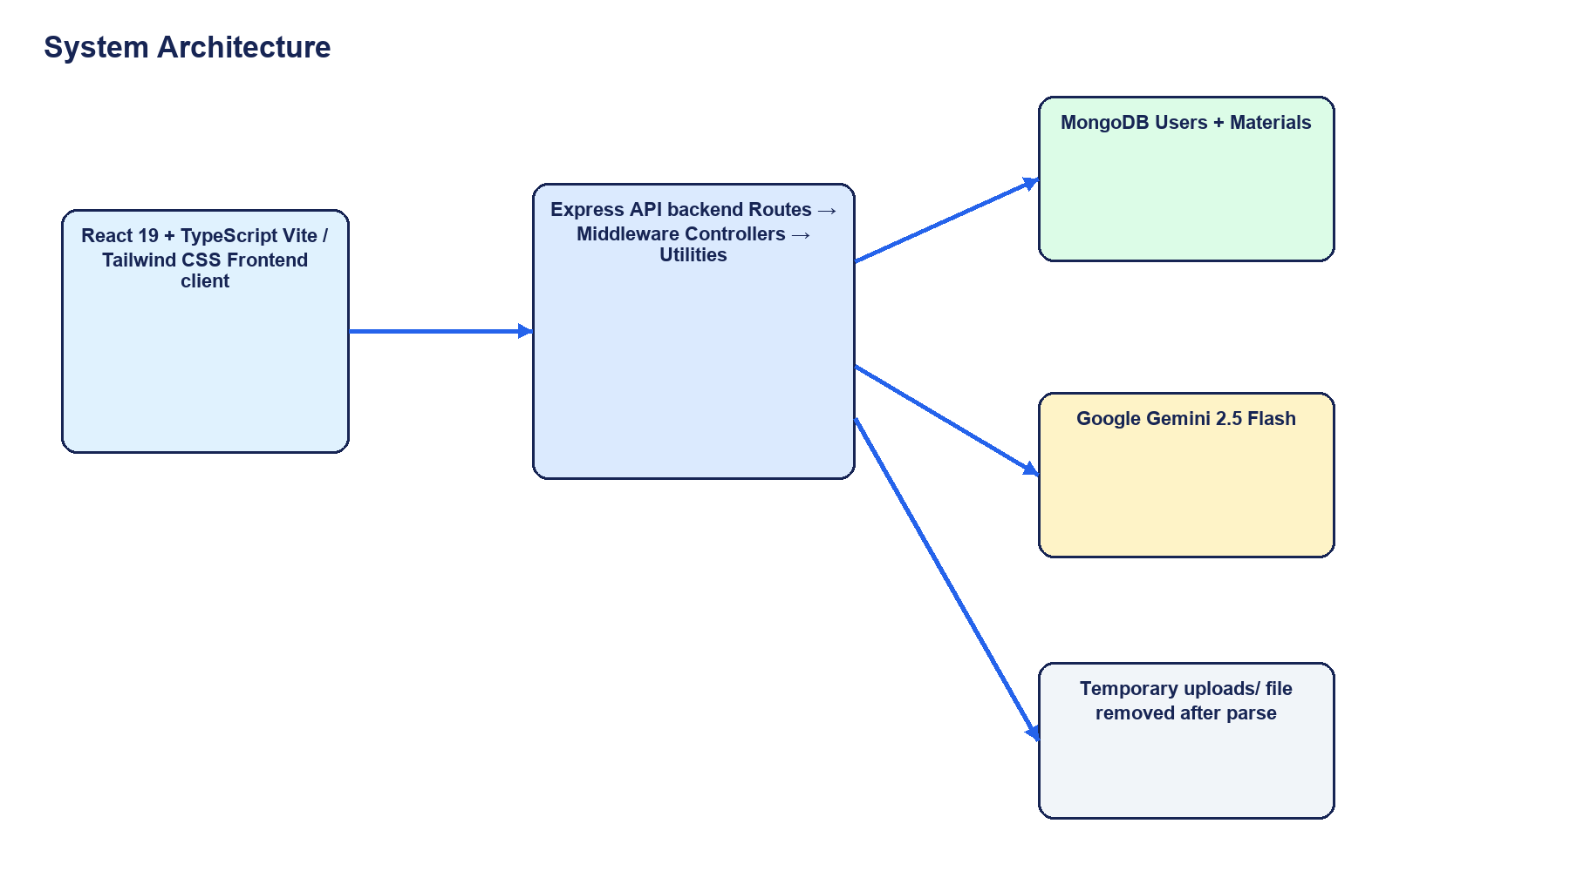
Project architecture based on the verified backend/ and client/ source folders.

Components Definition
Component | Definition | Status
React client | Landing, auth, dashboard, materials, quiz, planner, notes, analytics, settings. | Implemented / UI evidence
API entry point | Express JSON, CORS, route mounting, health response, error handling, startup. | Implemented
Authentication middleware | Bearer JWT verification and adminOnly role check. | Implemented; role escalation risk remains
Material processing | Multer, file filtering, extraction, Material creation, ownership checks, AI routes. | Implemented
AI utility | GoogleGenerativeAI using Gemini 2.5 Flash. | Implemented
MongoDB models | User and Material schemas with timestamps and generated assets. | Implemented
Admin API | User listing, statistics, and cascade deletion. | Backend implemented; client UI unverified

User Flow Diagram
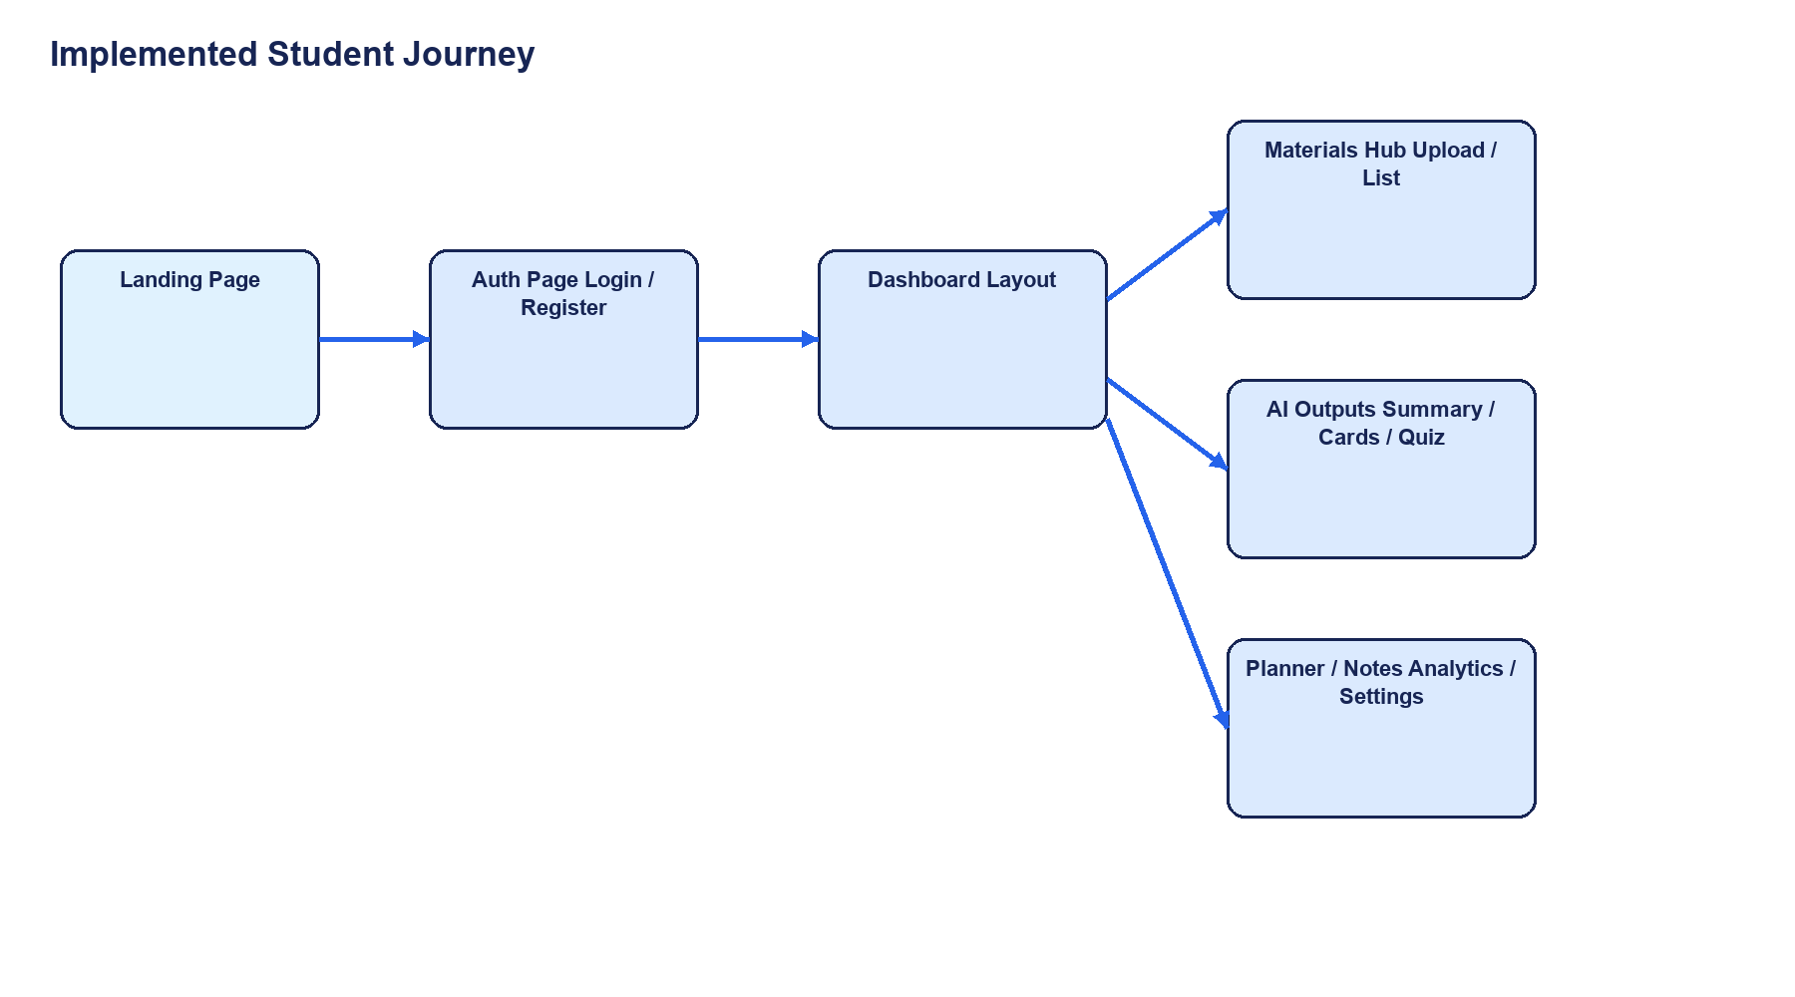
Student flow from landing page to dashboard and learning features.

Data Flow Diagram
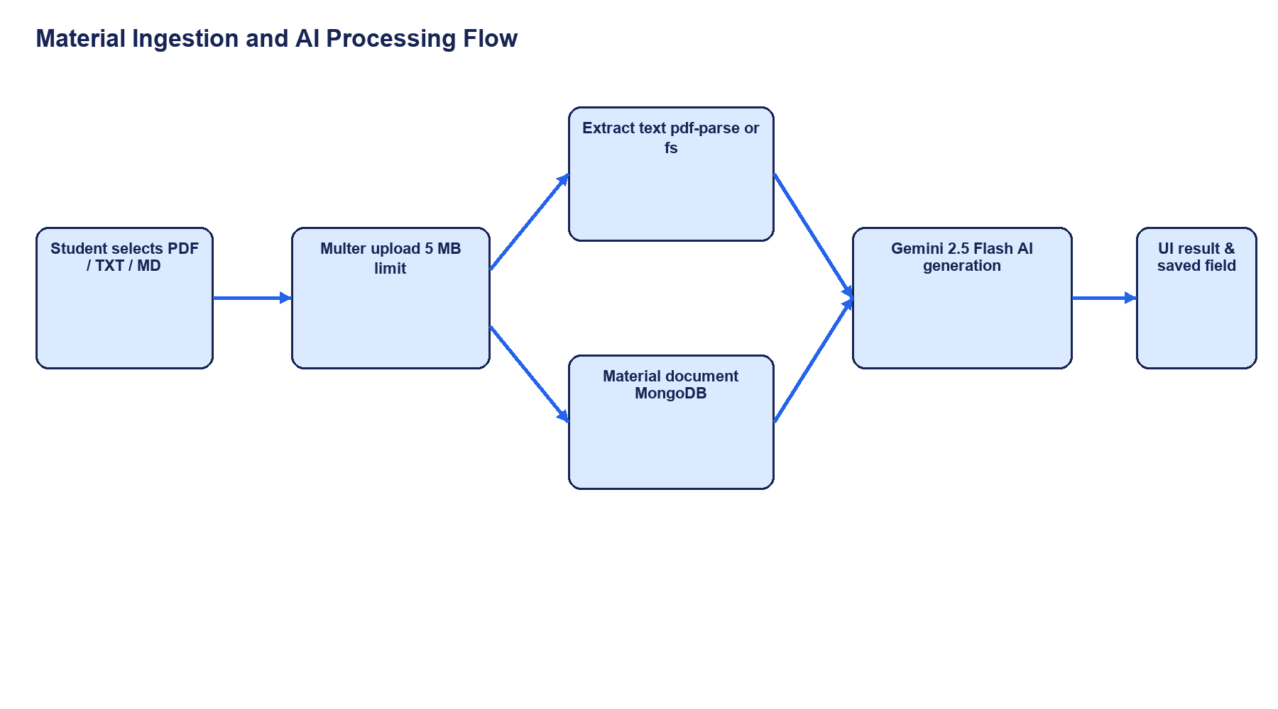
Material upload, extraction, persistence, AI generation, and UI result flow.

MVC / Request Pattern
The backend follows a route, middleware, controller, model, and utility pattern. Routes define paths and attach middleware. Middleware authenticates requests or checks administrative role. Controllers read request data, call utilities and models, and return JSON. Mongoose models define User and Material persistence.
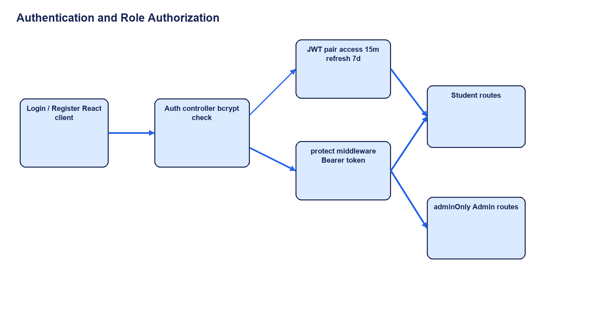
Authentication and role authorization flow.

Epic 2: Project Setup and Configuration

Creating the Project Folder
The implementation is organized into separate backend/ and client/ folders. The backend contains the Express entry point and source modules. The client contains the Vite/React application, components, context, services, and types.
Folder Structure Screenshot
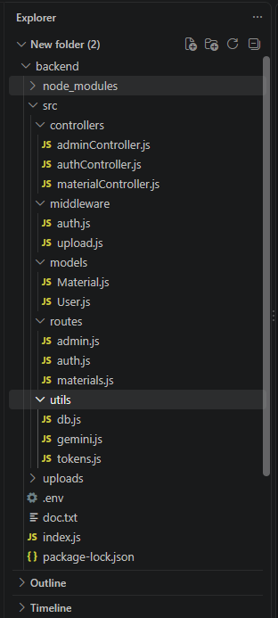

Project Initialization
The backend package is CommonJS and starts through nodemon index.js. Its test script is a placeholder that exits with an error, so no automated test pass is claimed. The client package is an ES module Vite application with development, build, lint, and preview scripts.
Area | Verified script
Backend start | npm start -> nodemon index.js
Backend test | npm test -> placeholder error; tests not evidenced
Frontend development | npm run dev -> vite
Frontend build | npm run build -> tsc -b && vite build
Frontend lint | npm run lint -> oxlint
Frontend preview | npm run preview -> vite preview

Environment Configuration
The backend reads variables for MongoDB, JWT signing, Gemini access, port, and runtime configuration. The client reads VITE_API_URL for its API base URL. Real credentials must remain outside source files and documentation.
Backend: MONGO_URI, JWT_ACCESS_SECRET, JWT_REFRESH_SECRET, GEMINI_API_KEY, PORT, NODE_ENV
Frontend: VITE_API_URL
Setup verification requirement: install dependencies, configure services, run the build and lint commands, and capture results before claiming the project is fully runnable.

Epic 3: Backend Development

Backend Structure
The backend entry point configures dotenv and express-async-errors, creates Express, ensures an uploads folder exists, enables JSON and CORS, mounts auth/material/admin routes, exposes a health endpoint, and starts the server after attempting MongoDB connection. A global error handler returns JSON error messages.
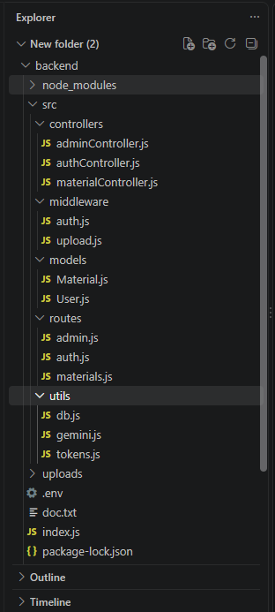

Core System Script Implementations

1. Application Entry Point (index.js)
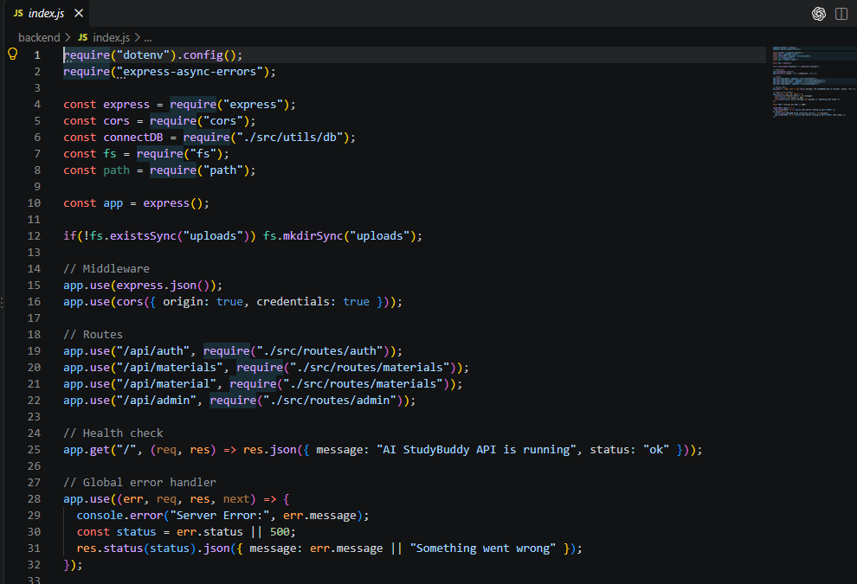
The source also exposes GET / as a health response and starts on process.env.PORT or 5000 after the database connection attempt. The startup fallback should be verified carefully because API availability is not the same as persistence availability.

2. Database Connection (src/utils/db.js)
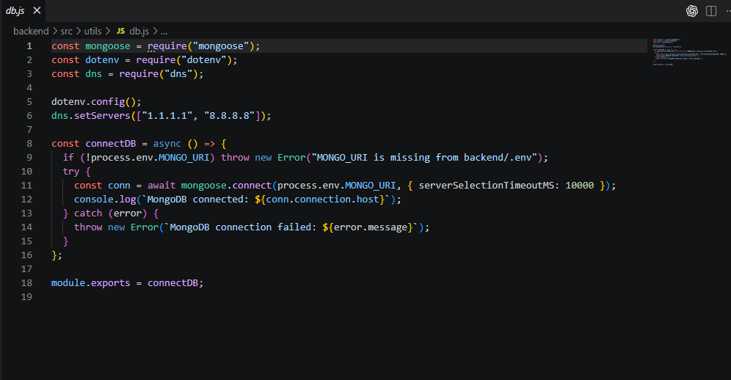

3. Authentication Middleware (src/middleware/auth.js)
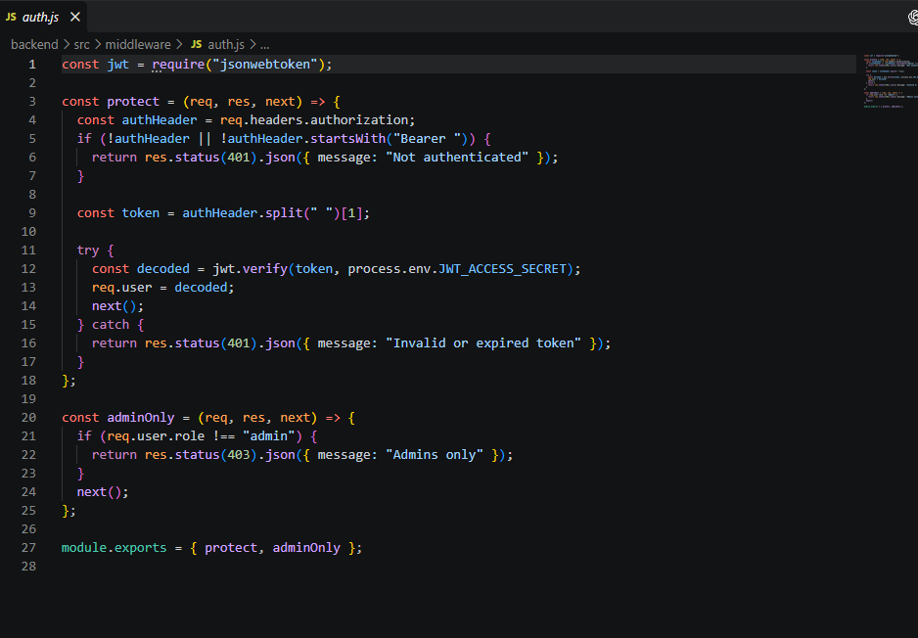
The code confirms Bearer-token authorization rather than HTTP-only cookie authorization. Registration accepts role from the request body and the User model allows admin, so this middleware must not be described as fully secure until public role escalation is fixed.

4. AI Integration (src/utils/gemini.js)
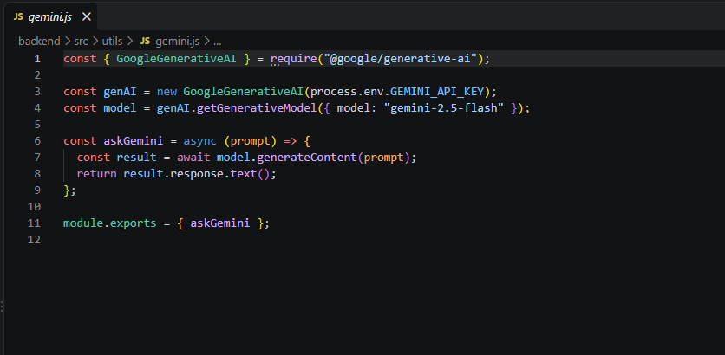

5. File Upload Middleware (src/middleware/upload.js)
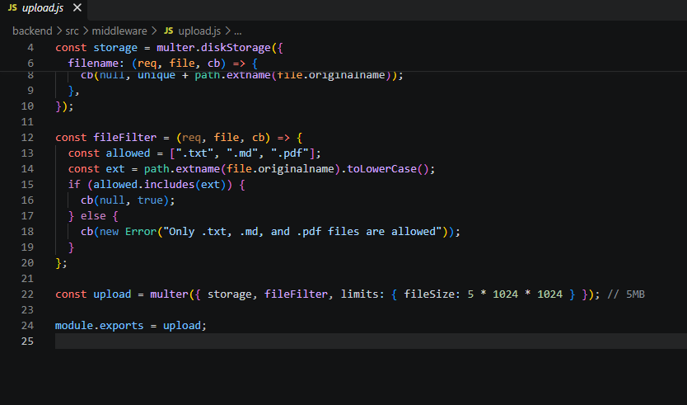
The upload middleware accepts TXT, Markdown, and PDF extensions and enforces five megabytes. The material controller attempts PDF parsing and removes the temporary uploaded file after extraction.

Epic 4: Database Configuration

Configure MongoDB
The backend expects MONGO_URI and connects with Mongoose using a ten-second server selection timeout. Database credentials, backups, and production network policy remain environment concerns and were not independently verified by source inspection.
Install Mongoose using the following command:

Mongoose Schema Definitions

1. User Schema (models/User.js)
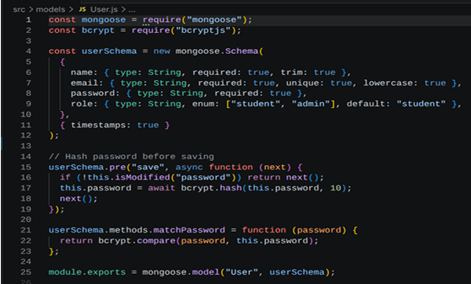
Password hashing is implemented. The role enum permits student and admin. The registration controller passes the request-body role into User.create, creating the documented public admin-registration privilege-escalation risk.

2. Study Material Schema (models/Material.js)
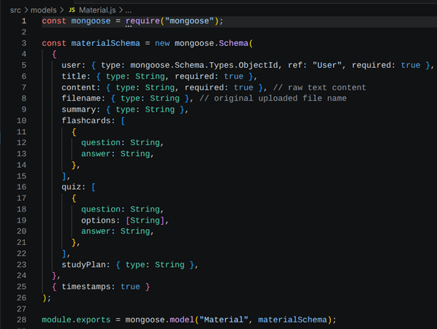

Database Collections
Collection | Purpose | Key fields
users | Accounts, identity, role, and ownership | name, email, password, role, timestamps
materials | Uploaded content and generated learning assets | user, title, content, filename, summary, flashcards, quiz, studyPlan, timestamps
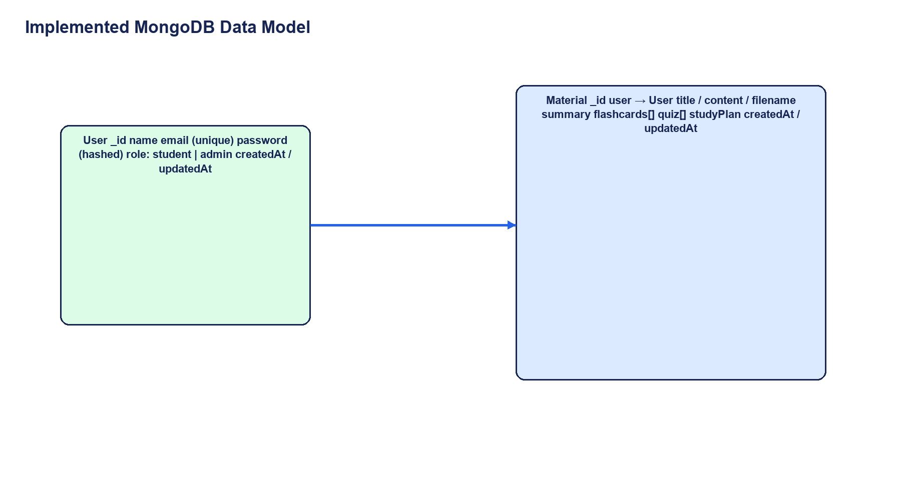
User-to-Material ownership and embedded generated learning assets.

API Route Interface Endpoints

1. Authentication APIs
Method | Endpoint | Purpose | Auth
POST | /api/auth/register | Register and return token data | Public; role-input risk
POST | /api/auth/login | Validate credentials and return tokens | Public
POST | /api/auth/refresh | Refresh using x-refresh-token header | Token exchange
POST | /api/auth/logout | Return stateless logout response | Client discards tokens

2. Study Material APIs
Method | Endpoint | Purpose
POST | /api/materials/upload | Upload file or direct content
GET | /api/materials | List visible materials
GET | /api/materials/:id | Read authorized Material
DELETE | /api/materials/:id | Delete authorized Material

3. AI Feature APIs
Method | Endpoint | Saved result
POST | /api/materials/:id/summarize | Material.summary
POST | /api/materials/:id/flashcards | Material.flashcards[]
POST | /api/materials/:id/quiz | Material.quiz[]
POST | /api/materials/:id/study-plan | Material.studyPlan

4. Administrative APIs
Method | Endpoint | Purpose
GET | /api/admin/users | List users without passwords
GET | /api/admin/stats | Return student and material counts
DELETE | /api/admin/users/:id | Delete user and cascade-delete materials

Epic 5: Project Execution

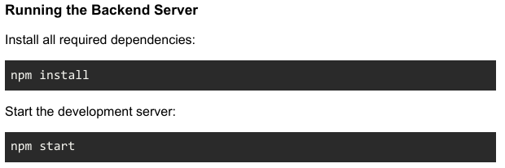

After successful execution, the server connects to MongoDB and starts listening for incoming API request
Running the Frontend
Start the development server:
npm run dev

API Testing
The following cases are derived from actual endpoints. They are procedures and expected outcomes, not claims that requests have already passed.

1. User Registration
POST /api/auth/register
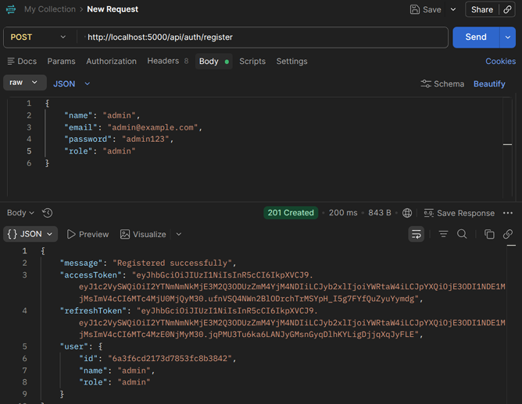
Expected: HTTP 201 with message, accessToken, refreshToken, and user. Verify password hashing. Attempt role=admin as a security test; it must not grant public administrator privileges after hardening.

2. User Login
POST /api/auth/login
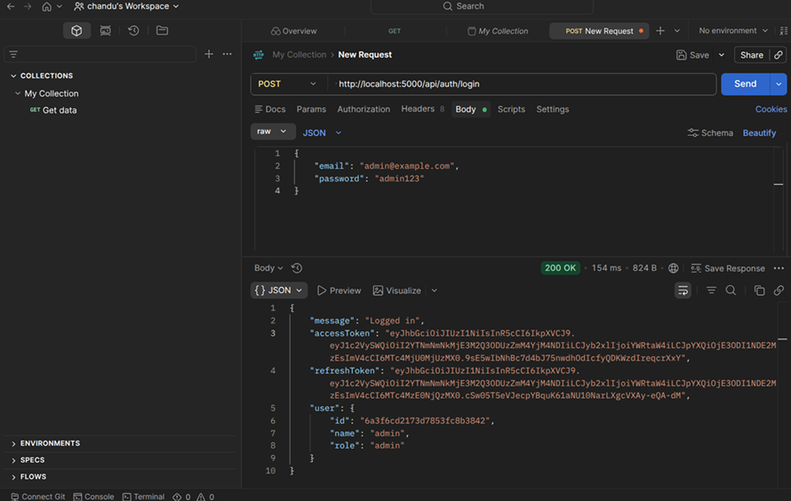
Expected: HTTP 200 with accessToken, refreshToken, and user. The client stores session values in localStorage. If the API fails, the client may create a local demo session, so dashboard display alone is not proof of backend login.

3. Upload Study Material
POST /api/materials/upload
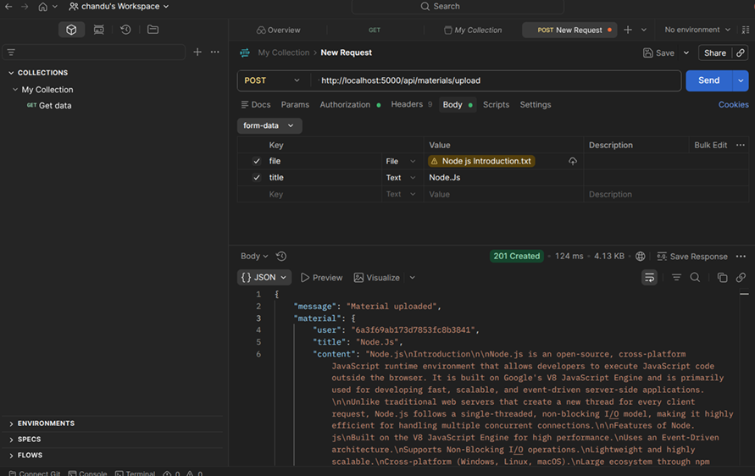
Expected: HTTP 201, extracted content, Material record, and deletion of the temporary file. Unsupported extensions and files over five megabytes should be rejected.

4. Generate AI Summary
POST /api/materials/<id>/summarize
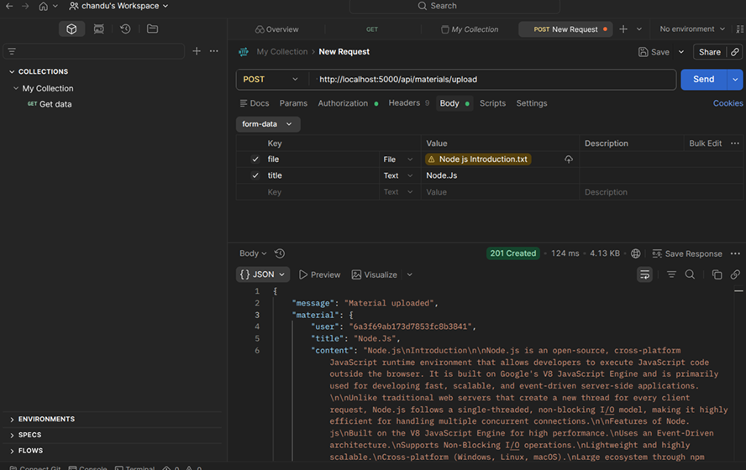
Expected: JSON summary and Material.summary persistence.

5. Generate AI Flashcards
POST /api/materials/<id>/flashcards
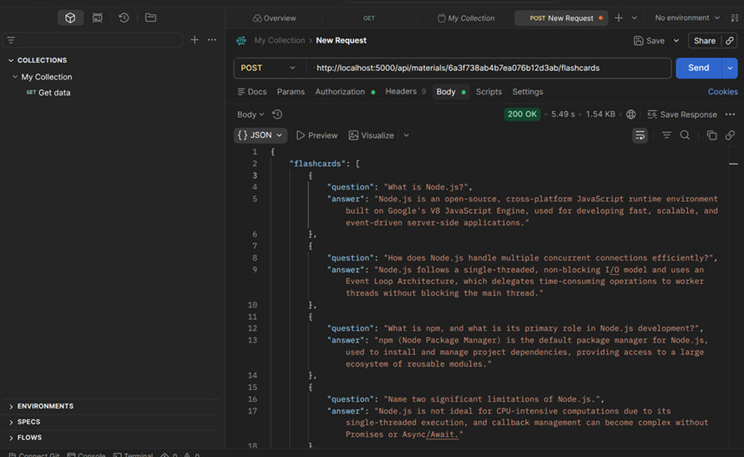
Expected: question/answer array returned and stored in Material.flashcards.

6. Generate AI Quiz
POST /api/materials/<id>/quiz
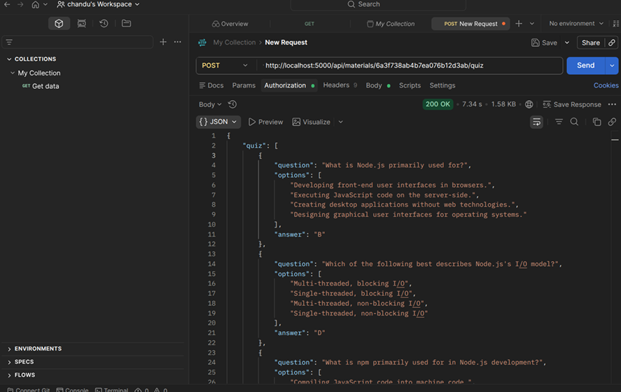
Expected: question/options/answer array returned and stored in Material.quiz. QuizPlayer should render and score the result.

7. Generate AI Study Plan
POST /api/materials/<id>/study-plan
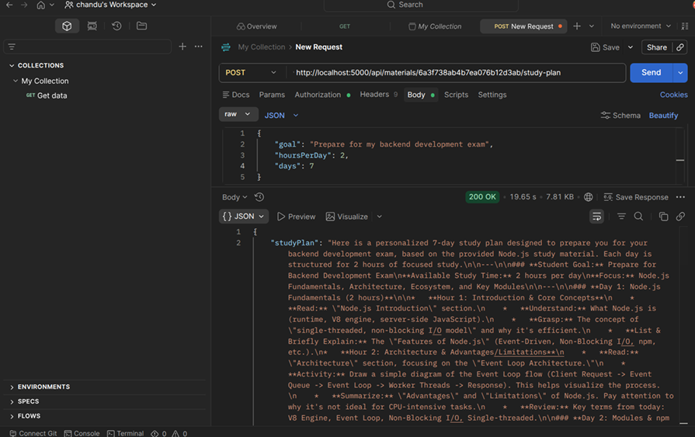
Expected: studyPlan returned and stored on the Material document. This is distinct from the frontend-only planner task list.

Verification and Release Checklist
Check | Status / evidence required
Automated tests | Unverified; backend test script is a placeholder
Demo fallback distinction | Execute API-failure scenario and distinguish demo from backend session
Public admin-role registration | Security risk; fix, execute, and capture evidence
Upload and extraction | Execute PDF/TXT/MD, invalid extension, and over-5 MB cases
AI quality | Review representative outputs with a subject expert
Admin operations | Execute user list, stats, and cascade deletion with database evidence
AdminPanel integration | Unverified in selected current client source
Production deployment | Unverified; confirm hosting, secrets, monitoring, backups, recovery
Video : https://drive.google.com/file/d/1auhWnoW_7ymeTmwBy78ZXhqJoVDEi7bf/view?usp=sharing
Code : https://github.com/rogith-cyber/Ai_study_buddy.git

