COSC 211

Assignment #2 | Alex Rogov | Std#: 52162740

Q1) d) What does this program do?

This program enters and counts the number of characters (up to 12) in the user’s input.

e)1.2) What are the memory addresses of the data labeled *len*, *buffer*, and *str?*

***len****:* 0x10010000 to including 0x10010003  *(len* is .word so it takes 4 bytes or 32 bits*)*

***buffer****:* 0x10010004 to including 0x10010010 (*buffer* is 40 bits)

***str***: 0x10010010 to including 0x1001001c (*str* takes34 bits)

1.3) Yes, if “.align 4” were to be commentated out, there would be change to the answer ‘1.2’. This is because the “.align” directive applies to the next directive which happens to be “*str”*. Commentating out “.align 4” would subtract the “str” memory address by 16 bits. With .align we use .word amount of bytes but without .align, we use a byte for each other

Q2)

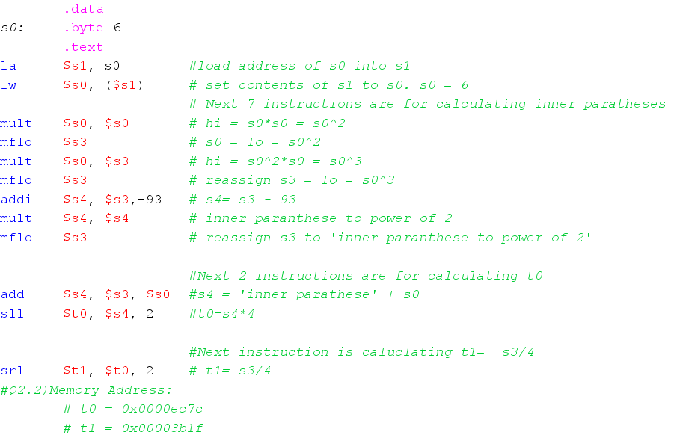

Q3) s0 = pow([((s3*2+s2)*5)/(s2+6)],2) & (s4 << 2)