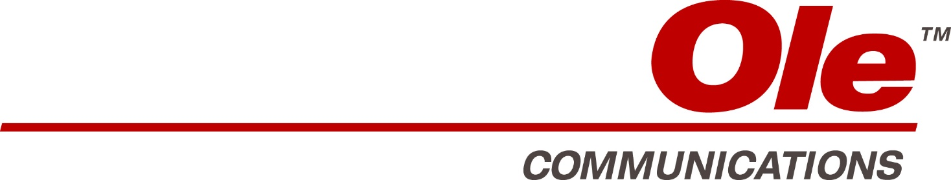

Agenda Board of Directors Meeting
February 21st, 2018
- OLE Communications Group 2018 10:00 AM - 10:30 AM
  - CEO 2018 Overview
  - New Corporate Structure
  - 2018 Objectives & Meetings Agenda

- OLE Digital & Business Development 10:30 AM - 1:00 PM
  - 2018 Overview, Key Issues & Objectives
  - Playground
    - Latin America Joint Venture
    - Playground Equity Investment
  - America Digital Project
  - Digital AD Sales Unit
  - OLE Digital Budget 2018
  - LYNX
  - MVS Box – Opportunity
  - Review of Management Initiative & Conclusions
LUNCH 1:00PM - 1:45 PM
- Ole Broadcasting 1:45 PM - 3:00 PM
  - 2018 Overview, Key Issues & Objectives
  - 2017 Financial Actuals vs Budget & 2016 Actuals
  - 2018 Budget
  - NBCU Bogota
  - A&E Ole Bogota Expansion
  - Arbona Tech Facility
  - Mundo OLE to VC Medios
  - DirecTV Sport
  - Affiliate VOD Distribution Analysis
  - Review of Management Initiative & Conclusions

- VC Multichannel (Argentina/Chile/Colombia/CA/DR) 3:00 PM - 4:00 PM
  - 2018 Overview, Key Issues & Objectives
  - 2017 Financial Actuals vs Budget & 2016 Actuals (Per Division)
  - 2018 Budget (Per Division, Per Country & Consolidated)
  - NBCU Contract Extension
  - Colombia & Centro America
  - DirectTV AD Sales Representation
  - Review of Management Initiative & Conclusions

- OLE Venezuela (VC MC Venezuela, IVC Networks, VC Sports) 4:00 PM - 5:30 PM
  - 2018 Overview, Key Issues & Objectives
  - 2017 Financial Actuals vs Budget & 2016 Actuals (per Division)
  - 2018 Budget (Per Division & Consolidated)
  - IVC HBO Distribution
  - VC Sports 2018 & Beisbol Play
  - DirecTV Sport
  - Review of Management Initiative & Conclusions
7 PM OLE BOD & MANAGEMENT DINNER

Agenda Board of Directors Meeting
February 22nd, 2018

- OLE BOD 10:00 AM - 10:30 AM
  - Areas for Improvement
  - Operating Cost Discussion
  - OLE Media Cost Allocations
  - New Office Space 8th Floor
- HBO 10:30 AM - NOON
  - 2018 Overview, Key Issues
  - 2017 Financial Actuals vs Budget & 2016 Actuals
  - 2018 Budget
  - 2018 Activities Agenda
  - ATT/Warner Merger
  - NBCU Negotiation Update
  - WB Negotiation Update
  - Basic Channels Distribution Agreement
  - Basic Channels NGTVR
  - 2018 Challenges

- HBO Basic Channels NOON - 1 PM
  - HBO Information & Reports
  - Digital Distribution Rights
  - Expanded Digital Package Rights
  - HBO Basics Meetings
LUNCH 1:00 PM - 2:00 PM
- A&E 2:00 PM - 3:30 PM
  - 2018 Overview, Key Issues
  - 2017 Financial Actuals vs Budget & 2016 Actuals
  - 2018 Budget
  - Activities Agenda
  - A&E Output Deal
  - A&E LATAM New Organization
  - History en Espanol
  - AETN Performance Analysis
  - 2018 Challenges
- NBCU 3:30 PM - 4:30 PM
  - 2018 Overview, Key Issues
  - 2017 Financial Actuals vs Budget & 2016 Actuals
  - 2018 Budget
  - NBCU BOD Meeting Report & Analysis
  - 2018 Challenges

- OLE BOD 4:30 PM - 5:00 PM
Analysis, Conclusions & Resolutions

