**Nora’s Bagels**

1NF Table

CREATE TABLE BagelsDB (

BagelOrderID INT,

BagelID INT,

OrderDate DATETIME,

FirstName VARCHAR(20),

LastName VARCHAR(20),

Address1 VARCHAR(20),

Address2 VARCHAR(20),

City VARCHAR(20),

State VARCHAR(20),

Zip VARCHAR(20),

MobilePhone VARCHAR(20),

DeliveryFree VARCHAR(20),

BagelName VARCHAR(20),

BagelDescription VARCHAR(50),

BagelPrice VARCHAR(20),

BagelQuantity VARCHAR(20),

SpecialNotes VARCHAR(80),

PRIMARY KEY (BagelOrderID, BagelID)

);

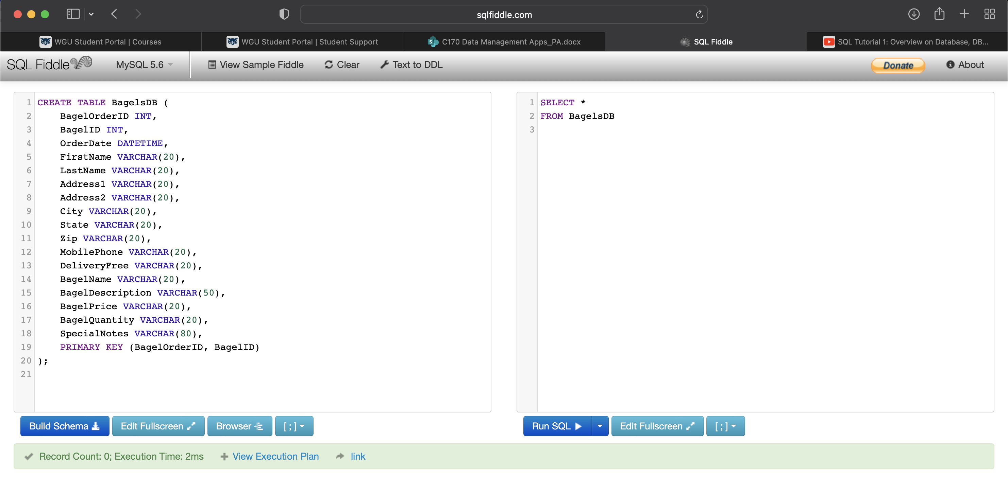

Loaded with Generic VALUES

