**1A – Nora’s Bagels**

**First Normal from Blue Print**

|  |  |
| --- | --- |
| **BAGEL ORDER** | |
| PK | Bagel Order ID |
| PK | Bagel ID |
|  | Order Date |
|  | First Name |
|  | Last Name |
|  | Address 1 |
|  | Address 2 |
|  | City |
|  | State |
|  | Zip |
|  | Mobile Phone |
|  | Delivery Fee |
|  | Bagel Name |
|  | Bagel Description |
|  | Bagel Price |
|  | Bagel Quantity |
|  | Special Notes |

**A1B - Second Normal Form (2NF)**

|  |  |  |  |  |  |  |  |
| --- | --- | --- | --- | --- | --- | --- | --- |
| **BAGEL ORDER** | |  | **BAGEL ORDER LINE ITEM** | |  | **BAGEL** | |
| PK | Bagel Order ID |  | PK / FK | Bagel Order ID |  | PK | Bagel ID |
|  | Order Date | 1:M | PK / FK | Bagel ID | 1:M |  | Bagel Price |
|  | First Name |  |  | Bagel Quantity |  |  | Bagel Description |
|  | Last Name |  |  |  |  |  | Bagel Name |
|  | Address 1 |  |  |  |  |  |  |
|  | Address 2 |  |  |  |  |  |  |
|  | City |  |  |  |  |  |  |
|  | State |  |  |  |  |  |  |
|  | Zip |  |  |  |  |  |  |
|  | Mobile Phone |  |  |  |  |  |  |
|  | Delivery Fee |  |  |  |  |  |  |
|  | Special Notes |  |  |  |  |  |  |

**Explanation:** 1 bagel order may contain many bagels order line items. A bagel order line item may contain many bagels.

**A2C Third Normal Form (3NF)**

|  |  |  |  |  |  |  |  |  |
| --- | --- | --- | --- | --- | --- | --- | --- | --- |
| **ORDER** | | |  | **BAGEL ORDER LINE ITEM** | |  | **BAGEL** | |
| PK | Bagel Order ID | |  | PK / FK | Bagel Order ID |  | PK | Bagel ID |
| FK | Customer ID | | 1:M | PK / FK | Bagel ID | 1:M |  | Bagel Price |
|  | Order Date | |  |  | Bagel Quantity |  |  | Bagel Description |
|  | Delivery Fee | |  |  |  |  |  | Bagel Name |
|  | Special Notes | |  |  |  |  |  |  |
|  | M:1 |  |  |  |  |  |  |  |
| **Customer Info** | | |  |  |  |  |  |  |
| PK/FK | Customer ID | |  |  |  |  |  |  |
|  | First Name | |  |  |  |  |  |  |
|  | Last Name | |  |  |  |  |  |  |
|  | Address 1 | |  |  |  |  |  |  |
|  | Address 2 | |  |  |  |  |  |  |
|  | City | |  |  |  |  |  |  |
|  | State | |  |  |  |  |  |  |
|  | Zip | |  |  |  |  |  |  |
|  | Mobile Phone | |  |  |  |  |  |  |

**Explanation:** Many Orders can have 1 customer, 1 Order may have many Bagel Order Line Items, A Bagel Order Line Item may have many Bagels.

**Final Physical Database Model**

|  |  |  |  |  |  |  |  |  |  |  |
| --- | --- | --- | --- | --- | --- | --- | --- | --- | --- | --- |
|  | | |  | **BAGEL ORDER LINE ITEM** | | |  | **BAGEL** | |  |
| PK | BagelOrderID | INT |  | PK / FK | bagelOrderID | INT |  | PK | BagelID | INT |
| FK | CustomerID | INT | 1:M | PK / FK | bagelID | VARCHAR(2) | 1:M |  | BagelPrice | NUMERIC(5,2) |
|  | OrderDate | TIMESTAMP |  |  | BagelQuantity | INT |  |  | BagelDescription | VARCHAR(30) |
|  | DeliveryFee | NUMERIC(5,2) |  |  |  |  |  |  | BagelName | VARCHAR(30) |
|  | SpecialNotes | VARCHAR(60) |  |  |  |  |  |  |  |  |
|  | M:1 |  |  |  |  |  |  |  |  |  |
|  | | |  |  |  |  |  |  |  |  |
| PK | CustomerID | INT |  |  |  |  |  |  |  |  |
|  | FirstName | VARCHAR(30) |  |  |  |  |  |  |  |  |
|  | LastName | VARCHAR(30) |  |  |  |  |  |  |  |  |
|  | Address1 | VARCHAR(30) |  |  |  |  |  |  |  |  |
|  | Address2 | VARCHAR(30) |  |  |  |  |  |  |  |  |
|  | City | VARCHAR(25) |  |  |  |  |  |  |  |  |
|  | State | VARCHAR(2) |  |  |  |  |  |  |  |  |
|  | Zip | INT |  |  |  |  |  |  |  |  |
|  | MobilePhone | VARCHAR(10) |  |  |  |  |  |  |  |  |

**2B – Jaunty Coffee Co.**

**Table Creation**

CREATE TABLE Employee (

employee_id INT,

first_name VARCHAR(30),

last_name VARCHAR(30),

hire_date DATE,

job_title VARCHAR(30),

shop_id INT,

PRIMARY KEY (employee_id)

);

CREATE TABLE Coffee_Shop (

shop_id INT,

shop_name VARCHAR(50),

city VARCHAR(50),

state CHAR(2),

PRIMARY KEY (shop_id)

);

CREATE TABLE Coffee (

coffee_id INT,

shop_id INT,

supplier_id INT,

coffee_name VARCHAR(30),

price_per_pound NUMERIC(5,2),

PRIMARY KEY (coffee_id)

);

CREATE TABLE Supplier (

supplier_id INT,

company_name VARCHAR(50),

country VARCHAR(30),

sales_contact_name VARCHAR(60),

email VARCHAR(50),

PRIMARY KEY (supplier_id)

);

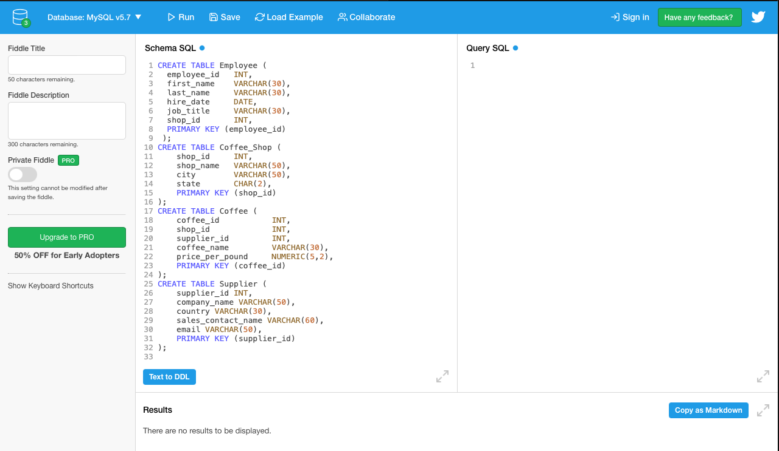

**SHOW TABLES:**

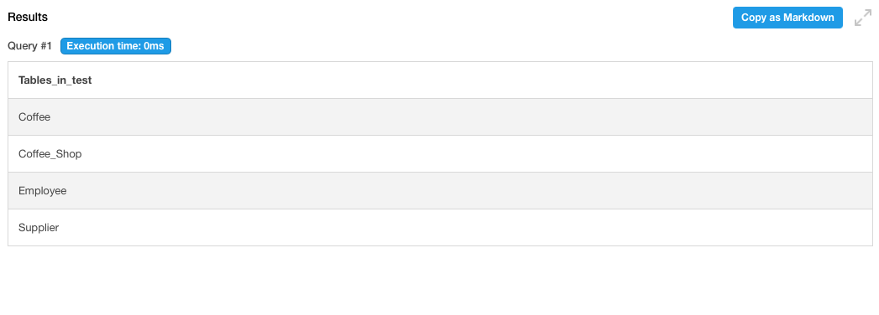

**Population of Tables:**

INSERT INTO Employee(employee_id, first_name, last_name, hire_date, job_title, shop_id)

VALUES

(1, 'John', 'Travolta', '1962-01-05', 'Owner', 9001),

(2, 'Samual', 'Jackson', '1969-05-12', 'Manager', 9002),

(3, 'David', 'Hassellhoff', '1955-07-22', 'Temp', 9003);

INSERT INTO Coffee_Shop(shop_id, shop_name, city, state)

VALUES

(9001, 'Caffeine Express', 'Draper', 'UT'),

(9002, 'StarBoys', 'Seattle', 'WA'),

(9003, 'CoffeeExpress', 'Salt Lake City', 'UT');

INSERT INTO Coffee(coffee_id, shop_id, supplier_id, coffee_name, price_per_pound)

VALUES

(2001, 9001, 8, 'Mocha', '5.99'),

(3001, 9002, 9, 'Americano', '6.99'),

(4001, 9003, 7, 'PineappleExpress', '29.99');

INSERT INTO Supplier(supplier_id, company_name, country, sales_contact_name, email)

VALUES (8, 'MadHatter', 'USA', 'Tony Stark', 'tony.stark@email.com'),

(9, 'StarStruck', 'USA', 'Steve Rogers', 'steve.rogers@email.com'),

(7, 'StarBoy', 'Guam', 'Bruce Banner', 'brucebanner@gmail.com');

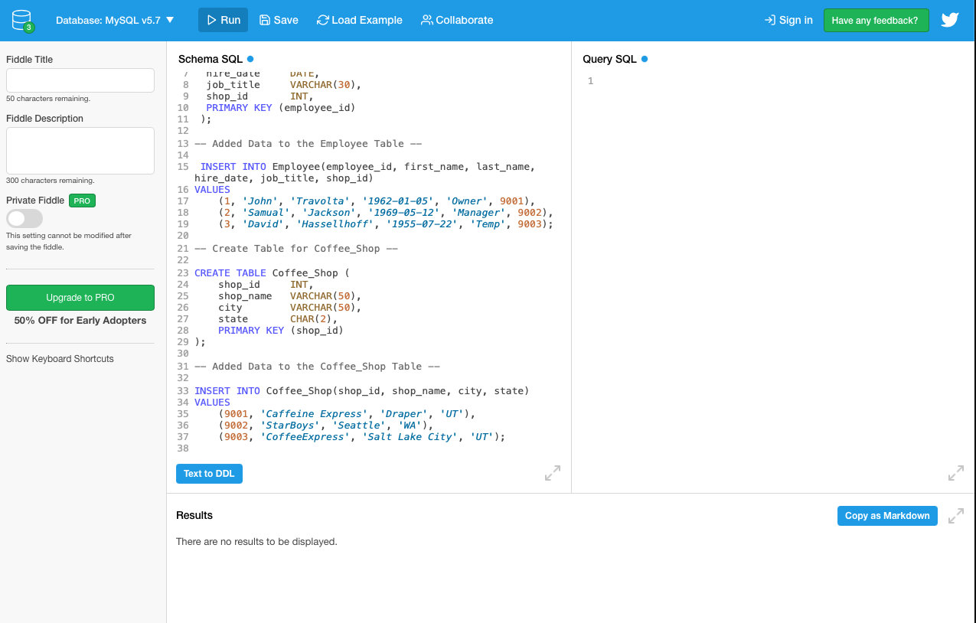

**Proof of Working Tables**

SELECT *

FROM Employee, Coffee_Shop, Coffee, Supplier

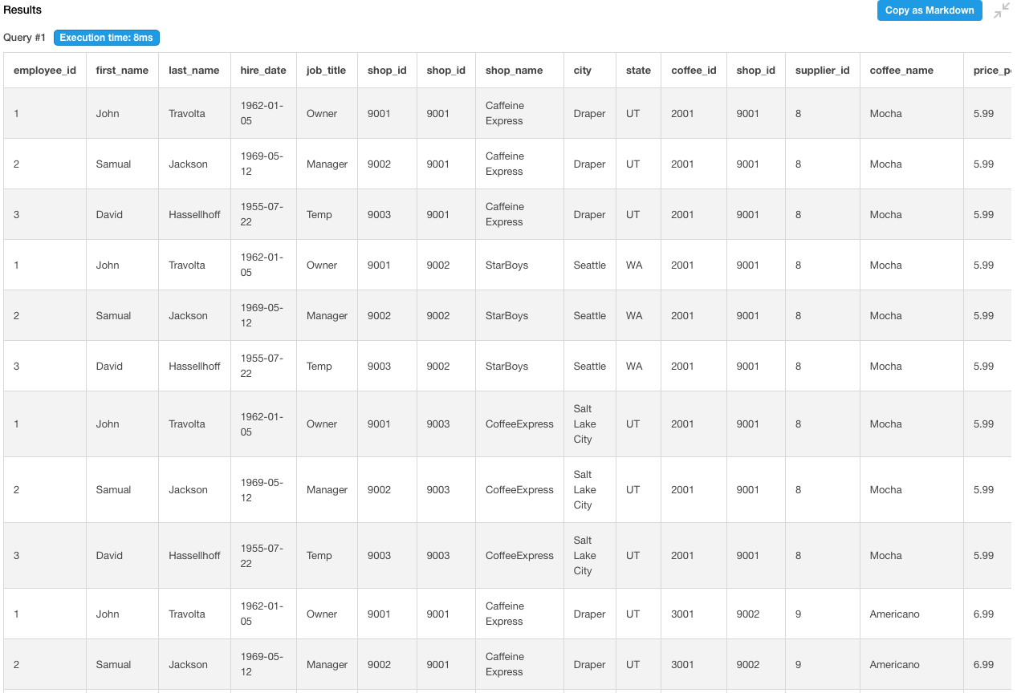

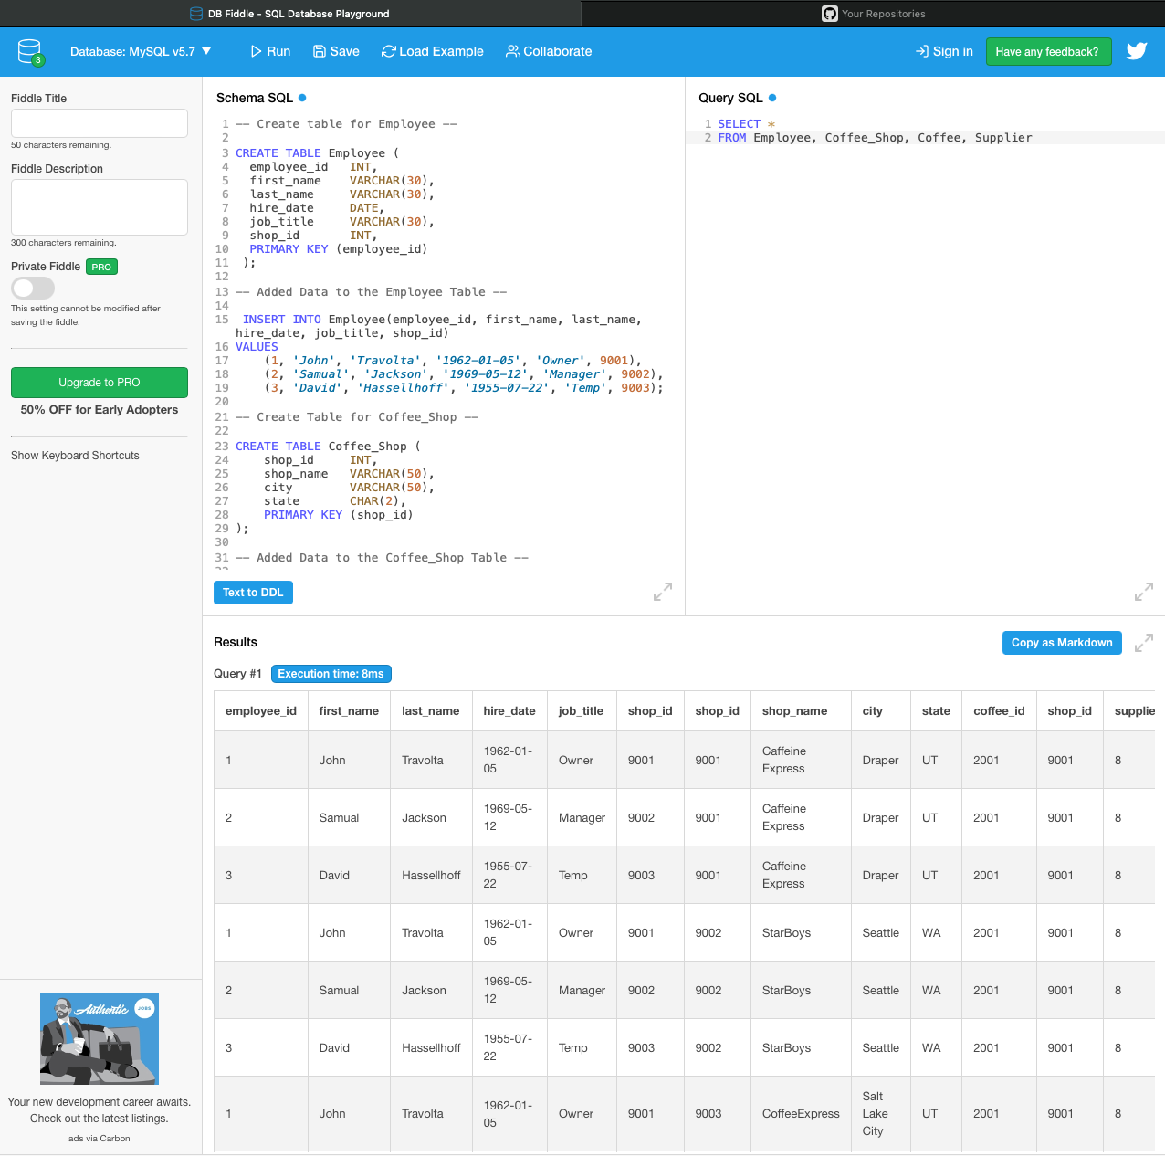

**CREATE VIEW:** EmployeeView

CREATE VIEW EmployeeView AS

SELECT

employee_id,

CONCAT (first_name,

last_name) AS employee_full_name,

hire_date,

job_title,

shop_id

FROM

Employee

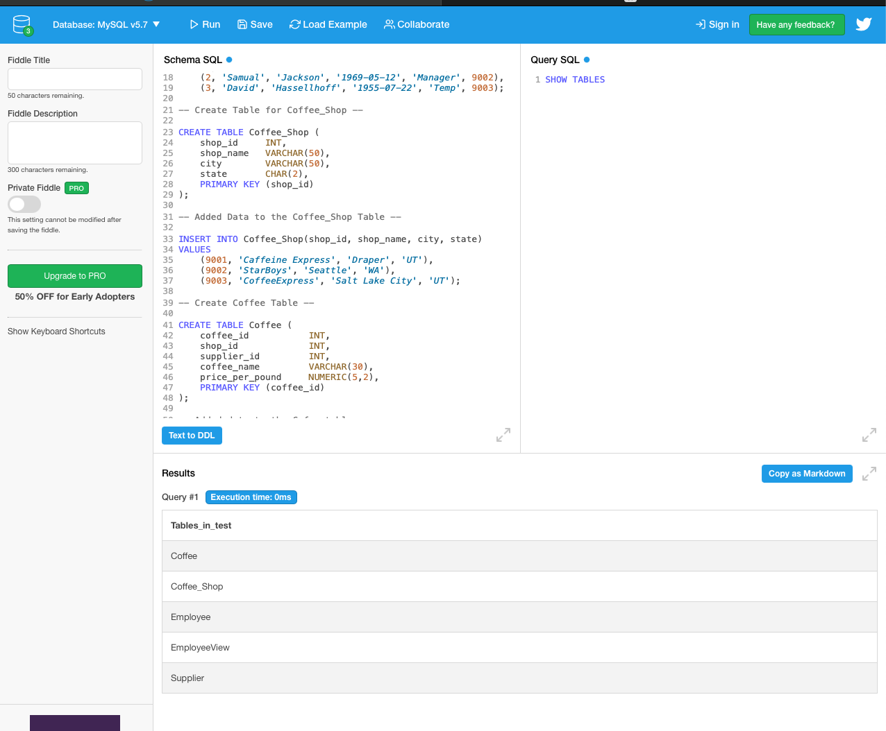

Select Statement Showing Employee View

SELECT * FROM EmployeeView

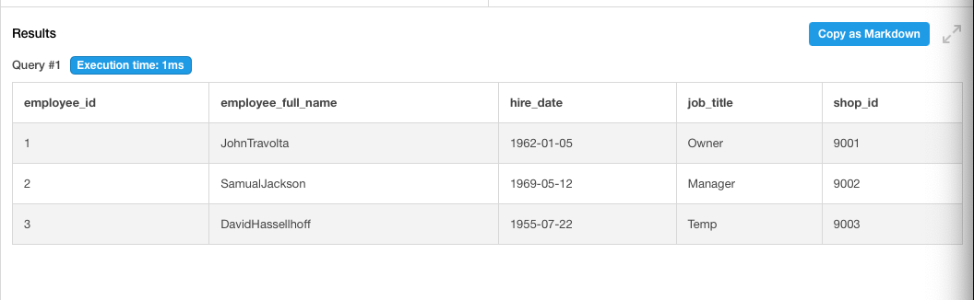

**INDEX:** SHOW INDEX FROM Coffee

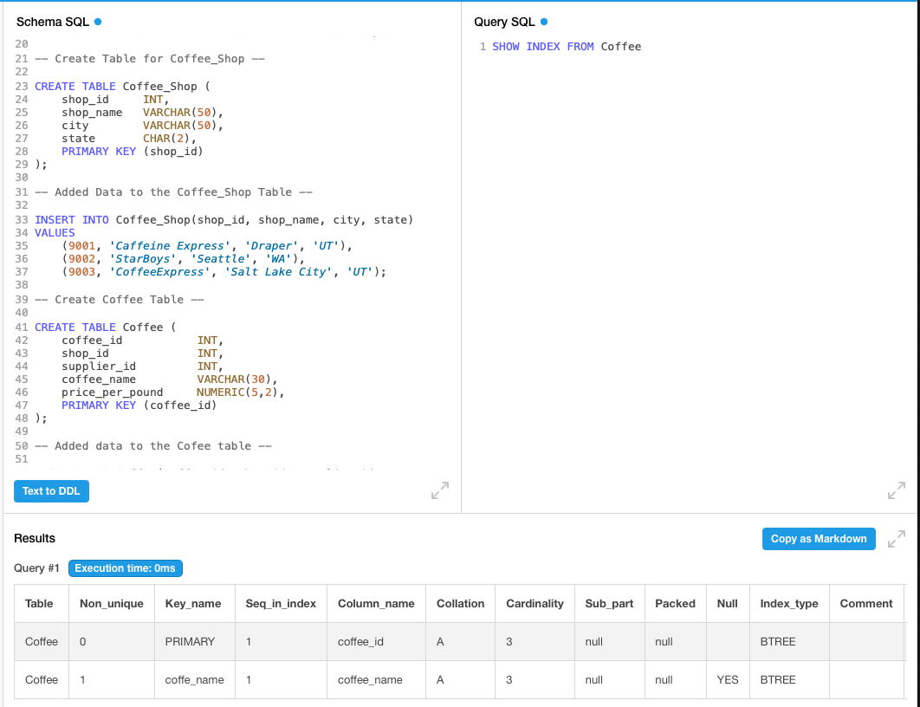

**SFW Statement:**

SELECT *

FROM Coffee

WHERE coffee_name = 'Mocha';

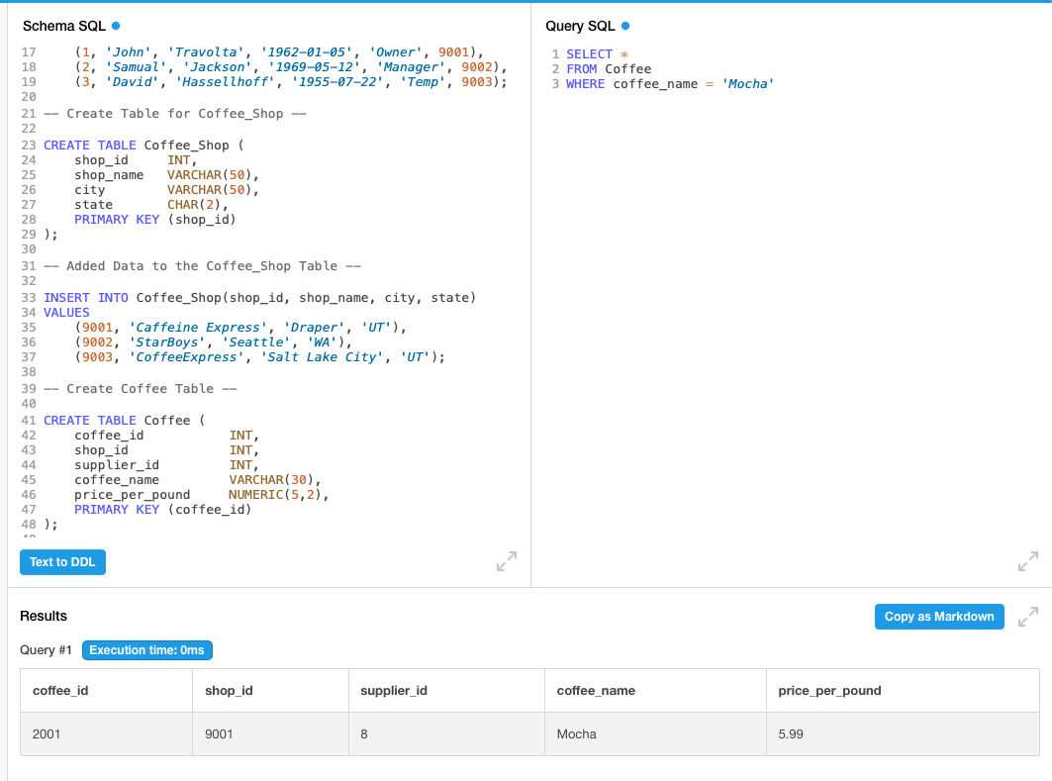

**Three Table INNER JOIN:**

SELECT Employee.employee_id, Employee.first_name, Employee.last_name, Coffee_Shop.city, Coffee_Shop.shop_name, Coffee.coffee_name

FROM ((Employee

INNER JOIN Coffee_Shop ON Employee.shop_id = Coffee_Shop.shop_id)

INNER JOIN Coffee ON Coffee_Shop.shop_id = Coffee.shop_id);

