AOS Project 4
Pradeep Jawahar – pjawahar3@gatech.edu
Rohit Nair – rnair7@gatech.edu

Design

The library implements a conservative recovery model where in writes to the backing store are made only on rvm_truncate & rvm_init. All other actions, such as one in rvm_about_to_modify & rvm_commit write to the log file.

Updates to backing store are made in following cases :
- Upon Intialization, if log contains valid & committed transactions.
- In rvm_truncate(), if log contains valid & committed tranactions.
- If log file size exceeds a particular threshold (Epoch Truncation).

To handle crash-recoveries we have implemented a recovery tree. The recovery happens inside the rvm_map function call. The tree recovers the mapped memory back to appropriate contents for all un-commited transaction. It also updates the backing store in case of valid commits.

Log File Structure

Our library uses a single log file per RVM region. The Log is structured on a per transaction basis. The Log file's record content is as follows -

<Segment Name> | <Record ID> | <TimeStamp> | <type>|<Offset> | <Size> | <Data> | EOL

Every call to about to rvm_about_to_modify() creates a new record in the log file with an incremental “Record ID”. A succeeding call to rvm_commit() would then create record(s) in the log file, with the matching “Record ID”. “Type field” saves the context of the record, i.e. either update, commit or abort.

Example – Consider the following Code Snippet:
rvm_about_to_modify(trans,seg[0],0,8);
sprintf(seg[0],"Testing.");
rvm_about_to_modify(trans,seg[1],0,8);
sprintf(seg[1],"Complete");
rvm_commit_trans(trans);

Generates a log file with content -
testsegment |transseg0|2563170781|update |0|8|tttttttt|EOL|
testsegment1 |transseg1|2563170782|update |0|8|tttttttt|EOL|
testsegment |transseg0|2563170793|commit |0|8|Testing.|EOL|
testsegment1 |transseg1|2563170793|commit |0|8|Complete|EOL|

Recovery Tree

The recovery tree is an n-ary tree with the following structure:

RVM
Region
Segment 1
Segment 2
Segment N
Trans 1
Trans N
..
….
Trans 1

Once the tree has been populated from the log file, its a simple task of traversal & making the appropriate modifications to memory/backing store.

Epoch Truncation:
We explicitly call the rvm_truncate_log function in case we detect the log file has exceeded a threshold number of records. The reason our threshold is not based on file size is that we store parts of segment data & hence the file-size can vary greatly depending on the offset that the user provides. We have chosen to truncate the log file in case there are more than 10 records in the log file. We are following a Read-Delete-Update-Write approach during truncation so as to simplify the task of removing records from the log file. After a truncate operation all commit & its corresponding update records will be removed from the log file. In case there are pending transactions then these will be written back to the new log file in the order of their timestamps.

Issues:
There might be an issue with memory leaks since we are not explicitly using free. The issue lies with the fact that we use dynamic allocations in most of the library functions, but there is no function in the API list which forces us to free these newly allocated memory. Also the library is not thread-safe since we use multiple global structures. Also our implementation of the Epoch Truncations is not concurrent with the views in the LRPC paper.

Test Cases:
In addition to satisfying the five test cases, we tested our program on the following 2 cases.

test1.c – This creates an uncommitted transaction & then the same segment is mapped again to check if the memory has been recovered back to the intended state.

test2.c – This checks if an already existing but unmapped segment be mapped with a larger size.
It maps a segment to a size of 1000, unmaps it & then maps again with an increased size of 2000 bytes.

ScreenShots

In this particular run we ran abort.c first. Since abort.c left a non-zero sized log file, we then ran truncate.c to ensure that our library was performing its abort functionality well.
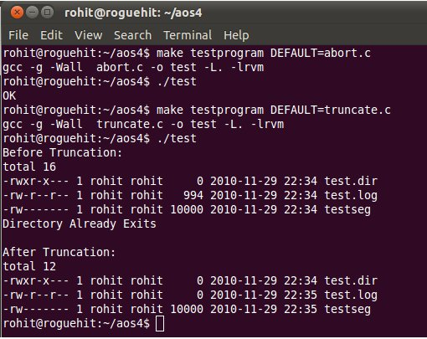

In this particular run, we ran the rest of the provided test cases.
