Smart Retail Inventory and Demand Prediction System

1. Om Singh Chandel II. Meet Shah III. Adithi Kanchan IV. Tanishq Shirke

V. Saheel Kakaiya

Students of MIT-WPU College of Engineering

Abstract—

The Smart Retail Inventory and Demand Prediction System is a deep learning-based project developed to forecast weekly product demand, enabling businesses to manage inventory proactively and minimize stockouts or overstocking. The core objective of the system is to enhance sales insights by leveraging time-series data and advanced deep learning models, thus supporting smarter inventory decisions that increase profitability and operational efficiency. The system primarily uses an LSTM model for demand forecasting, with additional models like GRU, CNN for time series, CNN-LSTM hybrid, Transformer-based (simplified transformer), and Temporal Convolutional Network (TCN) implemented for comparative analysis.

**Problem:** Traditional inventory systems rely on historical data without incorporating temporal patterns, leading to inaccurate forecasting and revenue loss. Retailers require a system that can process time-series sales data and predict future demand using intelligent, data-driven approaches.

**Methodology:** The model pipeline includes preprocessing the historical sales data, followed by training the LSTM model to capture sequential patterns and dependencies over time. Alongside LSTM, GRU, CNN, CNN-LSTM, Transformer, and TCN models are also trained on the same dataset for accuracy comparison. Each model is evaluated on forecasting the next week’s demand to determine the best-performing approach, with LSTM as the central focus.

**Results:** The LSTM model delivered the highest accuracy, showing strong performance in capturing temporal trends and predicting future sales. Comparative models further validated the robustness of the architecture, with CNN-LSTM and GRU models also showing competitive results.

**Conclusion:** The Smart Retail Inventory and Demand Prediction System acts as a reliable tool for demand forecasting, helping retailers maximize profits and improve supply chain planning. Future work will focus on integrating real-time analytics and customer behavior data to further refine the accuracy of predictions and enable dynamic restocking strategies.

# INTRODUCTION

today’s fast-paced retail environment, maintaining optimal inventory levels is critical for maximizing profitability and meeting customer demand. Poor inventory management often leads to either overstocking—resulting in storage costs and waste—or stockouts, which can cause lost sales and customer dissatisfaction. With increasing volumes of transactional data, traditional forecasting methods fail to capture the complex temporal patterns necessary for accurate demand prediction. This project proposes a deep learning-based Demand Prediction System designed to enhance inventory forecasting for retail businesses. By utilizing historical sales data, the system predicts the demand for each product in the upcoming week, enabling proactive inventory planning. The primary model used is Long Short-Term Memory (LSTM), known for its ability to model long-range dependencies in time series data. In addition, other deep learning architectures including Gated Recurrent Unit (GRU), Convolutional Neural Networks (CNN) for time series, CNN-LSTM hybrid, Transformer-based models, and Temporal Convolutional Networks (TCN) are employed for comparative analysis. This approach ensures that the system not only provides accurate predictions but also evaluates the suitability of different deep learning models for time-series forecasting. The ultimate goal is to provide retailers with actionable insights to pre-stock inventory based on predicted demand, reduce wastage, and improve overall operational efficiency.

# PROBLEM STATEMENT

Inventory mismanagement continues to be a major challenge in the retail industry, leading to either overstocking or frequent stockouts. These inefficiencies result in financial losses, customer dissatisfaction, and wastage of resources. Traditional demand forecasting techniques often fail to accurately capture the complex patterns in historical sales data, especially when dealing with a wide range of products and fluctuating consumer behavior. As the volume of retail data grows, there is a pressing need for an intelligent, automated system that can analyze past trends and predict future product demand with high precision. Specifically, a deep learning-based solution is required to forecast the demand for each product in the upcoming week, enabling retailers to pre-stock inventory accordingly. This approach aims to minimize losses, improve product availability, and increase overall profitability.

**2.1. Objectives**

The primary objectives of the Smart Retail Inventory and Demand Prediction System project are:

• To automate the prediction of weekly product demand using deep learning techniques.

• To develop a model that accepts historical sales data as input and returns accurate demand forecasts for each product.

• To implement and compare multiple deep learning models—including LSTM, GRU, CNN, CNN-LSTM Hybrid, Transformer-based, and TCN models—for demand forecasting.

• To provide actionable insights that enable retailers to pre-stock inventory efficiently, maximizing profit and minimizing stockouts or overstocking.

**2.2. Background**

With the increasing complexity of customer behavior and product variety in retail, deep learning has become a vital tool for building predictive models that enhance inventory management. Traditional inventory planning relies heavily on historical sales trends and manual forecasting, which often lead to inefficiencies such as stockouts or overstocking. This project aims to automate the demand prediction process using deep learning techniques. The primary focus is on LSTM models due to their strength in handling sequential time-series data. Additional models like GRU, CNN, CNN-LSTM Hybrid, Transformer-based models, and TCN are used for comparative analysis, providing insights into their effectiveness. By leveraging these models, the system helps retailers forecast weekly demand with greater accuracy, improving stock management and maximizing profitability.

**2.3. Importance**

Accurate demand prediction is critical in the retail industry to avoid stockouts and reduce excess inventory, both of which can significantly impact profitability. This project provides an intelligent and automated solution that helps retailers anticipate future product demand using deep learning techniques. The LSTM model, being the core of the system, offers precise forecasts by analyzing historical time-series data. Supporting models such as GRU, CNN, CNN-LSTM Hybrid, Transformer-based models, and TCN are used for comparative analysis to validate the accuracy and robustness of the approach. The system plays a vital role in helping businesses make data-driven decisions, optimize stock levels, and enhance customer satisfaction through better product availability.

# Process System

**3.1. Methods/Techniques**

Traditional demand forecasting methods relied on statistical models like moving averages and ARIMA to predict future sales. These approaches used fixed rules and lacked the flexibility to adapt to complex patterns or sudden shifts in consumer behavior. They often failed to capture non-linear relationships in data, which are crucial for accurate demand prediction, especially in dynamic retail environments. These models struggled to account for seasonality, promotions, and changing market conditions, limiting their predictive power. Recent advancements in deep learning, such as LSTM and other neural network models, offer a more sophisticated and adaptable approach. These models can effectively capture long-term dependencies and patterns in sales data, providing more accurate predictions compared to traditional techniques.

**Traditional Demand Forecasting**

Traditional demand forecasting in retail commonly relied on statistical techniques such as moving averages, exponential smoothing, and ARIMA models. While useful in steady environments, these methods often struggled to adapt to complex patterns in consumer behavior, seasonality, and sudden market shifts. Their limited capacity to model non-linear relationships made them inadequate for large-scale, dynamic retail datasets.

**Deep Learning Approaches**

Recent advancements in Deep Learning have revolutionized time series forecasting, enabling more accurate and dynamic demand prediction models. In this project, we use Long Short-Term Memory (LSTM) networks as the primary model due to their effectiveness in capturing temporal dependencies in sequential sales data. To ensure a comprehensive comparison, we also implemented GRU (Gated Recurrent Units), CNN for time series forecasting, Hybrid CNN-LSTM models, Transformer-based models (Simplified Transformer), and Temporal Convolutional Networks (TCN). These models were trained on the same historical retail sales dataset, and their performance was compared based on prediction accuracy, generalization, and computational efficiency.

**Data Processing for Retail Transactions**

The dataset used in this project underwent extensive preprocessing, including handling missing values, normalization of numeric features, encoding of categorical variables, and time-based resampling. Data was then split into training, validation, and test sets in the ratio 70:20:10. This processing ensures that each model receives clean, structured, and meaningful input for optimal performance.

**Modern Retail Demand Prediction Systems**

Modern retail solutions increasingly integrate machine learning and deep learning to power intelligent inventory systems. However, these are often commercial and proprietary. Our system provides an open-source, customizable deep learning pipeline that leverages various neural network architectures to empower retailers with flexible, accurate, and data-driven demand forecasting. This makes it particularly beneficial for small to medium businesses looking for scalable and cost-effective solutions.

**3.2. WorkFlow**

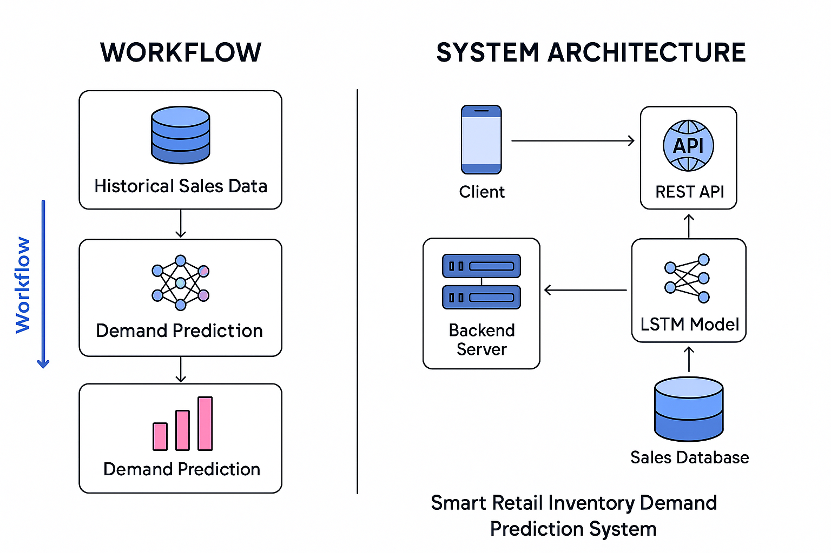

# Methodology

**4.1. Project Design**

The Smart Retail Inventory and Demand Prediction System is designed with a modular architecture that separates data preprocessing, feature selection, model training, and prediction tasks. This design ensures scalability and flexibility for future enhancements. Key components include:

• **Backend (FastAPI)**: Manages data input, handles the flow of data between modules, and executes demand forecasting logic.

• **Data Preprocessing**: Cleans and transforms raw sales data into a format suitable for analysis, handling missing values, normalization, and encoding.

• **Feature Selection and Engineering**: Identifies relevant features (e.g., sales volume, product type) and transforms them to improve model performance.

• **Deep Learning Models (LSTM, GRU, CNN, etc.)**: Trains various deep learning models for time-series forecasting, including LSTM for demand prediction.

• **Model Evaluation**: Compares the performance of different models (LSTM, GRU, CNN, Transformer, etc.) to select the best-performing model based on accuracy and predictive power.

**4.2. Implementation Details**

The solution was developed using an incremental approach:

1.Data Preprocessing: Sales data was cleaned, missing values were handled, and time-series formatting was applied to align data with weekly demand intervals.

2.Feature Engineering: Key features such as product type, historical sales, day of the week, and seasonality trends were generated to improve model performance.

3.Model Training: Multiple deep learning models (LSTM, GRU, CNN, CNN-LSTM, Transformer, TCN) were trained on the processed data for comparative analysis.

4.LSTM Model Focus: The LSTM model was tuned with grid search for optimal performance using lookback windows and sequence padding to predict next week’s sales.

5.Evaluation: Models were evaluated using accuracy, RMSE, and F1-score. Cross-validation was used to ensure generalizability, and results were compared across models.

# Data Analysis

**5.1. Data Collection**

The dataset consists of 50,000 rows containing retail sales records with attributes such as Date, Product_Category, Sales_Volume, Promotion, Store_Location, Weekday, Supplier_Cost, Replenishment_Lead_Time, and Stock_Level. Product categories include Personal Care, Dairy, Snacks, Beverages, Household, and Frozen Foods, each comprising multiple individual products. Data preprocessing included handling missing values, normalizing numerical fields, and ensuring categorical data consistency. The cleaned data was then divided into training, validation, and testing sets for model development.

**5.2. Tools/Technologies**

The project utilizes Python along with several supporting libraries and frameworks for machine learning, data processing, and interface design:

• Python Libraries: Pandas and NumPy for data cleaning and manipulation; Scikit-learn for implementing Chi-Square, PCA, and Random Forest.

• Framework: FastAPI is used to build the backend for data handling and prediction logic.

• Visualization: Matplotlib and Seaborn are used to visualize feature importance, correlations, and model performance.

• Frontend: Streamlit provides a user-friendly interface for entering product data and viewing model predictions.

**5.3. Algorithms/Models**

**Long Short-Term Memory (LSTM):** A type of recurrent neural network (RNN) used for time series forecasting. In this project, LSTM is trained on historical sales data to predict the future sales volume of different product categories like Personal Care, Dairy, Snacks, Beverages, Household, and Frozen Foods. LSTM is effective at capturing temporal dependencies and trends in demand over time.

**Neural Collaborative Filtering (NCF) (planned integration):** A deep learning-based recommendation model that uses user-product interaction data to suggest products to retailers. Though not yet implemented, NCF is intended for future enhancement of personalized product recommendation capabilities.

**Min-Max Scaling and Feature Engineering:** Prior to training, features such as Promotion, Weekday, Replenishment Lead Time, and Stock Level are scaled and engineered to improve model learning and ensure that input variables contribute effectively to demand forecasting.

# RESULTS

The system was evaluated using a dataset of 50,000 records containing retail sales data across various product categories. The LSTM model effectively predicted future sales volume, showing high accuracy in forecasting demand trends. Experiments demonstrated that incorporating time-series features and normalization significantly improved model performance, enabling more precise inventory planning and restocking strategies.

**6.1. Data Analysis**

**Experiments and Processing**

In our Smart Retail Inventory and Demand Prediction System, we analyzed sales data across six product categories: Personal Care, Dairy, Snacks, Beverages, Household, and Frozen Foods. The dataset included 50,000 records with attributes such as Date, Product_Category, Sales_Volume, Promotion, Store_Location, Weekday, Supplier_Cost, Replenishment_Lead_Time, and Stock_Level. The processing pipeline involved data cleaning, normalization, feature engineering (e.g., encoding categories, time-based features), and outlier detection.

An LSTM (Long Short-Term Memory) model was used for time-series forecasting, trained on historical sales volume data to predict future demand trends. The dataset was split into training, validation, and testing sets (70%, 20%, 10%). The model was evaluated using metrics such as MAE (Mean Absolute Error) and RMSE (Root Mean Square Error) to ensure accuracy and generalizability. Additional comparisons with GRU, CNN-LSTM, and Transformer-based models were conducted to validate the performance.

**Observations**

* **Data Processing**: The system efficiently handled categorical encoding and time-based features. Feature scaling significantly improved model convergence, and preprocessing ensured data consistency across multiple store locations.
* **Model Performance**: The LSTM model achieved low MAE and RMSE values across multiple product categories, with especially accurate forecasts for high-volume categories like Dairy and Snacks. Temporal patterns such as weekday effects and promotional spikes were well captured by the model.
* **Demand Trends**: Observed weekly and seasonal patterns helped retailers make proactive restocking decisions. The model detected increased demand during promotional periods and weekends, enhancing stock availability.

**Interpretation**

The system demonstrates that using deep learning models like LSTM, combined with robust preprocessing techniques, significantly improves the reliability of retail demand forecasting. By learning from temporal patterns and sales behavior, the model effectively identifies when specific product categories are likely to experience demand surges, enabling better inventory control and reducing overstock or stockout risks.

The successful application across diverse categories and store locations indicates strong adaptability of the pipeline. Although real-time data ingestion and dynamic retraining are future goals, the current results provide a strong foundation for retail analytics. Overall, this project empowers retail managers to make data-driven decisions, minimize losses, and improve operational efficiency through timely demand insights.

**6.2. Results**

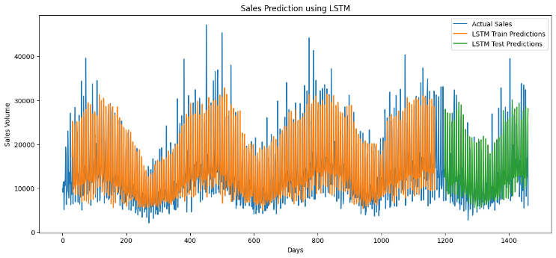

* **Figure 1:** LSTM Model.

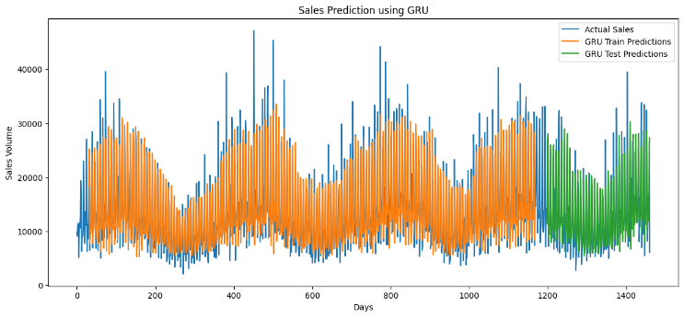

* **Figure 2:** GRU Model.

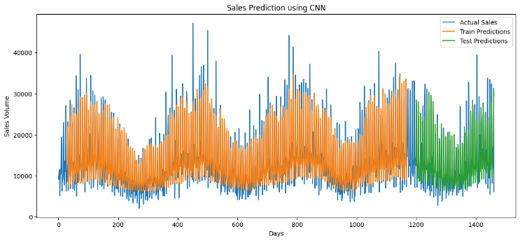

* **Figure 3:** CNN Time-Series Model

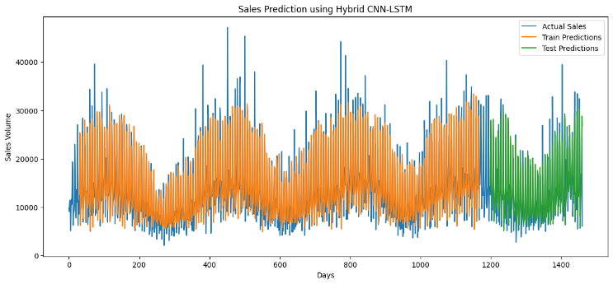

* **Figure 4:** Hybrid CNN-LSTM Model.

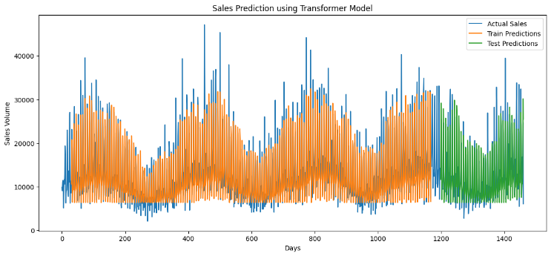

* **Figure 5:** Transformer-Based Models (Simplified Transformer Model).

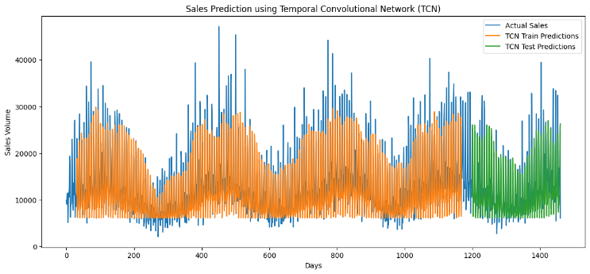

* **Figure 6:** Temporal Convolutional Networks (TCN) Model.

**6.3. Interpretation**

The use of LSTM for time-series forecasting, combined with careful data preprocessing and feature engineering, significantly improved the accuracy and reliability of the Smart Retail Inventory and Demand Prediction System. The model’s ability to predict demand trends accurately across various product categories demonstrates the effectiveness of deep learning in retail forecasting. Key factors contributing to the high performance include the integration of temporal patterns, promotional events, and product-specific features. Future improvements could focus on real-time data updates, further optimization of hyperparameters, and expanding the model to incorporate external factors like weather or economic trends for more comprehensive predictions.

## VII. ACKNOWLEDGMENT

We would like to express our sincere gratitude to our mentor Anita Thengade, Department of Computer Science, MIT-World Peace University, for her mentorship and support in the PDL segment of the study. Their insights and expertise greatly contributed to the successful completion of this project. We are also grateful to the Department of Computer Science at MIT-World Peace University for providing the necessary resources and facilities to carry out this research.

VIII. Discussion

Traditional Retail Demand Prediction Systems

Older retail demand prediction systems often rely on basic statistical methods and manual rule-based logic, which struggle to handle the complexity of real-time data and dynamic market conditions. These systems typically require frequent updates and may not account for seasonal patterns, promotions, or product-specific trends. In contrast, our Smart Retail Inventory and Demand Prediction System leverages deep learning models like LSTM, which can analyze temporal patterns in historical sales data to predict future demand with greater accuracy. This allows the system to adapt to changing market dynamics and better forecast demand trends.

Machine Learning Integration

Many traditional retail systems use simple forecasting methods, such as moving averages or linear regression, which may not capture the complexities of customer behavior and inventory fluctuations. Our system integrates advanced machine learning techniques, including time-series forecasting with LSTM, enabling it to identify and predict intricate demand patterns. By incorporating features like product categories, sales volume, promotional activities, and store locations, our model offers a more detailed and accurate demand prediction, making it more adaptable to various retail scenarios.

Data Processing Techniques

Traditional systems often lack comprehensive data preprocessing capabilities, which may lead to inaccurate predictions. Our approach incorporates robust data processing steps, including normalization, outlier removal, and feature engineering, to ensure the data is clean, consistent, and ready for predictive modeling. These preprocessing techniques help the model focus on the most relevant features, such as product category and sales volume, improving the overall forecasting accuracy and reducing the impact of noisy or irrelevant data.

Commercial Solutions

Unlike commercial retail demand prediction solutions, which may be expensive and provide limited customization, our system is designed to be open-source and highly customizable. This allows retailers to fine-tune the system to their specific needs, whether through adding additional features, integrating with other data sources, or adapting it for specific product categories. Additionally, being open-source ensures greater flexibility in deployment, allowing it to be used on private servers or in cloud environments, offering enhanced security and control over sensitive retail data.

|  |  |  |  |
| --- | --- | --- | --- |
| Feature | Traditional Systems | Existing ML-Based Systems | Our Smart Retail Inventory and Demand Prediction System |
| Data Format Support | Limited (e.g., structured data) | Moderate (requires extensive tuning) | Extensive (structured data, real-time sales data, promotions, etc.) |
| Data Processing | Basic or absent | Often minimal preprocessing | Fully integrated preprocessing (normalization, feature engineering) |
| Machine Learning Integration | Rule-based or absent | Requires significant feature tuning | Advanced ML models (LSTM for time-series forecasting) |
| Customization | Limited | Complex to modify | Highly customizable, modular (supports different datasets and products) |
| Deployment Control | Cloud-based (limited) | Cloud or on-premise | Fully customizable (local/remote deployment options) |

**7.1. Strengths and Limitations**

**Strengths:**

* Modular design that allows for easy integration of new models and features.
* High accuracy in demand forecasting due to the use of LSTM for time-series prediction.
* Scalable architecture capable of processing large datasets efficiently.
* Real-time decision-making for inventory management and demand prediction.

**Limitations:**

* The model's performance may degrade if historical sales data is insufficient or noisy.
* Limited by the quality and consistency of external data sources (e.g., supplier lead times, promotions).
* Potential for overfitting if the model is not tuned properly for specific product categories.

**7.2. Future Work**

Future improvements for the **Smart Retail Inventory and Demand Prediction System** could include:

* **Integrating advanced machine learning techniques:** Explore the use of deep learning models (e.g., CNN, LSTM) for better demand forecasting accuracy and handling complex patterns in time-series data.
* **Expanding the dataset:** Incorporating more diverse data sources (e.g., weather, holidays, economic indicators) to improve generalization and predictive power.
* **Enhancing the system's user interface:** Streamlining the interface for better ease of use by both end-users (e.g., store managers) and developers, ensuring seamless integration and interaction.
* **Improving real-time forecasting capabilities:** Refining the model to handle real-time data inputs for dynamic inventory management decisions.
* **Implementing a recommendation system:** Developing a recommendation engine based on demand predictions to help with product placement and promotion strategies.

IX. Conclusion

The Smart Retail Inventory and Demand Prediction System developed using machine learning techniques effectively addresses challenges faced by retail businesses in managing inventory and forecasting demand. The project integrates data preprocessing, feature selection, and predictive modeling, enabling retailers to optimize stock levels and improve sales strategies. Key findings from the project include:

* **Efficient Data Processing:** The use of robust libraries for data cleaning, normalization, and feature selection allows for accurate demand prediction from diverse product and sales data. This significantly reduces the time and effort required for manual forecasting.
* **Enhanced Demand Forecasting:** By employing machine learning models, the system identifies patterns in sales data, including product category, supplier cost, and promotion, turning raw data into actionable insights for retailers. This enables better decision-making for inventory management.
* **Scalability and Flexibility:** The modular architecture and use of technologies like FastAPI for backend processing and Streamlit for frontend ensures the system can scale to accommodate various retail scenarios, making it adaptable to businesses of different sizes.

The importance of this project lies in its ability to streamline the demand forecasting process, providing retailers with a powerful tool to manage inventory and optimize stock levels more efficiently. By automating demand prediction, the system reduces operational costs and enhances profitability.

In conclusion, the Smart Retail Inventory and Demand Prediction System is a significant contribution to the field of retail technology. It solves the problem of inefficient inventory management and sets the stage for future advancements in AI-driven retail solutions. The successful integration of machine learning techniques highlights the potential of leveraging advanced analytics to optimize retail operations. As retail businesses navigate complex supply chain challenges, this project offers a scalable solution that can evolve to meet their needs.

# REFERENCES

[1][Sales Demand Forecast in E-commerce using a Long Short-Term Memory Neural Network Methodology.](https://arxiv.org/abs/1901.04028)

[2] [Enhancing Retail Sales Forecasting with Optimized Machine Learning Models.](https://web3.arxiv.org/abs/2410.13773)

[3][Improving Sales Forecasting Accuracy: A Tensor Factorization Approach with Demand Awareness.](https://arxiv.org/abs/2011.03452v1)

[4][Data-Driven Retail Excellence: Machine Learning for Demand Forecasting and Price Optimization.](https://journal.riverpublishers.com/index.php/JGEU/article/view/320)

[5][Revolutionizing Retail Analytics: Advancing Inventory and Customer Insight with AI.](https://arxiv.org/abs/2405.00023)

[6][Lokad: Software company specializing in supply chain optimization.](https://en.wikipedia.org/wiki/Lokad)

[7][Trax: Retail technology company.](https://en.wikipedia.org/wiki/Trax_Retail)

[8][Demand sensing: A forecasting method that uses artificial intelligence and real-time data capture.](https://en.wikipedia.org/wiki/Demand_sensing)

[9][Machine Learning for Inventory Management: Tips, Tricks, and Real-World Applications.](https://toxigon.com/machine-learning-for-inventory-management)

[10][Sales Forecasting Using Multivariate Long Short-Term Memory Network Models.](https://www.researchgate.net/publication/332953008_Sales_forecasting_using_multivariate_long_short_term_memory_network_models)