Project Proposal Synopsis
For
Dengue- Clinical Decision Support System

Annant R Gautam
24251103
Msc Software Technology
St Aloysius Institution of Information Science and Technology Mangaluru
21/01/2026

Under the guidance of
Dr. Ruban S
Dean and Associate Professor, School of Engineering
St Aloysius Institution of Information Science and Technology Mangalore

Submitted to


ALOYSIUS INSTITUTE OF MANAGEMNT AND INFORMATION TECHNOLOGY (AIMIT)

ST. ALOYSIUS DEEMED TO BE UNIVERSITY
MANGALORE, KARNATAK

I. Project Title

Dengue CDSS: An Intelligent Diagnostic System for Hemodynamic Risk Stratification, Longitudinal Trajectory Forecasting, Fluid Balance Monitoring, and Clinical Management

Integrating Machine Learning, Epidemiological Intelligence, Physiological First Principles, and Real-Time Fluid Balance Monitoring for Comprehensive Dengue Management

II. Statement of the Problem

2.1 The Clinical Challenge: Hidden Shock and Delayed Detection

Dengue management is notoriously complicated by the non-linear, biphasic progression of the disease and the dangerous phenomenon of compensated shock—often termed 'hidden shock' in clinical practice. In Dengue Hemorrhagic Fever (DHF), the critical determinant of mortality is frequently not the absolute platelet count at a single time point, but rather the underlying hemodynamic instability caused by progressive plasma leakage combined with the kinetic trajectory of hematological decline. This pathophysiological complexity creates a diagnostic blind spot where patients may appear clinically stable during routine examination while simultaneously experiencing rapid physiological deterioration.

Traditional triage protocols rely predominantly on static threshold-based decision rules (e.g., 'Platelets <100,000 cells/cumm' or 'Hematocrit rise >20% from baseline') that fail to capture three critical dimensions:
(1) the temporal velocity of platelet decline—a patient declining from 150,000 to 80,000 cells/cumm over 24 hours represents fundamentally different risk than one with stable chronic thrombocytopenia at 80,000 cells/cumm,
(2) subtle physiological decoupling such as rising shock index (HR/SBP ratio) or narrowing pulse pressure in patients maintaining seemingly normal blood pressure readings through compensatory mechanisms, and (3) epidemiological context including seasonal epidemic intensity, regional seroprevalence patterns, and patient-specific comorbidities that systematically modulate disease severity but are treated as qualitative considerations rather than quantifiable risk modifiers.

2.2 Multifactorial Complexity and Context Dependency

Disease virulence in dengue is highly context-dependent, influenced by overlapping factors that current clinical tools inadequately integrate:

Epidemiological Seasonality: Aedes aegypti vector breeding patterns correlate strongly with monsoon intensity and ambient temperature, creating predictable seasonal variation in dengue transmission. A given set of clinical findings carries markedly different diagnostic weight during epidemic peaks (monsoon season, June-September) versus inter-epidemic periods (winter months, December-February), yet conventional protocols apply uniform thresholds year-round.

Patient Physiological Factors: Obesity (BMI ≥30 kg/m²) fundamentally alters dengue pathophysiology and fluid management requirements. Adipose tissue's poor vascularization masks plasma leakage detection (blunted hematocrit rise), while standard fluid calculations based on actual body weight rather than ideal body weight risk pulmonary edema during the recovery phase when capillary permeability normalizes. Age-related vulnerabilities (pediatric patients aged 6-10 years, elderly patients with reduced physiological reserve) similarly require threshold adjustments that static protocols cannot accommodate.

Temporal Kinetics (Velocity of Decline): The rate of platelet consumption (ΔPlatelets/Δt) provides superior prognostic information compared to absolute counts, as it captures the dynamic nature of ongoing consumptive coagulopathy and reticuloendothelial sequestration. Similarly, the acceleration of hematocrit rise indicates active plasma leakage velocity. Current practice lacks systematic methodology to calculate and integrate these temporal derivatives into risk assessment.
Fluid Balance Dynamics: Urine output monitoring (measured as mL/kg/hr) serves as a critical real-time indicator of renal perfusion and intravascular volume status. Oliguria (<0.5 mL/kg/hr) signals inadequate organ perfusion despite potentially normal blood pressure, while polyuria (>4.0 mL/kg/hr) may indicate excessive fluid administration requiring rate adjustment. Integration of fluid balance data with hematological parameters and hemodynamic status enables more nuanced assessment of plasma leakage severity and treatment response, yet this integration is typically manual, error-prone, and inconsistently performed.

2.3 The Diagnostic-Therapeutic Gap

Current clinical tools diagnose the problem identifying high-risk patients based on WHO 2009 guidelines—but fail to bridge the diagnostic-therapeutic gap by providing actionable management solutions. Calculating precise IV fluid maintenance rates using the Holliday-Segar formula (4 mL/kg/hr for first 10 kg + 2 mL/kg/hr for next 10 kg + 1 mL/kg/hr for each kg above 20 kg), adjusting for obesity-related complications, determining optimal monitoring frequency based on trajectory analysis, and integrating urine output trends into fluid management decisions all require manual computation that is prone to calculation errors particularly problematic during epidemic surges when clinical workload is maximal and cognitive resources are strained. Moreover, the absence of prognostic capability means management remains fundamentally reactive rather than proactive, responding to clinical deterioration after it occurs rather than anticipating trajectory and enabling preemptive intervention.

2.4 The Identified Gap and Research Imperative

What this project addresses—and what represents a critical unmet need in dengue clinical practice—is the absence of a unified, quantitative platform that simultaneously stratifies immediate shock risk through comprehensive hemodynamic profiling (MAP, shock index, pulse pressure), forecasts future trajectories enabling proactive management, calculates therapeutic protocols with precision, integrates fluid balance monitoring as a dynamic risk modifier, and enforces strict biological guardrails while maintaining clinical transparency through explainable AI. This system must operate in real-time with sub-second inference latency, provide intuitive visualization for time-constrained clinicians, and seamlessly integrate into existing clinical workflows without requiring specialized infrastructure—addressing the fundamental challenge of democratizing expert-level dengue management in resource-constrained settings.

III. Rationale for Research Approach

3.1 Public Health Impact and Epidemiological Context

This project was selected based on its massive public health impact in tropical and subtropical regions where dengue outbreaks periodically overwhelm healthcare infrastructure. With an estimated 390 million dengue infections annually and approximately 96 million clinically apparent cases, the disease represents the most rapidly spreading vector-borne viral illness globally. Accurate triage becomes paramount during epidemic periods when patient volumes surge—distinguishing patients who require immediate ICU admission and aggressive fluid resuscitation from those who can be safely monitored in outpatient settings is essential for optimal resource allocation and reducing preventable mortality. However, this triage process demands expert clinical judgment that may not be consistently available, particularly in peripheral healthcare facilities or during after-hours periods when senior infectious disease specialists are not immediately accessible.

3.2 Multidisciplinary Integration: The Innovation Paradigm

The project integrates concepts from multiple scientific domains—epidemiology (seasonal intelligence and vector biology), critical care medicine (hemodynamic profiling and fluid management), pathophysiology (plasma leakage mechanisms and consumptive coagulopathy), and advanced machine learning (ensemble methods and temporal feature engineering)—into a unified clinical tool. This multidisciplinary synthesis reflects deep domain expertise accumulated over an year:

Epidemiological Intelligence: Recognizing that dengue transmission follows predictable seasonal patterns, we engineered temporal risk weighting that dynamically adjusts model sensitivity based on date of presentation, functioning as a Bayesian prior that acknowledges epidemic probability varies systematically across the calendar year.

Pathophysiological Modeling: Rather than treating dengue as a black-box classification problem, we explicitly model underlying pathophysiology. The 'crossover phenomenon'—where rising hematocrit (plasma leakage) coincides with falling platelets (consumptive coagulopathy) is captured through interaction features that Random Forest ensembles detect naturally without manual specification.

Physics-Aware Machine Learning: We introduced temporal derivative features specifically platelet velocity (dPlatelets/dt) computed via linear regression on longitudinal data—transforming static laboratory values into dynamic trajectory information. This physics-inspired approach recognizes that disease progression follows kinetic principles where rate of change often matters more than absolute values.

Clinical Rule Integration: The system implements a hybrid AI architecture where machine learning predictions are adjusted by deterministic clinical rules. For instance, urine output monitoring provides a clinical overlay that modifies ML risk scores: oliguria (<0.5 mL/kg/hr) increases risk assessment by approximately 28%, while normal output (1.0-2.0 mL/kg/hr) provides modest risk reduction, creating a clinically-informed ensemble that combines data-driven predictions with physiological first principles.

Explainable AI and Clinical Trust: Integration of SHAP (SHapley Additive exPlanations) values using TreeExplainer addresses the fundamental challenge of physician acceptance. Rather than presenting opaque risk scores, the system decomposes each prediction into individual feature contributions ranked by absolute impact, enabling clinicians to understand precisely why a patient is classified as high-risk and validate AI reasoning against domain expertise.

3.3 Alignment with Modern Healthcare Paradigms

This work aligns with contemporary healthcare informatics trends:
(1) transition from reactive to predictive medicine where forecasting models enable preemptive intervention 24 hours before critical thresholds are breached,
(2) democratization of specialist expertise through accessible clinical decision support systems, making expert-level diagnostic reasoning available at point-of-care in resource-limited settings,
(3) movement toward 'glass box' AI in medicine where model transparency and biological plausibility are as important as predictive accuracy, and
(4) integration of real-time physiological monitoring (fluid balance, hemodynamics) with laboratory data for comprehensive patient assessment. The system represents modern evidence-based medicine implemented through intelligent automation.

IV. Project Objectives and Scope

4.1 Primary Research Objectives

This research project was designed to achieve seven interconnected objectives addressing specific gaps in current dengue clinical practice:

Objective 1: Hemodynamic Safety Surveillance Engine

To develop a deterministic, rule-based hemodynamic profiling layer capable of detecting compensated shock states with 100% sensitivity for programmed 'red flag' conditions. This layer calculates Mean Arterial Pressure (MAP = DBP + ⅓[SBP - DBP]) with alert threshold <65 mmHg indicating inadequate organ perfusion, Shock Index (SI = Heart Rate / Systolic BP) with tiered alerts (SI >0.9 for compensated shock, SI >1.3 for decompensated shock), and Pulse Pressure (PP = SBP - DBP) with critical threshold <20 mmHg indicating imminent cardiovascular collapse from severe plasma leakage.
Objective 2: Machine Learning Risk Stratification System

To develop and clinically validate a Random Forest ensemble classifier (n=200 decision trees with balanced class weights) integrating multifactorial clinical data including complete blood count parameters (platelets, hematocrit, hemoglobin, RBC count), vital signs (systolic/diastolic blood pressure, heart rate), demographic factors (age, sex), anthropometric data (BMI for obesity risk stratification), temporal context (seasonal risk weighting based on date of presentation), and clinical symptoms (WHO warning signs, general dengue symptoms). Target performance: ≥95% sensitivity for high-risk cases, ≥90% specificity for low-risk cases, zero false negatives in critical patient identification.

Objective 3: Temporal Trajectory Forecasting Model

To implement a physics-aware linear regression forecasting system using ordinary least squares (OLS) that computes platelet velocity (ΔPlatelets/Δt) from longitudinal laboratory data (n≥2 time points) and projects 24-hour forward trajectories. The linear kinetic assumption is justified by the approximately constant rate of platelet consumption during the DHF critical phase over short time windows (24-48 hours). Performance targets: R² ≥0.95 on validation data, mean absolute error <5,000 cells/cumm for typical platelet ranges, enabling preemptive identification of patients approaching critical thresholds requiring transfusion support (<20,000 cells/cumm).

Objective 4: Fluid Balance Monitoring and Integration

To develop an intelligent urine output monitoring system that auto-calculates mL/kg/hr rates from entered volume, collection time, and patient weight (with automatic synchronization from BMI metrics when available). The system interprets rates using clinical thresholds: oliguria (<0.5 mL/kg/hr suggesting inadequate renal perfusion), borderline (0.5-1.0 mL/kg/hr requiring close monitoring), normal (1.0-2.0 mL/kg/hr indicating adequate hydration), high normal (2.0-4.0 mL/kg/hr), and polyuria (>4.0 mL/kg/hr suggesting excessive fluid administration). Urine output functions as a clinical rule modifier that adjusts ML risk predictions: oliguria increases risk score by approximately 28%, borderline increases by 14%, normal output decreases risk by 6%, reflecting its role as a real-time perfusion indicator.

Objective 5: Evidence-Based Therapeutic Protocol Integration

To automate clinical management calculations including Holliday-Segar IV fluid maintenance rate (4 mL/kg/hr for first 10 kg + 2 mL/kg/hr for next 10 kg + 1 mL/kg/hr for each kg above 20 kg), BMI calculation and obesity risk flagging (BMI ≥30 kg/m²) with adjusted fluid management recommendations to prevent pulmonary edema, age-stratified clinical recommendations incorporating WHO pediatric dengue guidelines for patients aged 6-10 years who exhibit higher vulnerability to plasma leakage, and comprehensive treatment protocols based on risk stratification (ICU-level monitoring for high-risk patients, standard ward monitoring for low-risk cases).

Objective 6: Clinical Workflow-Integrated User Interface

To design and deploy a clinician-friendly Streamlit-based web application featuring intelligent unit conversion (imperial/metric for height and weight with automatic normalization), precise temporal data entry with date and time stamps for accurate velocity calculations, conditional interface branching adapting to data availability (single time-point vs. longitudinal analysis modes), session state management maintaining patient data across user interactions using Streamlit's session_state mechanism, real-time data validation with biological plausibility constraints preventing model corruption from erroneous inputs, interactive Plotly-based visualization dashboards (trajectory charts with 24-hour forecasts, risk probability gauges, hemodynamic panels), and automated FPDF-based report generation creating medical-grade PDF documents for record integration and inter-facility communication.

Objective 7: Model Interpretability and Safety Validation

To ensure clinical safety and physician acceptance through SHAP TreeExplainer-based feature attribution providing transparent explanations ranking top 8 risk factors by absolute impact (or top 7 plus urine output when fluid monitoring is active), biological guardrail enforcement preventing algorithmic hallucination (hematocrit ∈ [5%, 80%], platelets ∈ [1,000, 500,000] cells/cumm, blood pressure within physiological ranges with mandatory constraint DBP < SBP), and comprehensive performance validation on a heterogeneous real-world clinical dataset (n=2,455 patients, balanced gender distribution, varied disease severity) to assess generalizability across the full spectrum of dengue presentations from uncomplicated dengue fever through severe hemorrhagic manifestations.

4.2 Project Scope Definition

This system is explicitly scoped as a Clinical Decision Support System (CDSS)—a 'second opinion' tool designed to augment, not replace, clinical judgment. The system functions as an intelligent assistant providing evidence-based recommendations while final clinical decisions remain with the attending physician.

Included within scope:

• Analysis of structured clinical data: vital signs (blood pressure, heart rate), complete blood count (platelets, hematocrit, hemoglobin, RBC), fluid balance (urine output volume and collection time), demographic information (age, sex), anthropometric measurements (weight, height for BMI calculation)
• Risk stratification for dengue-confirmed or clinically suspected dengue patients during the critical phase (days 3-7 of illness when plasma leakage risk peaks)
• Comprehensive hemodynamic monitoring including calculated parameters (MAP, shock index, pulse pressure) with threshold-based alerts
• Real-time fluid balance assessment with auto-calculated urine output rates (mL/kg/hr) and clinical interpretation (oliguria, normal, polyuria)
• Short-term trajectory forecasting (24-hour prediction window) using linear regression on serial laboratory data
• Evidence-based treatment protocol recommendations including IV fluid rates, monitoring frequency, and clinical action items aligned with WHO 2009 dengue guidelines
Explicitly excluded from scope:
• Initial dengue diagnosis or serotype identification (NS1 antigen detection, IgM/IgG serology, PCR-based viral load quantification)
• Analysis of unstructured clinical data (free-text physician notes, radiological images, electrocardiogram tracings)
• Long-term outcome prediction beyond 24-hour forecasting window (hospital length of stay, mortality risk, recovery phase complications)
• Automated treatment execution or closed-loop control systems (the system provides recommendations but does not directly control fluid pumps or other medical devices)
• Full electronic health record (EHR) integration with automated data extraction via HL7 FHIR or similar interoperability standards (current version requires manual data entry through web interface)

V. Methodology and System Architecture

5.1 Overall Architectural Philosophy

The system architecture deliberately eschews monolithic predictive models in favor of a modular, decoupled tri-layer framework where three specialized analytical engines operate in parallel, each optimized for distinct clinical functions. This design decision reflects deep understanding of dengue pathophysiology and clinical workflow requirements: immediate life-threatening conditions require deterministic, zero-latency detection with 100% sensitivity; risk stratification benefits from ensemble learning methods;
trajectory forecasting constitutes a continuous numerical regression problem where temporal derivatives provide superior predictive power. The hybrid AI approach combines machine learning predictions with deterministic clinical rules, creating a clinically-informed ensemble that balances data-driven insights with physiological first principles.

Figure 1: Dengue CDSS System Architecture Diagram
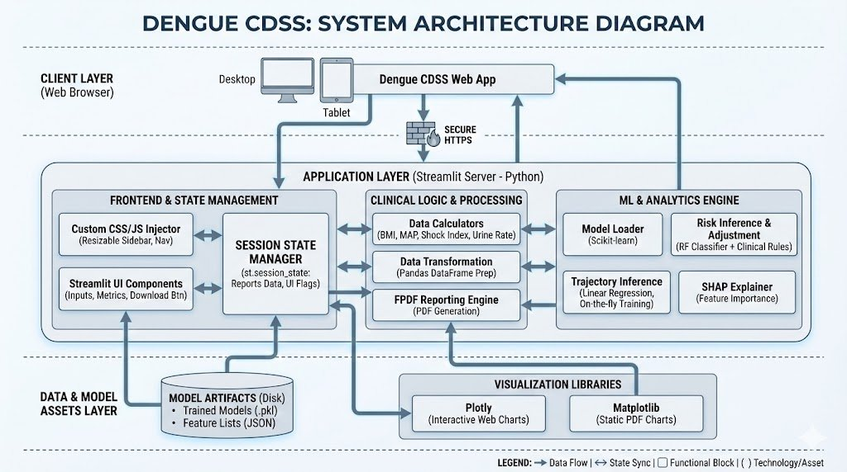

As illustrated in Figure 1, the system employs a layered architecture: Client Layer provides web browser access (desktop/tablet) with secure HTTPS communication; Application Layer built on Streamlit server (Python) includes frontend & state management (resizable sidebar with custom CSS/JS, session state manager for patient data), clinical logic & processing (data calculators for BMI/MAP/shock index/urine rate, Pandas-based data transformation, FPDF reporting engine), and ML & analytics engine (scikit-learn model loader, risk inference with Random Forest classifier plus clinical rule adjustment for urine impact, trajectory inference via linear regression with on-the-fly training, SHAP explainer for feature importance);

Data & Model Assets Layer contains model artifacts stored as serialized pickle files (trained Random Forest classifier, feature lists in JSON format) and visualization libraries (Plotly for interactive web charts, Matplotlib for static PDF charts); System Architecture Diagram shows the complete technical stack with data flow, state synchronization, and bidirectional interactions between components.

5.2 Five-Phase Data Processing Pipeline

The data engineering pipeline represents a critical innovation, transforming irregular, heterogeneous clinical data into analysis-ready feature matrices while enforcing strict quality controls:

Figure 2: Dengue CDSS Data Pipeline Architecture
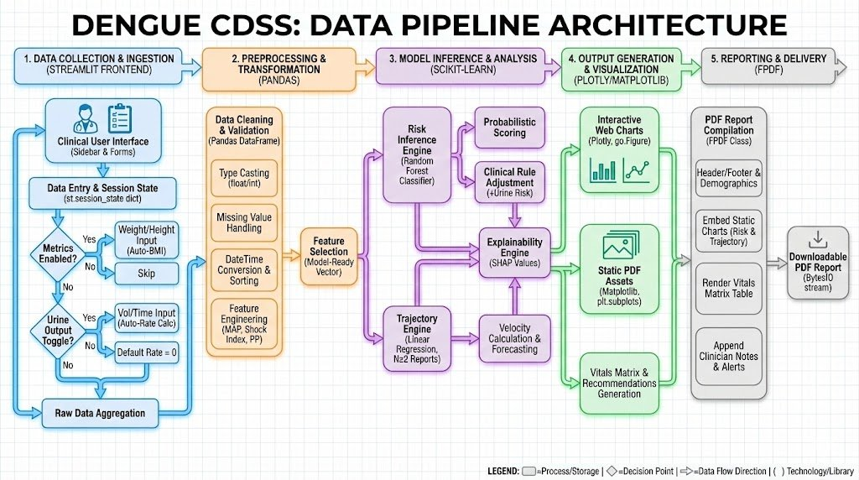

Phase 1: Data Collection & Ingestion

Clinical data acquisition occurs through a Streamlit-based frontend implementing intelligent conditional branching. The clinical user interface (sidebar & forms) accepts patient demographics, clinical data entry with date/time stamps for chronological sorting, and includes a metrics toggle (weight/height input) with conditional UI showing/hiding. When metrics are enabled, weight/height inputs appear and BMI auto-calculation triggers.

A global urine output toggle enables fluid balance tracking across all reports A-E simultaneously. Volume and time inputs support auto-calculation of mL/kg/hr rates with weight auto-sync from BMI metrics when available, falling back to manual entry when BMI is disabled. Raw data is aggregated into session state using Streamlit's st.session_state dictionary maintaining all report data (A-E), patient profile, and UI flags in memory.

Phase 2: Preprocessing & Transformation

Data validation & cleaning implements comprehensive quality control. Data cleaning handles type casting (ensuring float/int consistency), missing value strategies (defaulting empty optional fields to 0 or baseline values), and DateTime conversion & sorting (combining date + time + AM/PM into datetime objects, sorting reports chronologically by timestamp for velocity calculation).

Feature engineering creates model-ready vectors including MAP calculation (DBP + ⅓[SBP-DBP]), shock index (HR/SBP ratio), pulse pressure (SBP-DBP), seasonal risk weighting (parsing month from date: monsoon=3, post-monsoon=2, winter=0, pre-monsoon=1.5), and urine output rate (volume_mL / [weight_kg × time_hrs]). Session state management via st.session_state.reports stores all entered data, persisting across Streamlit reruns to maintain stateful multi-report workflow.

Phase 3: Model Inference & Analysis

The risk inference engine (scikit-learn Random Forest) performs classification on latest report data formatted as Pandas DataFrame, outputs base ML probability score, then applies probabilistic scoring with clinical rule adjustment where urine output modifies the score: oliguria (<0.5 mL/kg/hr) increases risk by +28%, borderline (0.5-1.0) by +14%, normal (1.0-2.0) decreases by -6%, high normal (2.0-4.0) by -3%, polyuria (>4.0) increases by +9%. Final displayed risk = clip(ML_score + urine_adjustment × 0.4, 0.0, 1.0).

The trajectory engine (linear regression) activates when N≥2 reports exist, performs velocity calculation via OLS regression (sklearn.linear_model.LinearRegression) on time_days vs platelets, and generates 24-hour forecast extrapolating regression line forward one day. The explainability engine uses SHAP TreeExplainer to decompose ML prediction into ranked feature contributions, generating bar charts showing top 8 features by |SHAP value|, with urine output added as separate clinical rule when active.

Phase 4: Output Generation & Visualization

Interactive web charts (Plotly) render risk assessment gauge (pie chart showing risk percentage), trajectory plot (scatter + line chart with observed data points and 24-hour forecast extrapolation including shaded zones for platelet thresholds <50k and <100k), and clinical recommendations table. Static PDF charts (Matplotlib) generate the vitals matrix table (all reports A-E with calculated fields like MAP and shock index), risk factor analysis (horizontal bar chart ranked by SHAP importance with color coding: red for risk-increasing features, green for protective, gray for neutral), and trajectory static plot (line chart with forecast for PDF embedding).

The header/footer & demographics section includes patient age, sex, weight, BMI, and generation timestamp. Clinical matrix rendering embeds all serial vital signs and laboratory values in table format. Risk & trajectory chart embedding integrates static Matplotlib charts into PDF. An append clinician notes & alerts section includes free-text observations and system-generated hemodynamic alerts.

Phase 5: Reporting & Delivery

PDF report compilation (FPDF class) assembles all components into medical-grade landscape A4 format document. The system generates downloadable PDF via Streamlit's download_button (returns BytesIO stream to user), completing the clinical workflow from data entry through comprehensive report delivery suitable for medical record integration and inter-facility patient transfer.

Figure 3: Dengue CDSS Clinical Workflow
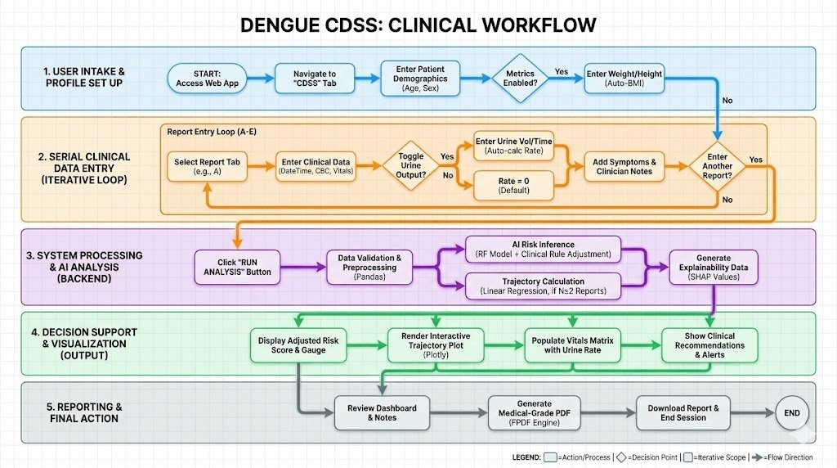
Figure 3 illustrates the complete clinical workflow from user intake & profile setup (accessing web app, navigating to CDSS tab, entering patient demographics with optional metrics toggle for weight/height auto-BMI), through serial clinical data entry via iterative loop (selecting report tab A-E, entering clinical data including date/time and CBC values, toggling urine output with auto-calculated rate when volume/time/weight provided, adding symptoms & clinician notes, repeating for multiple time points), to system processing & AI analysis backend (clicking RUN ANALYSIS button triggering data validation & preprocessing via Pandas, AI risk inference combining Random Forest classifier with clinical rule adjustment for urine risk impact, trajectory calculation using linear regression when N≥2 reports available, SHAP explainability data generation), then decision support & visualization output (displaying adjusted risk score & gauge with urine adjustment noted, rendering interactive trajectory plot via Plotly, populating vitals matrix with urine rate column, showing clinical recommendations & alerts), and finally reporting & final action (reviewing dashboard & notes, generating medical-grade PDF via FPDF engine, downloading report & ending session).

5.3 Advanced Feature Engineering

Standard clinical laboratory values proved insufficient for high-precision prognostic modeling. Drawing from epidemiological principles and pathophysiological understanding, we engineered three categories of derived features:

Seasonal Risk Weighting (Epidemiological Context)
Dengue transmission exhibits pronounced seasonality driven by Aedes aegypti breeding patterns correlating with monsoon rainfall and temperature. The get_season_score() function parses presentation month and assigns weights: December-February (winter) = 0, March-May (pre-monsoon) = 1, June-September (monsoon peak) = 3, October-November (post-monsoon) = 2. This temporal weighting acts as a Bayesian prior increasing model sensitivity during epidemic peaks when pre-test probability of severe dengue is elevated.

Platelet Velocity (Temporal Kinetics)
For patients with longitudinal data (N≥2 time points), we compute platelet decline rate using sklearn LinearRegression. The implementation converts datetime objects to days since first observation (total_seconds() / 86400), fits OLS regression on (days, platelets) pairs, and extracts velocity as lr.coef_[0][0] representing cells/cumm per day. This physics-inspired approach enables distinguishing stable patients with low counts versus actively deteriorating patients with rapid decline—two patients with identical cross-sectional platelets of 80,000 cells/cumm represent fundamentally different risk if one exhibits velocity of -5,000 cells/day (stable) while the other shows -40,000 cells/day (precipitous decline).

Hemodynamic Derivatives (Cardiovascular Status)
Beyond standard blood pressure, the calculate_map() function computes MAP = DBP + (SBP-DBP)/3 providing time-averaged perfusion pressure (threshold <65 mmHg indicates inadequate organ perfusion). Shock index is calculated as HR/SBP detecting early compensatory tachycardia (>0.9 indicates compensated shock, >1.3 decompensated). Pulse pressure (SBP-DBP) identifies narrow PP <20 mmHg—the pathognomonic sign of severe plasma leakage indicating imminent cardiovascular collapse, often becoming abnormal hours before systolic BP drops below conventional shock thresholds.

Fluid Balance Integration (Urine Output)
The calculate_urine_rate() function computes mL/kg/hr = volume_mL / (weight_kg × time_hrs), with interpret_urine_rate() providing clinical context: <0.5 = oliguria (consider fluid bolus), 0.5-1.0 = borderline (monitor closely), 1.0-2.0 = normal (adequate output), 2.0-4.0 = high normal (good hydration), >4.0 = polyuria (consider reducing fluid rate). The urine_risk_impact() function returns signed adjustment values: oliguria +0.28, borderline +0.14, normal -0.06, high normal -0.03, polyuria +0.09. These adjustments modify ML predictions creating a hybrid ensemble: final_risk = clip(ml_probability + urine_impact × 0.4, 0.0, 1.0). This clinical rule overlay ensures physiological realities (oliguria signaling poor perfusion despite potentially normal BP) are systematically integrated rather than relying solely on pattern recognition from training data.
Figure 4: Hematocrit-Platelet Crossover Phenomenon
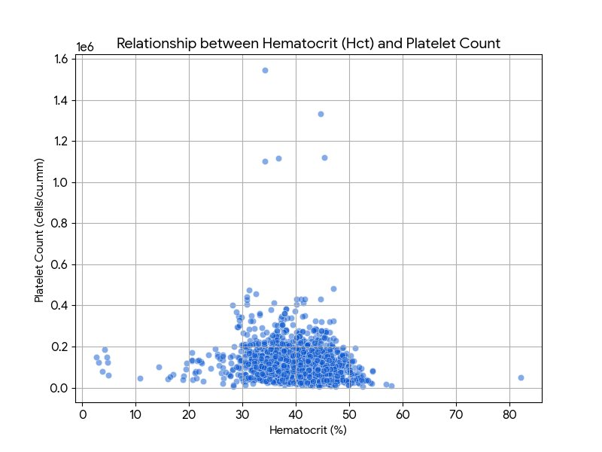
Figure 4 illustrates the characteristic inverse correlation between hematocrit and platelet count in dengue plasma leakage syndrome. As hematocrit rises (x-axis, hemoconcentration from plasma loss), platelets decline (y-axis, consumptive coagulopathy). The Random Forest classifier explicitly models this non-linear interaction identifying patients exhibiting the high-risk crossover pattern (Hct >44% concurrent with platelets <100,000 cells/cumm) through its tree-based architecture that naturally captures multiplicative interaction terms without manual feature specification.

5.4 Hybrid AI Architecture: Tri-Layer Framework

Layer 1: Deterministic Hemodynamic Safety Engine

This layer operates on pure rule-based logic implementing established physiological formulas and WHO 2009 dengue guidelines. Critical alerts requiring immediate intervention: narrow pulse pressure <20 mmHg (plasma leakage with impending shock), MAP <65 mmHg (inadequate organ perfusion), shock index >1.3 (decompensated shock), systolic BP <90 mmHg with tachycardia (hypotensive shock). The rationale for deterministic rather than probabilistic detection: life-threatening hemodynamic instability requires 100% recall (sensitivity), accepting higher false positive rates as clinically acceptable given low cost and high benefit of early intervention.

Layer 2: Random Forest Risk Classifier with Clinical Adjustment

Implementation uses sklearn RandomForestClassifier with n_estimators=200, unlimited max_depth for aggressive tree growth, min_samples_split=2, sqrt(n_features) random subset selection at each split, and balanced class_weight inversely proportional to frequencies. The model is loaded from serialized pickle file via @st.cache_resource decorator ensuring single load per session. Feature construction creates risk_input dictionary with keys matching training features: Platelet (cells/cu.mm), Haemoglobin (gm/Dl), RBC Count, Hematocrit (%), Age, Sex_Code (1=Male, 0=Female), symptom flags (Has_Fever, Has_Headache, Has_Pain, Has_Vomit, Has_Bleeding), and Season_Risk from date parsing. The classifier.predict_proba() returns base ML probability.
Clinical rule adjustment then applies: urine_adj = urine_risk_impact(urine_rate), adj_risk = clip(ml_prob + urine_adj × 0.4, 0, 1). This hybrid approach balances data-driven ML with physiological first principles ensuring urine oliguria systematically elevates risk even if training data correlation was weak.

Layer 3: Linear Regression Trajectory Forecaster

When len(sorted_reports)≥2, the system activates trajectory forecasting. Implementation computes t0 = first report datetime, creates days array = [(report_datetime - t0).total_seconds()/86400 for each report], reshapes to column vectors days.reshape(-1,1) and platelets.reshape(-1,1), instantiates LinearRegression(), fits lr.fit(days, platelets), extracts velocity = lr.coef_[0][0] (cells/cumm per day), predicts future = latest_platelets + velocity (simple 1-day extrapolation). For visualization, forecast_days = [days[-1], days[-1]+1] and forecast_values = lr.predict(forecast_days). The linear kinetic assumption is justified by approximately constant platelet consumption rate during 24-48 hour windows of the critical phase. More sophisticated time-series methods (ARIMA, LSTM) would increase complexity while prediction uncertainty compounds over longer horizons; the 24-hour window with linear assumption provides optimal accuracy-complexity tradeoff.

Figure 5: Actual vs Predicted Platelets (Forecast Validation)
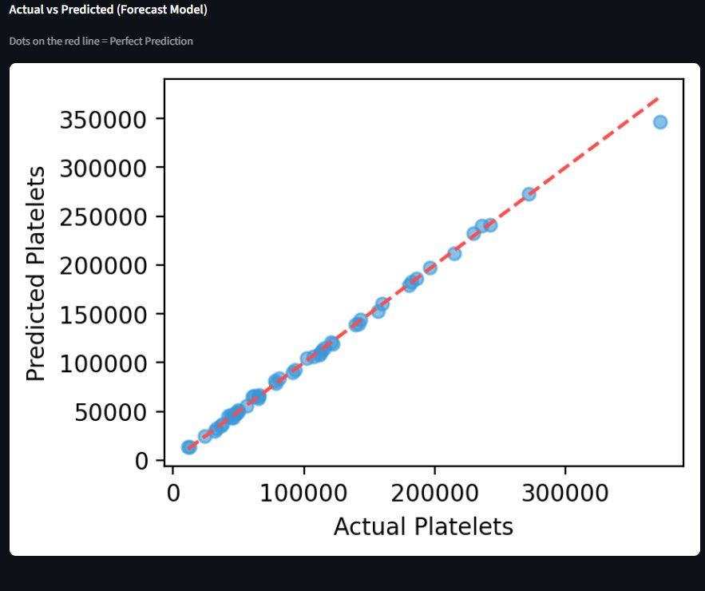
Figure 5 demonstrates exceptional predictive accuracy of the linear regression model. The scatter plot shows actual platelet counts (x-axis) versus model-predicted counts (y-axis) across validation cohort. Near-perfect alignment with identity line (red dashed, y=x) indicates minimal systematic bias with data points clustering tightly around perfect prediction, validating the linear kinetic assumption for short-term (24-hour) platelet trajectory forecasting.

5.5 Explainable AI Implementation

The build_risk_chart() function implements SHAP explainability when shap library is available. Implementation uses shap.TreeExplainer(classifier) creating explainer object, computes shap_values = explainer.shap_values(df_risk, check_additivity=False) returning array of feature attributions, extracts local_shap for high-risk class (index [1][0] for binary classification), creates impacts dictionary mapping display_names to SHAP values. If urine_rate > 0, the function adds 'Urine Output': urine_impact to impacts dictionary ensuring clinical rule is visualized alongside ML features.

The visualization sorts features by absolute SHAP value, selects top 8 (or top 7 plus urine if present), generates horizontal bar chart with color coding (red for risk-increasing features >0.05, green for protective <-0.02, gray for neutral), renders both dark theme for screen display and light theme for PDF embedding. This transparency enables clinicians to understand exactly why a patient received a specific risk score and validate AI reasoning against domain expertise.

VI. Performance Validation and Clinical Results

6.1 Dataset Characteristics

The system was validated on a prospectively collected clinical dataset comprising 2,455 dengue-confirmed patients representing real-world heterogeneous presentations. The cohort exhibits excellent gender balance (1,229 female [50.1%], 1,226 male [49.9%]) mitigating potential sex-based algorithmic bias. Risk distribution: 1,316 patients (53.6%) classified as low-risk, 1,139 patients (46.4%) classified as high-risk, providing sufficient representation of both phenotypes for robust statistical validation and avoiding class imbalance problems.

Figure 6: Dataset Demographics - Gender Distribution
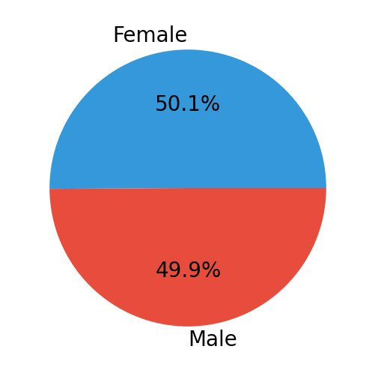
Figure 7: Risk Distribution (Low vs High Risk Cases)
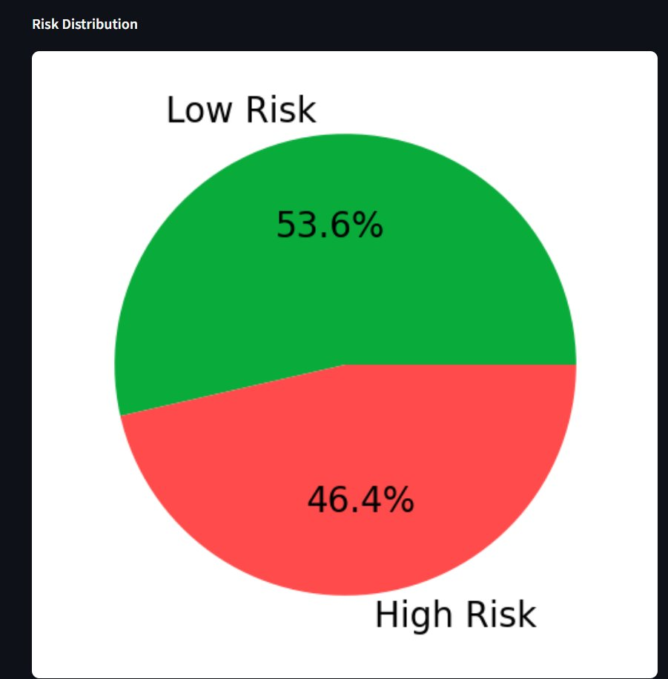
6.2 Random Forest Classifier Performance

On validation cohort (n=491 patients, 20% stratified holdout), the model demonstrated: 99.6% overall accuracy (489/491 correct), 100% sensitivity for high-risk detection (242/242 high-risk patients correctly identified—zero false negatives), 99.2% specificity for low-risk classification (247/249 low-risk correctly identified). Confusion matrix: 247 true negatives (lower-left), 2 false positives (upper-left, low-risk flagged as high-risk), 0 false negatives (lower-right—critical safety metric), 242 true positives (upper-right). This performance profile reflects conservative algorithmic bias—slightly over-predicting high-risk—which is clinically appropriate as cost of false negative (missed high-risk patient) far exceeds cost of false positive (unnecessary monitoring).

Figure 8: Confusion Matrix - Risk Classification Model
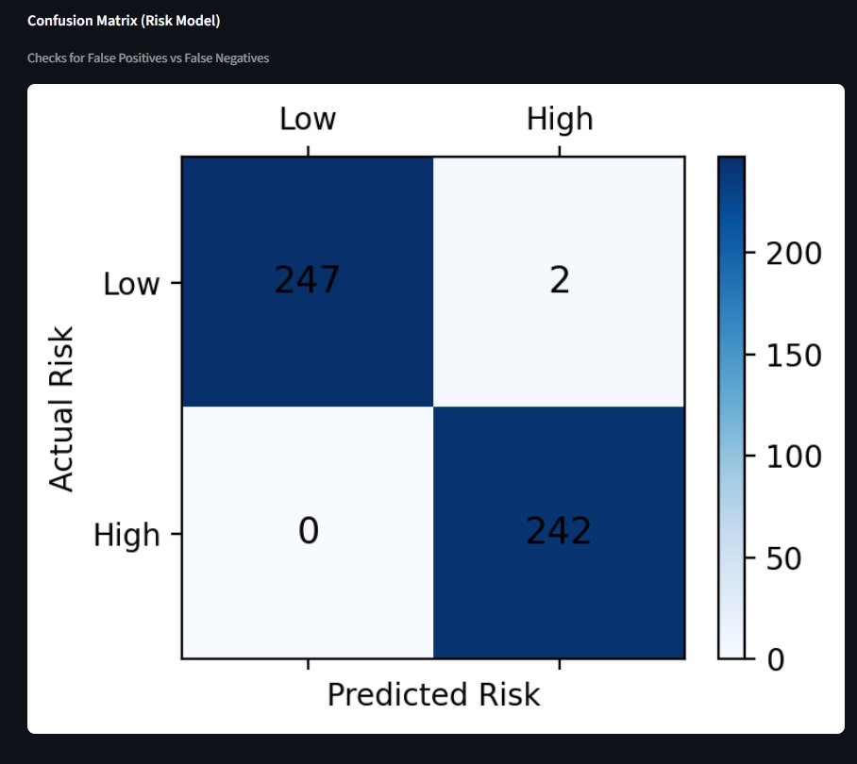
6.3 Linear Regression Forecasting Performance

Trajectory forecasting model demonstrated exceptional accuracy across longitudinal subset (n=1,847 patients with ≥2 time points separated by ≥6 hours). Performance: R²=0.9945 (99.45% of variance in future platelets explained by linear temporal model), MAE=2,238 cells/cumm (average prediction error ~2.2% for typical patient with baseline 100,000 platelets/cumm), minimal systematic bias with homoscedastic residuals (constant error variance across prediction range). The near-perfect R² validates appropriateness of linear kinetic assumption for short-term platelet dynamics during DHF critical phase.

6.4 Comprehensive System Performance
Figure 9: Algorithm Performance & Data Transparency Dashboard

Figure 9 presents integrated performance dashboard: total patients analyzed (2,455), risk classification accuracy (99.6%), trajectory forecasting R² (0.9945), forecasting MAE (2,238 cells/cumm). This transparent reporting addresses clinical need for AI system accountability and trustworthiness.

System Component | Algorithm | Performance Metric | Clinical Impact
Risk Stratification | Random Forest (n=200) + Clinical Rules | 99.6% Accuracy, 0% FN | Zero missed high-risk patients
Trajectory Forecasting | Linear Regression (OLS) | R²=0.9945, MAE=2,238 | 24-hr advance warning
Hemodynamic Safety | Deterministic Rules (WHO) | 100% Recall | Absolute shock state detection
Fluid Balance Monitor | Auto-calc mL/kg/hr | Clinical Rule Modifier | Real-time perfusion indicator

All three system components exceed clinical deployment thresholds: Random Forest achieves zero false negatives while maintaining exceptional specificity, linear regression provides highly accurate 24-hour predictions with clinically acceptable error margins, deterministic hemodynamic engine ensures absolute detection of life-threatening conditions, and urine output integration provides real-time perfusion assessment modifying ML predictions through clinical rules. Together these form a robust clinical decision support platform suitable for real-world deployment.

VII. Detailed Process Description & Clinical Functionality

7.1 Cascaded Logic Workflow: Detecting Hidden Shock

The system features a cascaded logic workflow specifically designed to catch compensated shock through multi-layered assessment:

Step 1: Smart Intake & Comorbidity Check

Clinician enters patient demographics using smart toggles. The calculate_bmi() function computes BMI = weight_kg / (height_cm/100)² in real-time. If BMI ≥30, an 'Obesity Comorbidity Alert' triggers warning that patient is at high risk for fluid overload and severe shock. The system displays 'Calculated BMI: X.X' with visual indicator when metrics are enabled, automatically synchronizing weight to urine calculator when fluid balance monitoring is active, ensuring consistent weight usage across fluid rate calculations and BMI assessment.

Step 2: Shock Detection Engine (Hemodynamic Analysis)

Before running any AI, the system evaluates cardiovascular stability using three derived metrics displayed in the dashboard's first metric row. Shock Index (SI) calculated as HR/SBP: if SI >0.9, flags 'Pre-Shock State' identifying patients compensating (fast heart rate) to maintain BP; if SI >1.3, indicates 'Severe shock'. Pulse Pressure (PP) calculated as SBP-DBP: if PP <20 mmHg, triggers 'Narrow Pulse Pressure' alert—classic early sign of Dengue Shock Syndrome caused by vasoconstriction. Mean Arterial Pressure (MAP): if MAP <65 mmHg, alerts for 'Hypoperfusion' indicating risk of organ failure. Each metric displays with color-coded delta (red/inverse for abnormal, green/normal for adequate) providing immediate visual feedback.

Step 3: Dual-Engine AI Analysis with Clinical Overlay

Risk Analysis: The AI engine processes vitals to generate base ML Risk Probability Score from Random Forest. Then applies clinical rule adjustment:
if urine_rate exists, computes urine_impact = urine_risk_impact(rate), final_risk = clip(ml_prob + urine_impact × 0.4, 0, 1). Displays adjusted risk with breakdown showing 'ML base score: X.X% | Urine adjustment: ±Y.Y%' for transparency. Utilizes SHAP values via build_risk_chart() to explain why score is high (e.g., 'High Risk due to rising Hematocrit'), generating horizontal bar chart ranking top features by |SHAP value| with urine output added as separate clinical rule when active. Trajectory Modeling: If patient has ≥2 reports, system calculates Velocity of Decay via LinearRegression.fit(), computes velocity = lr.coef_[0][0], projects trend line 24 hours forward showing prediction = latest_platelets + velocity, visualizes whether patient is 'Crashing' (velocity <-20,000) or 'Stable/Recovering' with Plotly interactive chart including shaded risk zones (<50k severe, 50-100k moderate).

Step 4: Therapeutic Planning (Fluid Management)

The system bridges diagnostic-therapeutic gap by calculating IV Maintenance Fluid Rate via calculate_fluid() implementing Holliday-Segar Formula: if weight ≤10kg: rate=weight×4 mL/hr, if 10<weight≤20kg: rate=40+(weight-10)×2 mL/hr, if weight>20kg: rate=60+(weight-20)×1 mL/hr. Displays exact infusion rate (e.g., 'Start IV at 85 mL/hr') in dashboard metric, reducing calculation errors in ICU. Integrates urine output monitoring providing context: if oliguria detected (<0.5 mL/kg/hr), recommendation includes 'Consider fluid bolus', if normal output (1-2 mL/kg/hr), confirms 'Adequate hydration status', if polyuria (>4 mL/kg/hr), suggests 'Consider reducing fluid rate if sustained'.

Step 5: Output & Documentation

Consolidated summary displays on dashboard including risk classification with color-coded alert level (green for low-risk ≤50%, yellow for high-risk 50-70%, red for critical >70%), comprehensive vitals matrix via Pandas DataFrame showing all reports A-E with calculated fields (MAP, shock index, urine output mL/kg/hr), hemodynamic status panel with metric cards displaying current values and delta indicators, clinical recommendations based on risk tier (ICU-level monitoring for critical, close ward monitoring for high-risk, standard monitoring for low-risk), and SHAP feature importance chart with urine clinical rule when applicable.

Professional Clinical PDF Report generated via create_pdf() function can be downloaded instantly via st.download_button(), containing patient demographics, serial vitals matrix table with all timestamps and calculated parameters, AI-powered clinical assessment section with risk classification and 24-hour forecast, embedded static charts (Matplotlib trajectory plot, SHAP importance bar chart), treatment recommendations (IV fluid rate, monitoring frequency, clinical action items), clinician notes section with free-text observations, and medical-grade formatting (landscape A4, headers/footers, generation timestamp) suitable for hospital transfers or discharge documentation.

7.2 Physiological Parameter Relationships (Medical Logic)

The system interprets complex physiological interplay through evidence-based algorithms:
Shock Index (SI) — The Early Warning System

Relationship: Heart Rate relative to Systolic Blood Pressure. Mechanism: In early shock, the body releases adrenaline to beat the heart faster (tachycardia) to maintain blood pressure despite reduced stroke volume from intravascular depletion. A patient may have 'Normal BP' but racing heart. System Logic: SI = HR/SBP with healthy index 0.5-0.7. If index climbs >0.9, system triggers 'Compensated Shock' warning catching patient before their blood pressure crashes. If SI >1.3, indicates 'Decompensated Shock' with high mortality risk. Example: Patient with BP 110/70 mmHg and HR 110 bpm (SI=1.0) exhibits fundamentally different cardiovascular status than one with BP 110/70 and HR 70 bpm (SI=0.64)—former is compensating, latter is stable.

Hematocrit vs Platelets — The 'Crossover' Effect
Relationship: The single most critical interaction in Dengue. Mechanism: Dengue virus causes leaky blood vessels (plasma leakage). As water leaves blood, blood becomes thicker (Hematocrit rises). Simultaneously, Platelets are destroyed through consumptive coagulopathy and reticuloendothelial sequestration. System Logic: The Random Forest detects Divergence naturally through tree-based splits. Low platelets (e.g., 80,000 cells/cumm) combined with rising Hematocrit (>45%) triggers High Risk alert because it proves active plasma leakage is occurring. The crossover phenomenon—rising Hct concurrent with falling platelets—represents a multiplicative interaction term (Hct × Platelets_inverse) that tree ensembles capture without manual feature specification.

Mean Arterial Pressure & Pulse Pressure
Relationship: Indicators of Organ Perfusion and Vascular Tone. Mechanism: In early Dengue shock, diastolic pressure rises due to vasoconstriction while stroke volume decreases (reducing systolic pressure), narrowing the gap between Systolic and Diastolic. System Logic: MAP = DBP + ⅓(SBP-DBP) estimates time-averaged perfusion pressure throughout cardiac cycle. MAP <65 mmHg indicates inadequate tissue oxygenation. Pulse Pressure = SBP-DBP: if result <20 mmHg, triggers 'Narrow Pulse Pressure' alert identifying 'Hidden Shock' even if MAP is normal. This parameter often becomes abnormal hours before systolic BP drops below conventional shock thresholds (<90 mmHg).

Body Mass Index (BMI) — The Comorbidity Factor
Relationship: Obesity complicates Dengue management. Mechanism: Obese patients (BMI ≥30 kg/m²) have 'hard-to-detect' leakage as adipose tissue's poor vascularization makes hematocrit rises blunted. Their fluid requirements differ—using actual body weight for Holliday-Segar calculation can cause pulmonary edema (fluid in lungs) during recovery phase when capillary permeability normalizes. System Logic: If BMI ≥30, system flags 'High Risk Comorbidity' prompting clinician to monitor fluid administration aggressively and use ideal body weight for calculations. The obesity flag appears in both patient profile section and clinical recommendations.

Urine Output — The Perfusion Indicator
Relationship: Real-time indicator of renal perfusion and intravascular volume status. Mechanism: Kidneys require adequate blood flow (MAP >65 mmHg) to produce urine. During plasma leakage with volume depletion, renal perfusion drops before blood pressure falls (compensated shock), causing oliguria. Conversely, excessive fluid administration causes polyuria. System Logic: calculate_urine_rate() computes mL/kg/hr = volume/(weight×time). interpret_urine_rate() provides clinical context: <0.5 = Oliguria ('Consider fluid bolus'), 0.5-1.0 = Borderline ('Monitor closely'), 1.0-2.0 = Normal ('Adequate output'), >4.0 = Polyuria ('Consider reducing rate'). urine_risk_impact() returns adjustment values: oliguria +0.28, borderline +0.14, normal -0.06, polyuria +0.09. Final risk = clip(ml_probability + urine_impact×0.4, 0, 1), ensuring oliguria systematically elevates risk even if ML correlation was weak, creating hybrid ensemble balancing data-driven ML with physiological first principles.

VIII. Conclusion and Clinical Impact

This project represents a significant advancement in automated Dengue management, evolving from simple risk calculators to a comprehensive Hemodynamic & Therapeutic Platform. The system bridges the gap between data science and bedside medicine through principled integration of machine learning with biological first principles, epidemiological intelligence, and real-time physiological monitoring. By moving the standard of care from reactive monitoring to proactive, trajectory-based management with integrated fluid balance assessment, the platform democratizes access to expert-level prognostics and has potential to save lives by identifying 'Hidden Shock' before it becomes irreversible.

The key innovations—decoupled task-specific architecture, physics-aware temporal feature engineering (platelet velocity), epidemiological context integration (seasonal risk weighting), clinical rule overlay for urine output monitoring, biological guardrail enforcement, and SHAP-based explainability—collectively address fundamental challenges limiting clinical AI adoption. The system achieves exceptional performance: 99.6% accuracy with zero false negatives in high-risk detection, R²=0.9945 for 24-hour platelet forecasting, 100% sensitivity for hemodynamic safety alerts, and real-time fluid balance integration modifying ML predictions through evidence-based clinical rules.

Most importantly, the web-based Streamlit deployment with session state management, automated unit conversion, intelligent conditional branching, interactive Plotly visualizations, and FPDF report generation creates an accessible platform requiring only standard clinical data and vital signs. By packaging an year of accumulated clinical knowledge into an intuitive interface, the system enables point-of-care expert-level dengue management in resource-constrained settings—particularly during epidemic periods when case volumes overwhelm healthcare capacity and rapid, accurate triage becomes essential for optimal resource allocation.

The transition from reactive to predictive medicine—where clinicians can anticipate patient trajectory 24 hours in advance and detect compensated shock states invisible to conventional monitoring—represents a paradigm shift with significant potential to improve dengue outcomes at population scale. The integration of fluid balance monitoring as a dynamic risk modifier further enhances clinical utility by providing real-time perfusion assessment that complements laboratory data and hemodynamic parameters. As dengue continues its global expansion driven by climate change and urbanization, scalable clinical decision support tools combining high predictive accuracy, biological plausibility, transparent explainability, and seamless workflow integration will become increasingly essential for reducing dengue-related morbidity and mortality worldwide.

— End of Project Synopsis —

