Previous Next
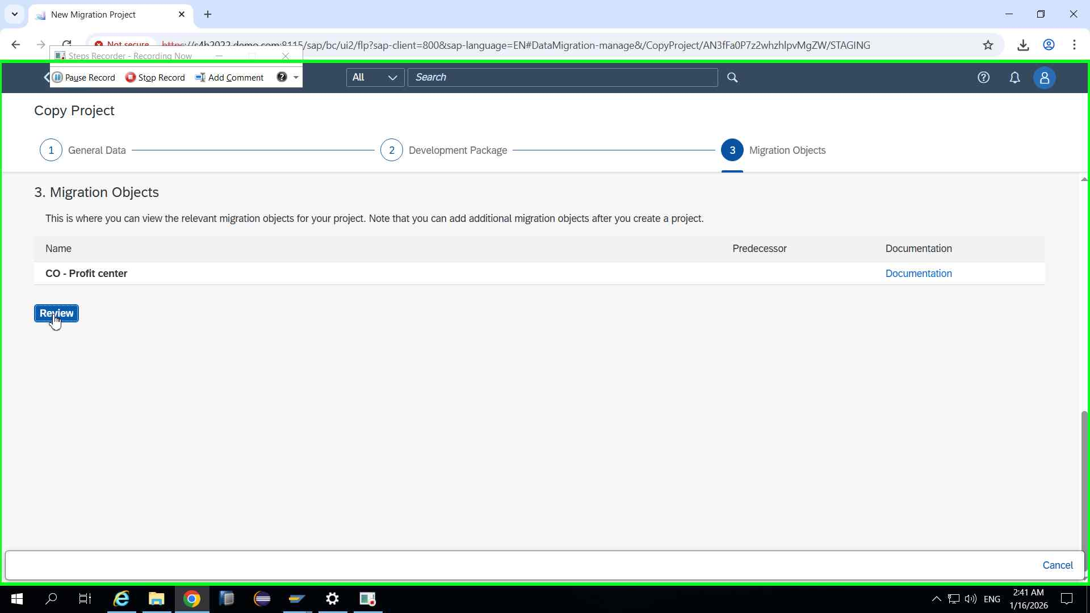Step 11 screenshot.

Previous Next
Step 12: (‎1/‎16/‎2026 2:41:41 AM) User left click in "New"
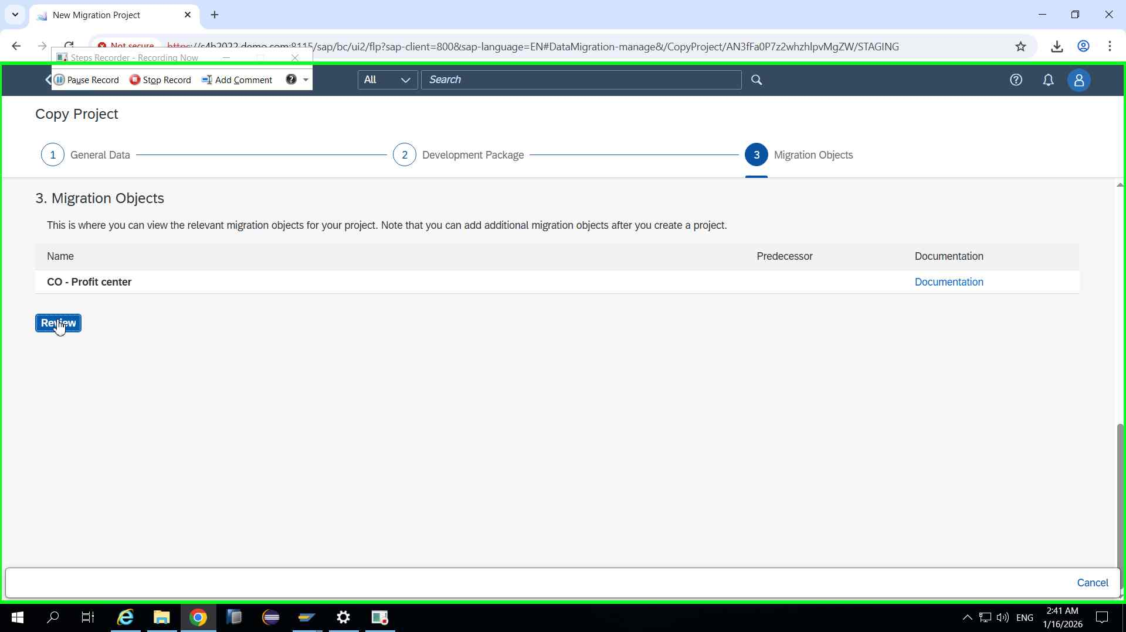Step 12 screenshot.

Previous Next
Step 13: (‎1/‎16/‎2026 2:42:21 AM) User left click in "New"
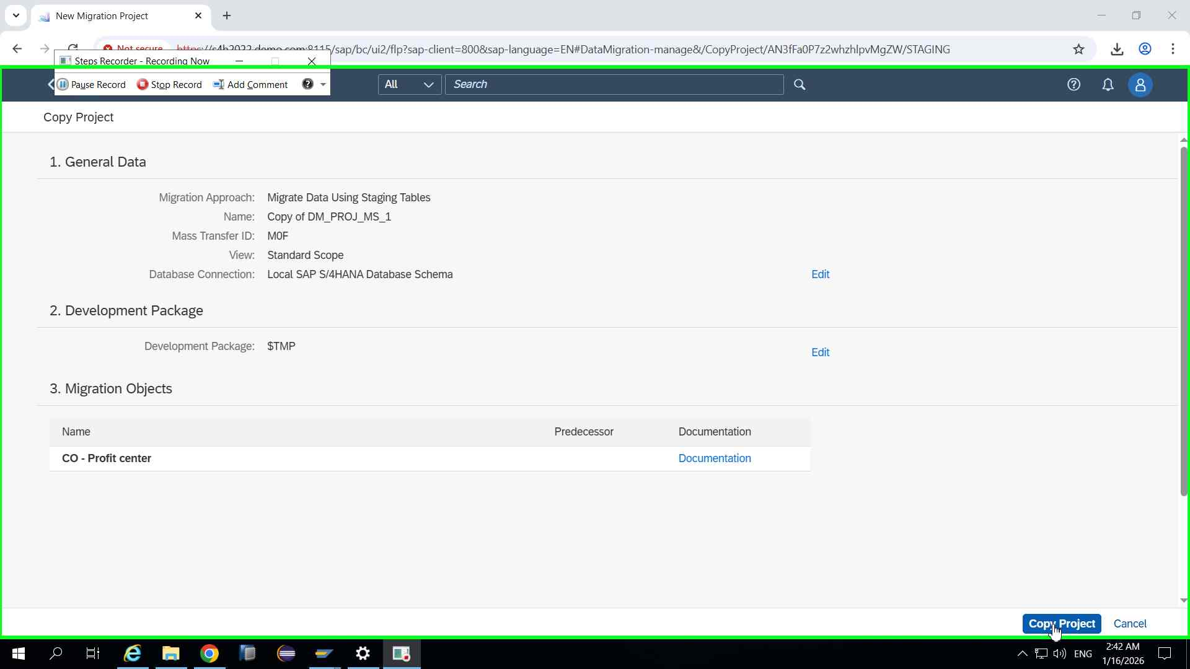Step 13 screenshot.

Previous Next
Step 14: (‎1/‎16/‎2026 2:42:31 AM) User left click in "New"
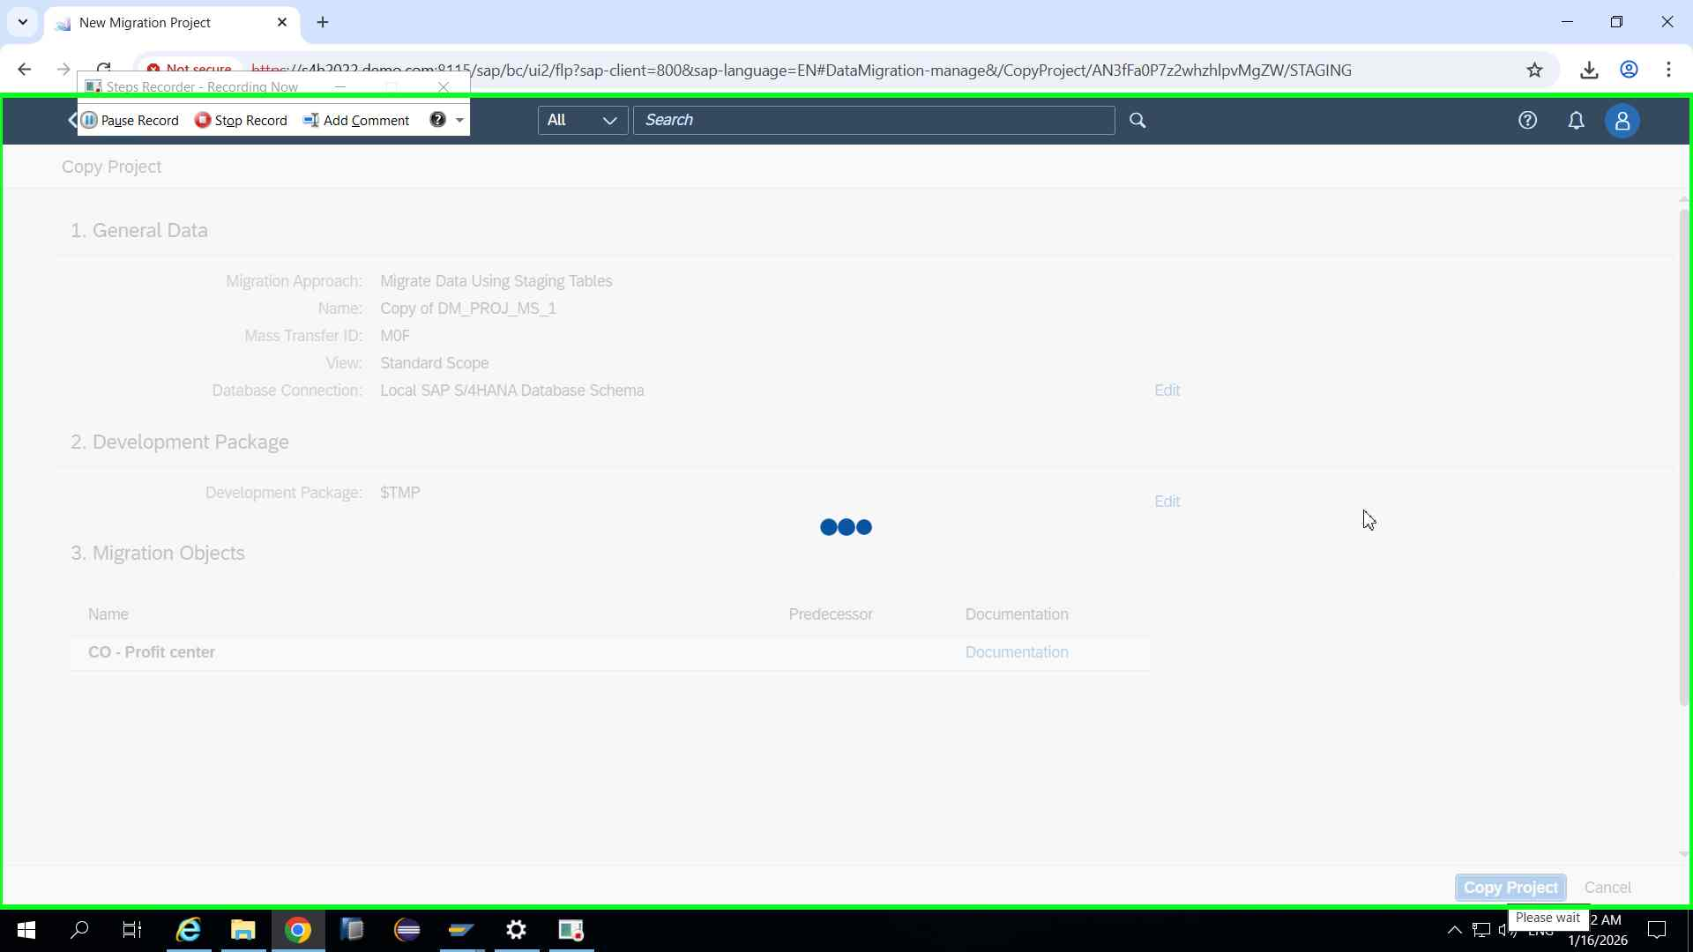Step 14 screenshot.

Previous Next
Step 15: (‎1/‎16/‎2026 2:42:41 AM) User left click in "Mig"
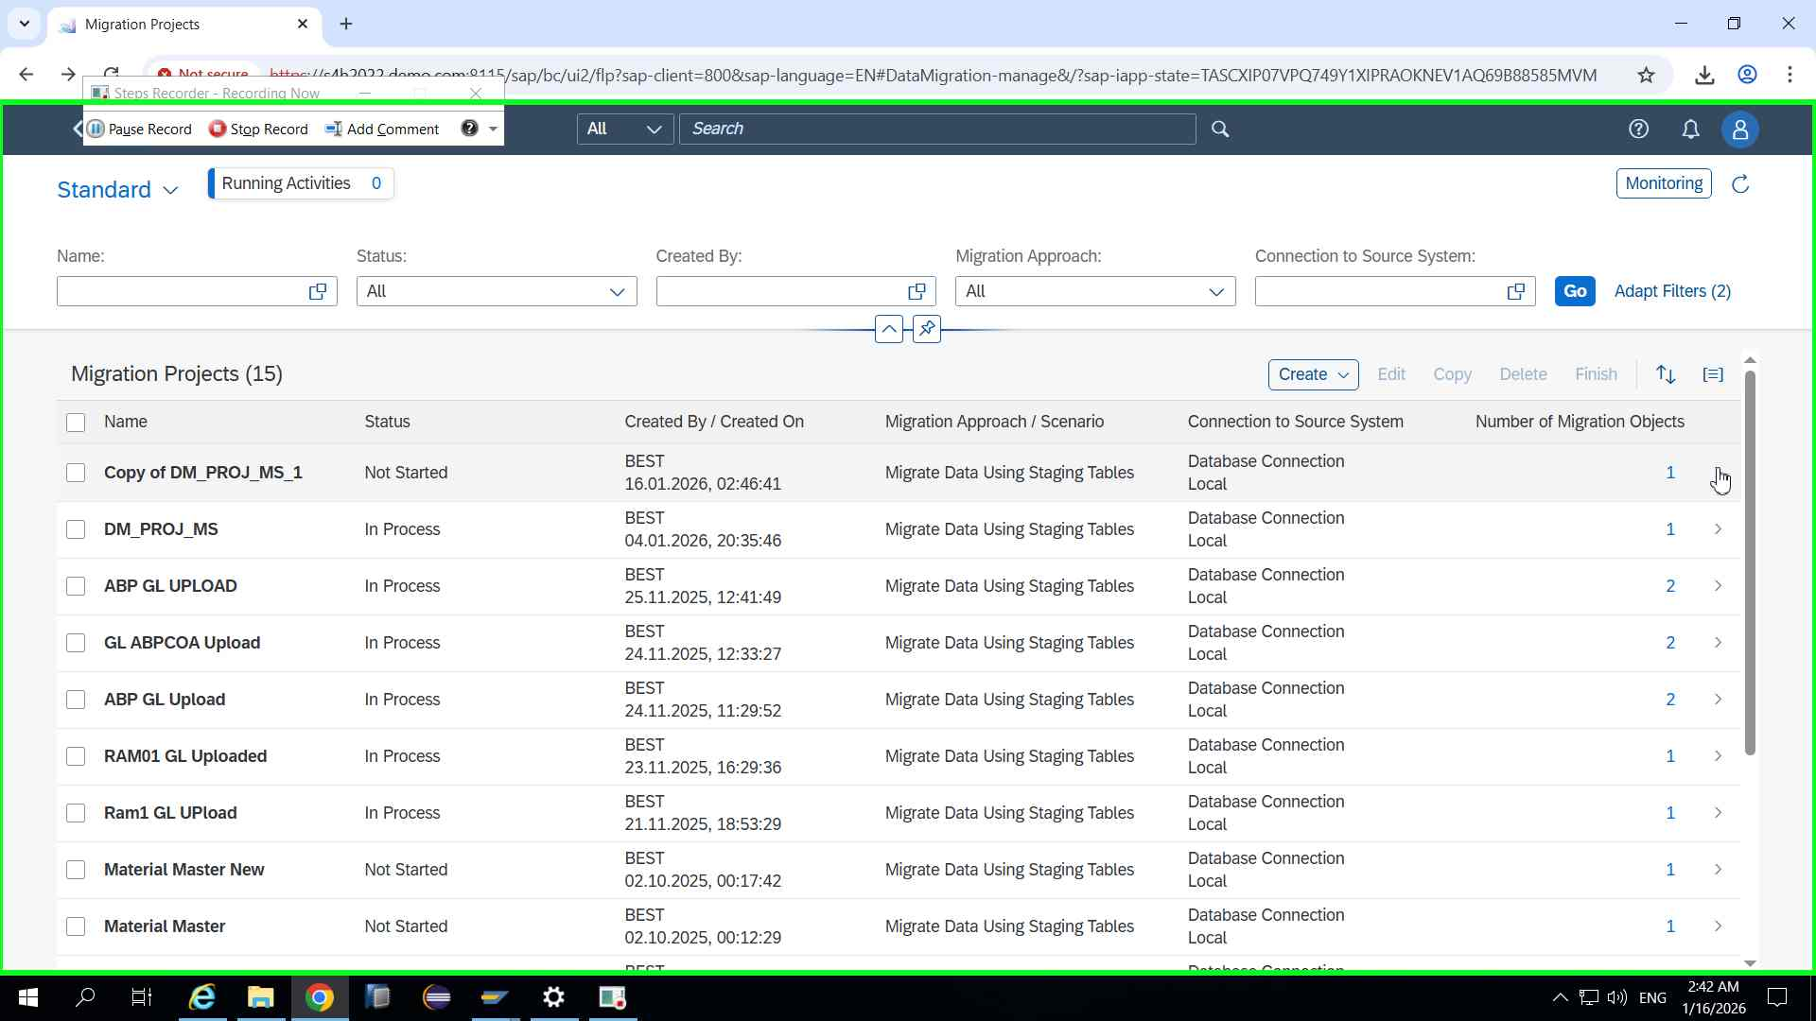Step 15 screenshot.

Previous Next
Step 16: (‎1/‎16/‎2026 2:42:46 AM) User left click in "Mig"
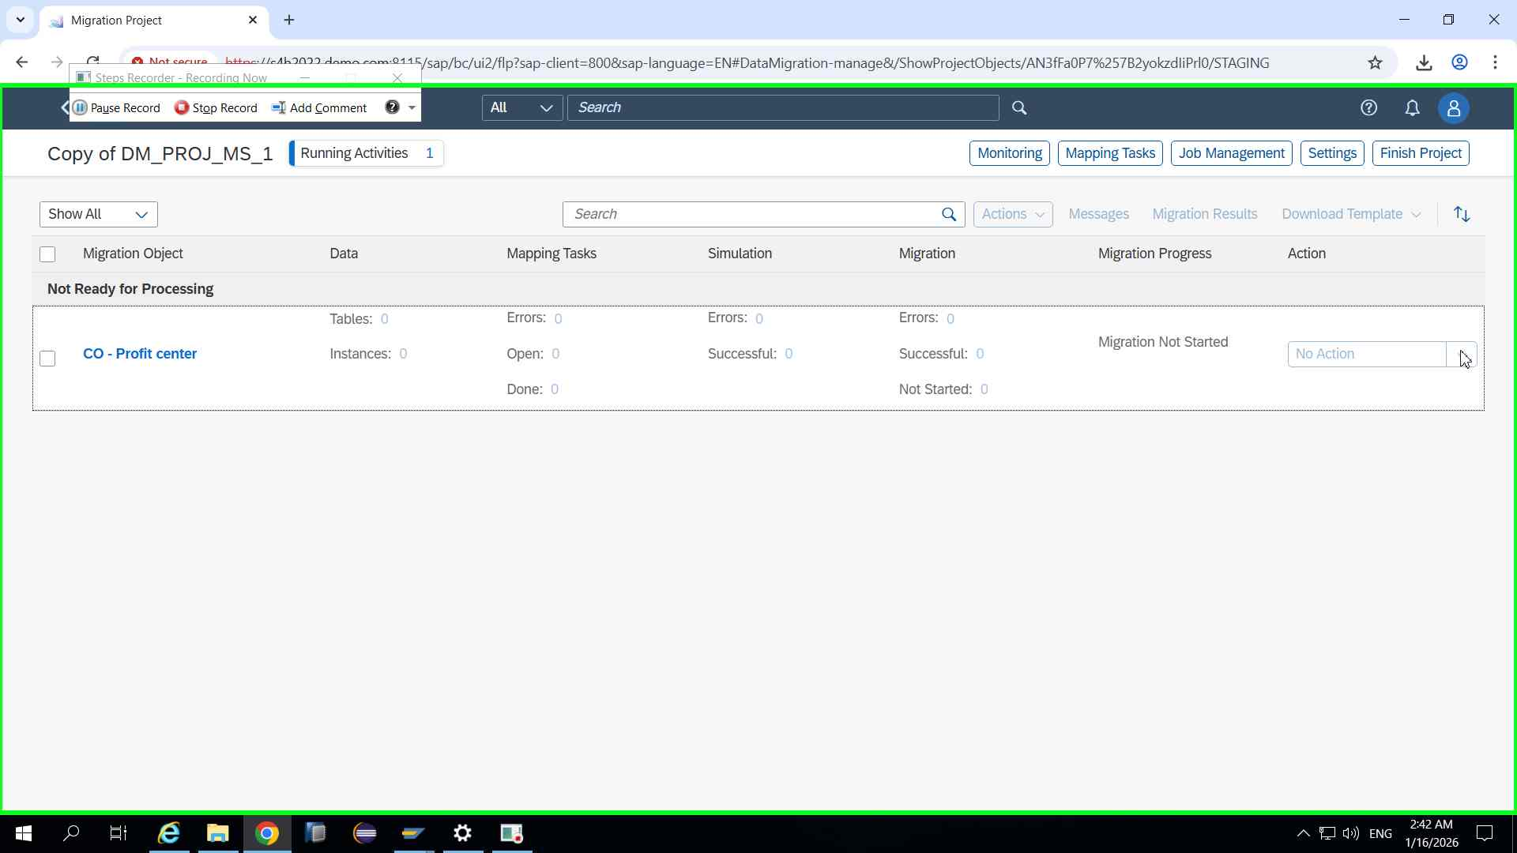Step 16 screenshot.

Previous Next
Step 17: (‎1/‎16/‎2026 2:42:52 AM) User left click in "Mig"
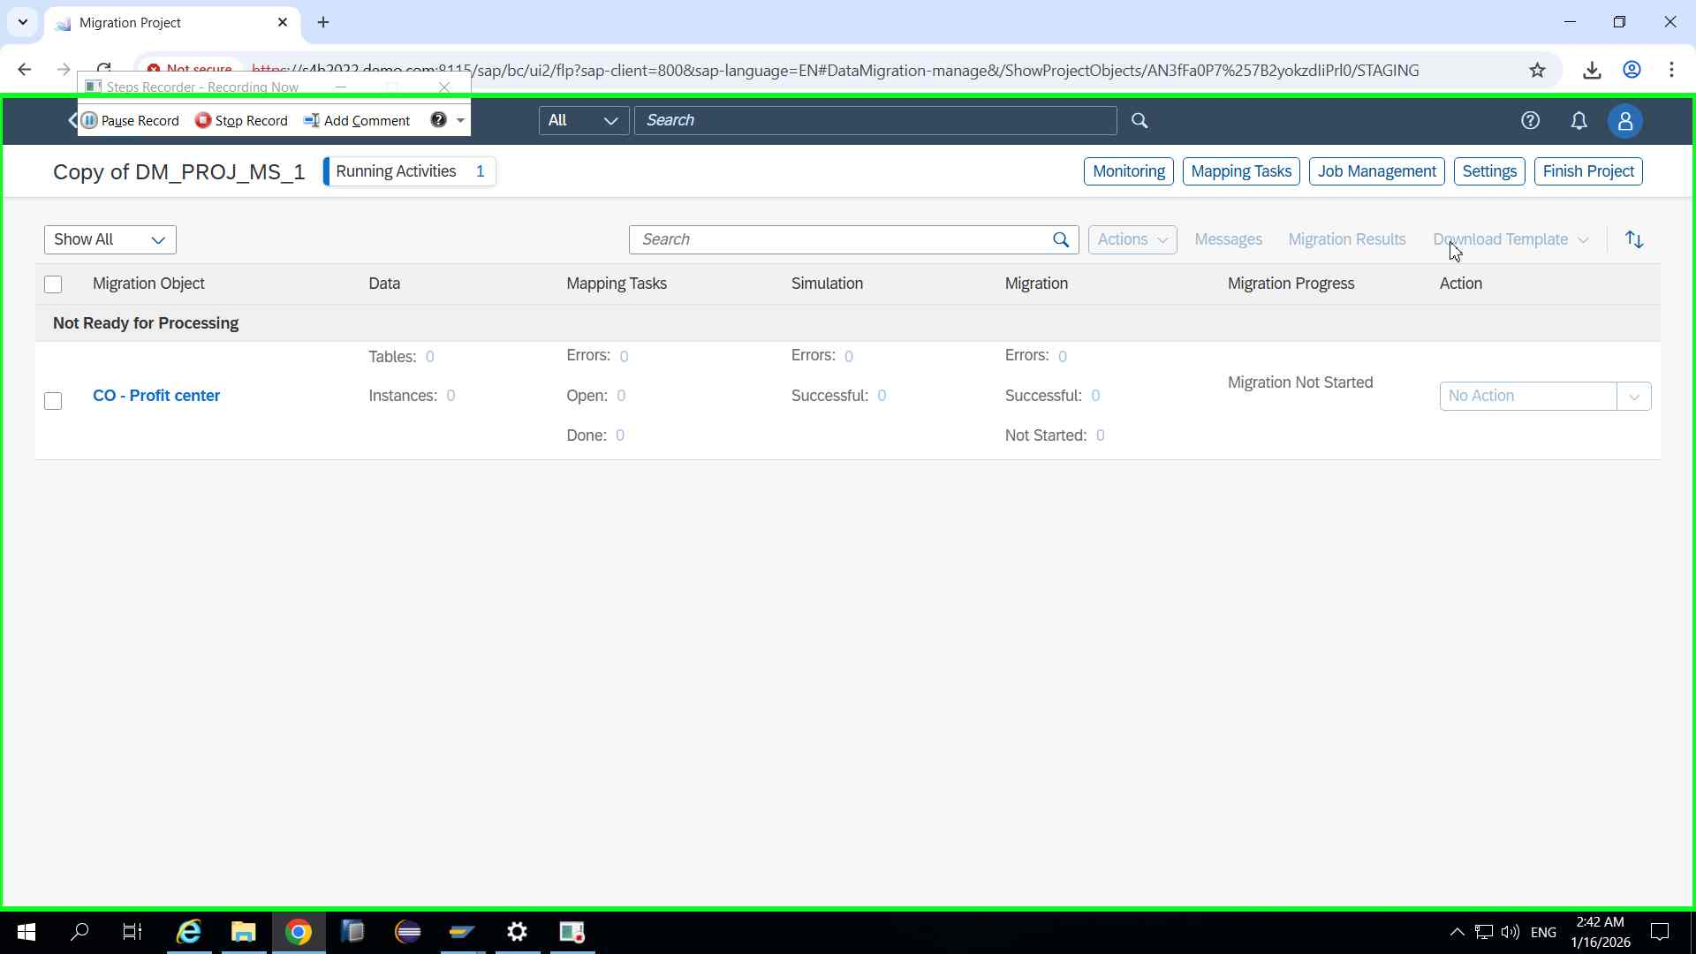Step 17 screenshot.

Previous Next
Step 18: (‎1/‎16/‎2026 2:42:56 AM) User left click in "Mig"
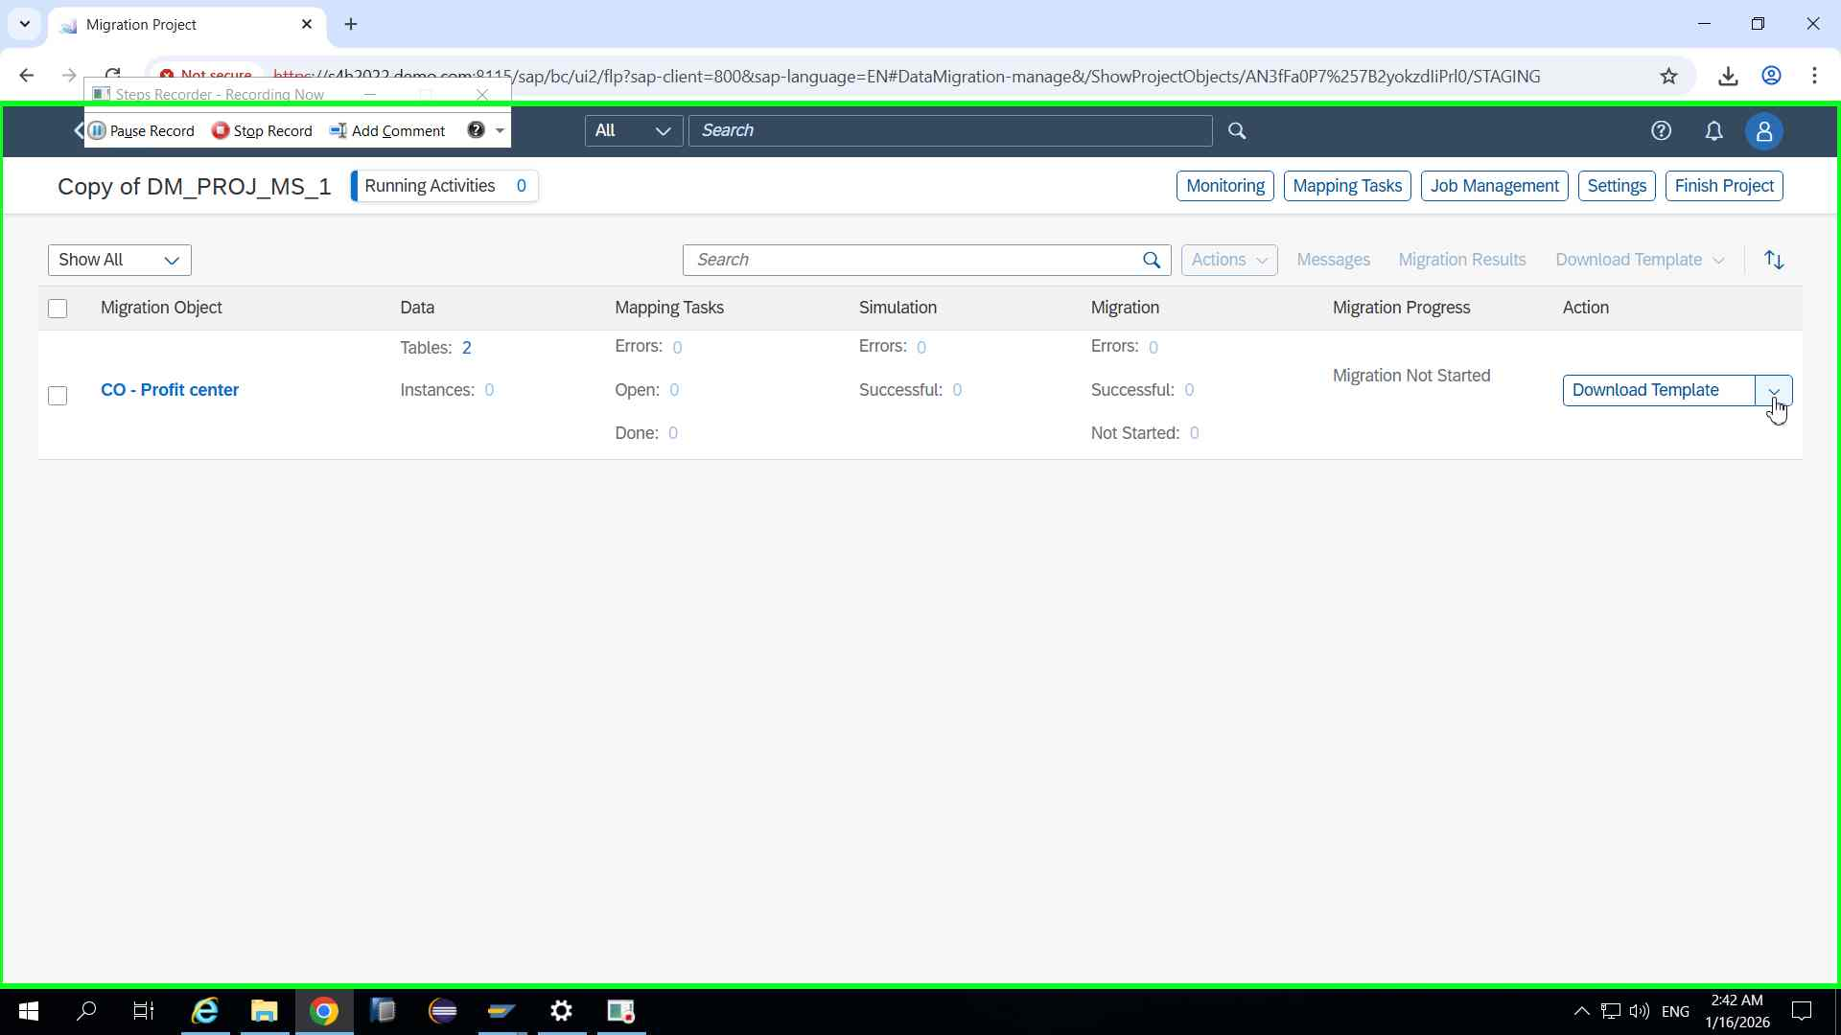Step 18 screenshot.

Previous Next
Step 19: (‎1/‎16/‎2026 2:43:02 AM) User left click in "Mig"
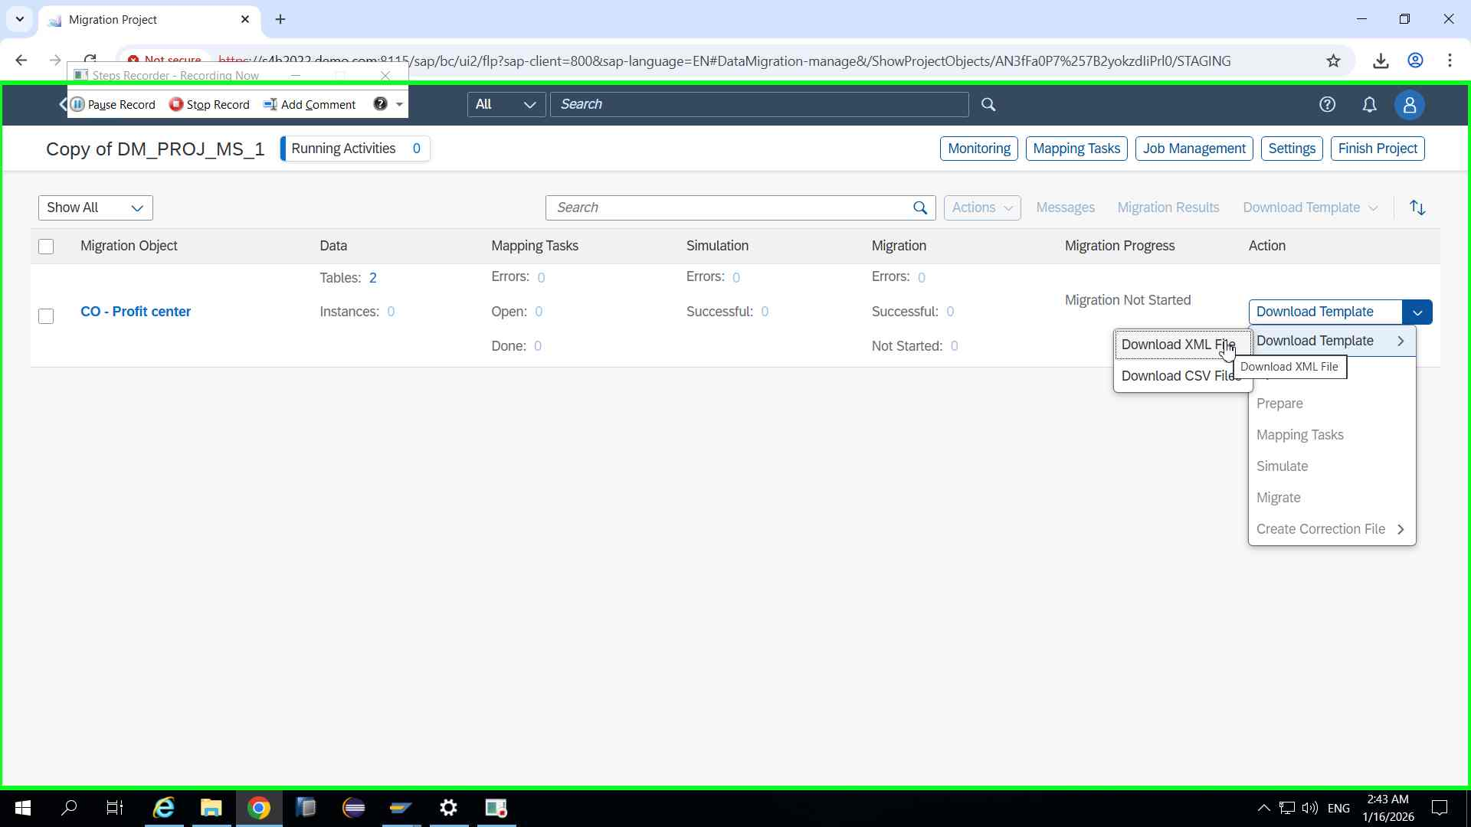Step 19 screenshot.

Previous Next
Step 20: (‎1/‎16/‎2026 2:43:06 AM) User left click on "Migration Project (document)" in "Mig"
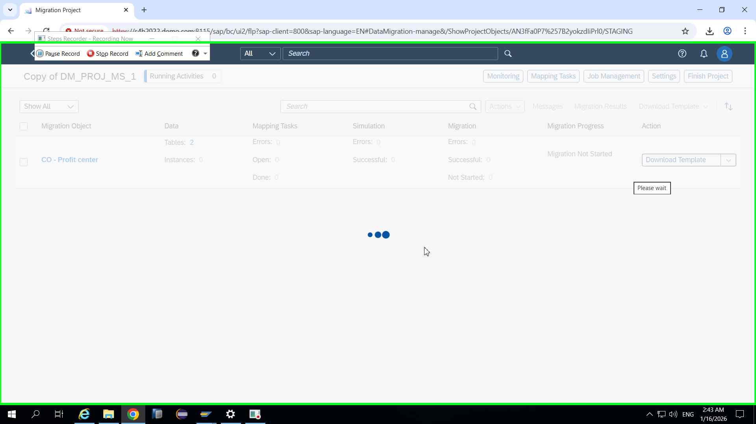Step 20 screenshot.

Previous Next
Step 21: (‎1/‎16/‎2026 2:43:14 AM) User left click in "Mig"
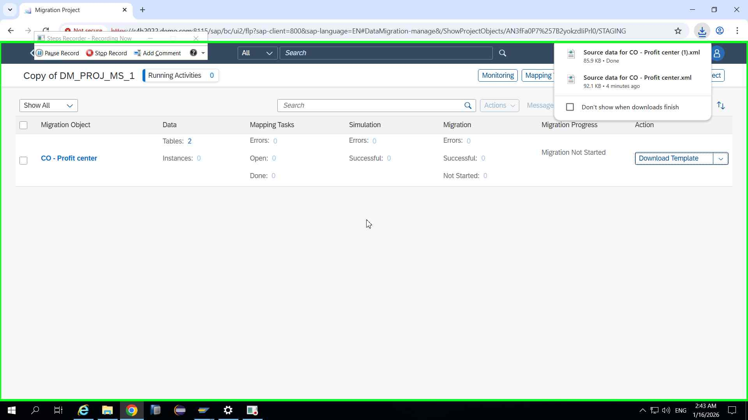Step 21 screenshot.

Previous Next
Step 22: (‎1/‎16/‎2026 2:43:17 AM) User left click on "File Explorer - 1 running window (button)"
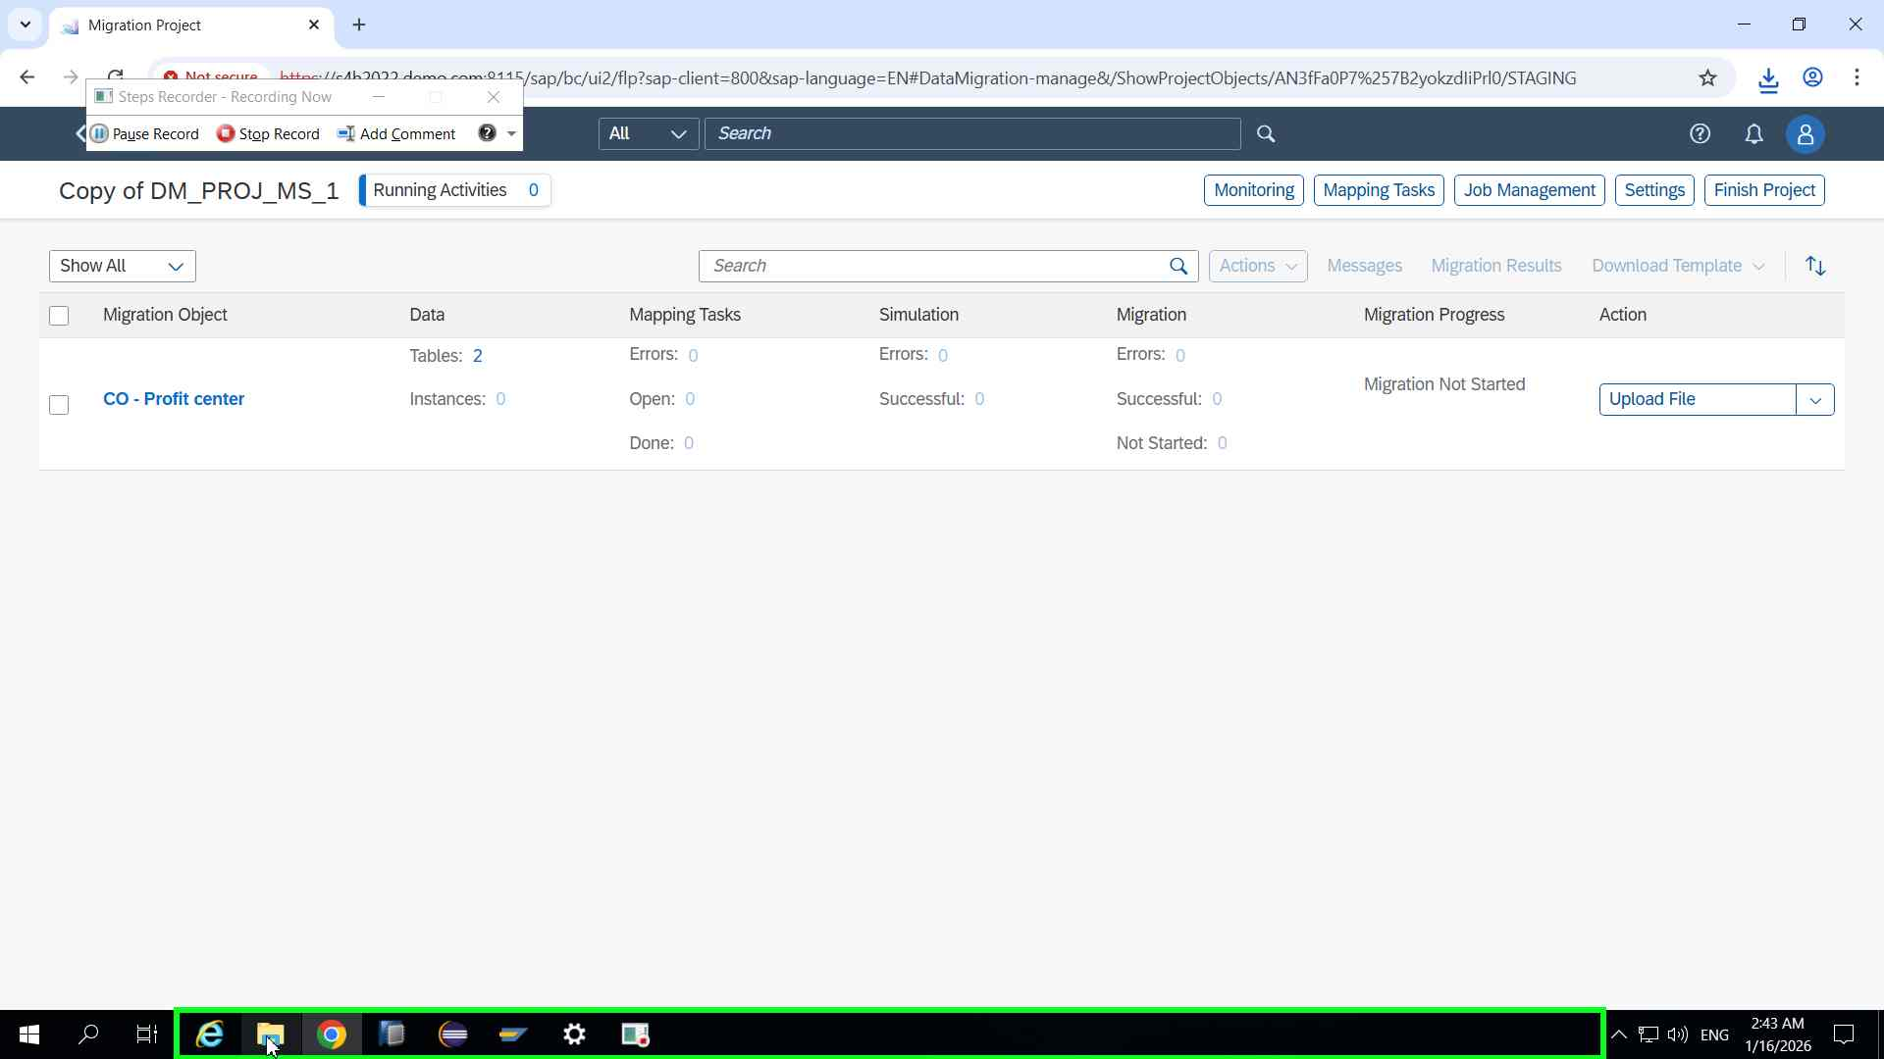Step 22 screenshot.

Previous Next
Step 23: (‎1/‎16/‎2026 2:43:20 AM) User left click on "Downloads (pinned) (tree item)" in "rcp"
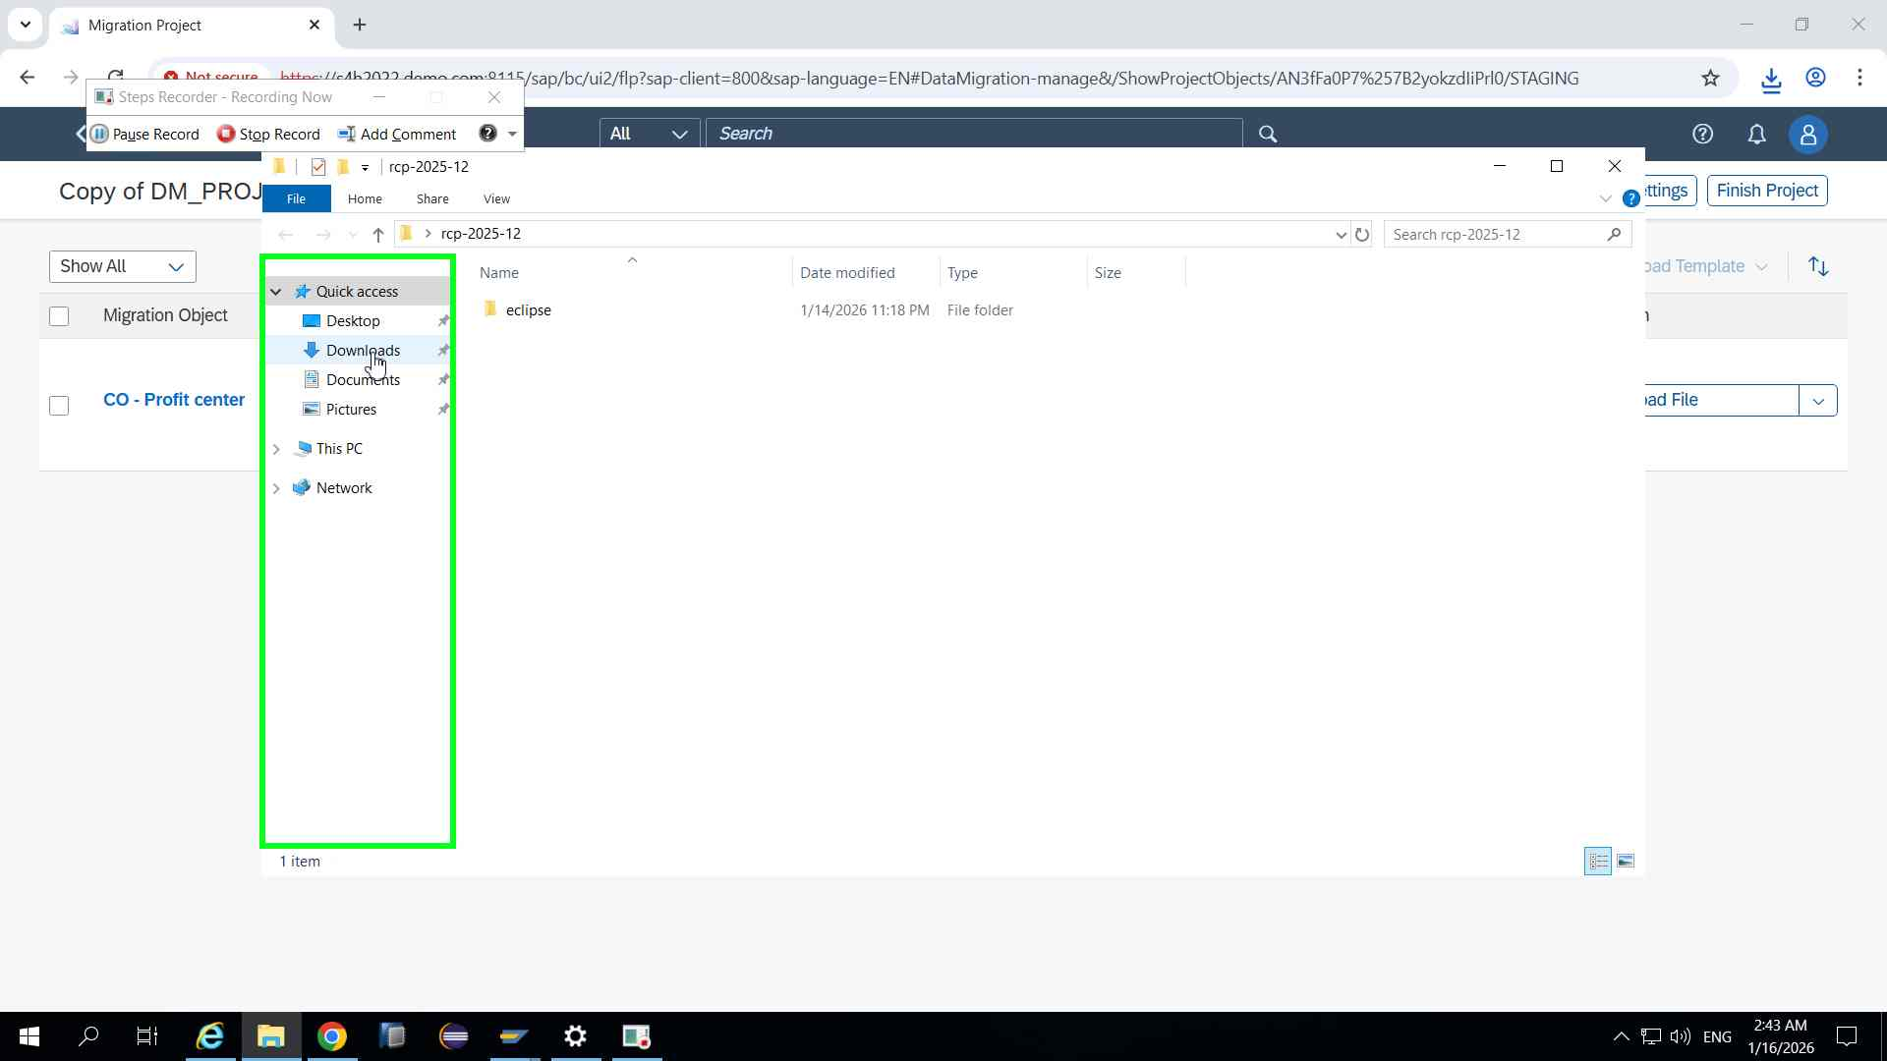Step 23 screenshot.

Previous Next
Step 24: (‎1/‎16/‎2026 2:43:24 AM) User left click on "Name (edit)" in "Dow"
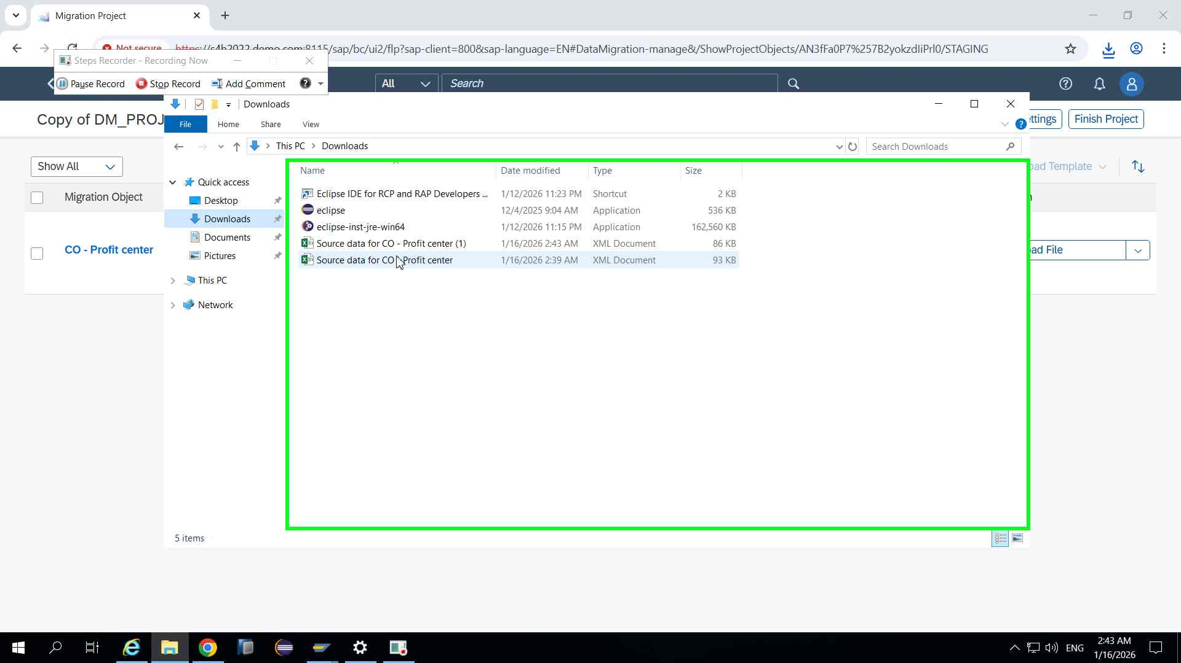Step 24 screenshot.

Previous Next
Step 25: (‎1/‎16/‎2026 2:43:26 AM) User left double click on "Name (edit)" in "Dow"
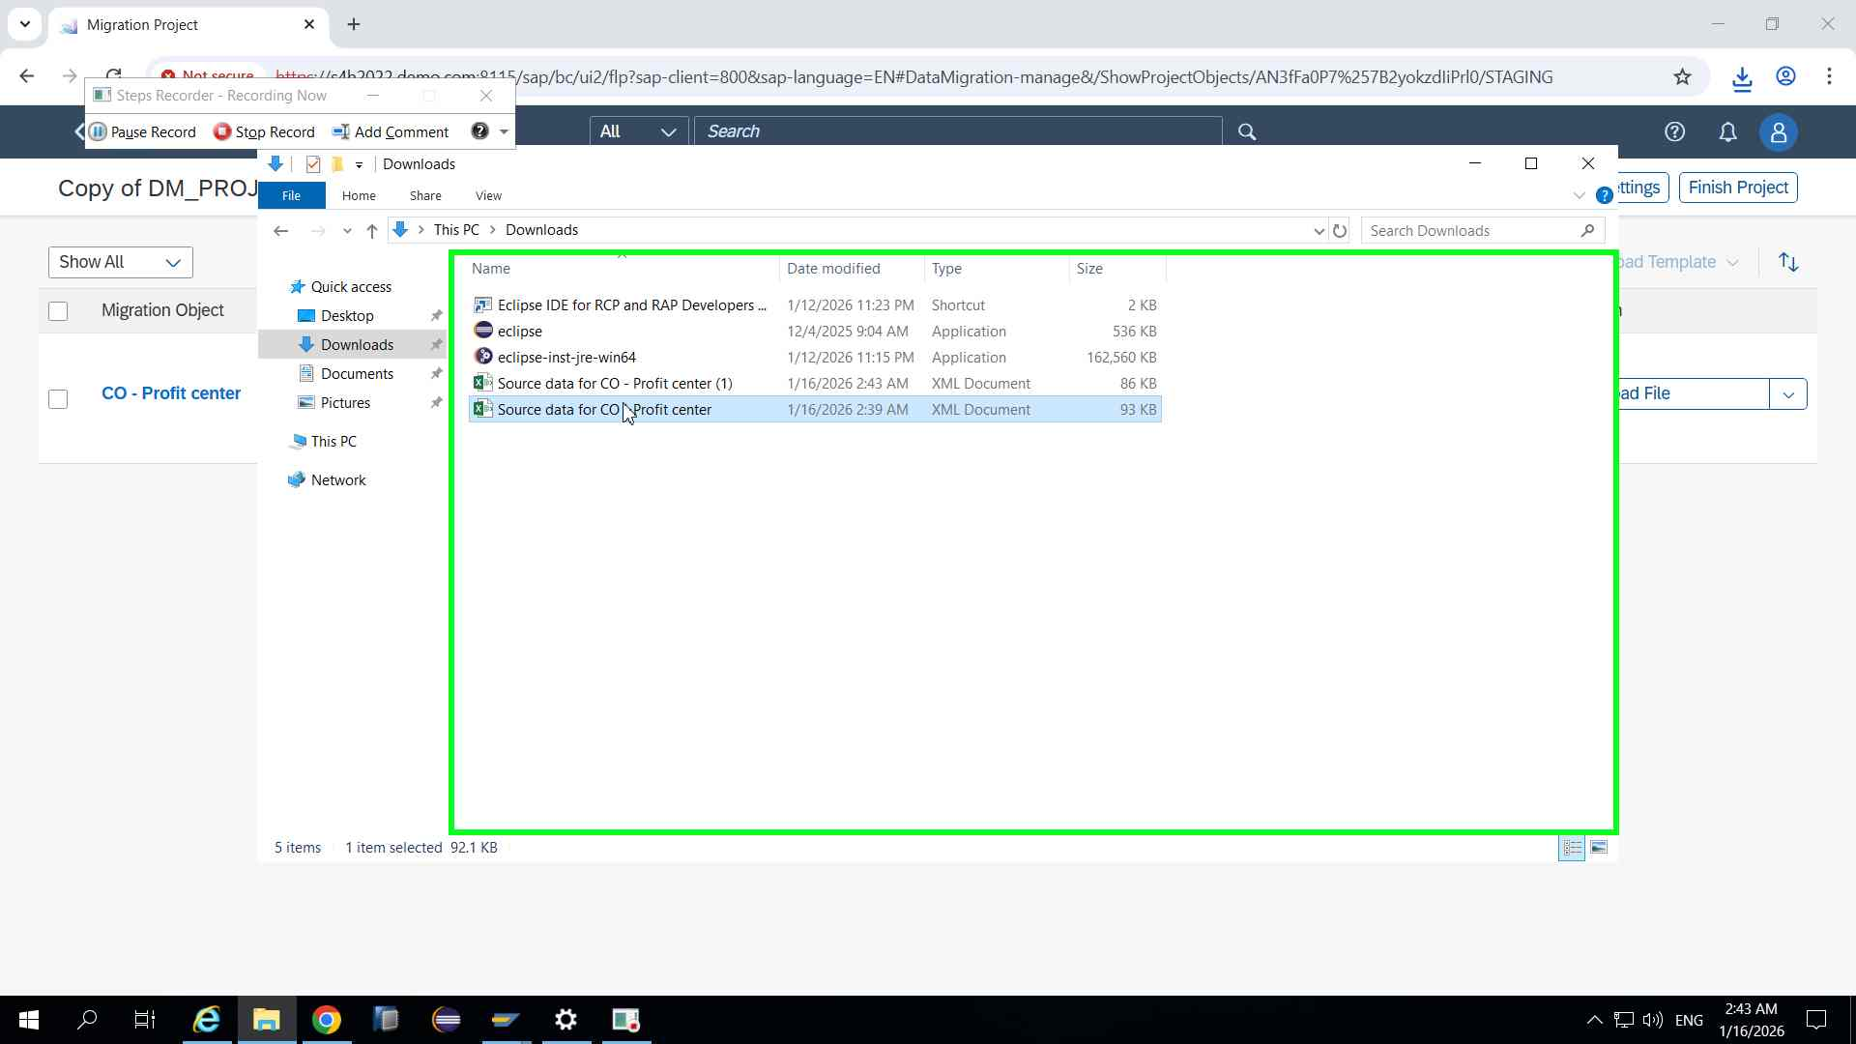Step 25 screenshot.

Previous Next
Step 26: (‎1/‎16/‎2026 2:43:33 AM) User left click on "OK (button)" in "Mic"
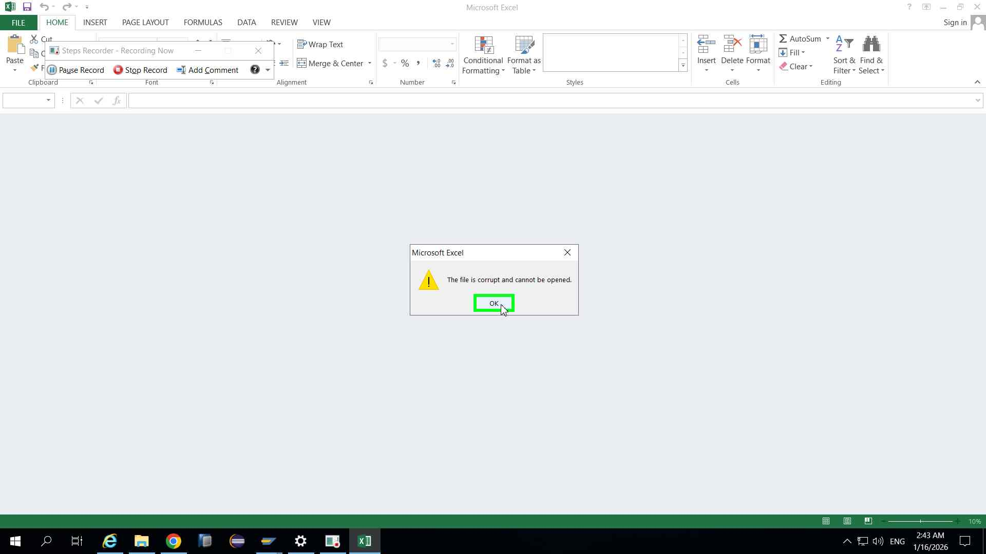Step 26 screenshot.

Previous Next
Step 27: (‎1/‎16/‎2026 2:43:43 AM) User left click on "Close (Button)" in "Mic"
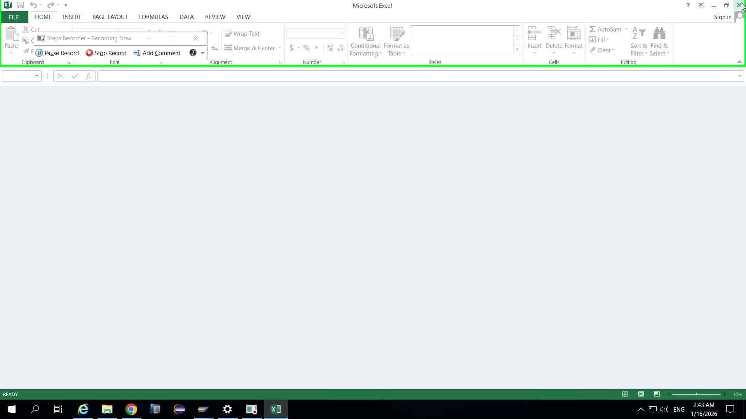Step 27 screenshot.

Previous Next
Step 28: (‎1/‎16/‎2026 2:43:45 AM) User left double click on "Name (edit)" in "Dow"
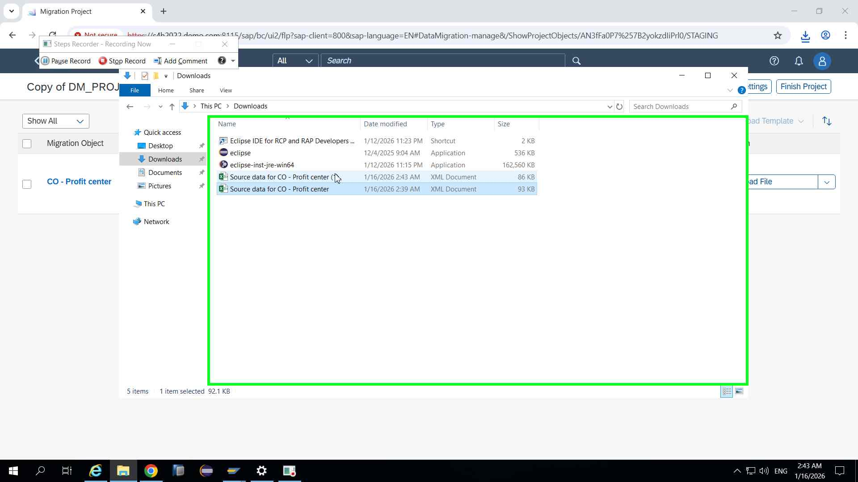Step 28 screenshot.

Previous Next
Step 29: (‎1/‎16/‎2026 2:43:54 AM) User left double click on "Name (edit)" in "Dow"
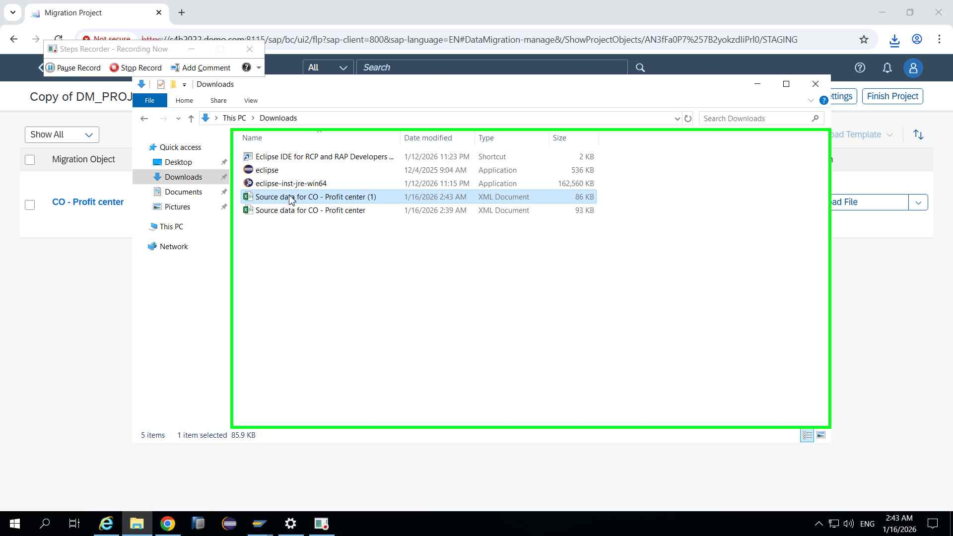Step 29 screenshot.

Previous Next
Step 30: (‎1/‎16/‎2026 2:44:03 AM) User left click on "Grid ()" in "Sou"
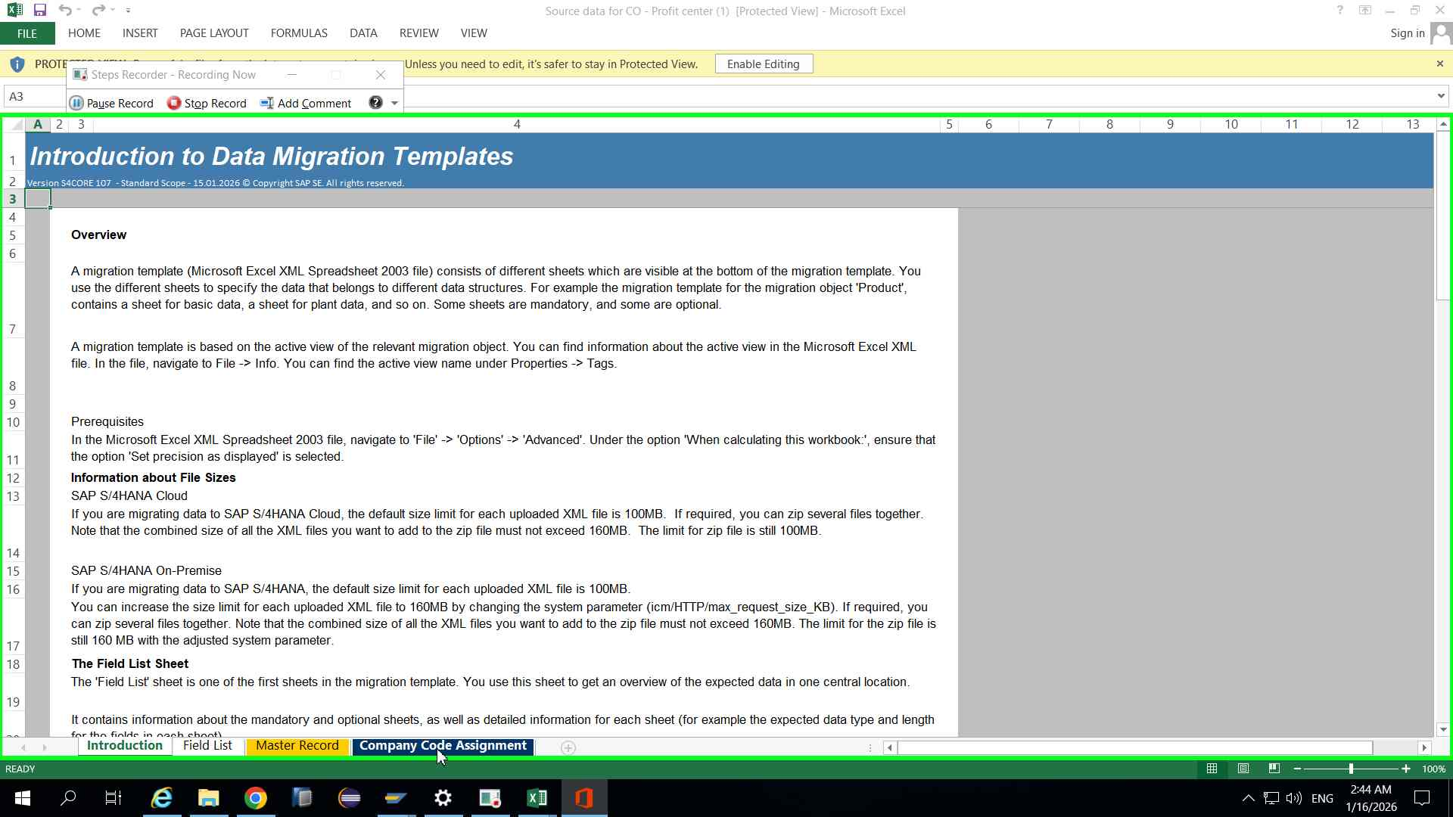Step 30 screenshot.

Previous Next
Step 31: (‎1/‎16/‎2026 2:44:05 AM) User left click on "Grid ()" in "Sou"
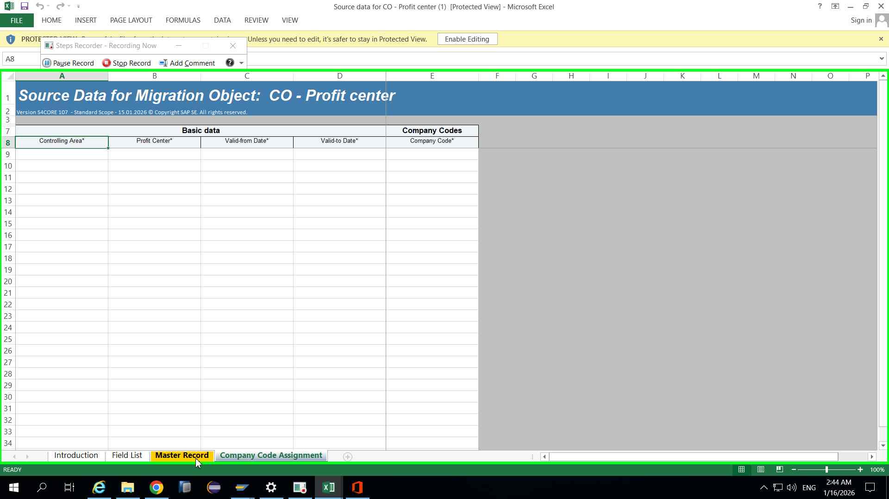Step 31 screenshot.

Previous Next
Step 32: (‎1/‎16/‎2026 2:44:07 AM) User left click on "Source data for CO - Profit center (1).xml[Protected View] ()" in "Sou"
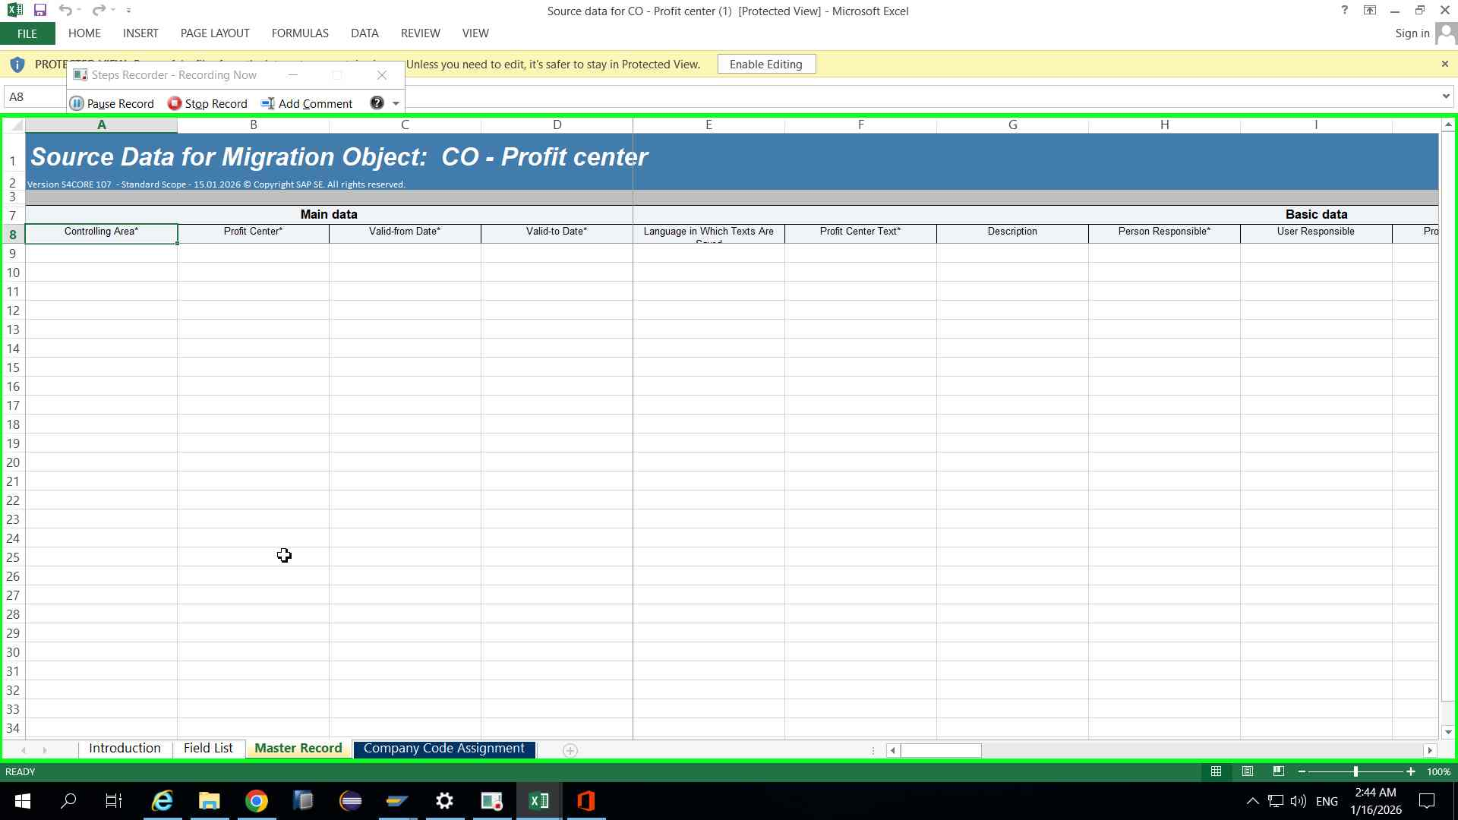Step 32 screenshot.

Previous Next
Step 33: (‎1/‎16/‎2026 2:44:10 AM) User left click on "Grid ()" in "Sou"
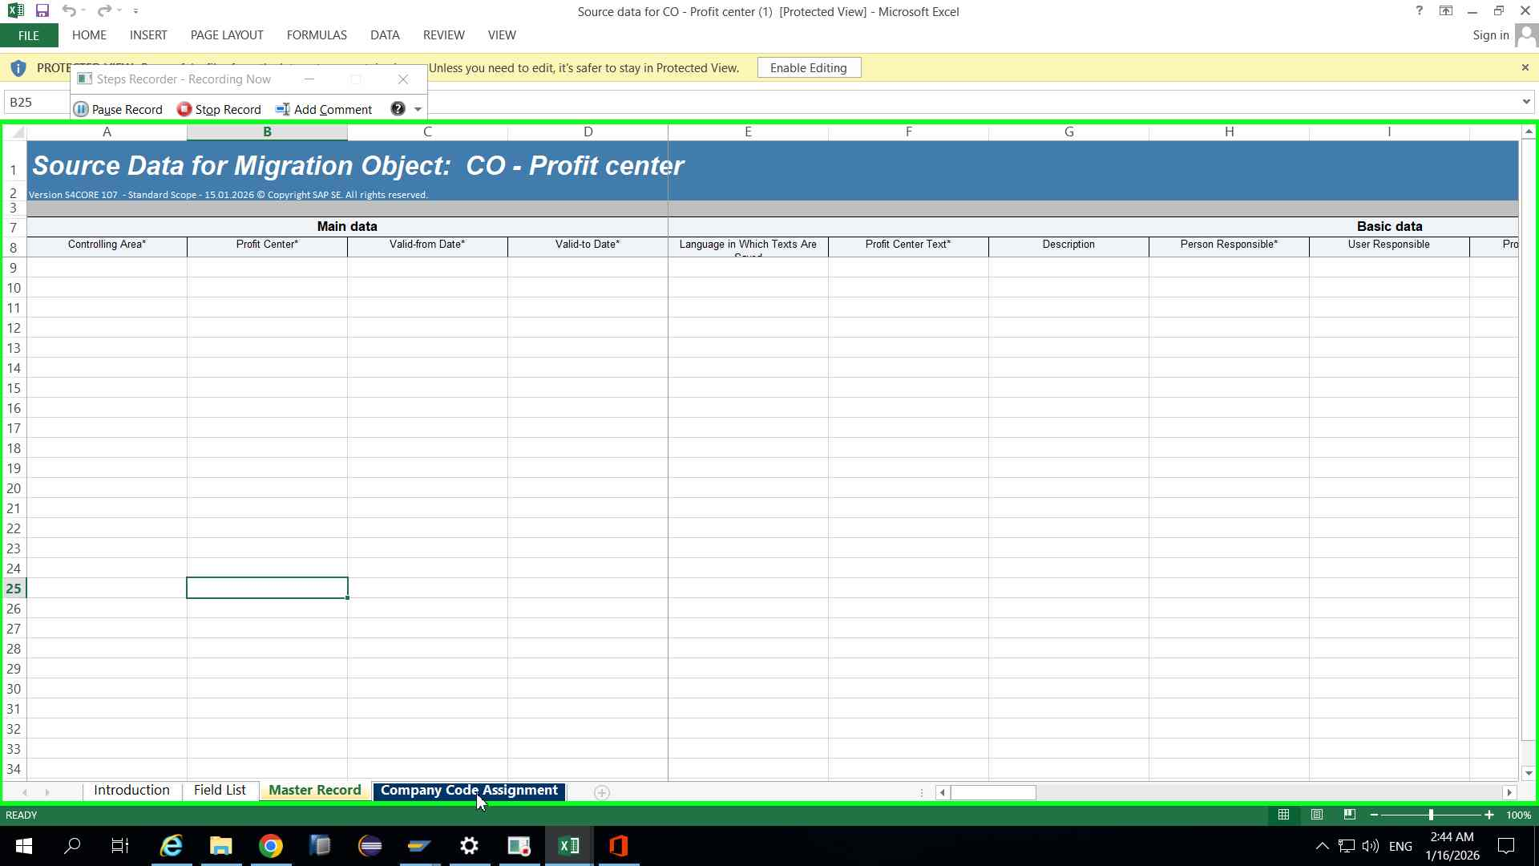Step 33 screenshot.

Previous
Step 34: (‎1/‎16/‎2026 2:44:12 AM) User left click on "Source data for CO - Profit center (1).xml[Protected View] ()" in "Sou"
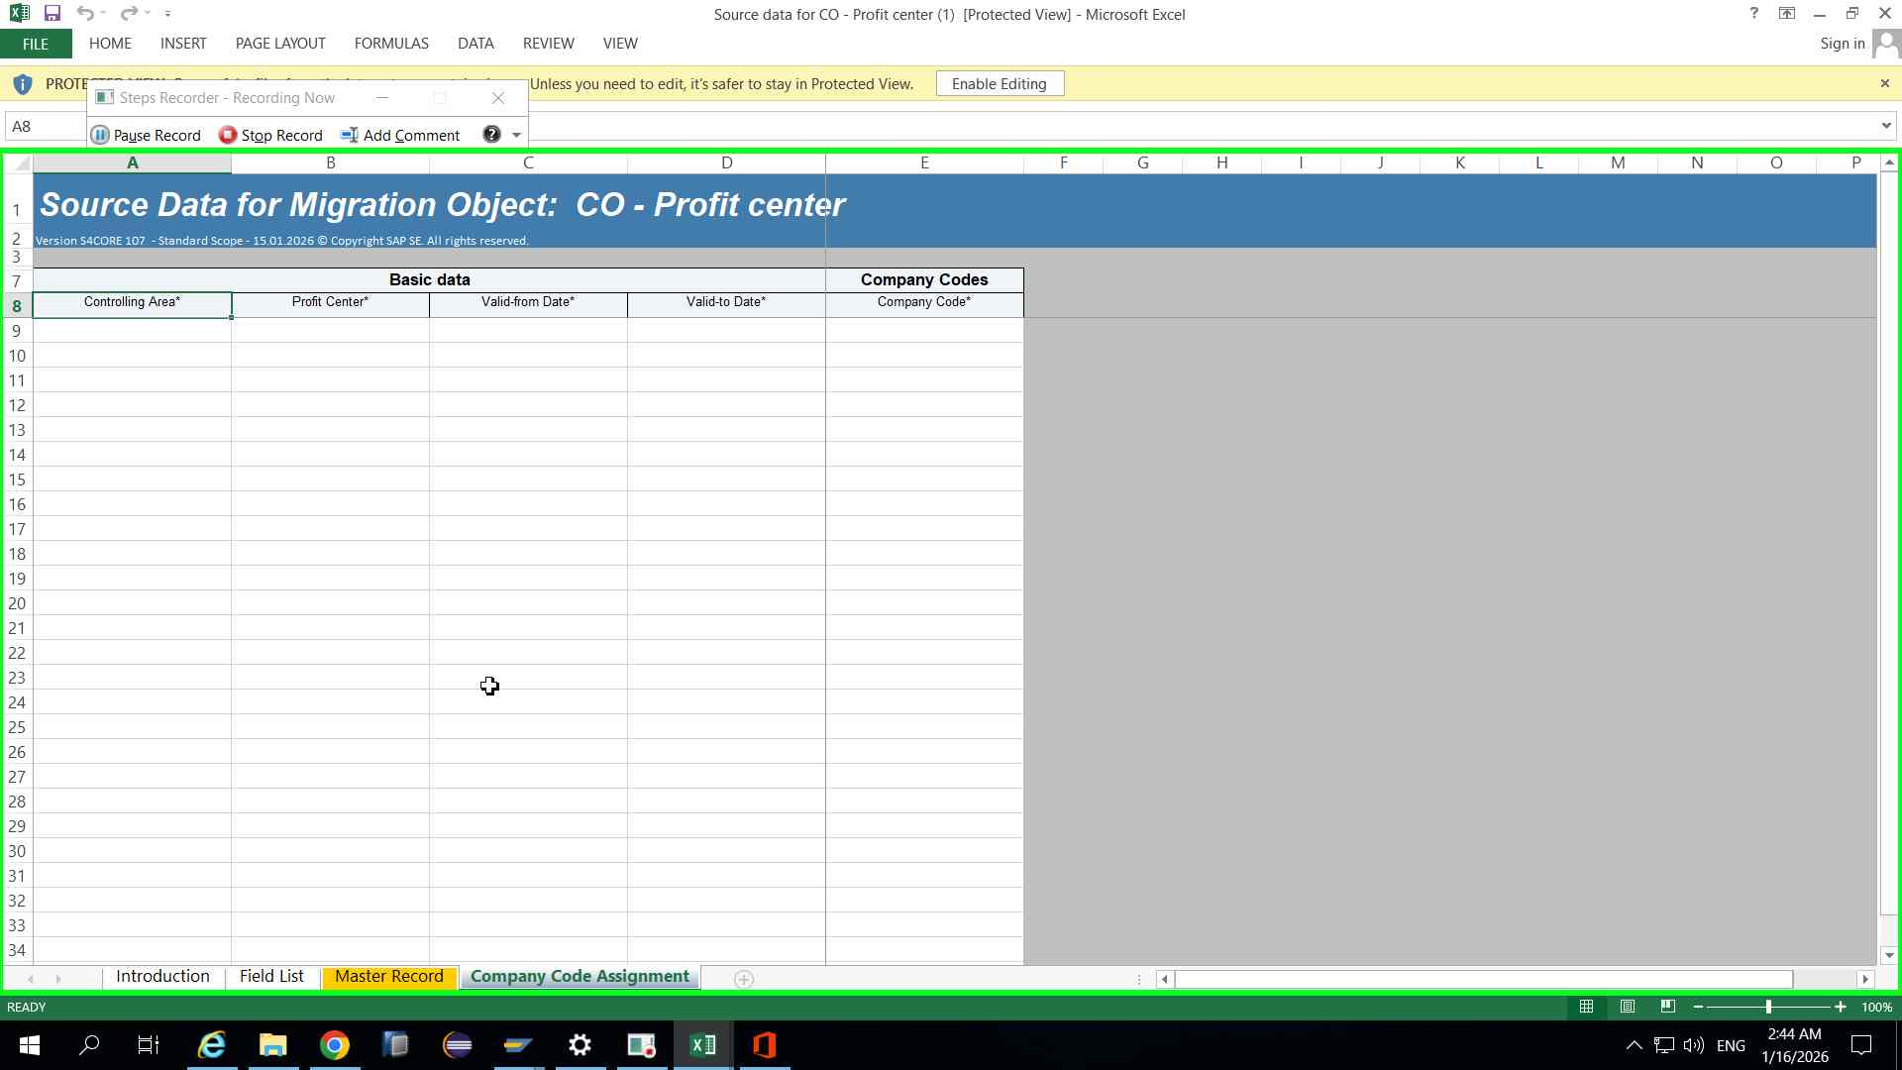

Previous Next
User left click in "Mig"
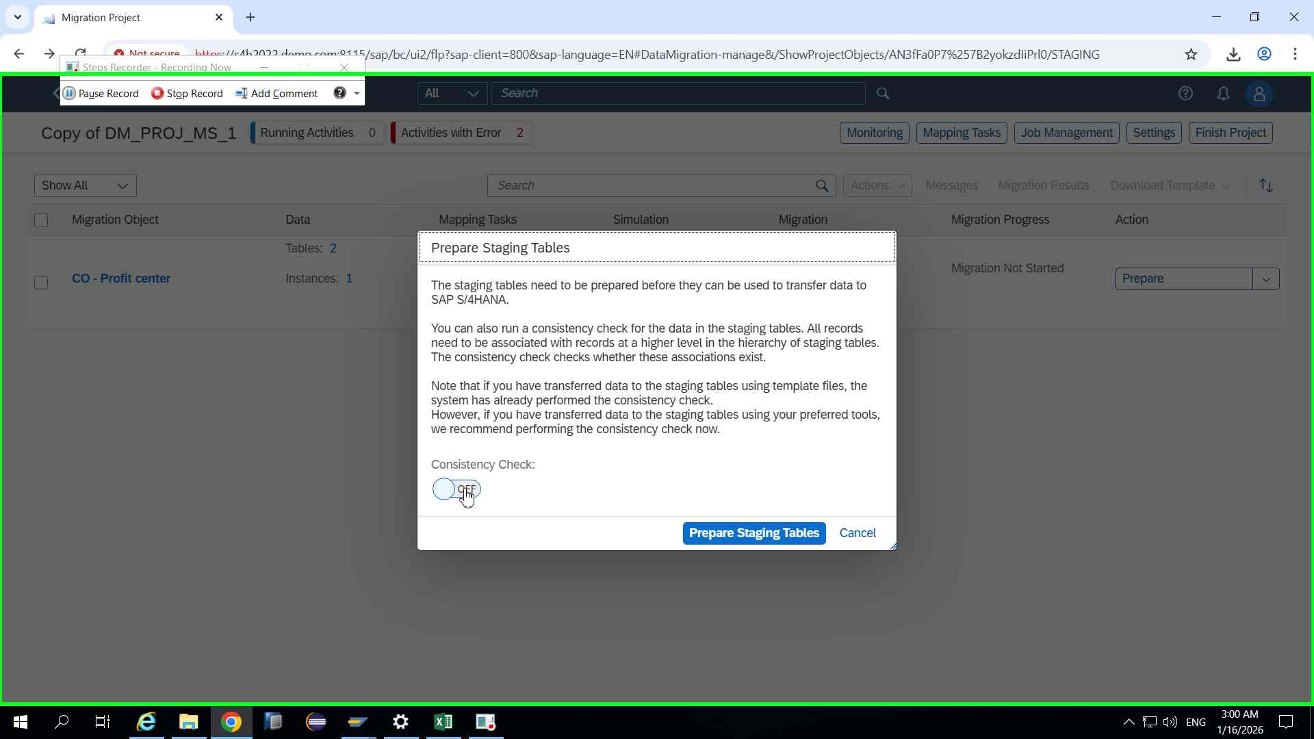Step 82 screenshot.

Previous Next
Step 83: (‎1/‎16/‎2026 3:00:55 AM) User left click in "Mig"
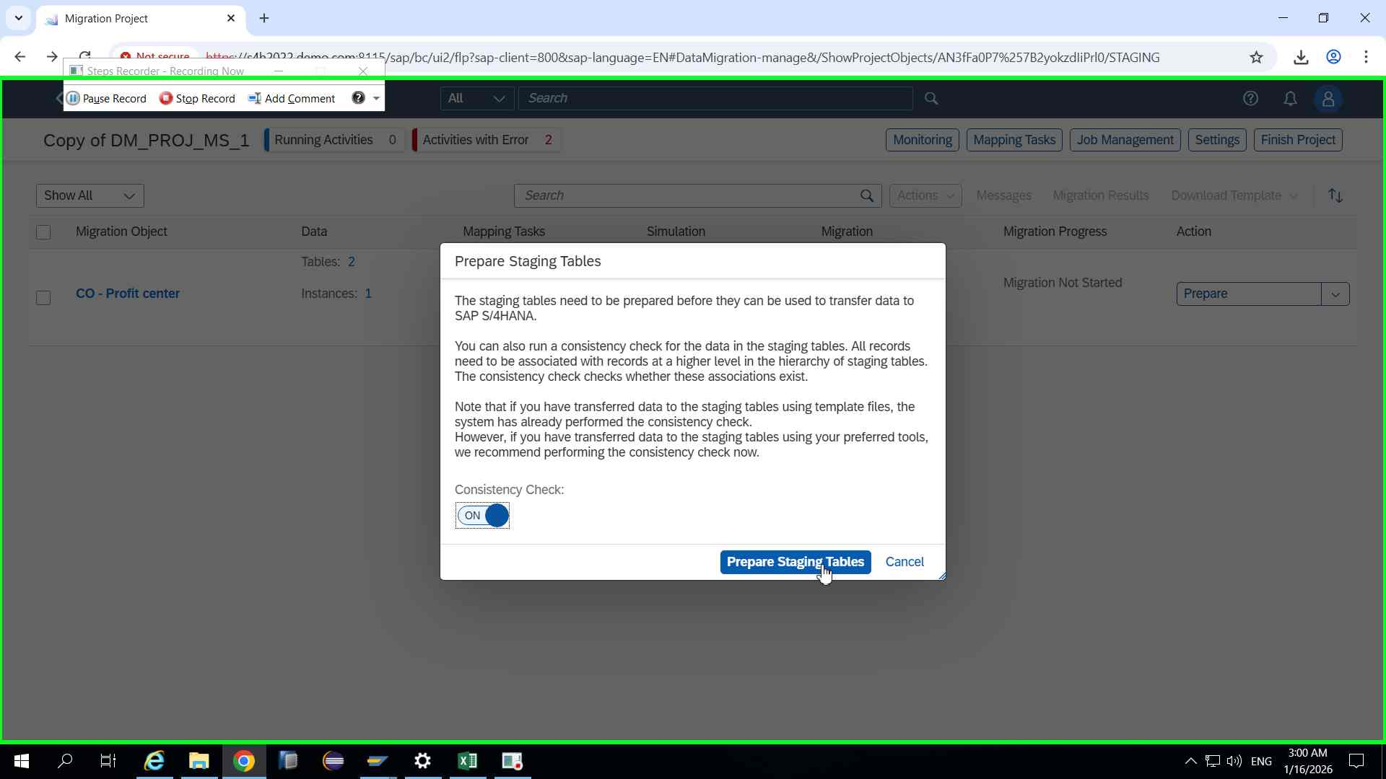Step 83 screenshot.

Previous Next
Step 84: (‎1/‎16/‎2026 3:01:17 AM) User left click in "Mig"
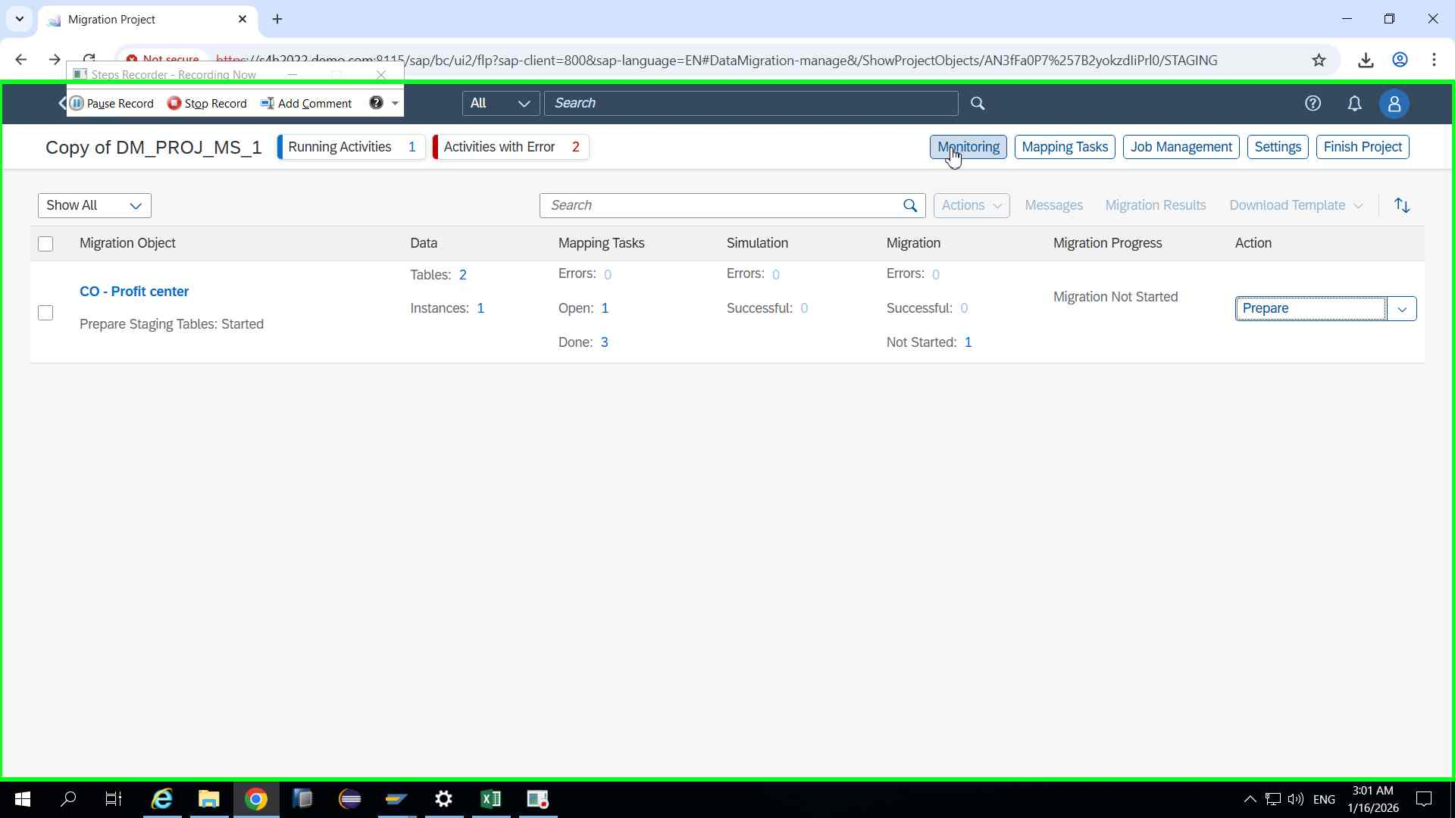Step 84 screenshot.

Previous Next
Step 85: (‎1/‎16/‎2026 3:01:23 AM) User left click in "Mon"
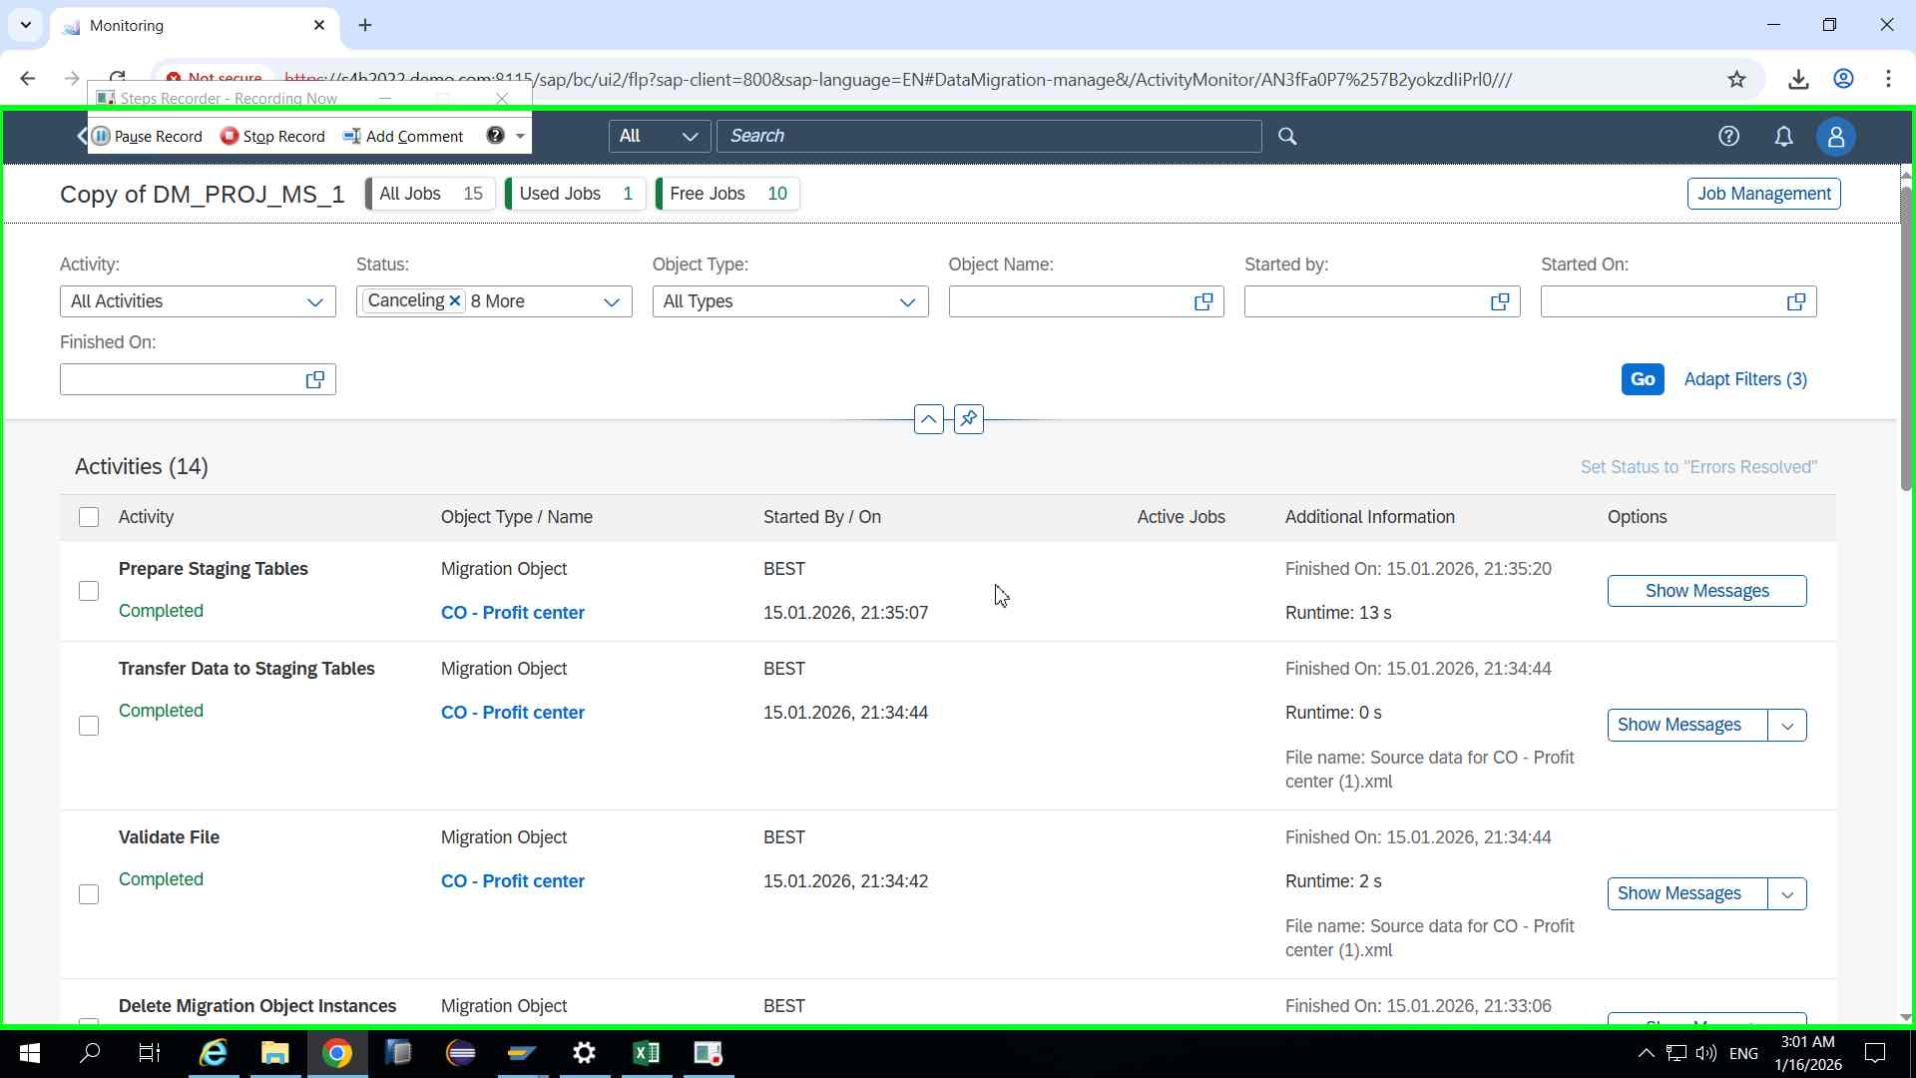Step 85 screenshot.

Previous Next
Step 86: (‎1/‎16/‎2026 3:01:27 AM) User left click in "Mon"
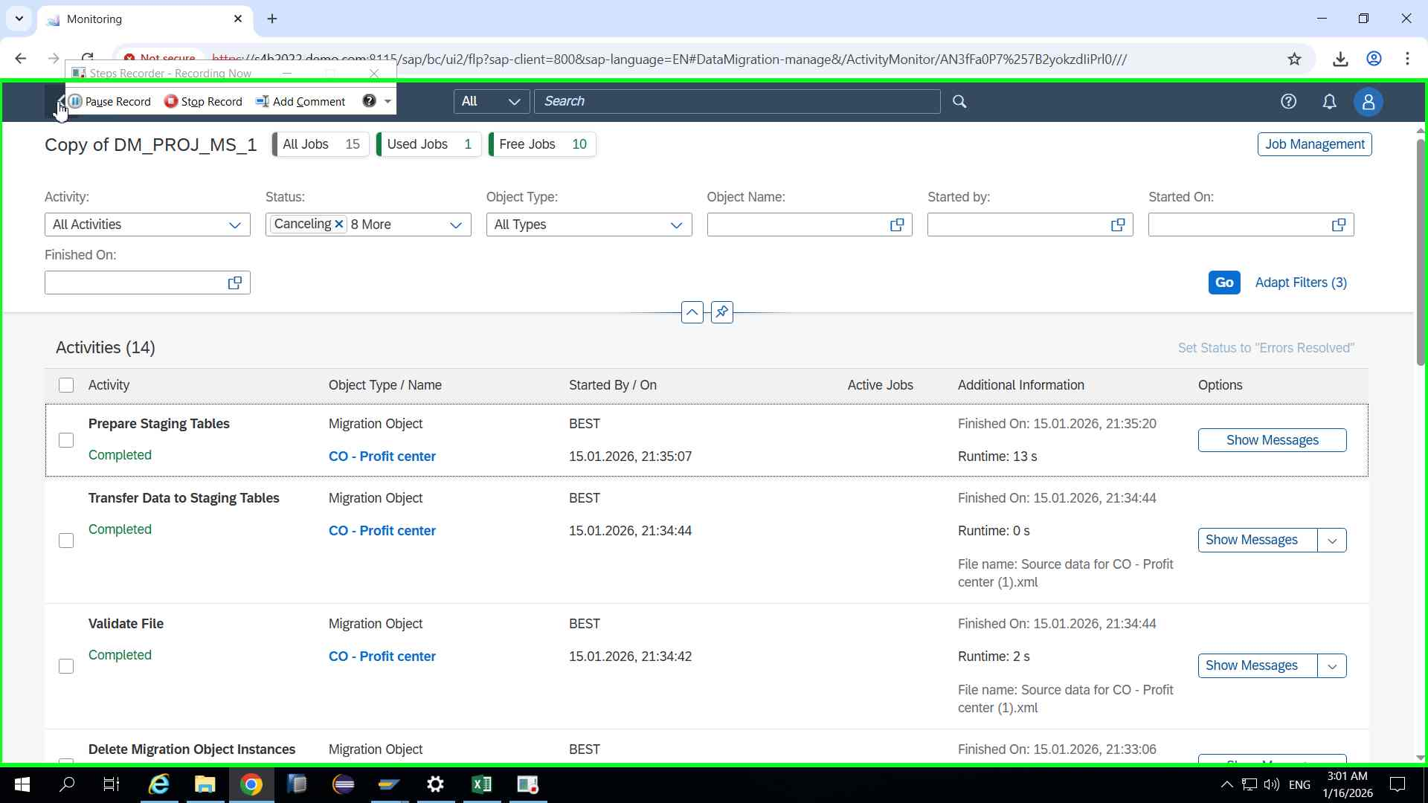Step 86 screenshot.

Previous Next
Step 87: (‎1/‎16/‎2026 3:01:29 AM) User left click in "Mig"
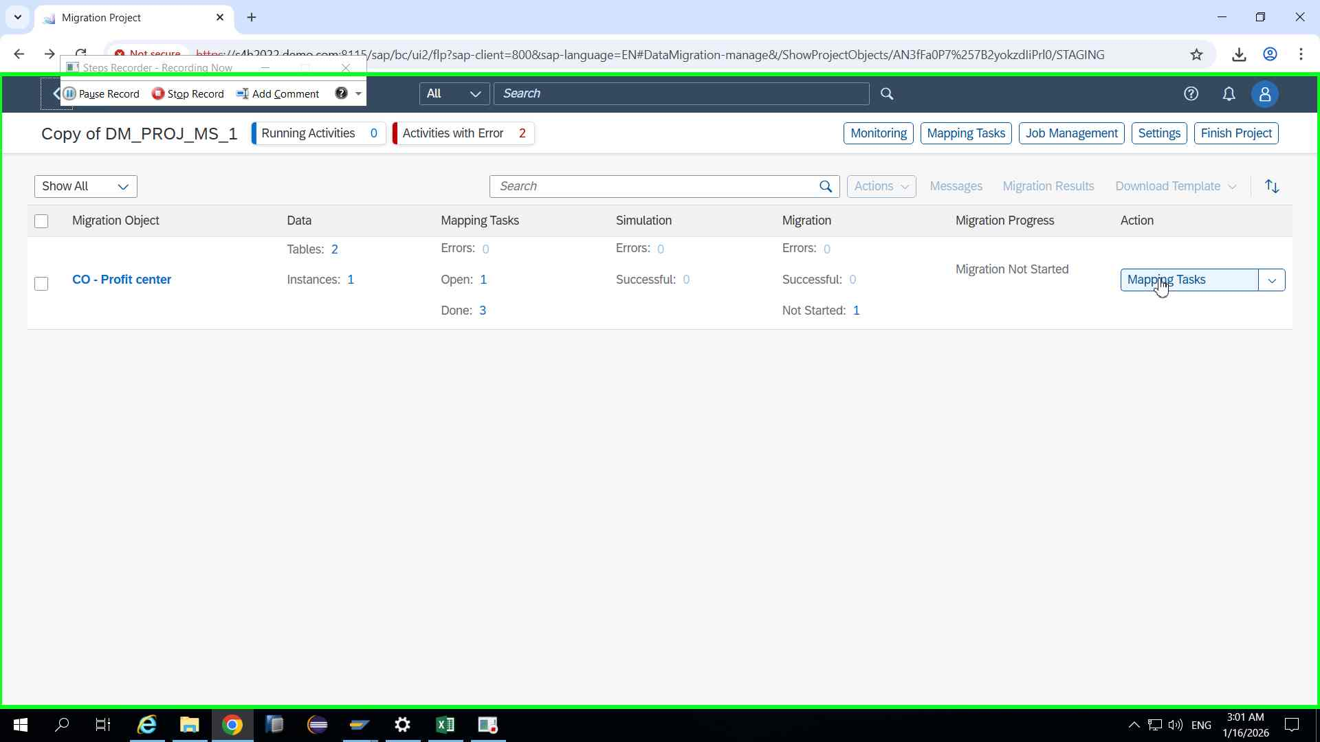Step 87 screenshot.

Previous Next
Step 88: (‎1/‎16/‎2026 3:01:32 AM) User left click in "Map"
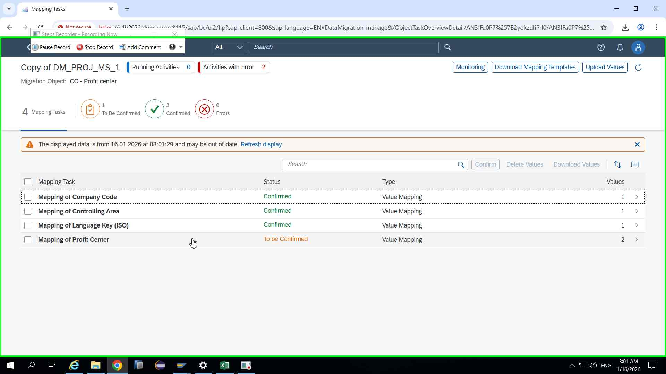Step 88 screenshot.

Previous Next
Step 89: (‎1/‎16/‎2026 3:01:35 AM) User left click in "Map"
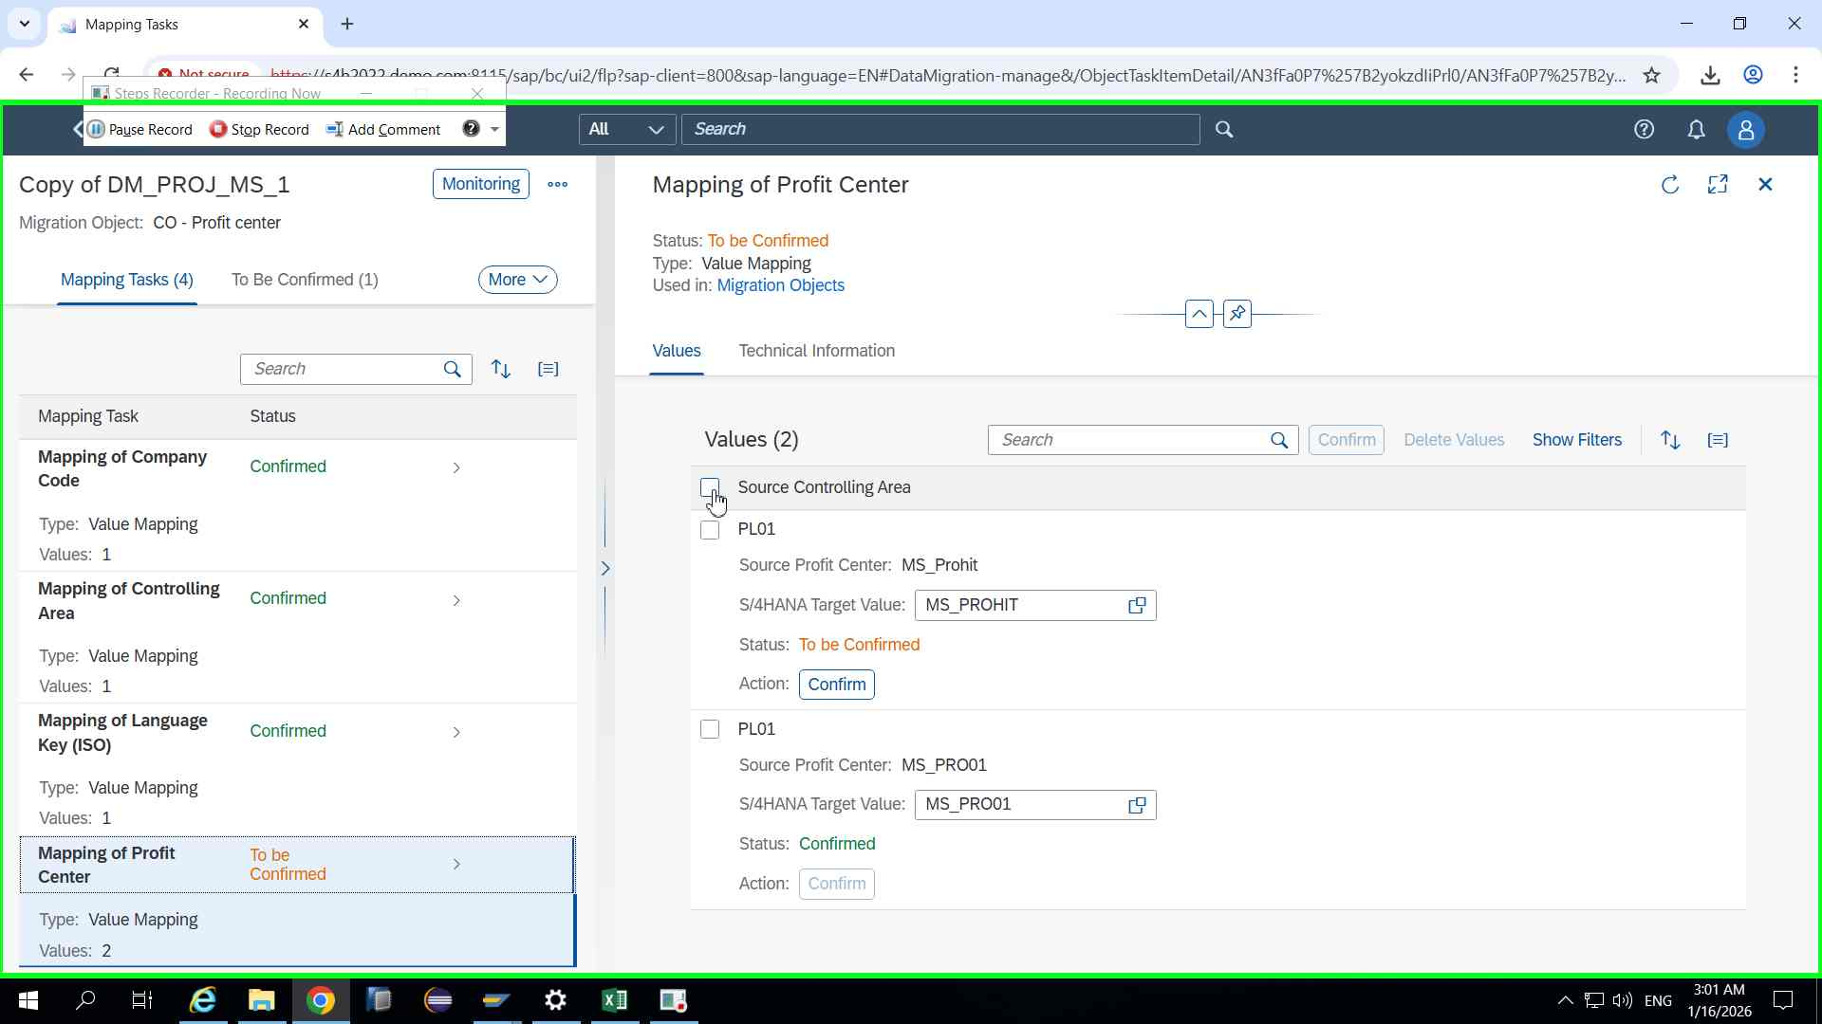Step 89 screenshot.

Previous Next
Step 90: (‎1/‎16/‎2026 3:01:37 AM) User left click in "Map"
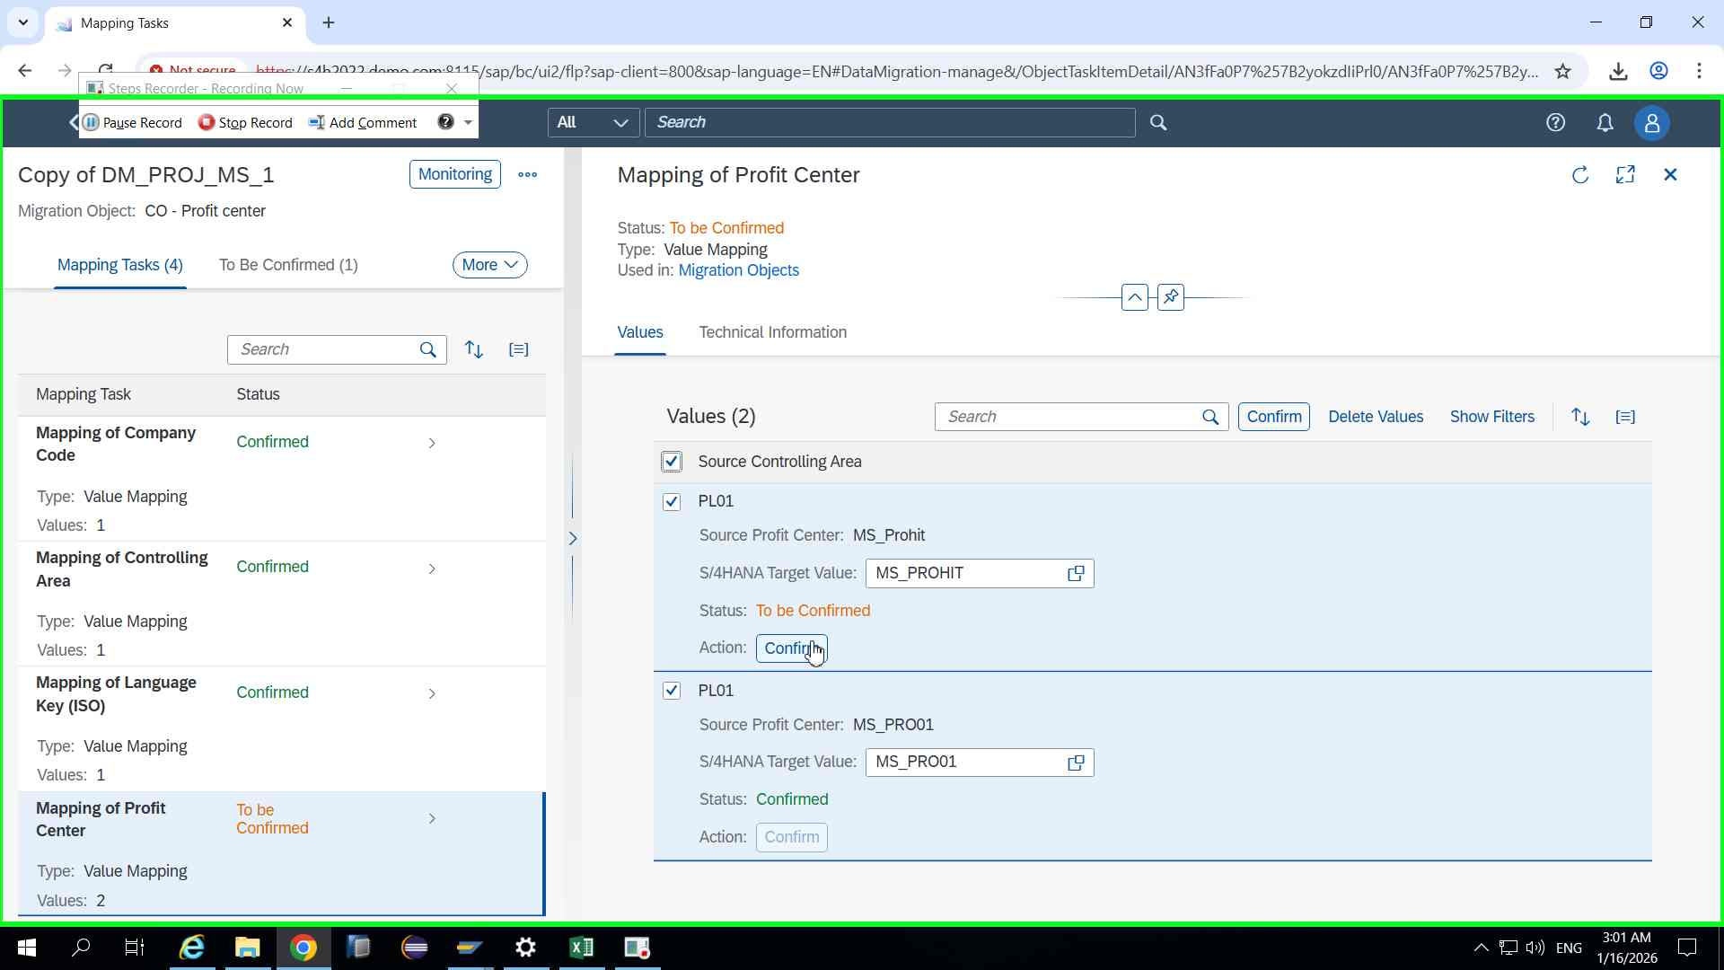Step 90 screenshot.

Previous Next
Step 91: (‎1/‎16/‎2026 3:01:45 AM) User left click in "Map"
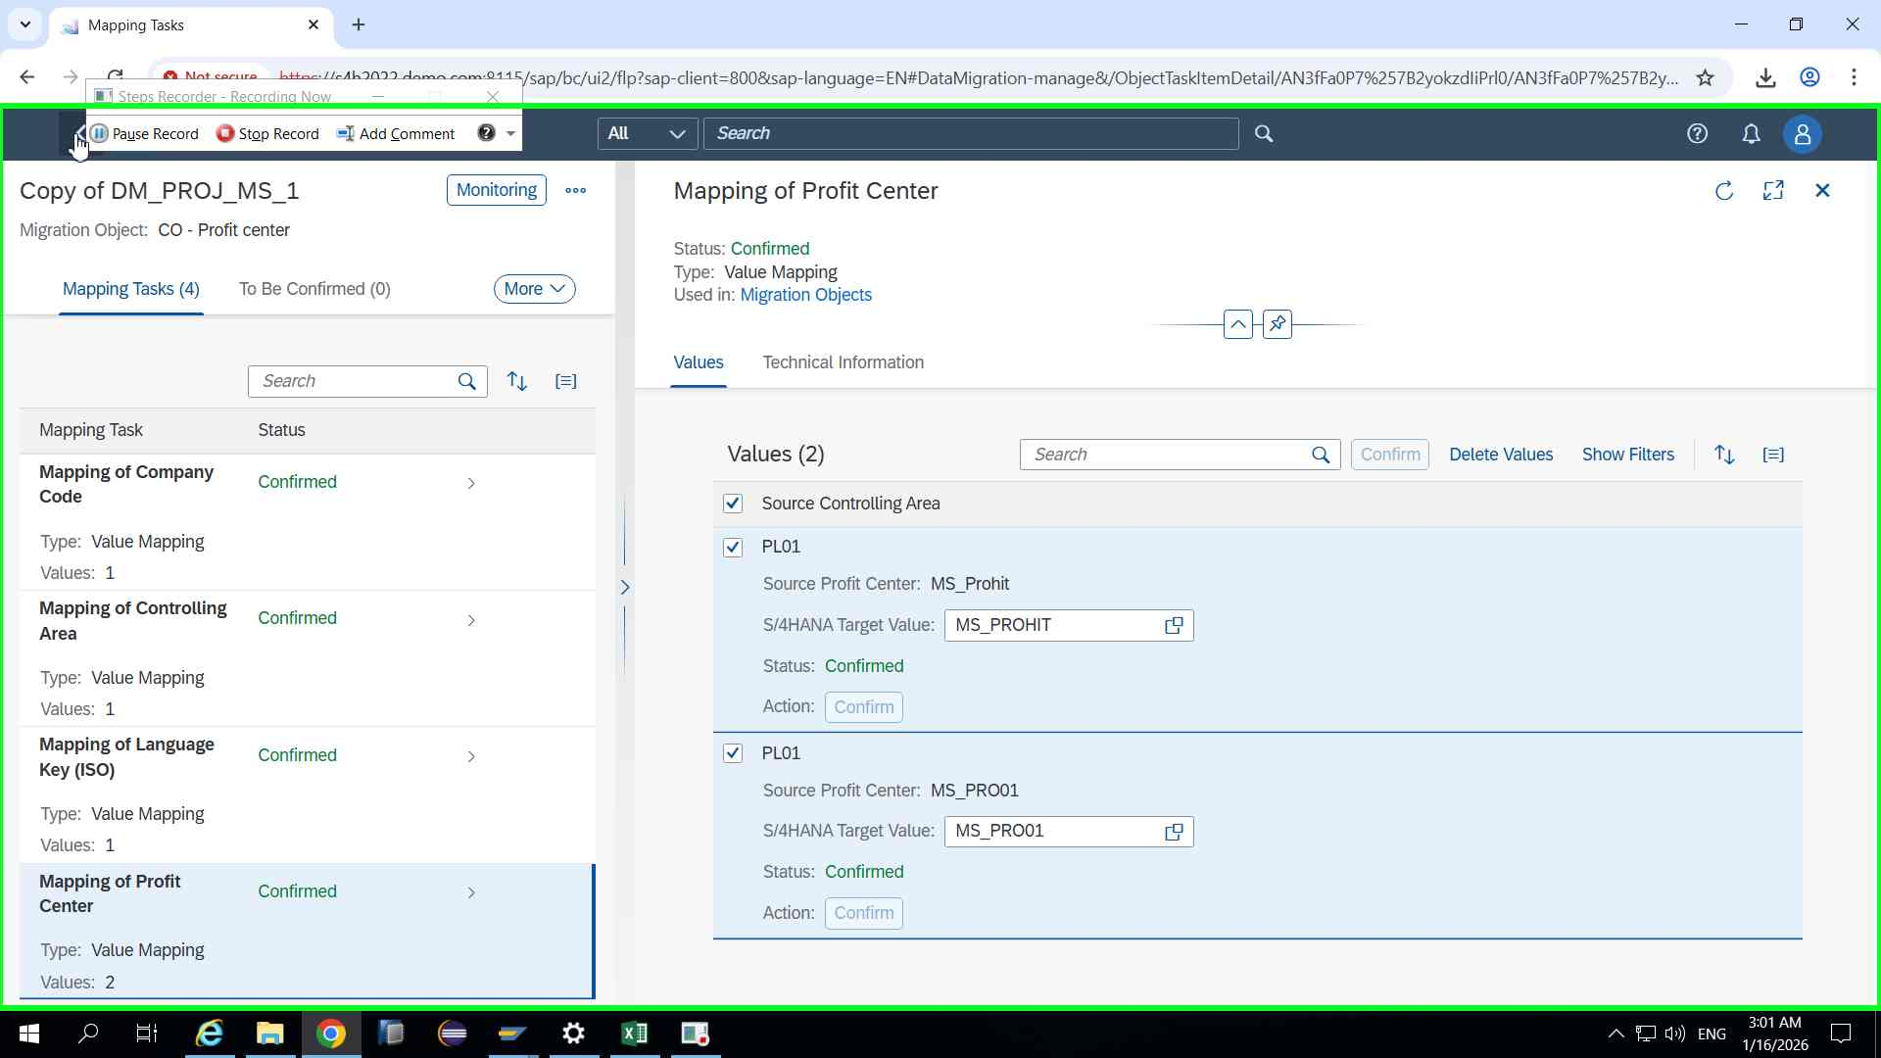Step 91 screenshot.

Previous Next
Step 92: (‎1/‎16/‎2026 3:01:48 AM) User left click in "Map"
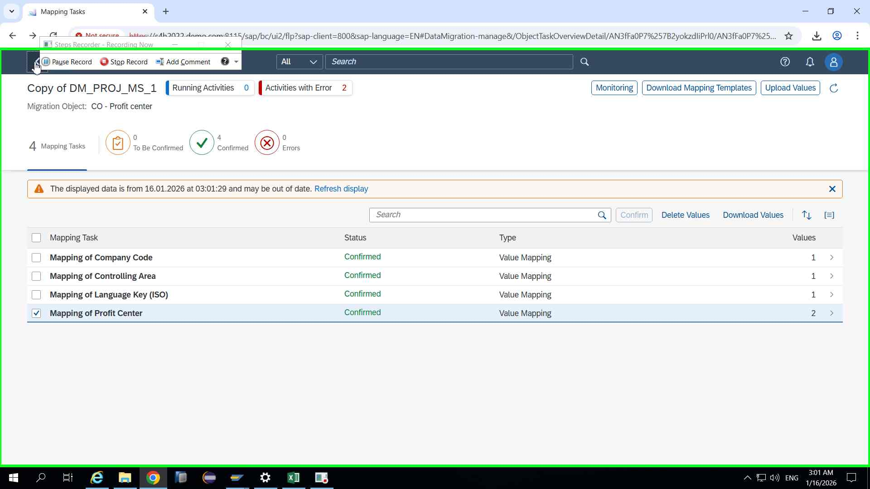Step 92 screenshot.

Previous Next
Step 93: (‎1/‎16/‎2026 3:01:52 AM) User left click in "Mig"
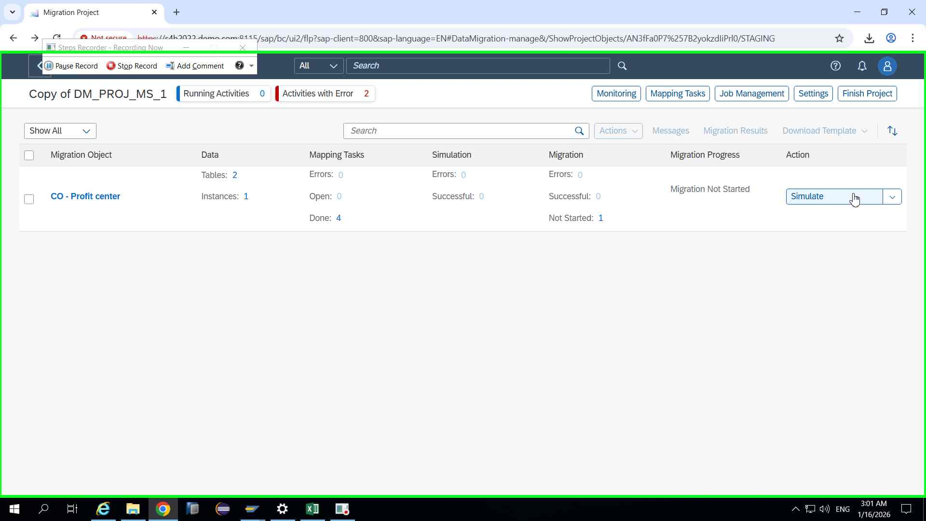Step 93 screenshot.

Previous Next
Step 94: (‎1/‎16/‎2026 3:01:54 AM) User left click in "Mig"
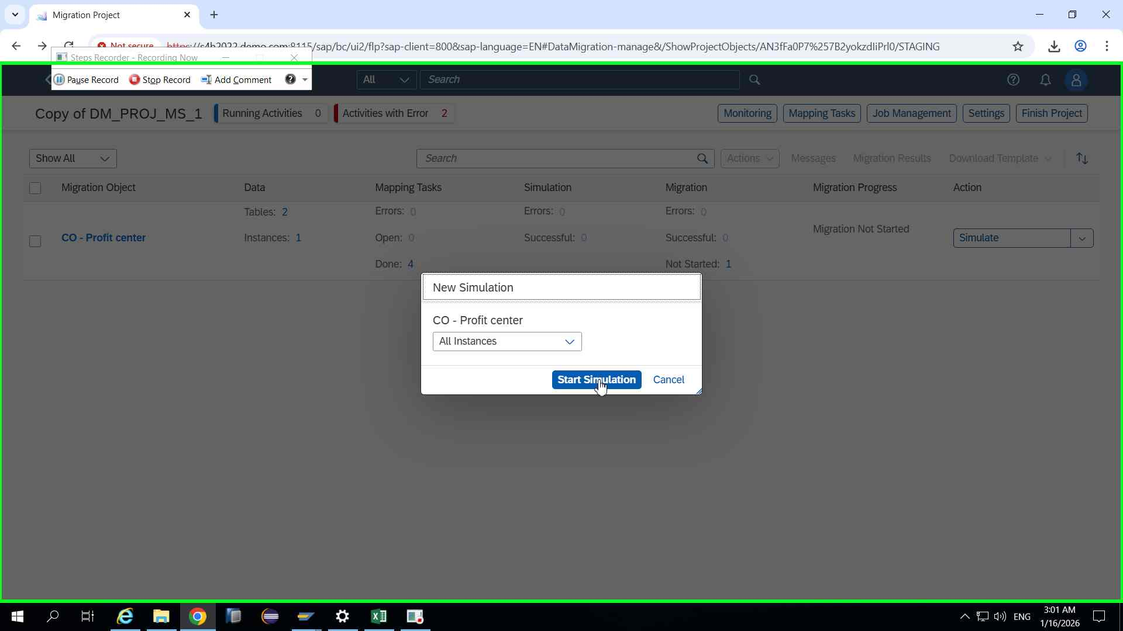Step 94 screenshot.

Previous Next
Step 95: (‎1/‎16/‎2026 3:02:01 AM) User left click in "Mig"
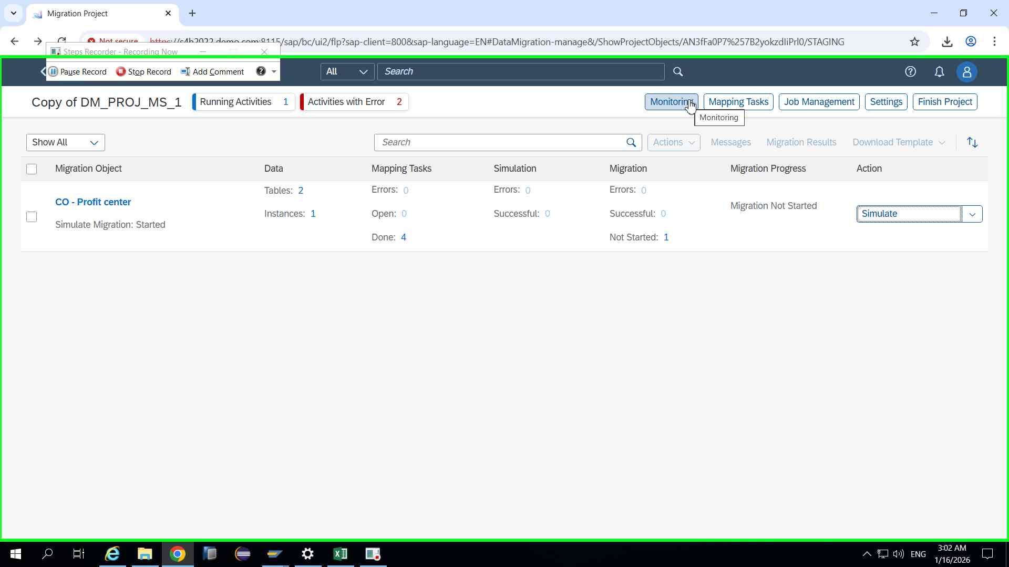Step 95 screenshot.

Previous Next
Step 96: (‎1/‎16/‎2026 3:02:08 AM) User left click in "Mon"
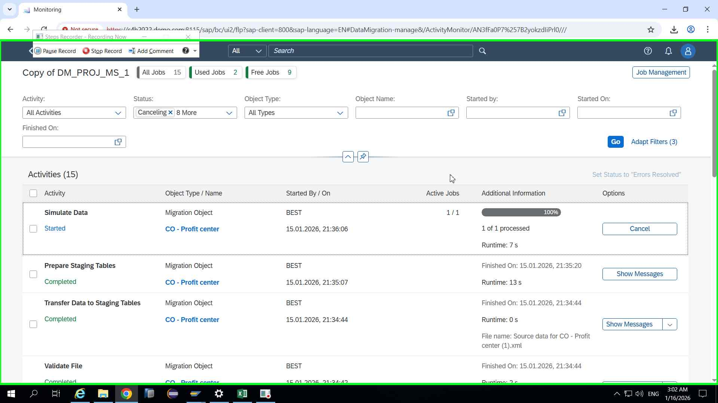Step 96 screenshot.

Previous Next
Step 97: (‎1/‎16/‎2026 3:02:16 AM) User left click in "Mon"
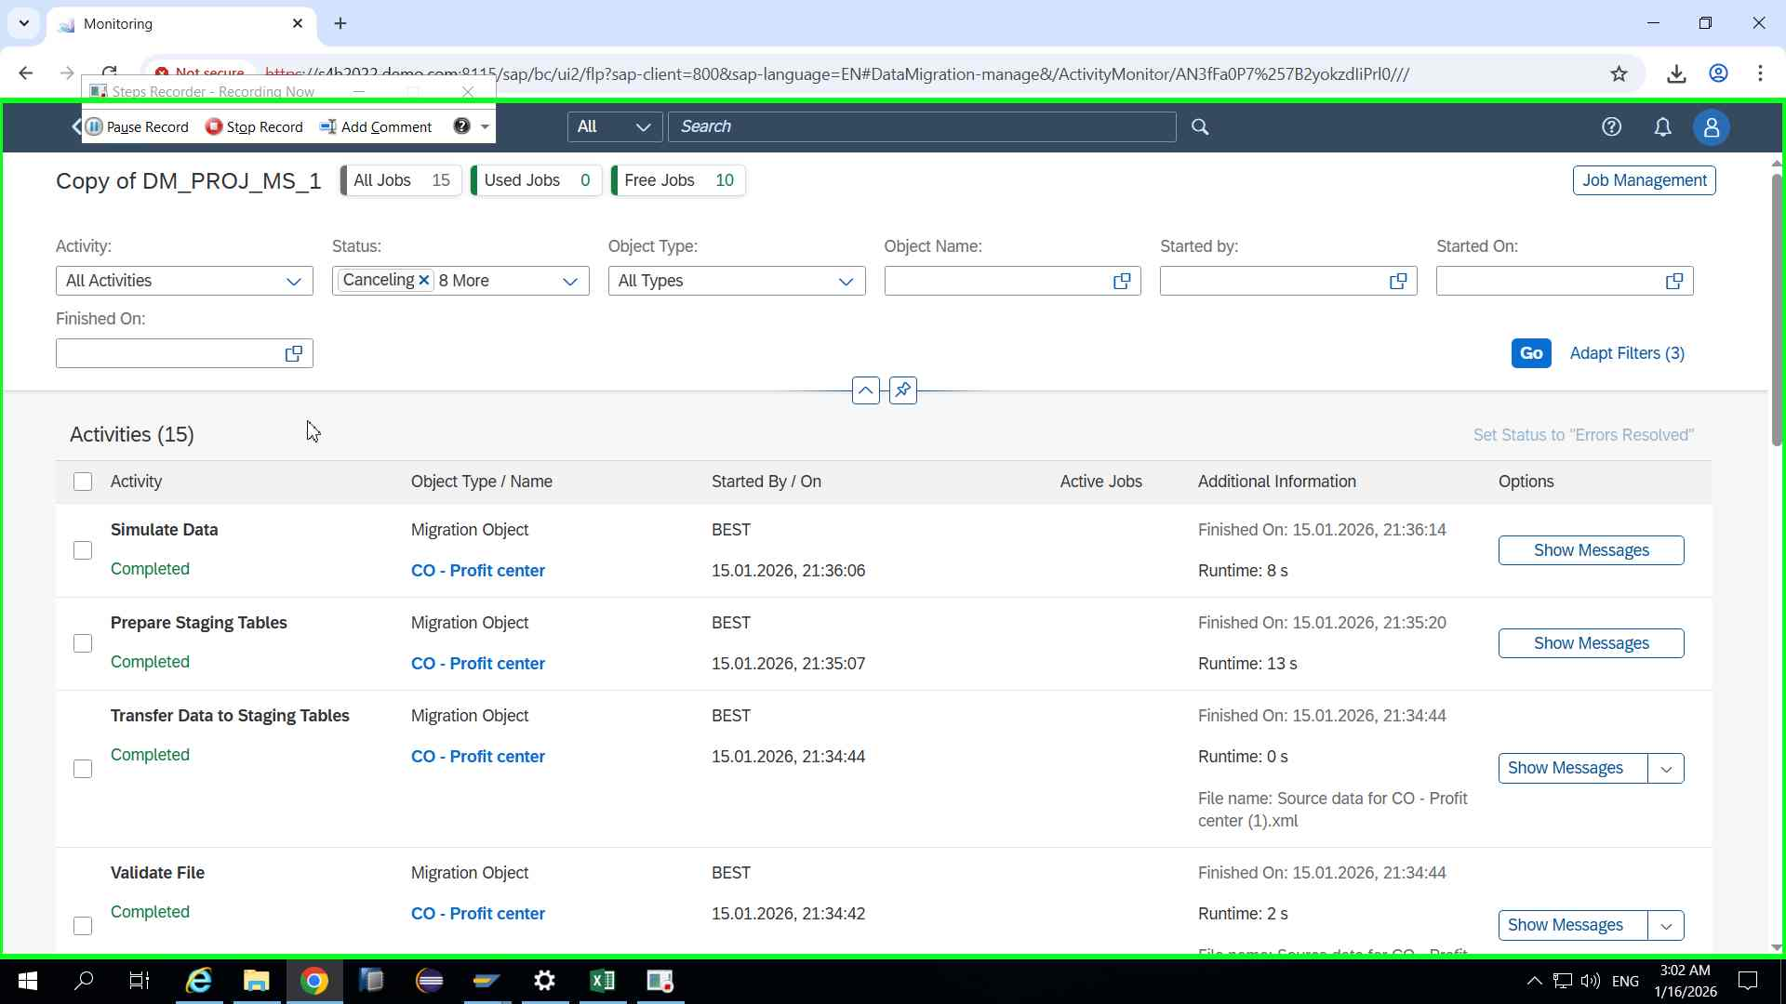Step 97 screenshot.

Previous Next
Step 98: (‎1/‎16/‎2026 3:02:18 AM) User left click in "Mon"
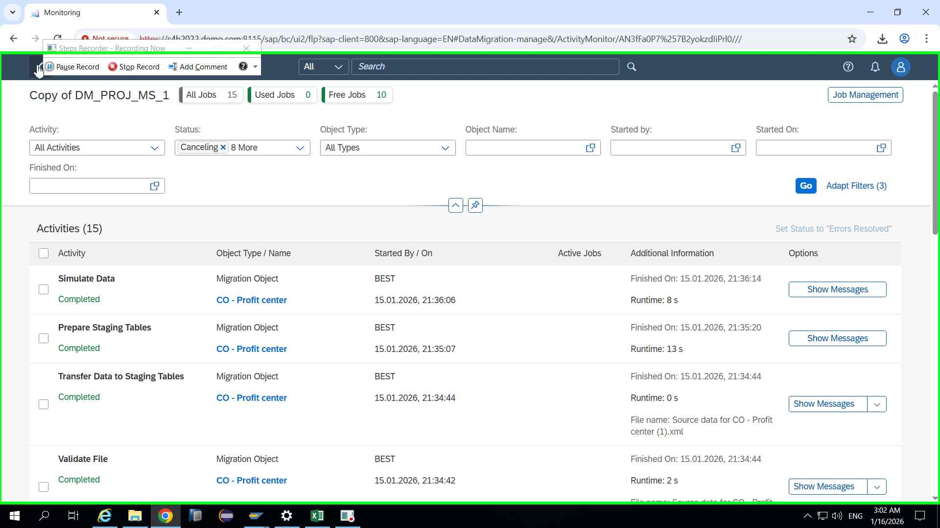Step 98 screenshot.

Previous Next
Step 99: (‎1/‎16/‎2026 3:02:21 AM) User left click in "Mig"
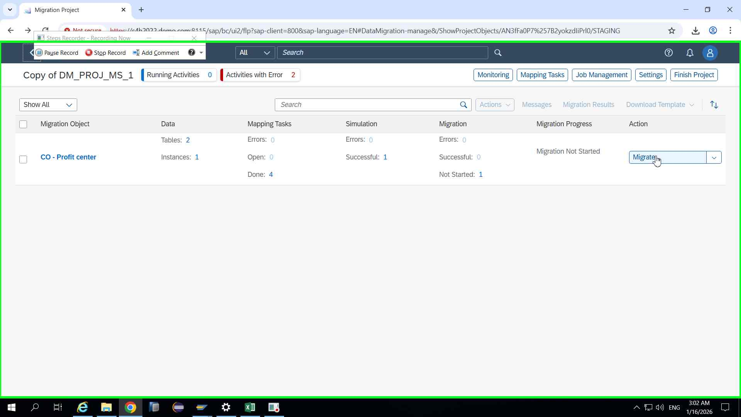Step 99 screenshot.

Previous Next
Step 100: (‎1/‎16/‎2026 3:02:23 AM) User left click in "Mig"
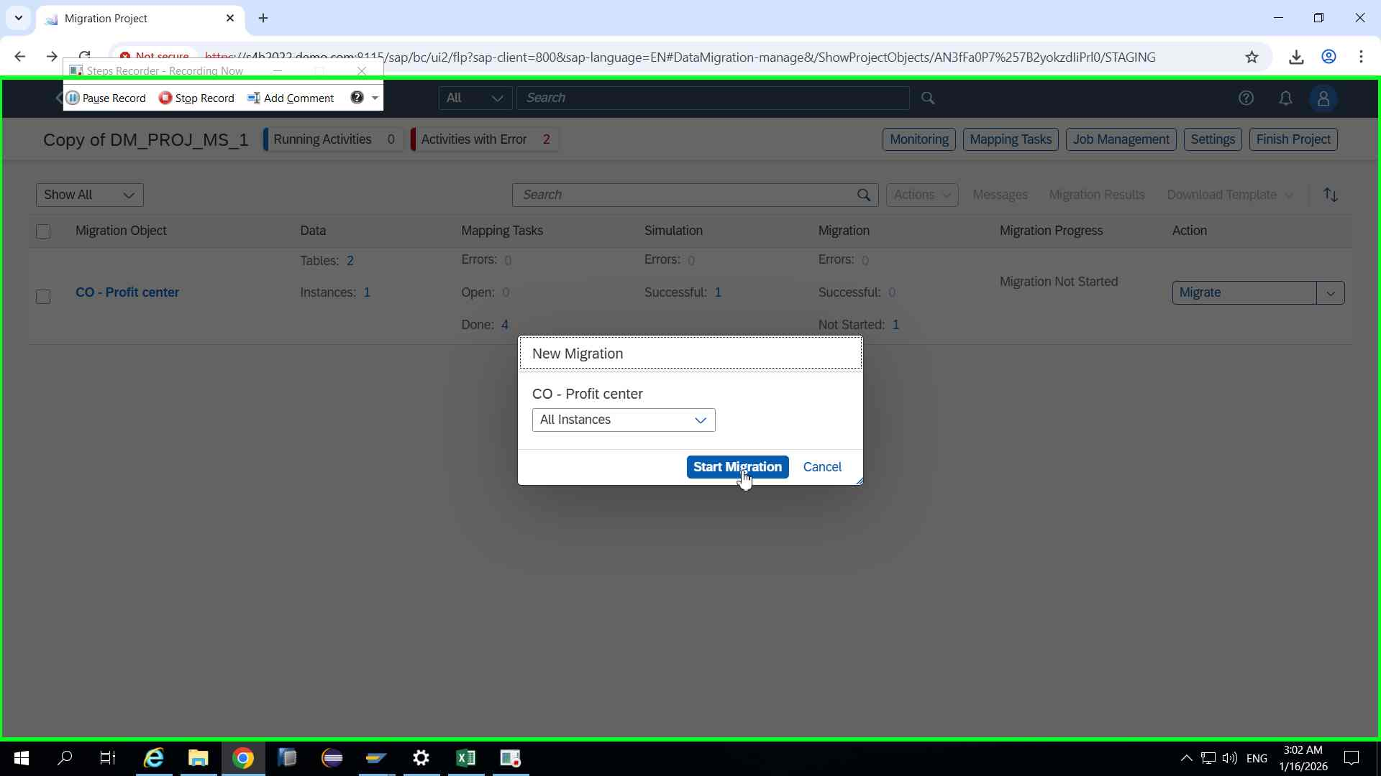Step 100 screenshot.

Previous Next
Step 101: (‎1/‎16/‎2026 3:02:25 AM) User left click in "Mig"
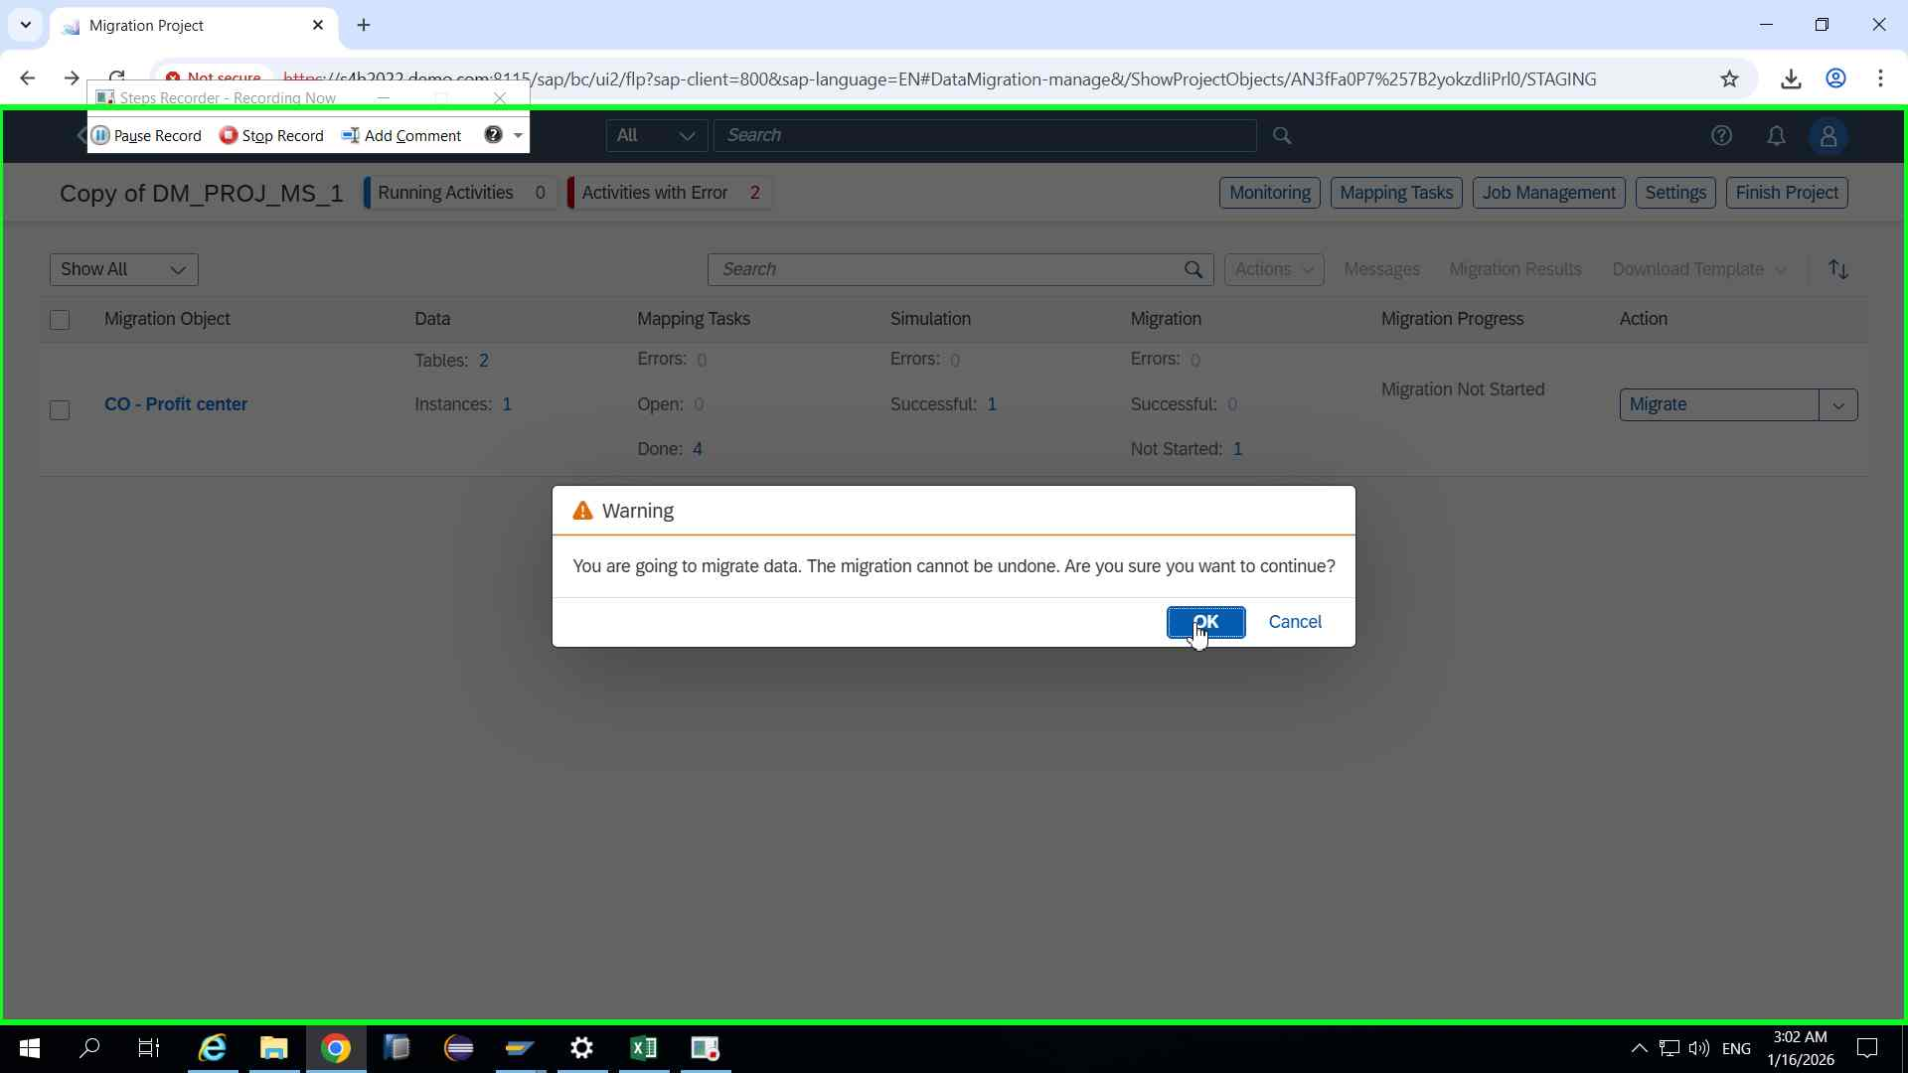Step 101 screenshot.

Previous Next
Step 102: (‎1/‎16/‎2026 3:02:31 AM) User left click in "Mig"
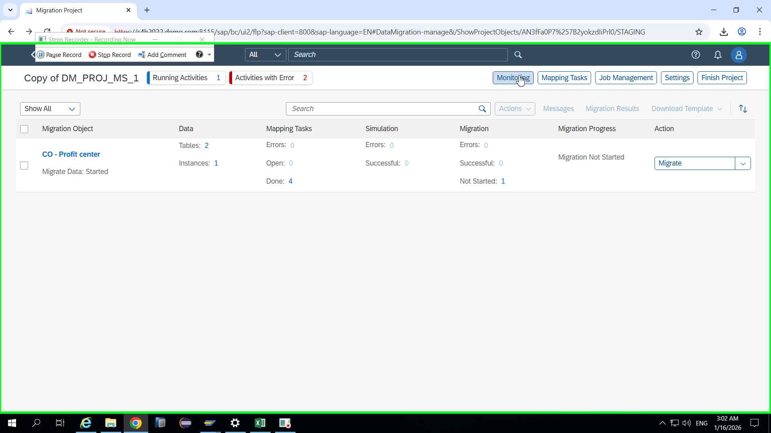Step 102 screenshot.

Previous Next
Step 103: (‎1/‎16/‎2026 3:02:34 AM) User left click in "Mon"
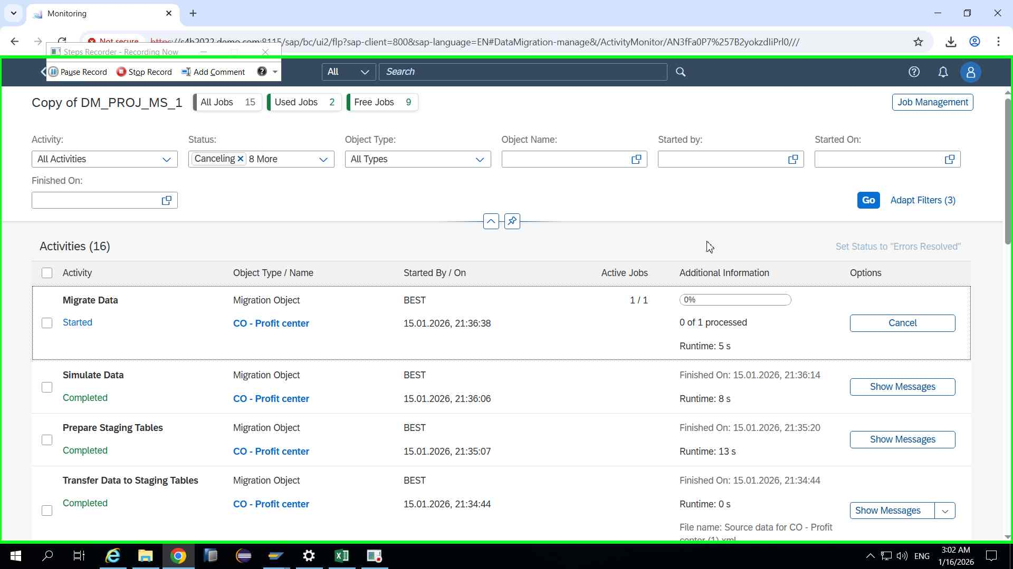Step 103 screenshot.

Previous Next
Step 104: (‎1/‎16/‎2026 3:02:46 AM) User left click in "Mon"
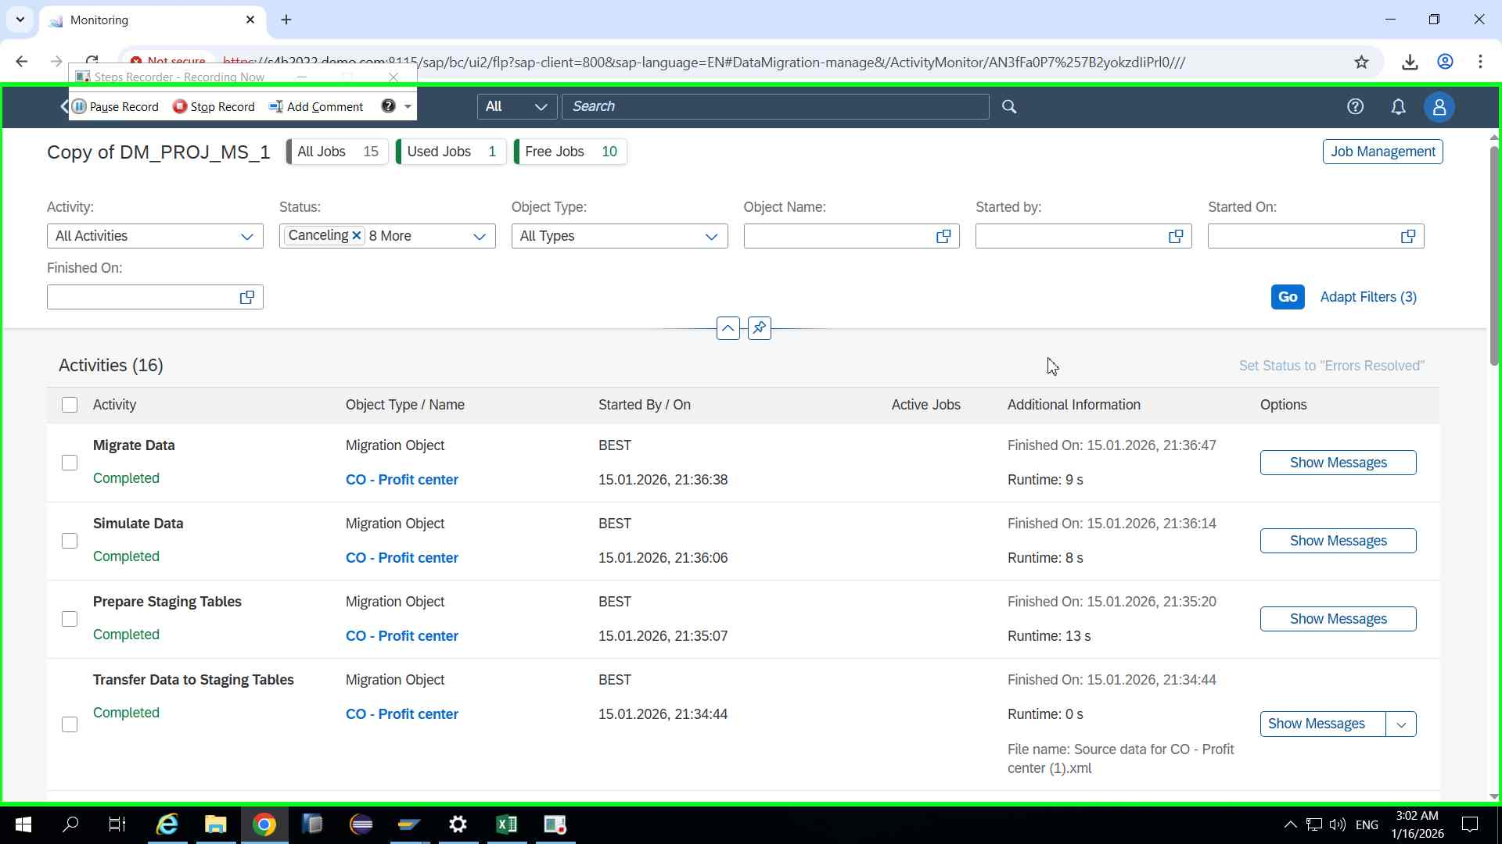Step 104 screenshot.

Previous Next
Step 105: (‎1/‎16/‎2026 3:02:54 AM) User left click in "Mon"
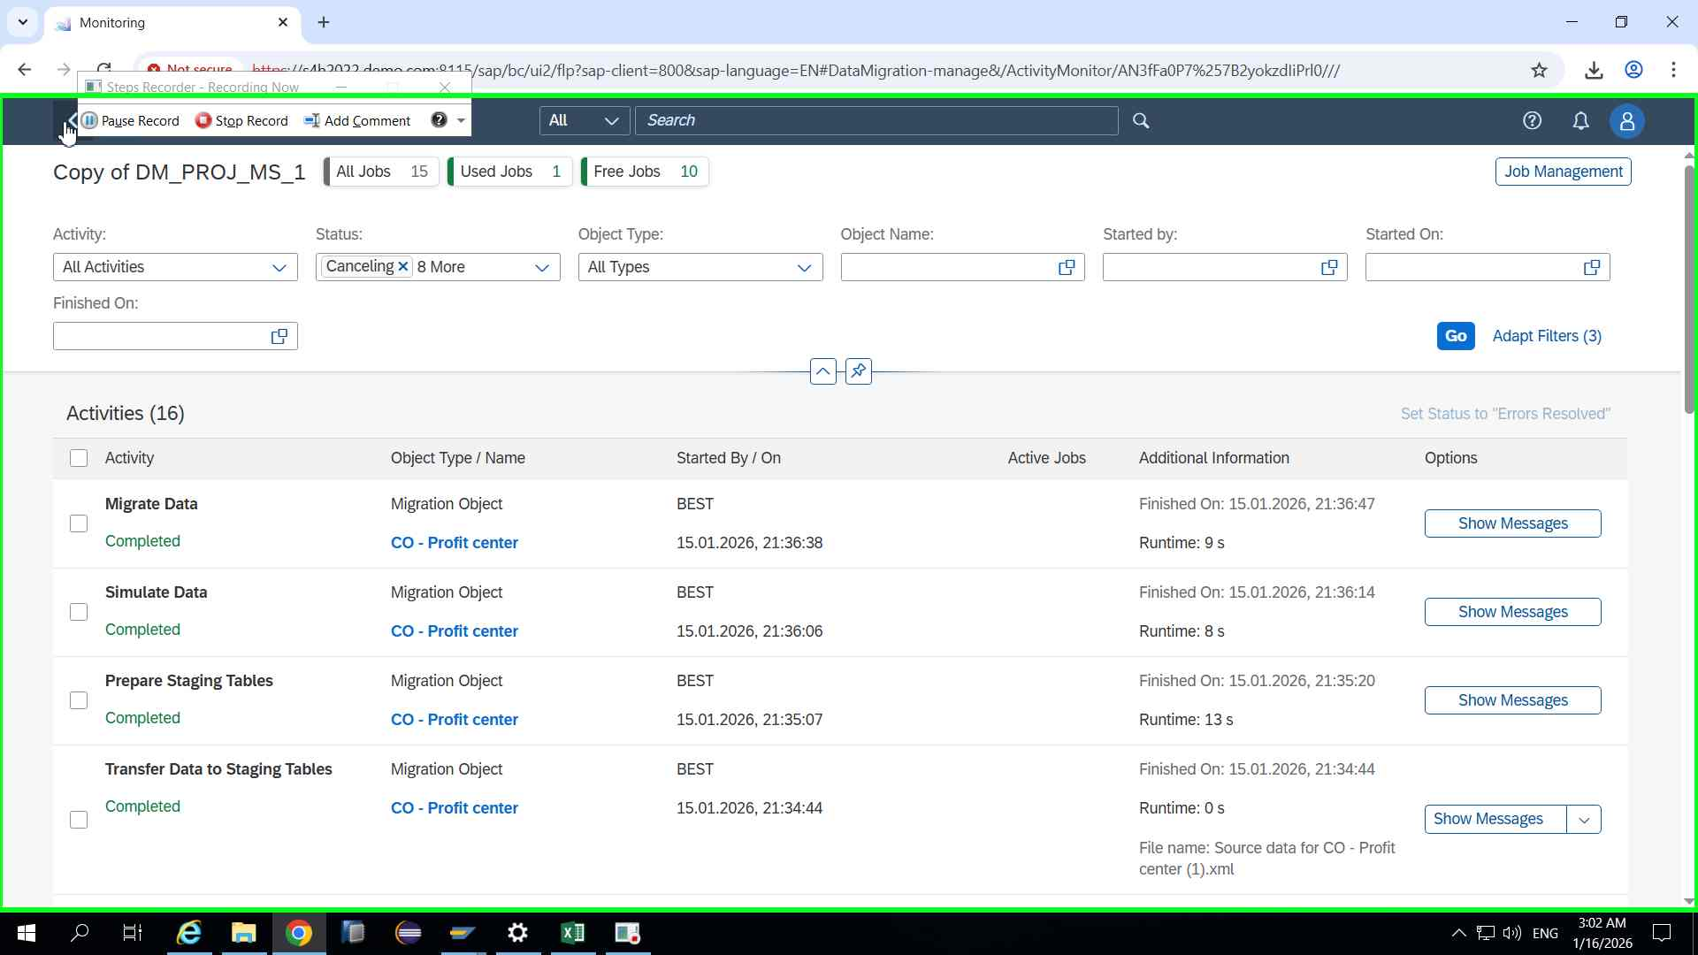Step 105 screenshot.

Previous
Step 106: (‎1/‎16/‎2026 3:02:58 AM) User left click in "Mig"
