Finding no. of customers, # of orders and the avg paid price per country

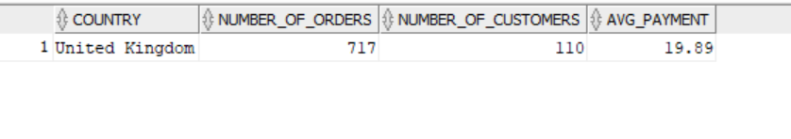

Figuring out the quantities ordered per date

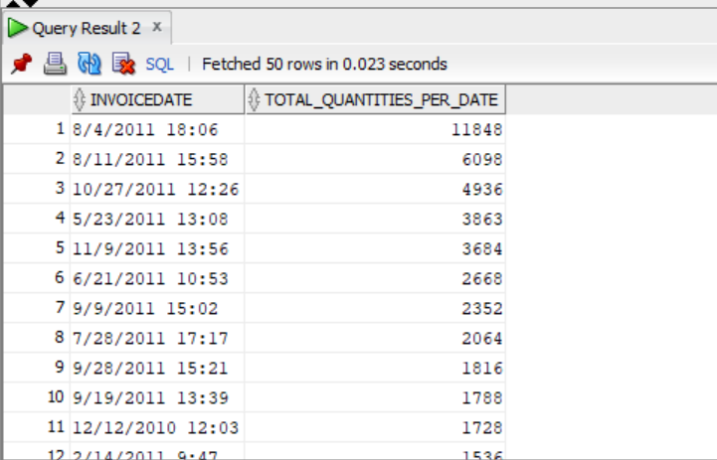

Figuring out the highest revenue made throughout the day

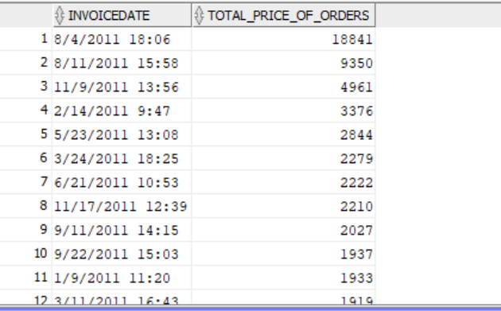

Figuring out the highest paid customers per interval

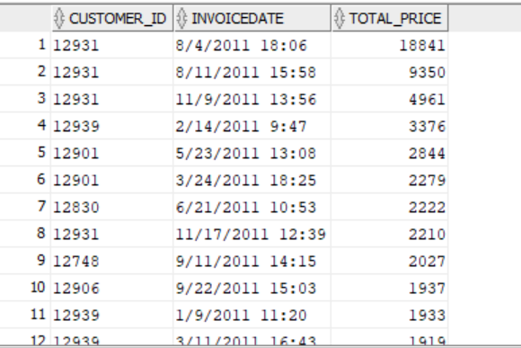

Extracting the highest date of each employee along with their order frequency and total price paid

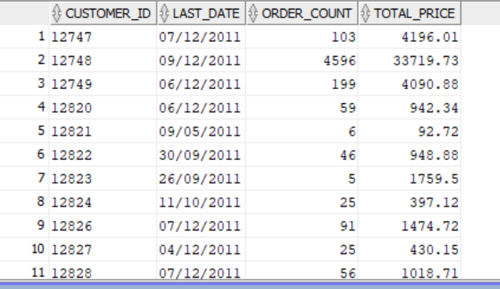

figuring out the recency of ordering per customer

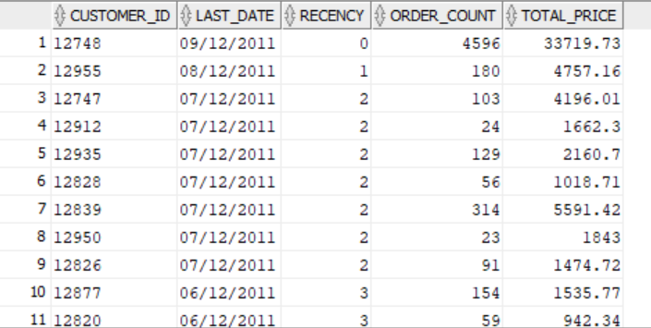

using NTILE to segment the 2 factors (Recency and Monetary) \*removed frequency since it indicates the volume as Monetary does\* to segment customers in the next step

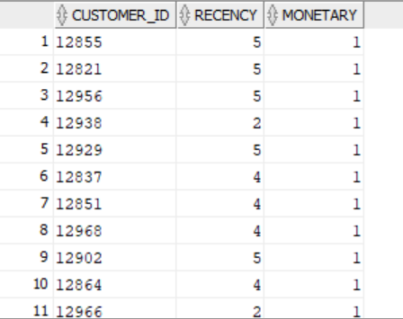

Segmenting Customers

