

**CST2120**

**Web Applications and Databases**

Coursework 3

**Restaurant Finder Web Application**

Student Name: Rohini Paligadu

Student ID: M00696984

Module Co-ordinator: Ameerah Assotally

Campus: Mauritius

Table of Contents

2 List of figures 2

3 Introduction 3

4 Website 3

4.1 Features 3

4.2 Layout 3

5 Database 7

# List of figures

Figure 1 Website wireframe 4

Figure 2 Home 5

Figure 3 Cuisines 5

Figure 4 Restaurants 5

Figure 5 Restaurant owners partner page 6

Figure 6 User sign in page 6

Figure 7 Restaurant owners sign in page 6

Figure 8 Restaurant analytics page accessed only by owner 7

Figure 9 Footer 7

Figure 10 Database design of restaurant finder application 7

# Introduction

The purpose of this project is to design a single page restaurant finder web application. The purpose of the application is to provide the user a platform to search for a variety of restaurants and review their experience. The application will allow user to search for a particular restaurant by the name, by the type of cuisine and by location. The user can also sort the restaurants in alphabetical order and leave reviews about the restaurant they chose. Restaurant owners will be able to upload their restaurant name and details on the website.

This report consists of five chapters including the table of contents, the list of figures and introduction. The fourth chapter describes the features and layout of the website. The final chapter defines the database.

# Website

## Features

The website consists of the different functionalities as described below.

* **Search**

The website consists of a search button which will allow users to look for restaurants by name, cuisine type or location.

* **Sort**

The user can sort the searched list in alphabetical order.

* **Login**

The user can login into the website using their username and password.

* **Register**

If the user does not have any account, they can sign up by filling in the register form.

* **Sign up for restaurant owners**

A restaurant owner can publish their restaurant name and details onto the website.

* **Login for restaurant owners**

The restaurant owner can log in using their email and password and view analytics of their restaurant.

* **Review**

User can add a review of their experience at any restaurant.

## Layout

The website is composed of several sections: the home page, types of cuisine that restaurants on our website offer, a list of restaurants, a section to encourage restaurant owners to partner with us, a sign in page for the customer and the owner respectively, a section where the owner can view the analytics of their website and finally the footer. It will be developed using HTML, CSS and JavaScript.

The wireframe of the website is shown below.

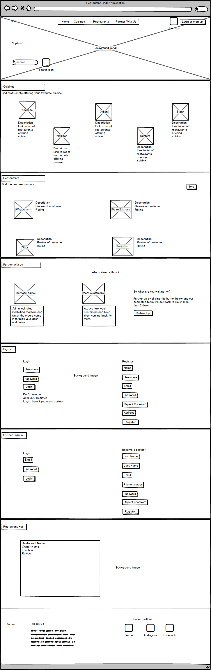

Figure 1 Website wireframe

Wireframes of individual sections of the website are found below.

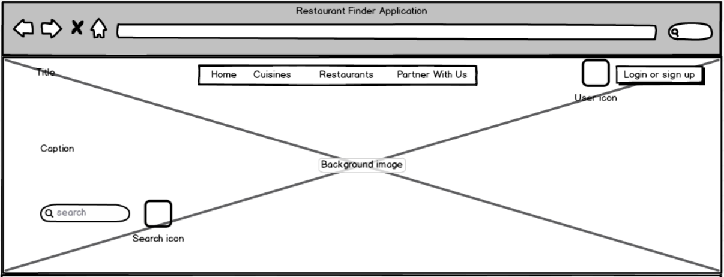

Figure 2 Home

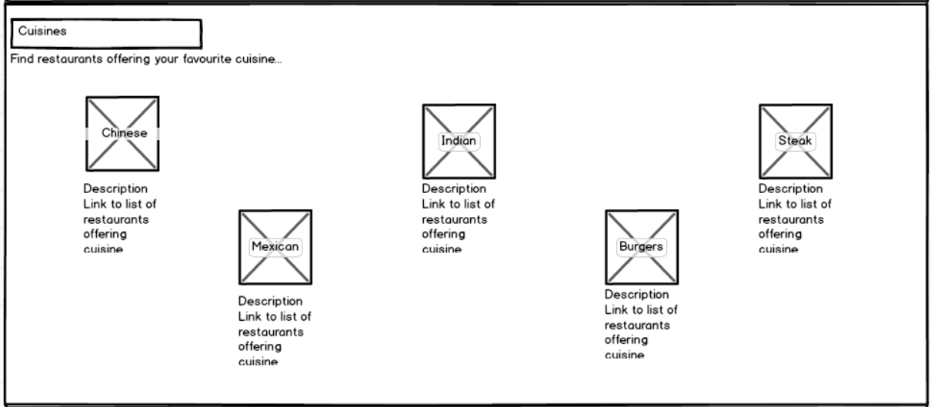

Figure 3 Cuisines

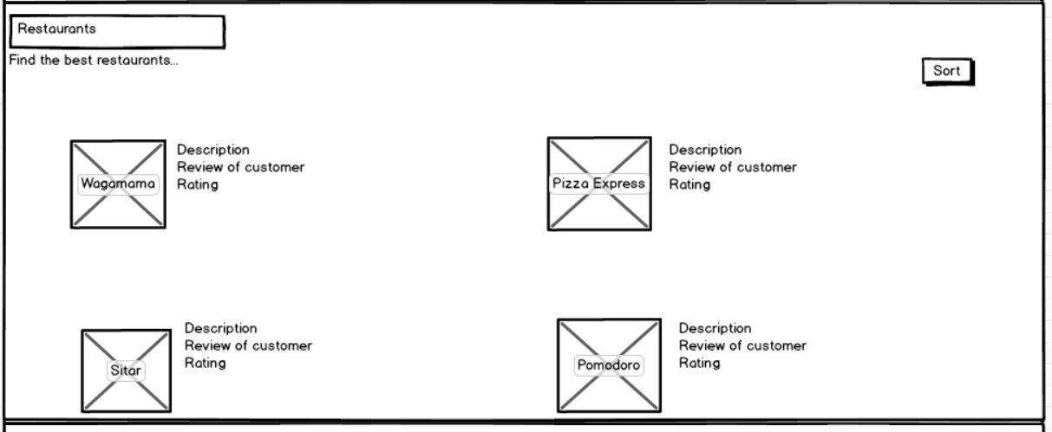

Figure 4 Restaurants

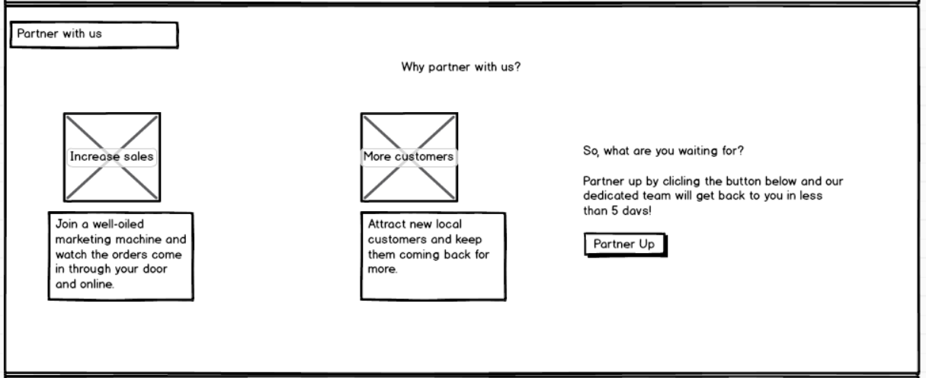

Figure 5 Restaurant owners partner page

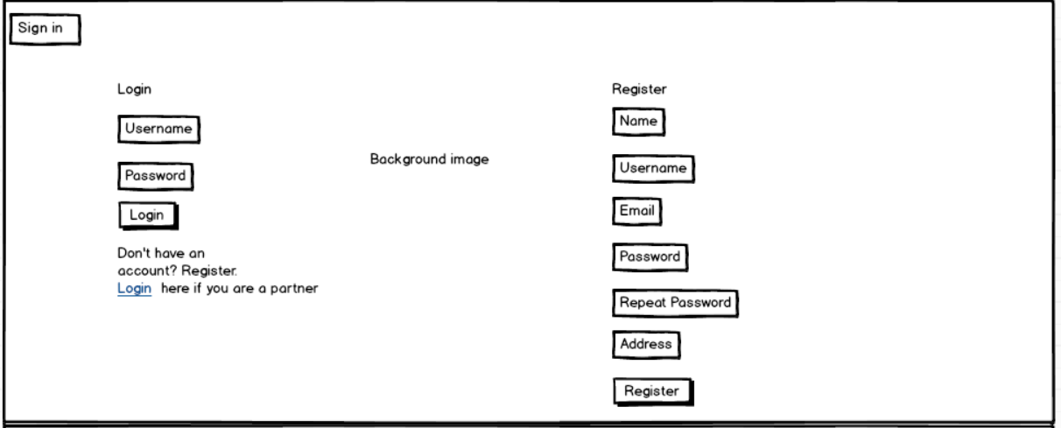

Figure 6 User sign in page

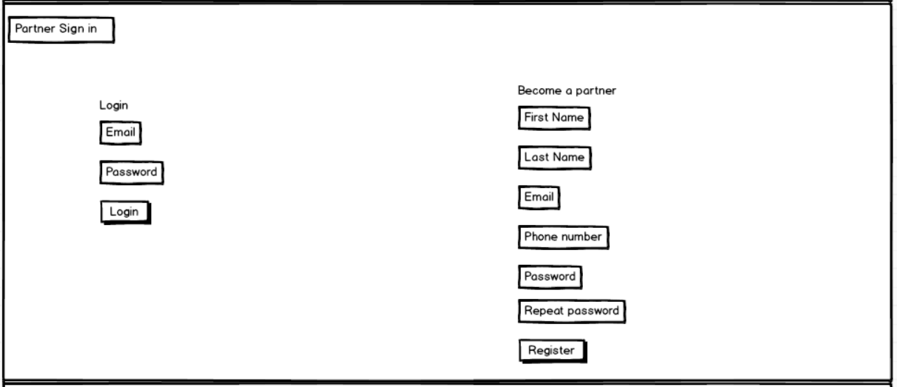

Figure 7 Restaurant owners sign in page

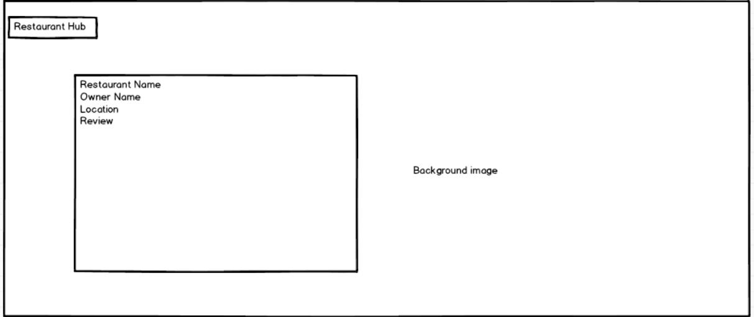

Figure 8 Restaurant analytics page accessed only by owner

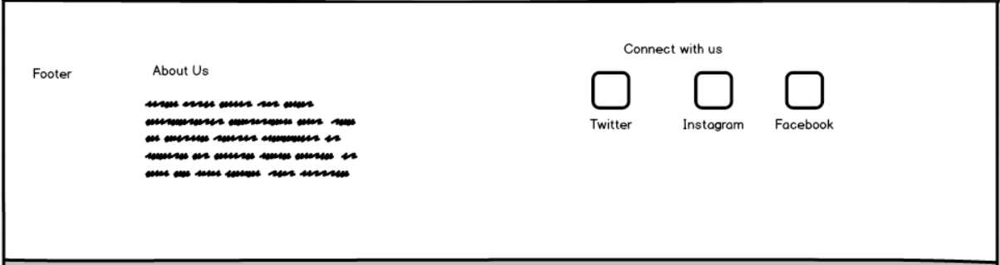

Figure 9 Footer

# Database

The database will be storing details of the restaurants, the users and the restaurant owners. MySQL will be used to store the tables. The following assumptions have been made when designing the database:

* One restaurant owner owns one restaurant.
* One restaurant is reviewed by many users.



Figure 10 Database design of restaurant finder application