**ERD for Student Attendance System**:

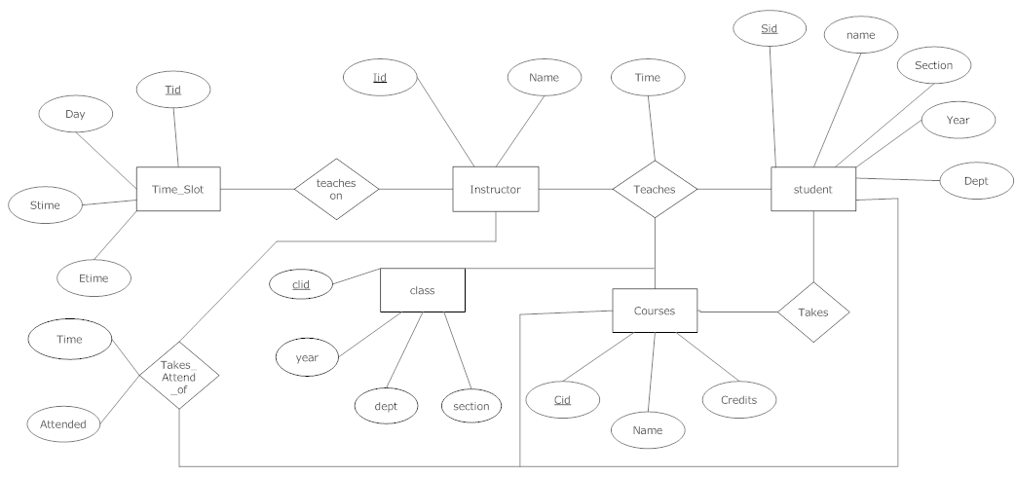

**Table Schema:**

1) Instructor ( Iid varchar2(5) constraint inst_pk Primary Key, name Varchar(10) not null)

2) Class ( Clid varchar2(6) constraint class_pk Primary Key, section Varchar2(1) constraint cls_nn1 not null,

year Number(1) Constraint year_cond_n check(year<5),check(year>0),

dept Varchar2(3) constraint cls_nn2 not null)

3) Timeslot ( Tid NUMBER(5), Day Varchar(5), Stime Varchar(5), Etime Varchar(5), Iid varchar2(5) Constraint time_fk References instructor(Iid), primary key(Tid,Iid))

4) Courses ( cid varchar2(10) constraint course_pk Primary Key, name Varchar(20), credits Number(1) Constraint credit_cond check(credits<5),check (credits>0))

5) Students( Sid varchar2(5) constraint stud_pk Primary Key, name Varchar2(10), section Varchar2(1),

year Number(1) Constraint year_cond check(year<5),check(year>0), dept Varchar2(3))

6) Teaches( Iid varchar2(5) Constraint tech1_fk References instructor(Iid), Tid Number(5), Cid varchar2(10) Constraint tech4_fk References Courses(Cid),

Clid varchar2(5) Constraint tech3_fk1 References class(Clid),

Sid varchar2(5) Constraint tech5_fk1 References students(Sid), primary key(Iid,Tid,Cid,Clid,Sid))

7) Takes( Sid varchar2(5) Constraint tak1_fk References students(Sid),

Cid varchar2(10) Constraint tak2_fk References Courses(Cid), primary key(Sid,Cid))

8) Takes_attend_of( Iid varchar2(5) Constraint att1_fk References instructor(Iid), Tid Number(5),

Sid Varchar2(5) Constraint att3_fk References students(Sid),

Cid Varchar2(10) Constraint att4_fk References Courses(Cid),

Attend Number(5),

primary key(Iid,Sid,Cid))

**Stored Procedures to access Routine:**

**1) Display The Routine For Whole Week:**

*create or replace procedure displayall*

*as*

*tid1 timeslot.tid%type;*

*stime1 varchar(5);*

*clid1 varchar(5);*

*iname varchar(5);*

*cname courses.name%type;*

*dy varchar(5);*

*cursor day_cur2 is*

*select distinct e.clid ,e.tid,e.stime,e.day,i.name,e.name*

*from (select * from (select * from teaches natural join courses) natural join timeslot) e*

*join instructor i using (iid) order by tid;*

*BEGIN*

*DBMS_OUTPUT.PUT_LINE('Period'||chr(9)||'Time'||chr(9)||'Day'||chr(9)||'Teacher'||chr(9)||'Class'||*

*chr(9)||'Subject');*

*OPEN day_cur2;*

*LOOP*

*FETCH day_cur2 INTO clid1,tid1,stime1,dy,iname,cname;*

*EXIT WHEN day_cur2%NOTFOUND;*

*DBMS_OUTPUT.PUT_LINE(tid1||chr(9)||stime1||chr(9)||dy||chr(9)||iname||chr(9)||clid1||chr(9)||*

*cname||chr(9));*

*END LOOP;*

*CLOSE day_cur2;*

*END;*

/

**Output:**

begin

displayall;

end;

/

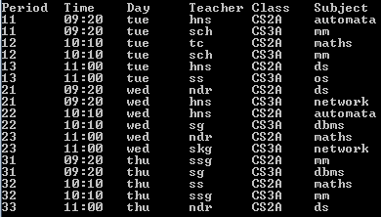

**2) Display The Routine For A Particular Class For The Whole Week.**

*create or replace procedure routine(cl varchar2)*

*as*

*iname instructor.name%type;*

*tid1 number(5);*

*cuid varchar2(5);*

*cname varchar2(10);*

*Stime1 varchar(5);*

*Etime1 varchar(5);*

*clid1 class.clid%type;*

*dy timeslot.day%type;*

*cursor wek_rou(cl varchar2) is*

*Select distinct e.clid,e.tid,e.Stime,e.Etime,i.name,e.cid,e.name,e.day*

*from (select * from (select * from timeslot natural join teaches)*

*natural join courses) e join instructor i using (iid) where clid=cl order by tid;*

*BEGIN*

*DBMS_OUTPUT.PUT_LINE('The Routine for the week for class:'|| cl);*

*DBMS_OUTPUT.PUT_LINE('Period'||chr(9)||'Time'||chr(9)||'Day'||chr(9)||'Teacher'||chr(9)||'Class'||*

*chr(9)||'Subject');*

*OPEN wek_rou(cl);*

*LOOP*

*FETCH wek_rou INTO clid1,tid1,Stime1,Etime1,iname,cuid,cname,dy;*

*EXIT WHEN wek_rou%NOTFOUND;*

*DBMS_OUTPUT.PUT_LINE(Tid1 ||chr(9)|| Stime1 ||chr(9)|| dy ||chr(9)|| iname ||chr(9)|| cuid ||*

*chr(9)|| cname);*

*END LOOP;*

*CLOSE wek_rou;*

*END;*

*/*

**Output:**

begin

routine('CS3A');

end;

/

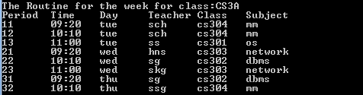

**3) Display The Routine For A Particular Class For A Particular Day Of The Week.**

*create or replace procedure day_routine(day1 varchar2,cl varchar2)*

*as*

*iname varchar(5);*

*tid1 varchar(5);*

*cuid varchar2(5);*

*cname courses.name%type;*

*Stime1 varchar(5);*

*Etime1 varchar(5);*

*clid1 class.clid%type;*

*cursor day_cur(dy varchar2,cl varchar2) is*

*Select distinct e.clid,e.tid,e.Stime,e.Etime,i.name,e.cid,e.name*

*from (select * from (select * from timeslot natural join teaches)*

*natural join courses) e join instructor i using (iid) where clid=cl and day=dy order by tid;*

*BEGIN*

*DBMS_OUTPUT.PUT_LINE('The Routine for the week for class:'|| cl ||' on '||day1);*

*DBMS_OUTPUT.PUT_LINE('Period'||chr(9)||'STime'||chr(9)||'ETime'||chr(9)||'Teacher'||chr(9)||'Cid'||*

*chr(9)||'Subject');*

*OPEN day_cur(day1,cl);*

*LOOP*

*FETCH day_cur INTO clid1,tid1,Stime1,Etime1,iname,cuid,cname;*

*EXIT WHEN day_cur%NOTFOUND;*

*DBMS_OUTPUT.PUT_LINE(Tid1 ||chr(9)|| Stime1 ||chr(9)|| Etime1 ||chr(9)|| iname||chr(9)||cuid||chr(9)||cname);*

*END LOOP;*

*CLOSE day_cur;*

*END;*

*/*

**Output**

begin

day_routine('tue','CS3A');

end;

/

