2.1. Alive actors whose name starts with “Phi” and did not participate in any

movie in 2014

* Pipeline:
* db.Members.aggregate([  
   {  
   $match:  
   {  
   name: {  
   $regex: /^Phi/,  
   },  
   deathyear: null,  
   },  
   },  
   {  
   $lookup:  
   {  
   from: "Movies",  
   localField: "_id",  
   foreignField: "actors.actor",  
   as: "result",  
   },  
   },  
   {  
   $match:  
   {  
   result: {  
   $gt: {  
   $size: 0,  
   },  
   },  
   },  
   },  
   {  
   $match:  
   {  
   startyear: {  
   $ne: 2014,  
   },  
   },  
   },  
  ])
* Results:   
  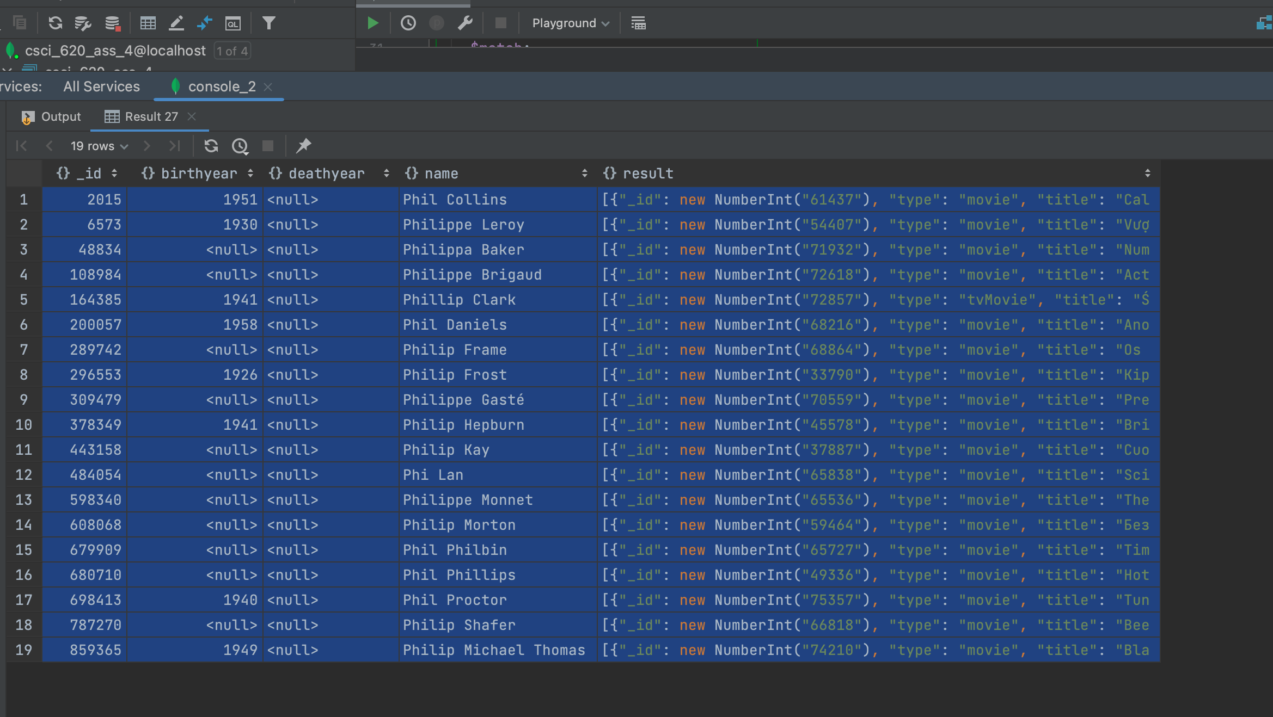

2.2. Producers who have produced more than 50 talk shows in 2017 and

whose name contain “Gill”.

* Pipeline:
* db.Members.aggregate([  
   {  
   $match:  
   {  
   name: {  
   $regex: "Gill",  
   },  
   },  
   },  
   {  
   $lookup: {  
   from: "Movies",  
   localField: "_id",  
   foreignField: "directors",  
   as: "result",  
   },  
   },  
   {  
   $unwind:  
   {  
   path: "$result",  
   preserveNullAndEmptyArrays: false,  
   },  
   },  
   {  
   $match: {  
   "result.startyear": 2017  
   },  
   },  
   {  
   $match: {  
   result: {  
   $gt: {  
   $size: 50,  
   },  
   },  
   },  
   },  
  ])
* Results:   
  No Matches

2.3. Average runtime for movies that were written by members whose names

contain “Bhardwaj” and are still alive.

* Pipeline:
* db.Members.aggregate([  
   {  
   $match: {  
   deathyear: null,  
   // name : {$regex : "Spielberg"}  
   name: {  
   $regex: "Bhardwaj",  
   },  
   },  
   },  
   {  
   $lookup: {  
   from: "Movies",  
   localField: "_id",  
   foreignField: "writers",  
   as: "result",  
   },  
   },  
   {  
   $match: {  
   result: {  
   $gt: {  
   $size: 0,  
   },  
   },  
   },  
   },  
   {  
   $unwind: {  
   path: "$result",  
   preserveNullAndEmptyArrays: false,  
   },  
   },  
   {  
   $group: {  
   _id: null,  
   avgRunTime: {  
   $avg: "$result.runtime",  
   },  
   },  
   },  
  ])
* Results:   
  No Matches

2.4. Alive producers with the greatest number of long-run movies produced

(runtime greater than 120 minutes).Pipeline:

* db.Members.aggregate([  
   {  
   $match:  
   {  
   deathyear: null,  
   },  
   },  
   {  
   $lookup: {  
   from: "Movies",  
   localField: "_id",  
   foreignField: "producers",  
   as: "result",  
   },  
   },  
   {  
   $unwind: {  
   path: "$result",  
   preserveNullAndEmptyArrays: false,  
   },  
   },  
   {  
   $match:  
   {  
   result: {  
   $gt: {  
   $size: 0,  
   },  
   },  
   },  
   },  
   {  
   $match: {  
   result: {  
   $gte: {  
   runtime: 120,  
   },  
   },  
   },  
   },  
  ])