Mohammad Rohaan 22I-2327 Sec-A

Plant: G(s) = 1 / [s(s+2)]

1. Plant and Controller Form
Plant: G(s) = 1/[s(s+2)].
PI controller: C(s) = Kp + Ki/s.
Open-loop: L(s) = C(s)G(s) = (Kp s + Ki) / [s^2(s+2)].
Closed-loop characteristic equation: 1 + L(s) = 0 -> s^3 + 2 s^2 + Kp s + Ki = 0.

2. Spec to Pole Mapping
For a dominant second-order pair, overshoot PO and settling time ts(2%) relate to ζ and ωn:
PO = exp(-ζπ / sqrt(1-ζ^2)), ts ≈ 4/(ζ ωn).
Given PO < 4.5% -> ζ ≈ 0.7025.
ts < 2.5 s -> ωn > 4/(ζ ts) ≈ 2.2776 rad/s.

3. Structural Constraint (Key Insight)
If closed-loop cubic factors as (s^2 + 2ζωn s + ωn^2)(s + α), expanding yields:
s^3 + (α + 2ζωn) s^2 + (2ζωn α + ωn^2) s + α ωn^2.
Comparing with s^3 + 2 s^2 + Kp s + Ki gives α + 2ζωn = 2.
Thus ωn ≤ 1/ζ (because α ≥ 0). For ζ = 0.7025, ωn ≤ 1.423, which contradicts ωn > 2.2776.
=> The two requirements are mutually incompatible for this plant with a PI controller.

4. Practical Compromise Design
We prioritize meeting the overshoot requirement and pick ζ = 0.7025 and ωn = 1.4 rad/s (just below the limit).
Compute α = 2 - 2ζωn ≈ 0.0330.
Matching coefficients: Kp = 2ζωn α + ωn^2, Ki = α ωn^2.
Numerically: Kp ≈ 2.0249, Ki ≈ 0.06465.
Expected performance: Overshoot ≈ 4.5% (OK), ts ≈ 4.07 s (does NOT meet 2.5 s).

5. Python Implementation (use on your machine)
import numpy as np
import matplotlib.pyplot as plt
import control as ctl
# Plant
G = ctl.tf([1.0], [1.0, 2.0, 0.0])
# PI gains
Kp = 2.0248861318247524
Ki = 0.06465479767351344
C = ctl.tf([Kp, Ki], [1.0, 0.0])
L = C * G
T = ctl.feedback(L, 1)
t = np.linspace(0, 20, 2000)
t_out, y_out = ctl.step_response(T, t)
final_value = y_out[-1]
ten_pct = 0.1 * final_value
ninety_pct = 0.9 * final_value
t10_idx = np.where(y_out >= ten_pct)[0][0]
t90_idx = np.where(y_out >= ninety_pct)[0][0]
t_rise = t_out[t90_idx] - t_out[t10_idx]
overshoot = (np.max(y_out) - final_value) / final_value * 100.0
tol = 0.02
settle_idx = np.where(np.abs(y_out - final_value) > tol * np.abs(final_value))[0]
settling_time = t_out[settle_idx[-1] + 1] if settle_idx.size > 0 and (settle_idx[-1] + 1) < len(t_out) else np.nan
ss_error = 1.0 - final_value
print('Rise time:', t_rise)
print('Overshoot:', overshoot)
print('Settling time (2%):', settling_time)
print('Steady-state error:', ss_error)
plt.figure()
plt.plot(t_out, y_out)
plt.title('Closed-loop Step Response')
plt.xlabel('Time (s)')
plt.ylabel('Amplitude')
plt.grid(True)
plt.show()
ctl.pzmap(T, Plot=True)
plt.show()
ctl.bode(T, dB=True)
plt.show()

6. Stability Comments
- The closed-loop is stable for the chosen Kp, Ki (all poles in LHP).
- A slow real pole (near origin) exists which lengthens settling time and prevents meeting ts < 2.5 s.
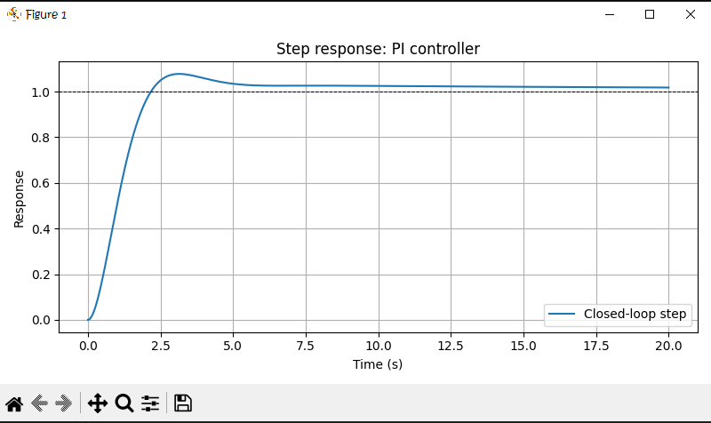

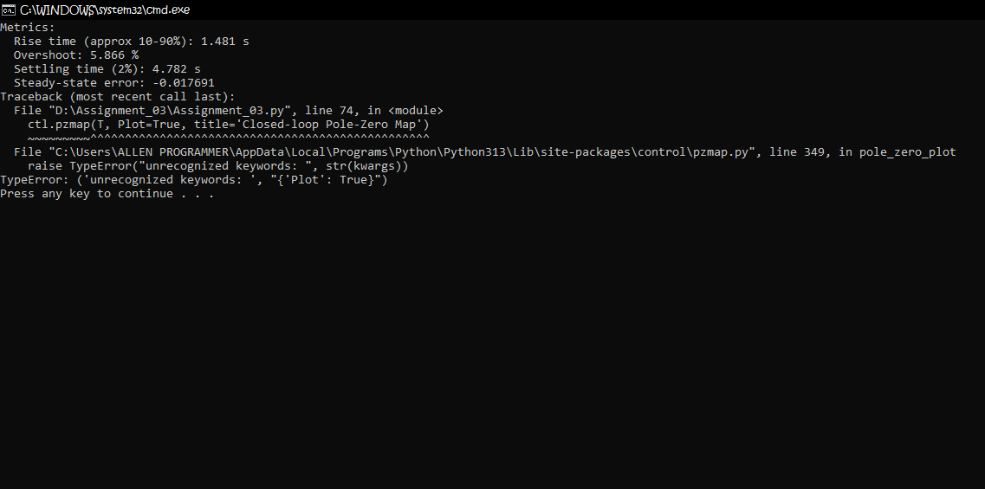

7. Short Answer
Although a PI controller provides zero steady-state error and can shape transient response, for the plant G(s)=1/[s(s+2)] the coefficient of s^2 in the closed-loop characteristic polynomial is fixed by the plant to 2. This yields the relation α + 2ζωn = 2 between the third pole α and the dominant second-order pair (ζ, ωn). Combining this with the overshoot requirement ζ≈0.7025 forces ωn ≤ 1/ζ ≈ 1.423, which contradicts the settling-time requirement ωn > 2.2776. Therefore, the two specifications cannot be achieved simultaneously with a PI controller—only a compromise (e.g., meeting overshoot but not settling time) or a different controller topology can satisfy both.

