Parallel and Distributed Computing — Final Project
K-means with Triangle Inequality: Scheduling vs Dimensionality

Mohammad Rohaan (22I-2327)
[Partner full name] (22I-xxxx) — replace before PDF
Section F

Abstract. We evaluate the public hybrid-triangle-kmeans implementation of Kwedlo & Czochanski (IEEE Access, 2019) on a single shared-memory machine (WSL2). Gap 1 compares default OpenMP loop scheduling versus a guided scheduling build (Makefile DYNAMIC=y) for Elkan’s algorithm while varying OMP_NUM_THREADS on a fixed medium dataset (N=200000, M=128, K=256). Gap 3 varies feature dimension M on synthetic datasets (N=100000, K=256, T=8), comparing Lloyd (naive) to Elkan and reporting the program’s average distance-calculation ratio and wall-clock time. We flag non-comparable scheduling pairs when iterations or SSE diverge (DIFF_PATH).

1. Introduction
K-means alternates assignment (each point to nearest centroid) and update (centroid means). Lloyd’s assignment costs O(NKM) distance evaluations per iteration in the worst case. Triangle-inequality variants such as Elkan’s method prune distance computations while remaining exact under the same arithmetic model as implemented in the reference code.
The base paper studies hybrid MPI/OpenMP implementations on a cluster and compares OpenMP scheduling policies at large scale. We narrow the scope to one workstation (WSL2) and two questions: (i) whether guided scheduling benefits Elkan at small thread counts, and (ii) how pruning effectiveness and runtime scale with dimensionality on synthetic data.

2. Base paper and problem context
Kwedlo & Czochanski (IEEE Access, 2019) implement Lloyd and triangle-inequality variants (Elkan, Annulus, Drake, Yinyang) with hybrid MPI/OpenMP, partition data and bounds across ranks, and use global reductions in the update step. They compare static versus guided OpenMP scheduling on a large machine using a high-dimensional descriptor dataset.
Our work reuses the authors’ single-node OpenMP kmeans binary at commit 0265d45a2eb04fec01ed53fc8635b277082ee284 (Bitbucket: wkwedlo/hybrid-triangle-kmeans). We do not modify their clustering algorithms; contributions are controlled experiments and analysis.

3. Project scope and objectives

3.1 In scope
- Author kmeans: two builds — default OpenMP loops vs DYNAMIC=y (guided on annotated loops).
- Algorithms: -a naive (Lloyd) baseline; -a elkan for triangle-inequality study.
- Gap 1: OMP_NUM_THREADS ∈ {1,2,4,8}, dataset gap1_medium.bin (200000×128), K=256, seed 42, stop -R 1e-4.
- Gap 3: N=100000, K=256, T=8, M ∈ {2,8,16,32,64,128}, synthetic bins from gen_gap3_bins.py.

3.2 Out of scope
- Multi-node MPI scaling (mpikmeans), GPU, edits to author Clust/*.cpp, hand-written SIMD intrinsics.

3.3 Research questions
RQ1: On WSL, does guided scheduling improve Elkan wall time versus the static-oriented build as threads increase, and when are runs not comparable because iterations or SSE differ?
RQ2: As M increases on i.i.d. synthetic data, how do the average distance-calculation ratio and Elkan vs naive runtime behave?

4. Baseline method (Lloyd / naive)
Baseline assignment evaluates distances to all K centroids per point (implementation: -a naive / NaiveKMA). Complexity of assignment is O(NKM) per iteration in the full-distance regime; the program reports Avg distance calculations ratio: 100 for naive runs in our logs.

5. Proposed methodology
Elkan (-a elkan) maintains bounds to skip many distance evaluations. We compare two binaries: kmeans_static_gap1 (make OPT=y OPENMP=y) and kmeans_guided_gap1 (same with DYNAMIC=y). Fair comparison when total iterations and bracket SSE match; otherwise label DIFF_PATH (parallel floating-point reduction order and scheduling can change the numerical path).

6. Experimental setup

6.1 Hardware and OS (recorded on WSL)
Item | Value
OS / kernel | Linux x86_64, WSL2 (example: 6.6.x-microsoft-standard-WSL2)
CPU | Intel Core i5-5300U @ 2.30GHz (replace if your machine differs)
Logical CPUs | 8 (nproc)
RAM (MemTotal) | ~7.9 GiB (8068228 kB — update if you rerun on another PC)
Toolchain | g++ (Ubuntu 13.3.x) — see README

6.2 Software and baseline revision
Compiler: g++ with -fopenmp per upstream Makefile; release kmeans targets. Git commit: 0265d45a2eb04fec01ed53fc8635b277082ee284.

6.3 Datasets and parameters
Gap 1: gap1_medium.bin — N=200000, M=128. Gap 3: gap3_N100000_M*.bin under experiments/data_gap3/, seed 42 from gen_gap3_bins.py. Common: K=256, Forgy init (-t default), -r 42, -R 1e-4.

7. Measurement methodology (profiling)
Primary metrics come from program stdout (application-level instrumentation), not an external sampling profiler: k-means execution time; Avg distance calculations ratio; total iterations; Best MSE (SSE). Logs: experiments/gap1_medium_runs.txt, experiments/gap3_runs.txt. Tables and plots generated with experiments/plot_pdc_figures.py.

8. Results

8.1 Gap 1 — Static-oriented vs guided (Elkan)
Table 1 summarizes medians from paired STATIC/GUIDED blocks (see parse_gap1_log.py). Ratio guided/static uses comparable pairs only (same iterations and |ΔSSE|<0.5 on bracket total).
Threads | Median static (s) | Median guided (s) | Median ratio G/S | Comparable / total
1 | 18.9018 | 18.8630 | 0.9943 | 5 / 5
2 | 11.3643 | 10.9344 | 0.9694 | 5 / 5
4 | 7.9637 | 7.9121 | — | 0 / 5
8 | 8.6657 | 8.0045 | — | 0 / 5
At T=4 and T=8, no pairs met the comparability criterion (DIFF_PATH). Do not claim a scheduling ‘winner’ from median times alone when paths differ.
Figure 1. Gap 1 — median wall time (all pairs).
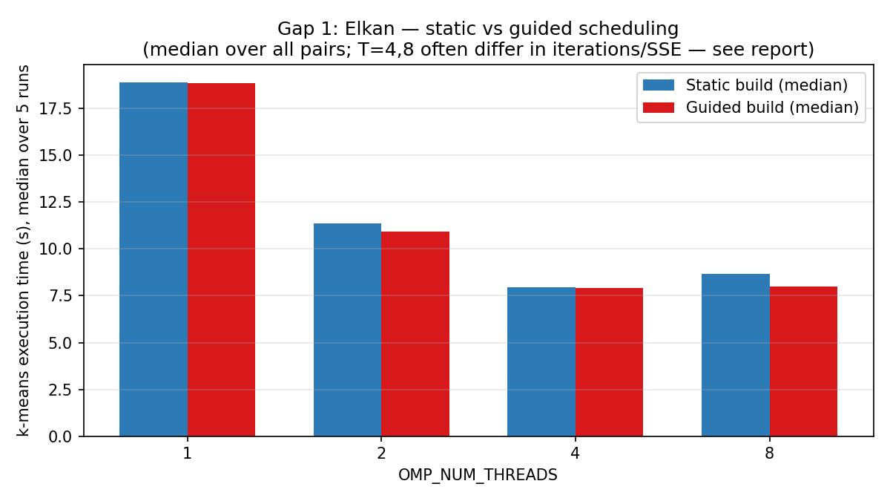
Figure 2. Gap 1 — medians for comparable pairs only (T=1,2).
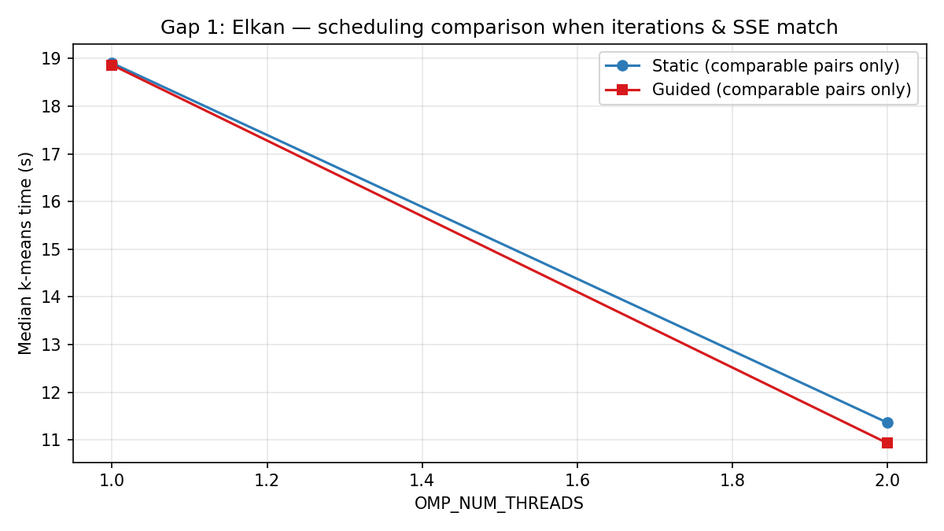

8.2 Gap 3 — Dimensionality (N=100000, K=256, T=8)
Table 2. Runtime, pruning ratio, and SSE comparability notes.
M | Naive (s) | Elk st | Elk gd | Ratio st | Ratio gd | it L/Es/Eg | n vs Es | Es vs Eg
2 | 13.3161 | 2.7458 | 2.6948 | 0.298 | 0.298 | 82/82/82 | match | match
8 | 4.1285 | 2.8219 | 2.8476 | 2.321 | 2.432 | 48/48/45 | match | differs
16 | 4.7254 | 3.2900 | 2.8113 | 5.671 | 5.671 | 47/47/47 | match | match
32 | 4.1874 | 2.5037 | 2.4925 | 11.716 | 11.716 | 30/30/30 | differs | match
64 | 5.7816 | 3.0624 | 3.5013 | 20.039 | 19.459 | 24/23/24 | differs | differs
128 | 9.0140 | 4.3204 | 4.0998 | 31.831 | 31.791 | 17/17/17 | differs | differs
Figure 3. Gap 3 — Avg distance calculations ratio vs M.
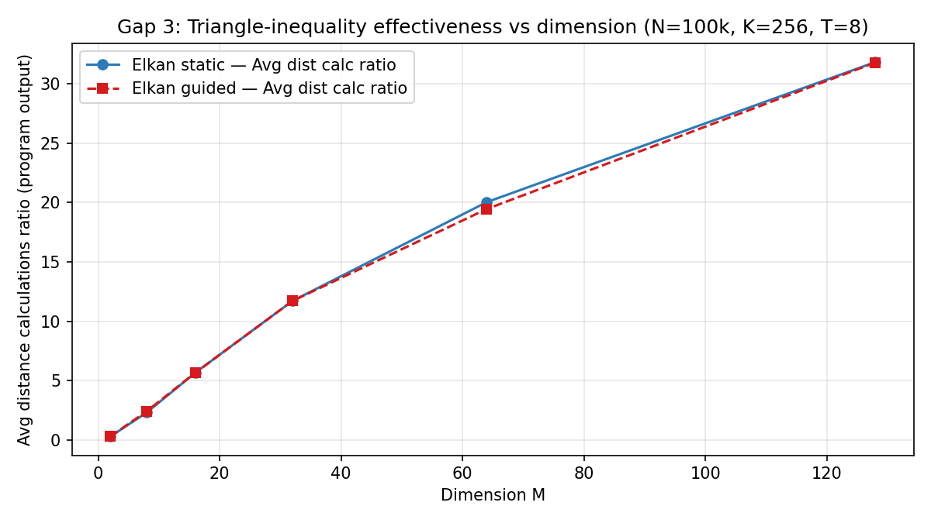
Figure 4. Gap 3 — Wall time vs M (naive vs Elkan builds).
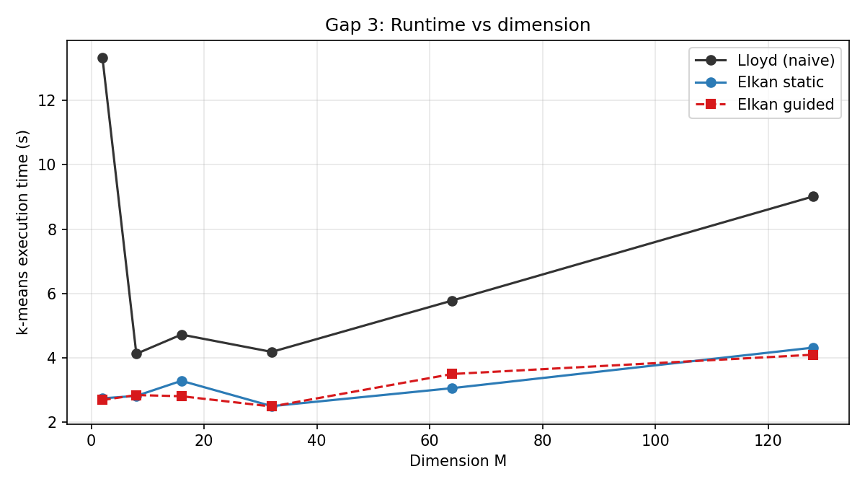
Figure 5. Gap 3 — Naive time / Elkan static time vs M.
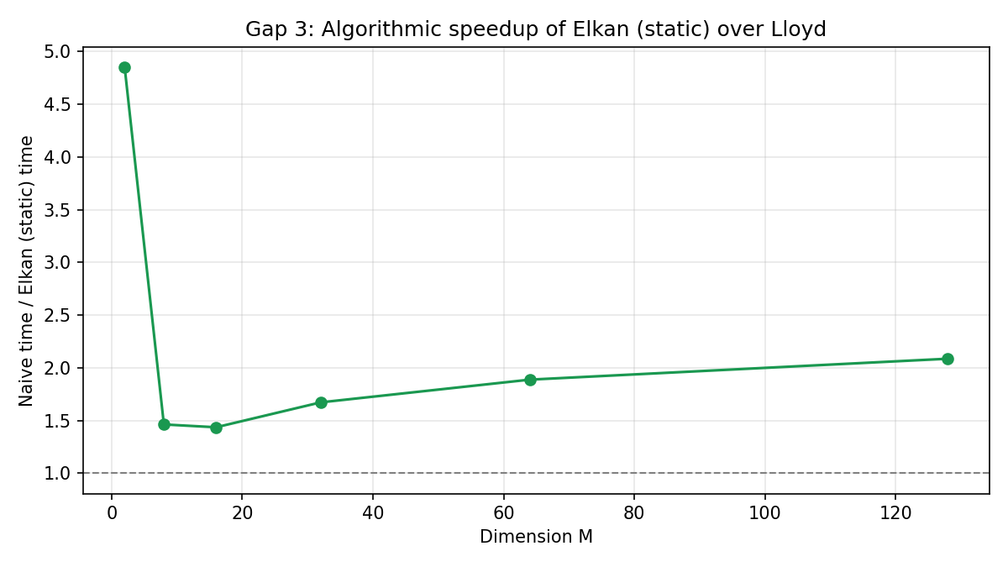

9. Discussion
Gap 1: At T=1–2, guided can be slightly faster when paths match; at T=4–8, scheduling-associated differences in reduction order yield mismatched iteration counts or SSE, so scheduling-only conclusions are ambiguous without deterministic reductions.
Gap 3: The average distance-calculation ratio rises with M on uniform random data, consistent with weaker pruning when distances concentrate (high-dimensional phenomenon — cite Beyer et al. 1999; Aggarwal et al. 2001 in your PDF references list).

9.1 Optional polish — variance and future work
Single timed runs per Gap 3 configuration: repeat each configuration 3–5× and report median/IQR for production-grade conclusions. Clustered synthetic mixtures could better match K-means use cases than pure i.i.d. uniforms. Deterministic parallel reductions (if enabled in a fork) would reduce DIFF_PATH frequency when comparing schedules.

10. Conclusion
We characterized Elkan vs naive across dimensions and compared OpenMP scheduling builds on one workstation. Scheduling effects are thread-dependent and sometimes non-comparable at higher T; pruning weakens as M increases on our synthetic generator. Future work: repeated trials, richer datasets, optional MPI scaling in lab environments.

11. LLM usage disclosure
LLMs (e.g. Cursor/ChatGPT) assisted with outlining, environment troubleshooting (PEP 668, dos2unix), and plotting/log-parsing workflow suggestions. All timings, SSE values, and figures were produced locally from our binaries and logs; both authors reviewed results against stdout.

12. References (minimum)
- W. Kwedlo & M. Czochanski, “A hybrid MPI/OpenMP parallelization of K-means algorithms accelerated using the triangle inequality,” IEEE Access, 2019. DOI 10.1109/ACCESS.2019.2907885.
- C. Elkan, “Using the triangle inequality to accelerate k-means,” ICML, 2003.
- G. Hamerly & C. Drake, Accelerating Lloyd’s Algorithm for K-Means Clustering, Springer, 2015.
- OpenMP Application Program Interface v4.5 (scheduling).
- K. Beyer et al., “When is nearest neighbor meaningful?” ICDT, 1999.
- C. Aggarwal et al., “On the surprising behavior of distance metrics in high dimensional space,” ICDT, 2001.
- hybrid-triangle-kmeans repository, Bitbucket, commit 0265d45a2eb04fec01ed53fc8635b277082ee284.

Appendix A — Reproduction commands
# Gap 1 summary (stdout pairs in gap1_medium_runs.txt)
python3 ~/22i-2327_F_FinalProject/experiments/parse_gap1_log.py \
~/22i-2327_F_FinalProject/experiments/gap1_medium_runs.txt \
| tee ~/22i-2327_F_FinalProject/experiments/gap1_parsed_summary.txt
# Figures + CSV + TABLE_*.md
python3 ~/22i-2327_F_FinalProject/experiments/plot_pdc_figures.py \
--exp-dir ~/22i-2327_F_FinalProject/experiments
# Gap 3 matrix (after data_gap3 bins exist)
export OMP_NUM_THREADS=8
~/22i-2327_F_FinalProject/experiments/run_gap3_matrix.sh

Appendix B — Sample log headers (Gap 3)
======== gap3_N100000_M128 naive static ========
Loading dataset /home/codetech/22i-2327_F_FinalProject/experiments/data_gap3/gap3_N100000_M128.bin... 100000 vectors, 128 features
Avg distance calculations ratio: 100
k-means execution time: 9.01404 seconds
======== gap3_N100000_M128 elkan static ========
Loading dataset /home/codetech/22i-2327_F_FinalProject/experiments/data_gap3/gap3_N100000_M128.bin... 100000 vectors, 128 features
Avg distance calculations ratio: 31.8309
k-means execution time: 4.32035 seconds
======== gap3_N100000_M128 elkan guided ========
Loading dataset /home/codetech/22i-2327_F_FinalProject/experiments/data_gap3/gap3_N100000_M128.bin... 100000 vectors, 128 features
Avg distance calculations ratio: 31.7908
k-means execution time: 4.09984 seconds
======== gap3_N100000_M16 naive static ========
Loading dataset /home/codetech/22i-2327_F_FinalProject/experiments/data_gap3/gap3_N100000_M16.bin... 100000 vectors, 16 features
Avg distance calculations ratio: 100
k-means execution time: 4.72543 seconds
======== gap3_N100000_M16 elkan static ========
Loading dataset /home/codetech/22i-2327_F_FinalProject/experiments/data_gap3/gap3_N100000_M16.bin... 100000 vectors, 16 features
Avg distance calculations ratio: 5.67133
k-means execution time: 3.29002 seconds
======== gap3_N100000_M16 elkan guided ========
Loading dataset /home/codetech/22i-2327_F_FinalProject/experiments/data_gap3/gap3_N100000_M16.bin... 100000 vectors, 16 features
Avg distance calculations ratio: 5.67133
k-means execution time: 2.81132 seconds
======== gap3_N100000_M2 naive static ========
Loading dataset /home/codetech/22i-2327_F_FinalProject/experiments/data_gap3/gap3_N100000_M2.bin... 100000 vectors, 2 features
Avg distance calculations ratio: 100
k-means execution time: 13.3161 seconds
======== gap3_N100000_M2 elkan static ========
Loading dataset /home/codetech/22i-2327_F_FinalProject/experiments/data_gap3/gap3_N100000_M2.bin... 100000 vectors, 2 features
Avg distance calculations ratio: 0.297865
k-means execution time: 2.74585 seconds
======== gap3_N100000_M2 elkan guided ========
Loading dataset /home/codetech/22i-2327_F_FinalProject/experiments/data_gap3/gap3_N100000_M2.bin... 100000 vectors, 2 features
Avg distance calculations ratio: 0.297932
k-means execution time: 2.69483 seconds
======== gap3_N100000_M32 naive static ========
Loading dataset /home/codetech/22i-2327_F_FinalProject/experiments/data_gap3/gap3_N100000_M32.bin... 100000 vectors, 32 features
Avg distance calculations ratio: 100
k-means execution time: 4.18744 seconds
======== gap3_N100000_M32 elkan static ========
Loading dataset /home/codetech/22i-2327_F_FinalProject/experiments/data_gap3/gap3_N100000_M32.bin... 100000 vectors, 32 features
Avg distance calculations ratio: 11.7163
k-means execution time: 2.50374 seconds
======== gap3_N100000_M32 elkan guided ========
Loading dataset /home/codetech/22i-2327_F_FinalProject/experiments/data_gap3/gap3_N100000_M32.bin... 100000 vectors, 32 features
Avg distance calculations ratio: 11.7163
k-means execution time: 2.49249 seconds
======== gap3_N100000_M64 naive static ========
Loading dataset /home/codetech/22i-2327_F_FinalProject/experiments/data_gap3/gap3_N100000_M64.bin... 100000 vectors, 64 features
Avg distance calculations ratio: 100
k-means execution time: 5.78157 seconds
======== gap3_N100000_M64 elkan static ========
Loading dataset /home/codetech/22i-2327_F_FinalProject/experiments/data_gap3/gap3_N100000_M64.bin... 100000 vectors, 64 features
Avg distance calculations ratio: 20.0393
k-means execution time: 3.06244 seconds
======== gap3_N100000_M64 elkan guided ========
Loading dataset /home/codetech/22i-2327_F_FinalProject/experiments/data_gap3/gap3_N100000_M64.bin... 100000 vectors, 64 features
Avg distance calculations ratio: 19.4586
k-means execution time: 3.50134 seconds
======== gap3_N100000_M8 naive static ========
Loading dataset /home/codetech/22i-2327_F_FinalProject/experiments/data_gap3/gap3_N100000_M8.bin... 100000 vectors, 8 features
Avg distance calculations ratio: 100
k-means execution time: 4.12854 seconds
======== gap3_N100000_M8 elkan static ========
Loading dataset /home/codetech/22i-2327_F_FinalProject/experiments/data_gap3/gap3_N100000_M8.bin... 100000 vectors, 8 features
Avg distance calculations ratio: 2.3207
k-means execution time: 2.8219 seconds
======== gap3_N100000_M8 elkan guided ========
Loading dataset /home/codetech/22i-2327_F_FinalProject/experiments/data_gap3/gap3_N100000_M8.bin... 100000 vectors, 8 features
Avg distance calculations ratio: 2.43171
k-means execution time: 2.84764 seconds

Appendix C — Optional perf stat (example command)
If linux-tools-generic / perf is available, a single aggregate hardware counter snapshot can complement program metrics. Example (edit paths if needed):
perf stat -e cycles,instructions,cache-references,cache-misses \
~/22i-2327_F_FinalProject/experiments/bin/kmeans_static_gap1 \
~/22i-2327_F_FinalProject/experiments/data_gap3/gap3_N100000_M32.bin \
-a elkan -c 256 -v 1 -r 42 -R 1e-4
(perf not run or unavailable — run the command above on WSL and paste output here manually.)

Appendix D — Gap 1 log excerpt
=== threads=1 run=1 STATIC ===
../experiments/bin/kmeans_static_gap1 compilation time: May 11 2026 01:17:39
Git branch: master
Other (probably g++) compiler
sizeof(OPTFLOAT): 4
sizeof(EXPFLOAT): 8
Minimal number of huge pages (threshold) per NUMA Node: 1.00
NUMA optimizations on
Loading dataset gap1_medium.bin... 200000 vectors, 128 features
Loading took 0.16727 seconds
Number of clusters: 256
First reclustering in YinyangMod at iteration: 5
Seeed of rng: 42
OpenMP version with 1 threads
Forgy initialization used
ElkanKMA
Initialization time: 0.000159859 seconds
Avg distance calculations ratio: 29.2536
18 total iterations
k-means execution time: 19.8992 seconds
Highest absolute difference between thread 0 and real time: Process 0 Delta: -0.319 Relative: 1.630%
Wall clock resolution: 1e-09 seconds
Thread clock resolution: 1e-09 seconds
k-means iteration time: 1.10551 seconds
0 k-means runs
Best MSE (SSE) 9.918280631 (1983656.126250267)
Total program execution time: 20.4512 seconds
=== threads=1 run=1 GUIDED ===
../experiments/bin/kmeans_guided_gap1 compilation time: May 11 2026 01:17:57
Git branch: master
Other (probably g++) compiler
sizeof(OPTFLOAT): 4
sizeof(EXPFLOAT): 8
Minimal number of huge pages (threshold) per NUMA Node: 1.00
NUMA optimizations on
Loading dataset gap1_medium.bin... 200000 vectors, 128 features
Loading took 0.132901 seconds
Number of clusters: 256
First reclustering in YinyangMod at iteration: 5
Seeed of rng: 42
OpenMP version with 1 threads
Forgy initialization used
ElkanKMA
Initialization time: 0.000238772 seconds
Avg distance calculations ratio: 29.2536
18 total iterations
k-means execution time: 18.9812 seconds
Highest absolute difference between thread 0 and real time: Process 0 Delta: -0.307 Relative: 1.644%
Wall clock resolution: 1e-09 seconds
Thread clock resolution: 1e-09 seconds
k-means iteration time: 1.05451 seconds
0 k-means runs
Best MSE (SSE) 9.918280631 (1983656.126250267)
Total program execution time: 19.2723 seconds
=== threads=1 run=2 STATIC ===
../experiments/bin/kmeans_static_gap1 compilation time: May 11 2026 01:17:39
Git branch: master
Other (probably g++) compiler
sizeof(OPTFLOAT): 4
sizeof(EXPFLOAT): 8
Minimal number of huge pages (threshold) per NUMA Node: 1.00
NUMA optimizations on
Loading dataset gap1_medium.bin... 200000 vectors, 128 features
Loading took 0.162163 seconds
Number of clusters: 256
First reclustering in YinyangMod at iteration: 5
Seeed of rng: 42
OpenMP version with 1 threads
Forgy initialization used
ElkanKMA
Initialization time: 0.000147367 seconds
Avg distance calculations ratio: 29.2536
18 total iterations
k-means execution time: 18.9018 seconds
Highest absolute difference between thread 0 and real time: Process 0 Delta: -0.307 Relative: 1.650%
Wall clock resolution: 1e-09 seconds
Thread clock resolution: 1e-09 seconds
k-means iteration time: 1.0501 seconds
0 k-means runs
Best MSE (SSE) 9.918280631 (1983656.126250267)

