Computer Science Department

University of Computer & Emerging Sciences (FAST-NUCES)

HOME WORK ASSIGNMENT COVER SHEET

COURSE TITLE Software Design & Analysis COURSE CODE CS3004

INSTRUCTOR DR. EJAZ AHMED TYPE √ (Please tick)
Indiv. Group
ASSIGNMENT NO HW-2 (Class)

ASSIGNMENT Use Case Diagram and Development of Template of POS

HAND OUT DATE 25-SEP-2025 DUE DATE 05-OCT-2025

ESTIMATE TIME 8 Hours

ASSESSMENT CRITERIA (or attached) | % Mark
Questions are attached (print copy)

This HW includes the following tasks (Total 4)
Requirement Analysis, Iterations, Use Case Diagram and Use Case Detailed Template

Submission: Any mistake or missing material will lead to the reduction of 5% marks.

Group of max 3 students is allowed, individual work is discouraged with 10% deduction

TO BE COMPLETED BY STUDENT (TEAM LEAD) GROUP MEMBERS ID
ID Sec#
ID Sec#
ID Sec#

NAME

ID NO Section#

Time Taken

DECLARATION: I/We declare that this Coursework is my/our group’s own work

SIGNATURES (All members)

GRADE/ MARK AWARDED COMMENTS

INSTRUCTOR’S SIGNATURE DATE

Brief:

The cashier at the POS primarily uses this interface to sell items and generate invoices for both registered and non-registered customers.

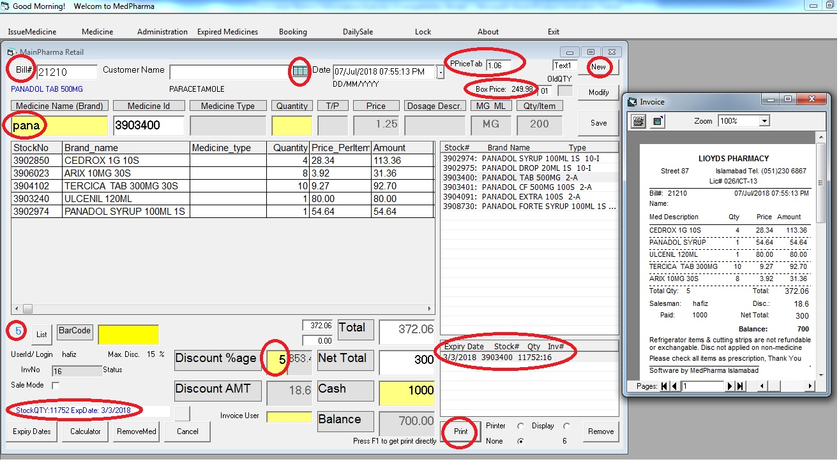

Requirements:

- Write down requirements analysis and Iterations
- Draw Use Case Diagram by considering other subsystems that support POS UI.
- Develop this UI using Java Swing/Fx (front end navigations)

