Angular CLI commands

- INSTALLING ANGULAR: npm install -g @angular/cli@latest (-g: globally latest: not a must)

- NAVIGATING TO THE FOLDER: cd C:\Users\drohacsi\OneDrive - ISYS-ON Informatikai Tanácsadó Kft\Dokumentumok\udemy

- CREATING A PROJECT: ng new project-name –-no-strict (must not contain: whitespace, „test”)

- NAVIGATING TO THE PROJECT: cd project-name

- RUNNING THE BUILD: ng serve (now you can see it in the browser: localhost:4200 -> depending on the port, 4200 is default)

- CREATING CUSTOM COMPONENTS: ng generate component <name> / ng g c <name> (new folder in app folder, 4 files like in app component)

- INSTALLING BOOTSTRAP: npm install --save bootstrap@3

Angular notes (code)

Property binding & Databinding
It is used to bind the values of component or model properties to the HTML element.
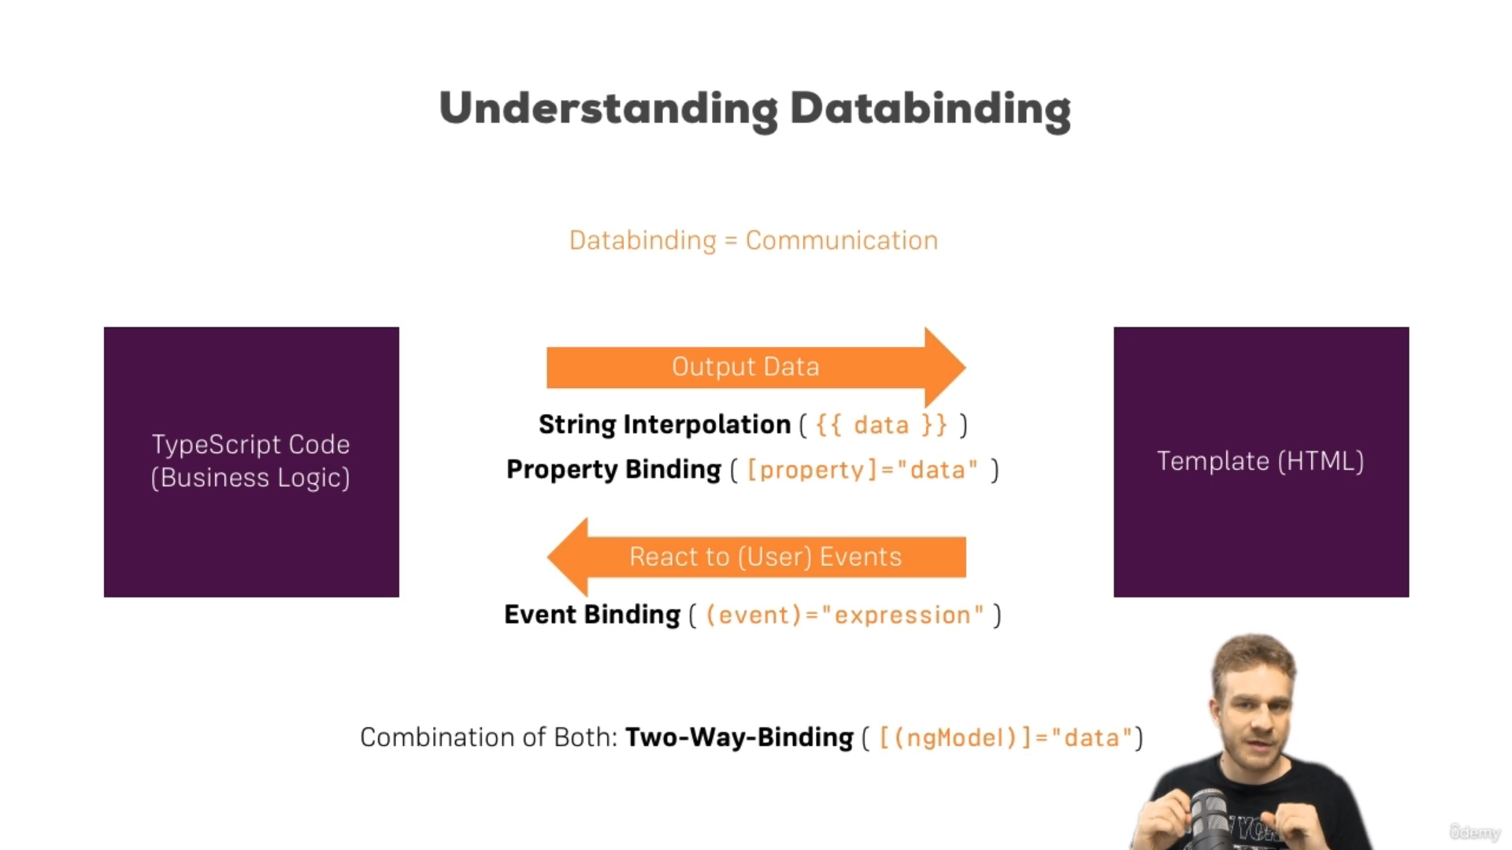

Input data to another component
From (ts): @Input(<name>) smth:String
@Input('srvElement') element: { type: string; name: string; conent: string };
To (html): [element] = smthElse
*ngFor="let serverElement of serverElements"
[srvElement]="serverElement"

Local references (in the same component)
<div *ngIf="onlyOdd; else odds">
<li class="list-group-item" *ngIf="number % 2 == 0">
{{ number }}
</li>
</div>
<ng-template #odds>
<li class="list-group-item" *ngIf="number % 2 != 0">
{{ number }}
</li>
</ng-template>

Encapsulation
The View Encapsulation in Angular is a strategy which determines how angular hides (encapsulates) the styles defined in the component from bleeding over to the the other parts of the application.
@Component({
selector: 'app-server-element',
templateUrl: './server-element.component.html',
styleUrls: ['./server-element.component.css'],
encapsulation :ViewEncapsulation.None
})
The CSS will be applied to other htmls because we ’disable’ the encapsulation which would prevent that.

Projecting Content into other Components (ng-content)
other component with the app-server-element tag:
<app-server-element>
<p>
<strong *ngIf="serverElement.type === 'server'" style="color: red">{{
serverElement.content
}}</strong>
<em *ngIf="serverElement.type === 'blueprint'">{{
serverElement.content
}}</em>
</p>
</app-server-element>
server-element.html:
<div class="panel-body">
<ng-content></ng-content> ← the content is going to appear here
</div>

Component Lifecycle
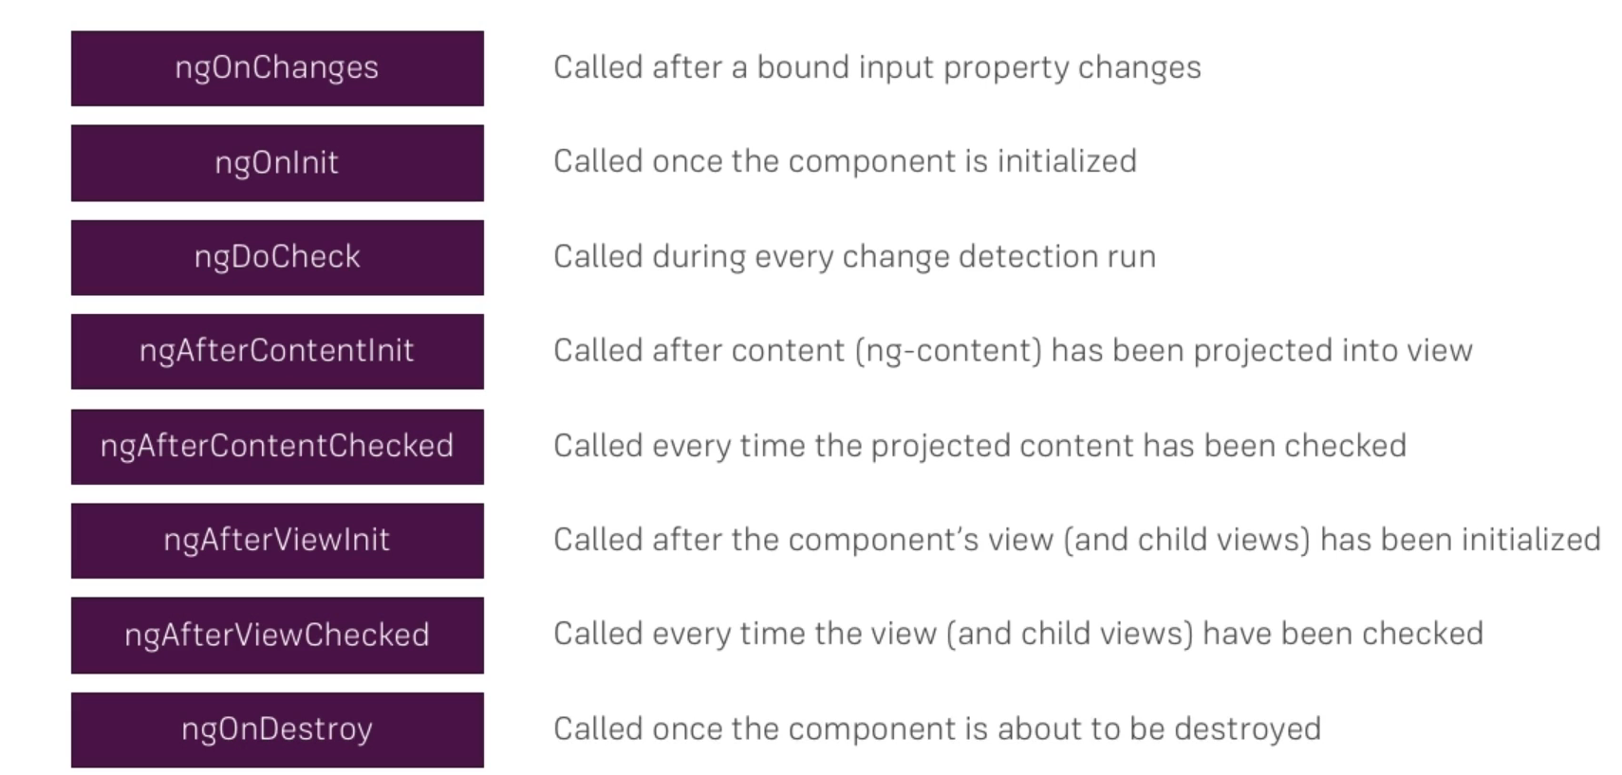

Attribute Directives vs. Structural Directives
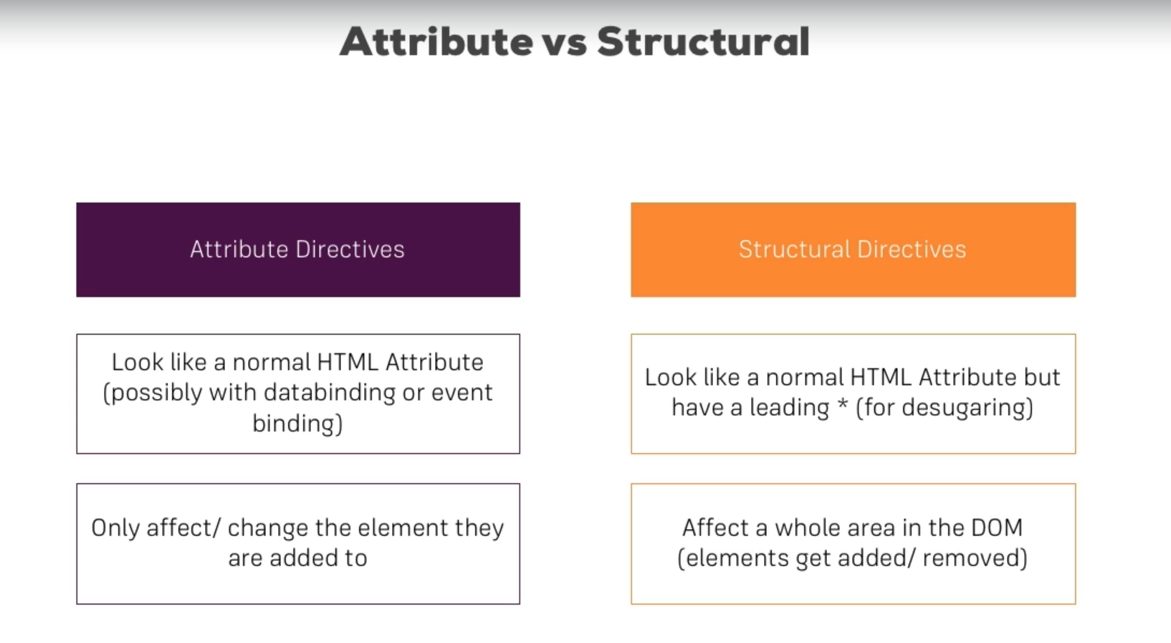
<ul
class="list-group"
*ngFor="let number of numbers"
[ngClass]="{ even: number % 2 == 0 }"
[ngClass]="{ even: number % 2 == 0 }"
[ngStyle]="{ color: number % 2 != 0 ? 'blue': 'plum'}"
>
<div *ngIf="onlyOdd; else odds">
<li class="list-group-item" *ngIf="number % 2 == 0">
{{ number }}
</li>
</div>
<ng-template #odds>
<li class="list-group-item" *ngIf="number % 2 != 0">
{{ number }}
</li>
</ng-template>
</ul>

HostListener
better-highlight.directive.ts (selector: appBetterHighlight):
@HostListener('mouseenter') mouseover(eventData: Event) {
this.renderer.setStyle(
this.elRef.nativeElement,
'background-color',
'pink'
);
}

app.component.html:
<p appBetterHighlight>Style mee slay!</p>
output:
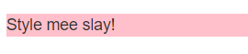

HostBind
@HostBinding('style.backgroundColor') backgroundColor: string; --> accesing the DOM
@HostListener('mouseenter') mouseover(eventData: Event) {
this.backgroundColor = 'plum';
}

Structural Directive
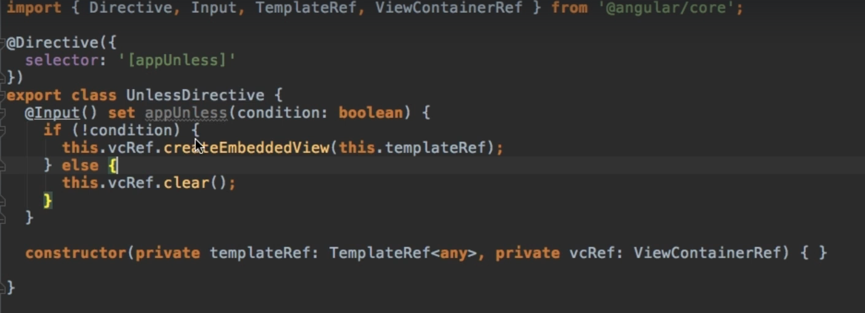
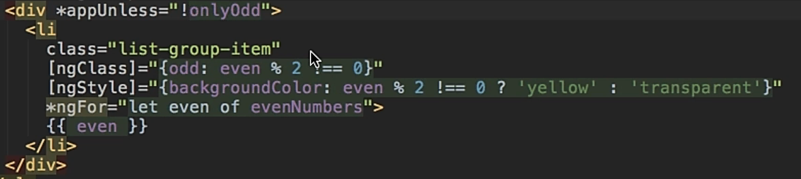

*ngSwitch
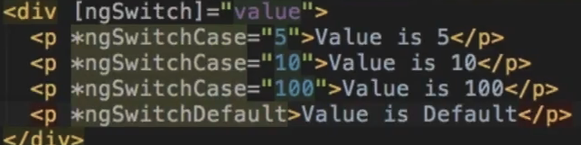

Services
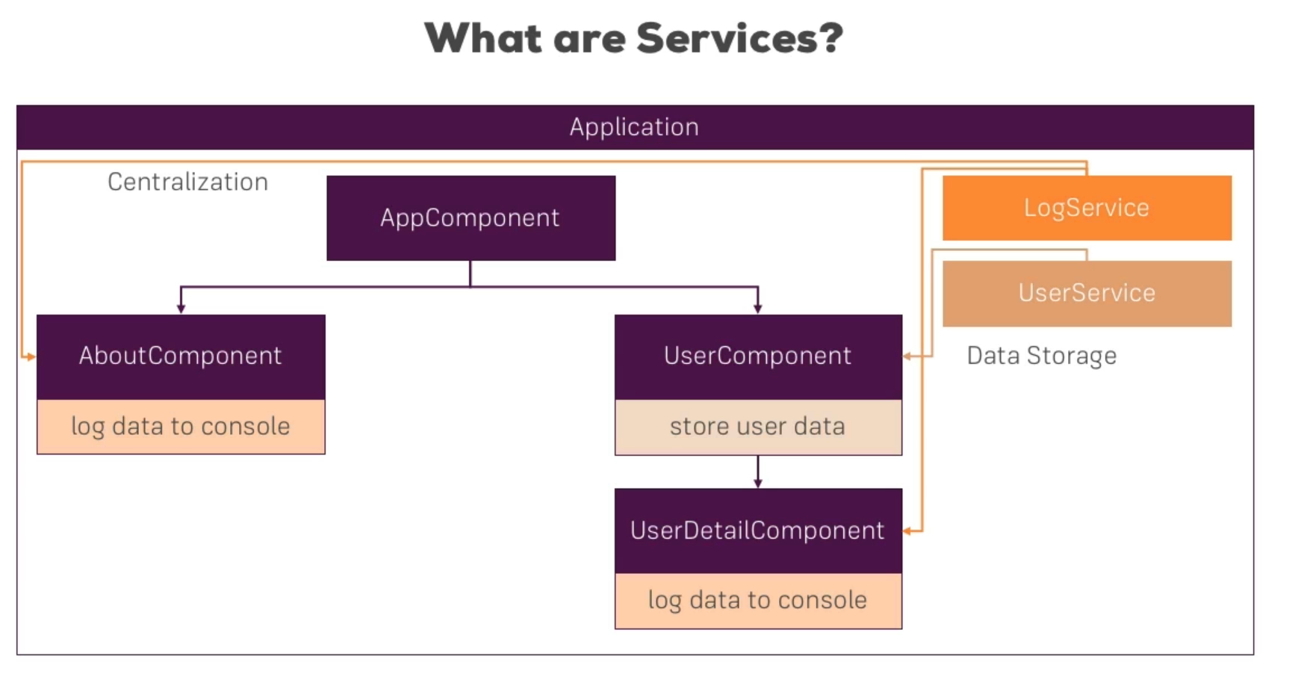
- no decoration needed
- services are simple typescript classes
- it is good for outsourcing your code into a service and have it there (it can prevent repeating code)
providers: [LoggingService],

constructor(private loggingService: LoggingService) {}

- if app.module has an instance of a service, all the child components will ’receive’ the same instace of that service, so if we create a new one in the child component, we use another instace of that service
- to use the same instance as the parent component uses, remove the service’s name from the providers list

Routes
routing-start
app.module.ts:
- import { Routes, RouterModule } from '@angular/router';
- imports: [BrowserModule, FormsModule, RouterModule.forRoot(appRoutes)],
- const appRoutes: Routes = [
{ path: '', component: HomeComponent },
{ path: 'users', component: UsersComponent },
{ path: 'servers', component: ServersComponent },
];

app.component.html:
- <router-outlet></router-outlet>

- absolute path: /servers

- relative path: servers

Observables
obs-01-start
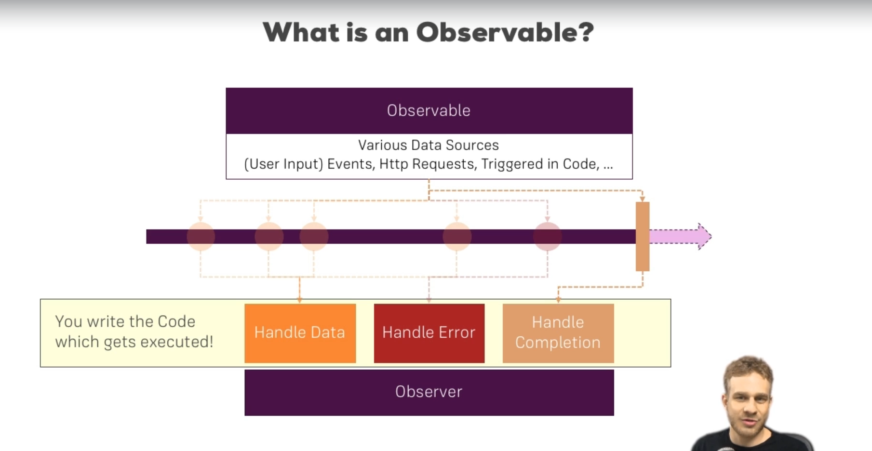

Installing RxJS
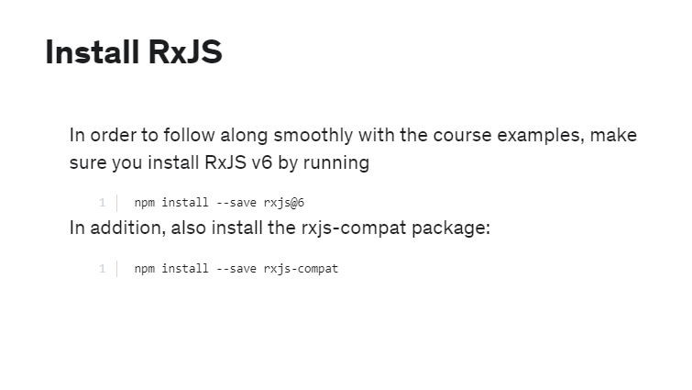

Subject

