**اللَّهُمَّ إِنِّي أَعُوذُ بِكَ مِنْ عِلْمٍ لَا يَنْفَعُ وَمِنْ قَلْبٍ لَا يَخْشَعُ وَمِنْ نَفْسٍ ‏لَا تَشْبَعُ ‏ ‏وَمِنْ دَعْوَةٍ لَا يُسْتَجَابُ لَهَا‏**

**“O Allah, I seek refuge in You from knowledge which does not benefit, from a heart that does not entertain the fear (of Allah), from a soul that is not satisfied and the supplication that is not answered.”**

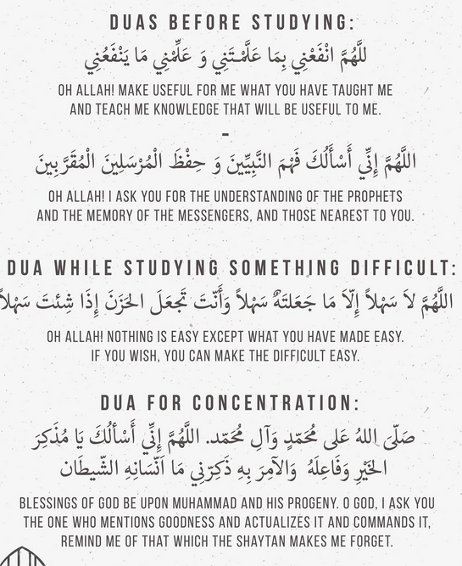

.

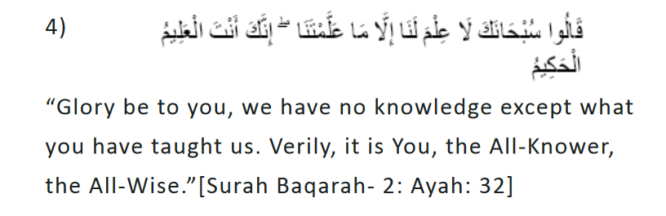

.

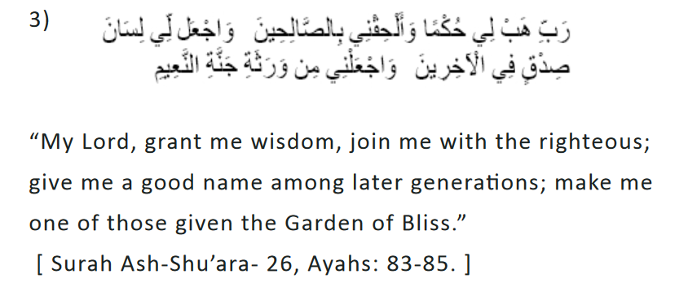

..

. 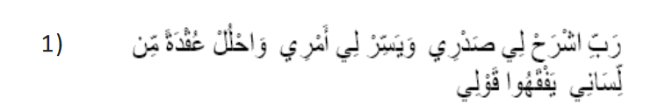

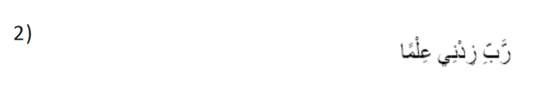

Tips

