Matlab question 1-

Part a)

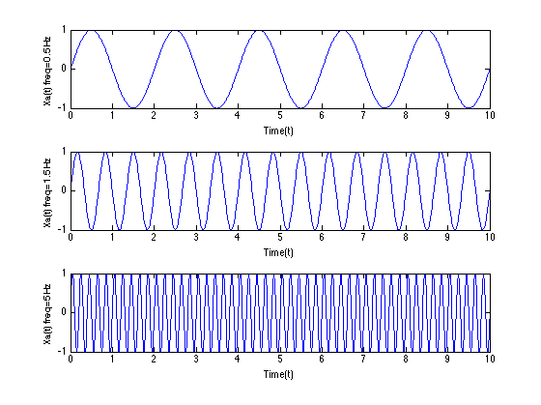

Part b)

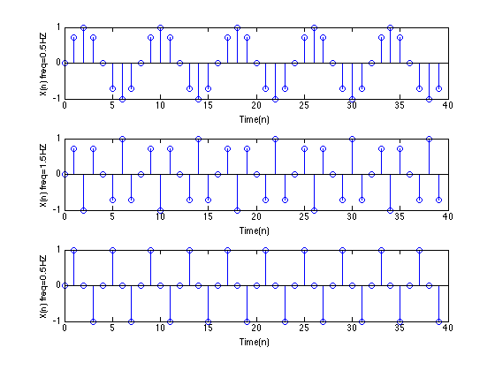

Part c)

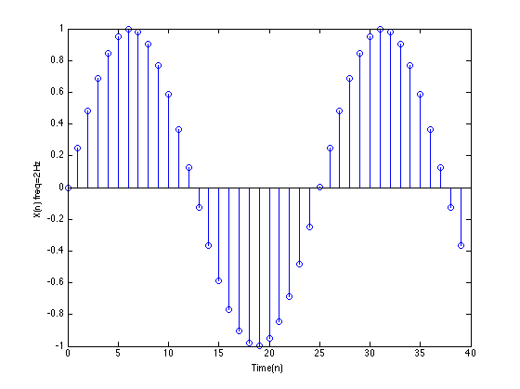

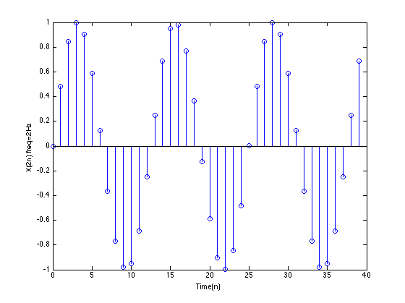Part d)

%1-part a

figure;

t=0:0.01:10;

f0_1=0.5;

Xo=sin(2*pi*f0_1*t);

subplot(3,1,1), plot(t,Xo);

xlabel('Time(t)');

ylabel('Xa(t) freq=0.5Hz');

f0_2=1.5;

X_1=sin(2*pi*f0_2*t);

subplot(3,1,2), plot(t,X_1);

xlabel('Time(t)');

ylabel('Xa(t) freq=1.5Hz');

f0_2=5;

X_2=sin(2*pi*f0_2*t);

subplot(3,1,3), plot(t,X_2);

xlabel('Time(t)');

ylabel('Xa(t) freq=5Hz');

%1-part b

figure;

Fs = 4;

n= 0:1:39;

f0_1=0.5;

Xn_0=sin(2*pi*(f0_1/Fs)*n);

subplot(3,1,1), stem(n,Xn_0);

xlabel('Time(n)');

ylabel('X(n) freq=0.5HZ');

f0_2=1.5;

Xn_1=sin(2*pi*(f0_2/Fs)*n);

subplot(3,1,2), stem(n,Xn_1);

xlabel('Time(n)');

ylabel('X(n) freq=1.5HZ');

f0_3=5;

Xn_2=sin(2*pi*(f0_3/Fs)*n);

subplot(3,1,3), stem(n,Xn_2);

xlabel('Time(n)');

ylabel('X(n) freq=0.5HZ');

%1-part c

figure

n= 0:1:39;

Fs = 50;

f0_c=2;

Xn_c=sin(2*pi*(f0_c/Fs)*n);

stem(n,Xn_c);

xlabel('Time(n)');

ylabel('X(n) freq=2Hz');

%1-part d

figure

n= 0:1:39;

Fs = 50;

f0_d=2;

Xn_d=sin(2*pi*(f0_d/Fs)*2*n);

stem(n,Xn_d);

xlabel('Time(n)');

ylabel('X(2n) freq=2Hz');

Problem 2)

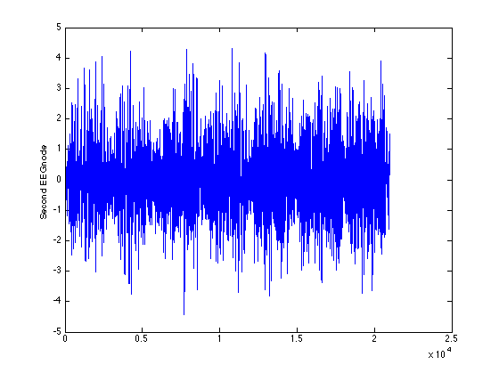Part a)

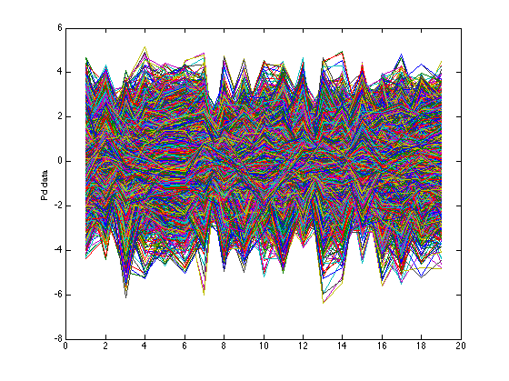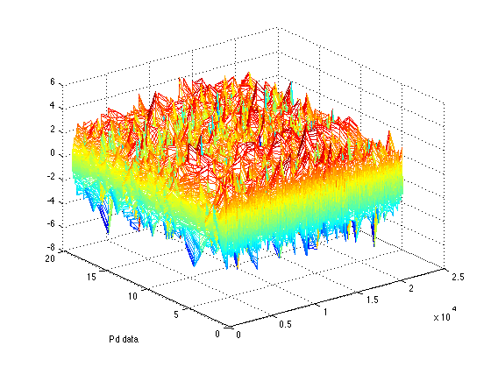

Part c)

Mesh for pd (rest)

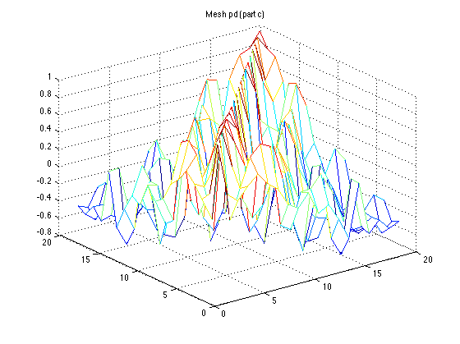

Eigen for pd (rest)

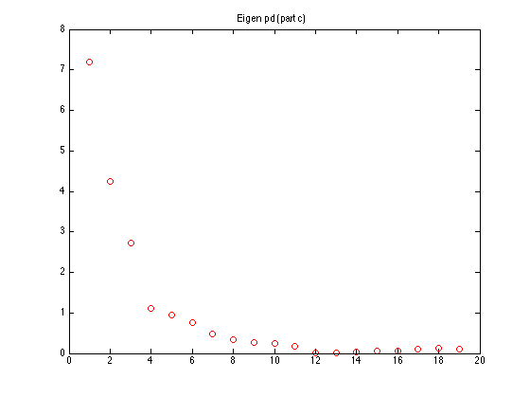

mesh for normal data (rest):

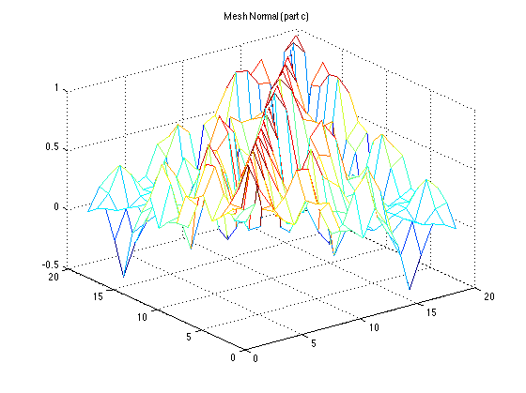

Eigen for normal data (rest):

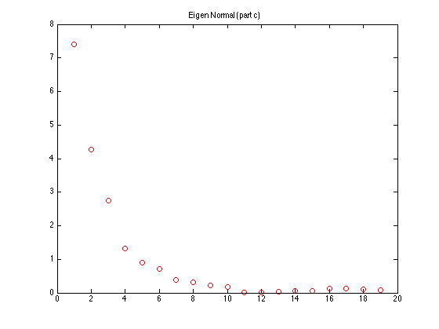

Part d)

Mesh for normal data (squeeze)

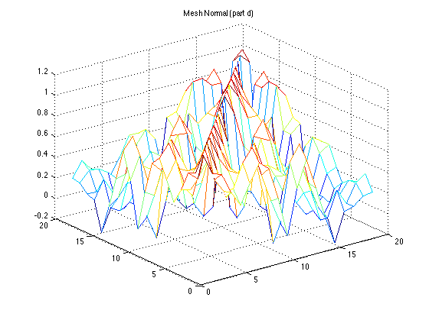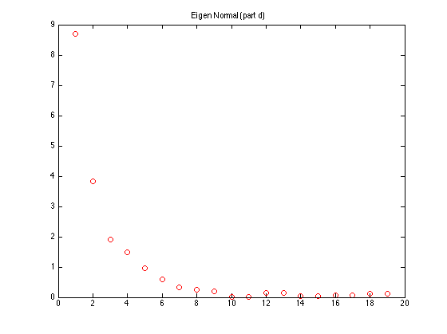

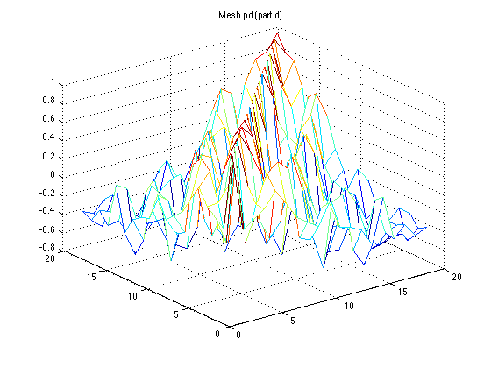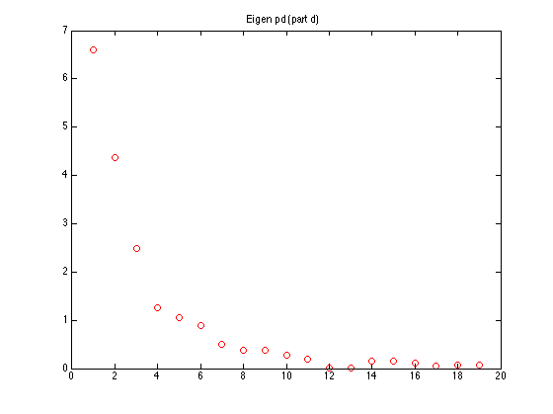

%2-part a

load('/Users/rohamsameni/Dropbox/summer 2013/466/problems/pdData.mat');

%plotting second EEG node

figure,plot(data(2,:));

ylabel('Second EEG node');

%plotting data

figure,plot(data);

ylabel('Pd data');

figure,mesh(data);

ylabel('Pd data');

%2- part b for pd

%Separating the data into the rest part and the squeezing part

[ind_0]=find(ampVec==0);

[ind_1]=find(ampVec==1);

%2- part c for pd

data_rest=data(:,ind_0);

R_c=corr(data_rest’);

figure, mesh(R_c);

eigen_c= eig(R_c);

figure,plot(eigen,'bo');

%2- part d for pd

data_squeez=data(:,ind_1);

R_d=corr(data_squeez’);

figure, mesh(R_d);

eigen_d= eig(R_d);

figure,plot(eigen_d,'bo');

load('/Users/rohamsameni/Dropbox/summer 2013/466/problems/normalData.mat');

%2- part b for normal

%Separating the data into the rest part and the squeezing part

[ind_0]=find(ampVec==0);

[ind_1]=find(ampVec==1);

%2- part c for normal

data_rest=data(:,ind_0);

R_c=corr(data_rest’);

figure, mesh(R_c);

eigen_c= eig(R_c);

figure,plot(eigen,'bo');

%2- part d for normal

data_squeez=data(:,ind_1);

R_d=corr(data_squeez’);

figure, mesh(R_d);

eigen_d= eig(R_d);

figure,plot(eigen_d,'bo');