CS9053 Introduction to Java Section I
Prof Dean Christakos
Date: Saturday, Oct 18th, 2025
Due: Saturday, Oct 25th, 2025 11:59 PM

Assignment 6

Building a UI Application

You are going to build a UI Application which incorporates a few Components you haven’t seen before, but the basics of how they are used will be included in the problem set code.

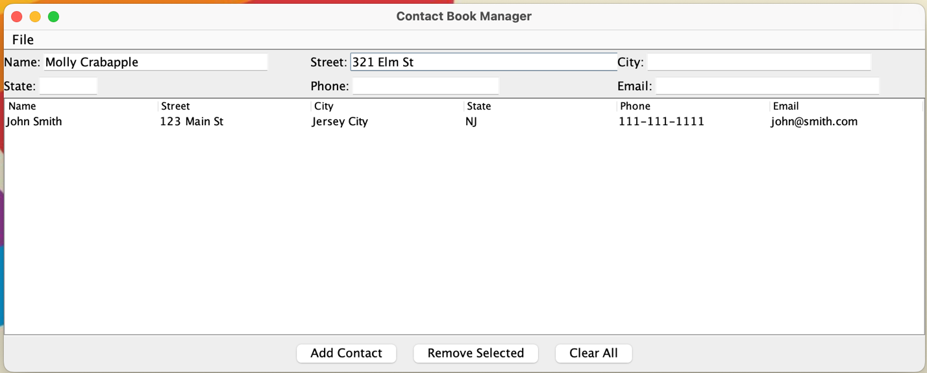

You will create a Contacts Manager. You will be able to enter user data into the contacts list, remove individual items or clear the items. For this you will use the JTable and DefaultTableModel classes, but those will be provided. This should be scrollable for large numbers of entries.

Then you should be able to save the contents of the contact list to a CSV file and load in the contacts from a CSV file with “Save” and “Open” options in the “File” Menu which should also allow you to Exit:

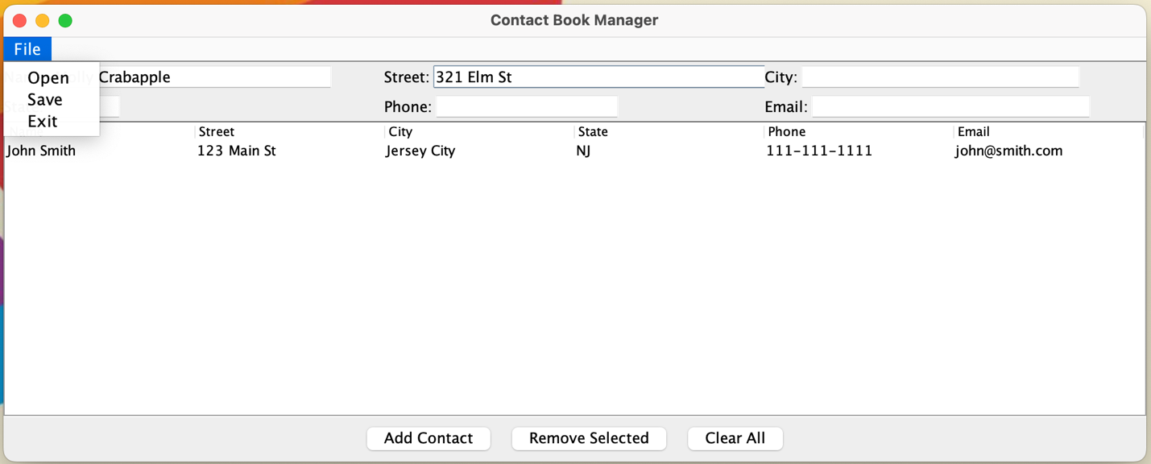

I have included the JFileChooser which will allow you to open and save files. You can figure out how that works from the skeleton code I have provided.

You don’t have to get the UI and layout of the components EXACTLY as shown in the example, but a hint about how to do it is that you can have components “flush left” by putting them in a BorderLayout and adding those components to the WEST region. You will get 2 extra credit points if you can recreate the layout exactly.

Remember that closing the window should exit the program.

There will be a recording of how this should be posted, as well.

