Introduction to Java
CS9053 Section I
Thursday 6 PM – 8:30 PM
Prof. Dean Christakos
Sept. 25th, 2025
Due: Oct 3rd, 2025 11:59 PM

Assignment 4

Part I: Inheritance

- Here is a class hierarchy diagram for Employee items. I have added the fields and a few methods, but you can figure out the getters and setters and constructors for yourself.

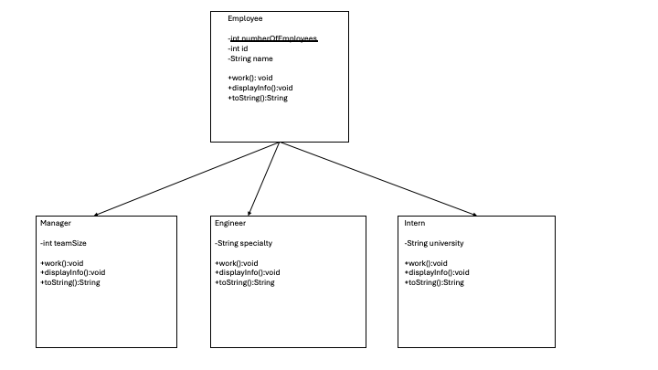

Requirements:
- Ids should be automatically generated from the numberOfEmployees static field.
- There should be appropriate getters and setters for each of these fields as well as toString() methods.
- There should also be equals() methods and in this case, the equals method should also check the id.
- “displayInfo” should be similar to the toString method but directly print out the class information.
- There is a work() method which should print out something related to the employee’s job. The Employee class can be generic (“doing work”), but the others should be related to their field values (eg, for Manager, “managing team of <teamSize>”).

Tasks:
- Create a Manager, 2 Employees, and 2 interns.

Part II – Arraylists

- Let’s create a workplace. Once again, I’ve left out the constructors and getters and setters.
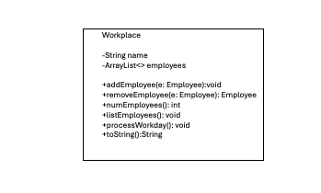

Requirements:
- I’ve also left out the parameterization of the ArrayList. It should be able to take only Employee objects and their subclasses.
- Create a workplace with a name of your choice. Then add the Employees you created in the previous section to it.

Tasks:
- Execute listEmployees() should print out all the employees in a list.
- Executive processWorkday() which should go through all objects in the employees ArrayList and run the “work()” method on each object.

