Logon

I tried to login with the username “Joe” and guessed common passwords, but they didn’t work. However, the website allows us to login with any other username and password combination.

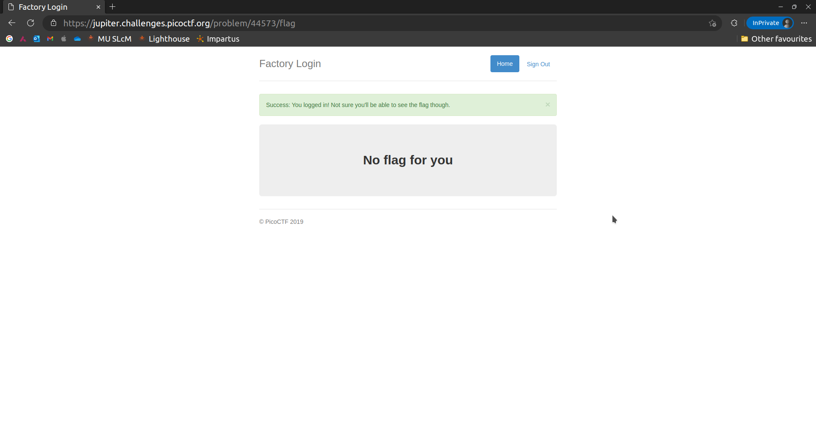

I examined the cookies and spotted an admin cookie. 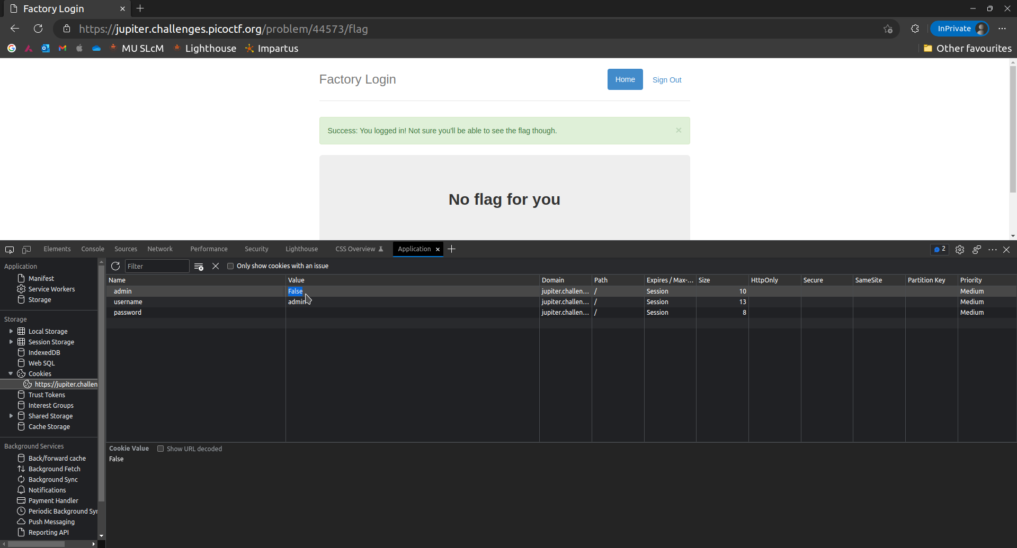

I changed the value to “True”, and lo and behold, the flag was visible.