Picobrowser

Bascially just spoofing a useragent lol

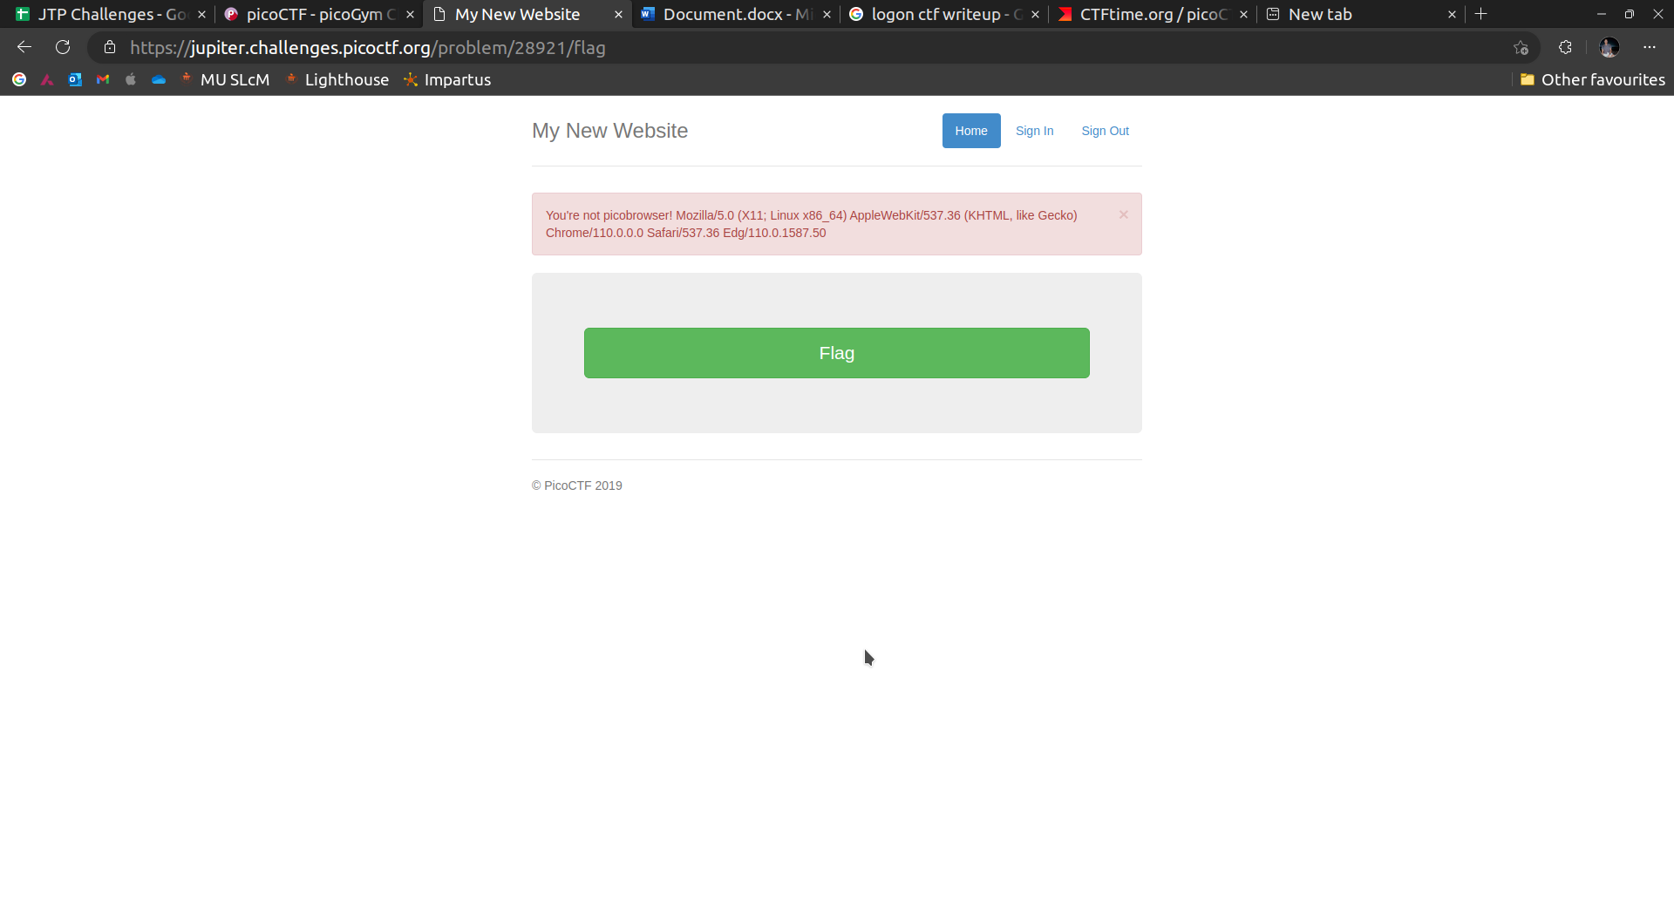

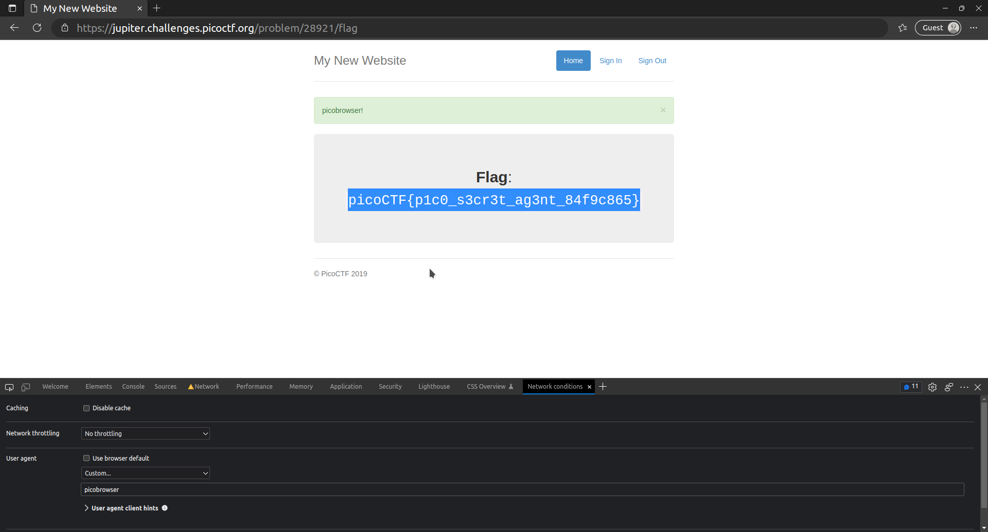

Changed the useragent to picobrowser and got the flag.