Notes on ARED:

9/25/2025

Trying to test and establish validity of streaming ARED w/ ball trees, came across disturbing increase in distances to closest cluster once the circular buffer filled up, as evidenced by “shelf” in graph below:

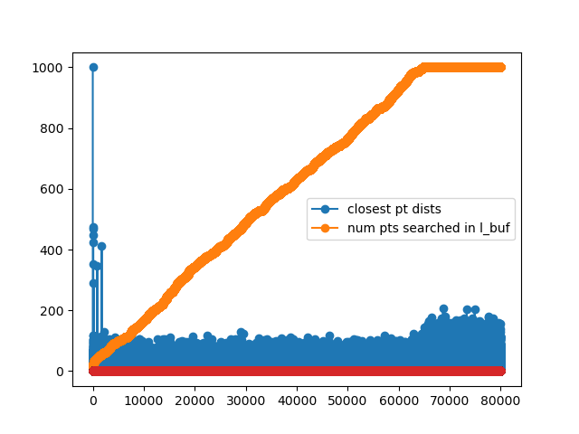
“shelf”

Tested ball trees, found only small bugs, tested w/ no ball trees brute force searching buffer all the time, still the same problem. Finally Nate had good explanation – “shelf” isn’t evidence of a bug, it’s because the algorithm results in more points towards the cluster centers being saved early on, which are then the first one forgotten after the buffer fills up. Those center points are important to distance – though not necessarily to # queries. Bottom line – don’t worry about shelf.

9/29/2025

continuing – some weird behavior – getting different results each run even though propagating random seed through??? Sometimes precision, recall terrible for relevant classes, but mostly good (with same random seed)

got confusion matrix working properly with labels with MNIST – need to make sure NICE and EMNIST are also working – need to be careful not to assume integer labels are sorted by sparsity...

