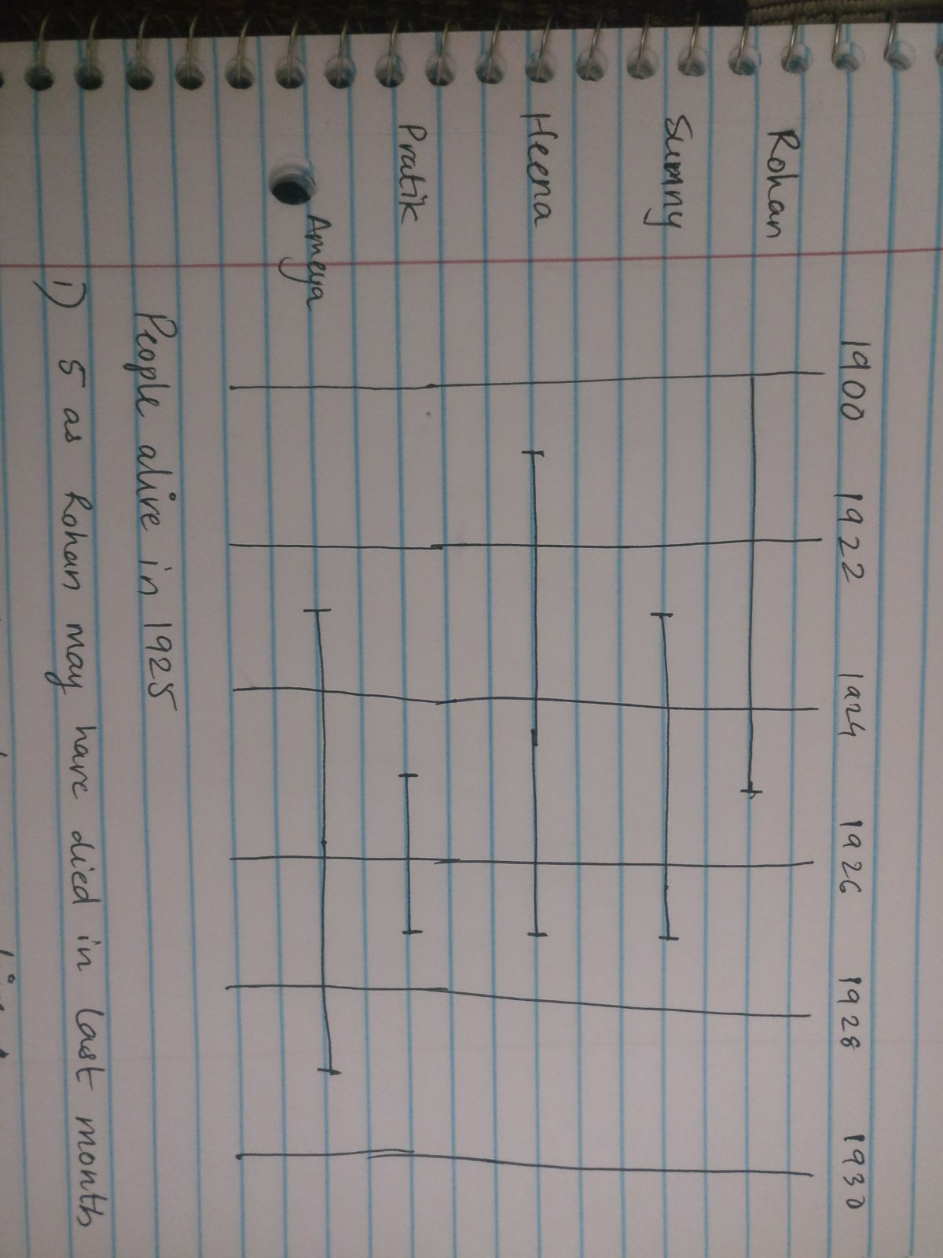

This type of problem has multiple answers for single questions, hence answer are sometimes ambiguous.

For eg: No of people alive in 1925

1. 5 as all of them was alive at some point of time in the year
2. 4 as till the end of the year only 4 were alive
3. 3 as only 3 people were alive throughout the year

Such questions have multiple possibilities hence the answer may vary case by case.