**Creating a broadcast network configuration in X-CTU using XBEE S1 module**

**Broadcast**:

**Block Diagram:**

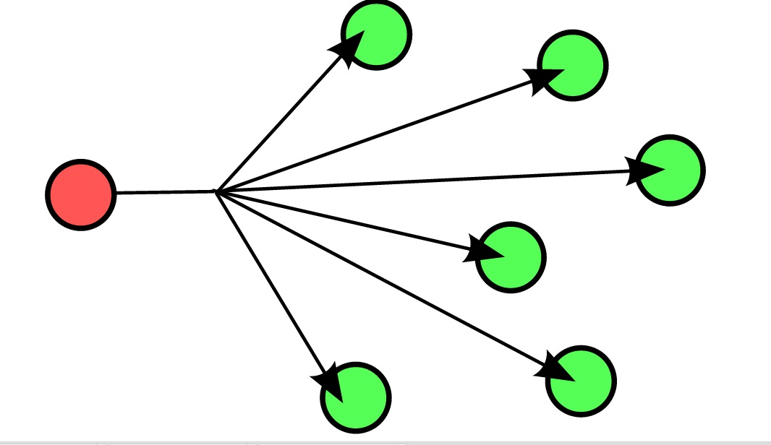

Fig 2.1 Block diagram of Broadcast

End user

End user

End user

End user

End user

End user

Server

The Broadcast Consists of a server who can communicate with his end users and the end users can communicate with the server but the end users cannot communicate between themselves.

**Components Required**:

* Zigbee modules(XBEE S1) - 4
* Zigbee adaptor - 4
* USB cable – 4
* Computers (we need 4 USB ports, in same or different computers).

The steps to create a Broadcast communication in XBEE module using 16-bit addressing are as follows:

**Step 1: Connecting Zigbee to PC.**

Make the connection between laptop and XBEE module using a USB cable as shown in figure.

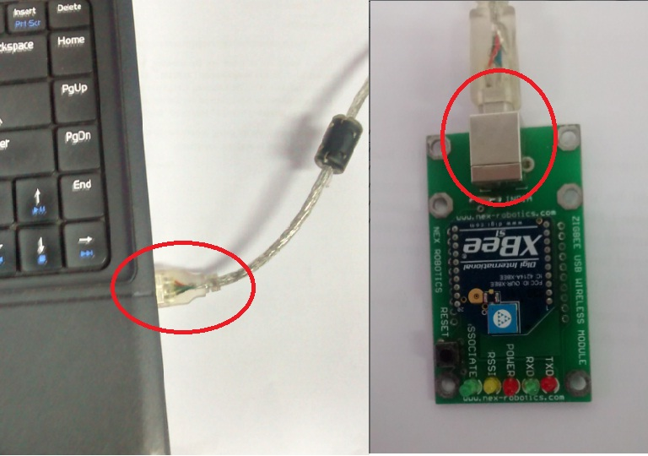

Figure 2.2 USB connections

The red Power LED in XBEE module must ON and green associate LED must start blinking.

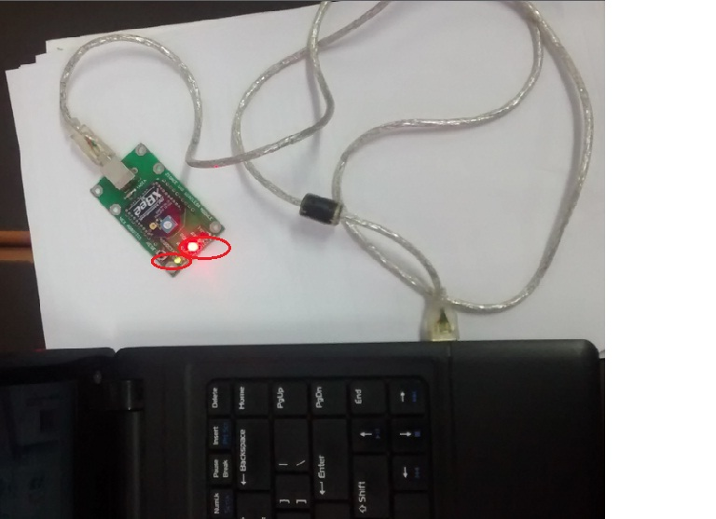

Fig 2.3 verification through LEDs

Repeat the step 1 four times for four different modules.

**Step 2: Launching X-CTU Software.**

Launch X-CTU windows from shortcut icon on desktop or program files in start menu.

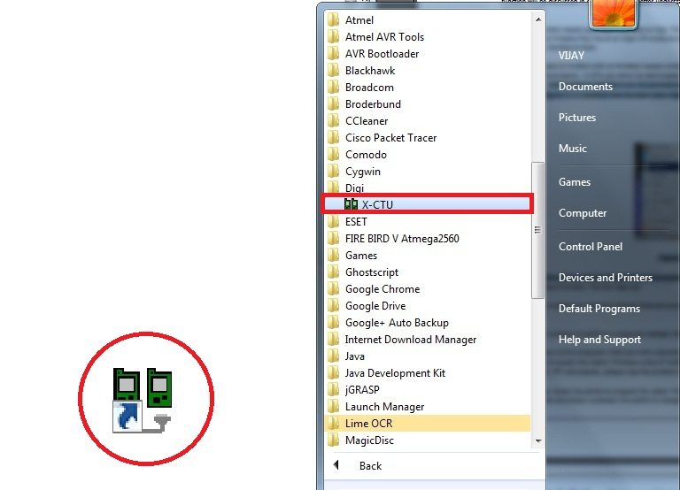

Fig 2.4 Launching of X-CTU

Do this for all four modules. Open multiple windows in same computer, one window for each module separately.

**Step 3: Testing and Querying the Network by Serial number verification.**

Notice the COM ports being displayed on the select COM port workspace. Test/Query each COM port individually in the windows opened previously.

The result of Test/Query must show serial numbers as shown in figure 2 if the connections are correct.

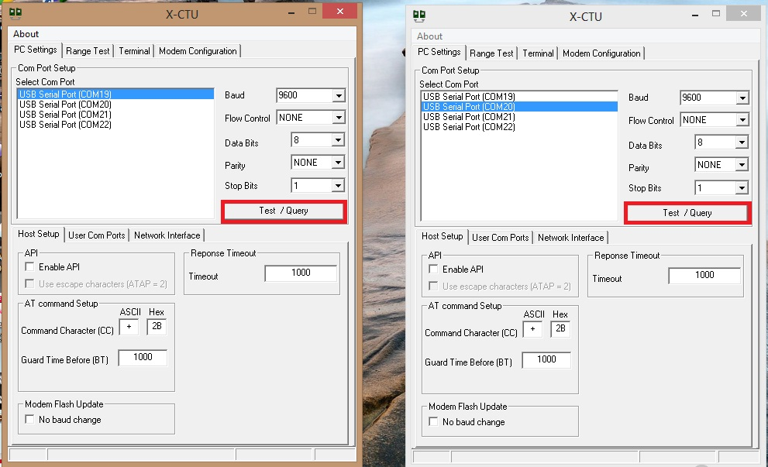

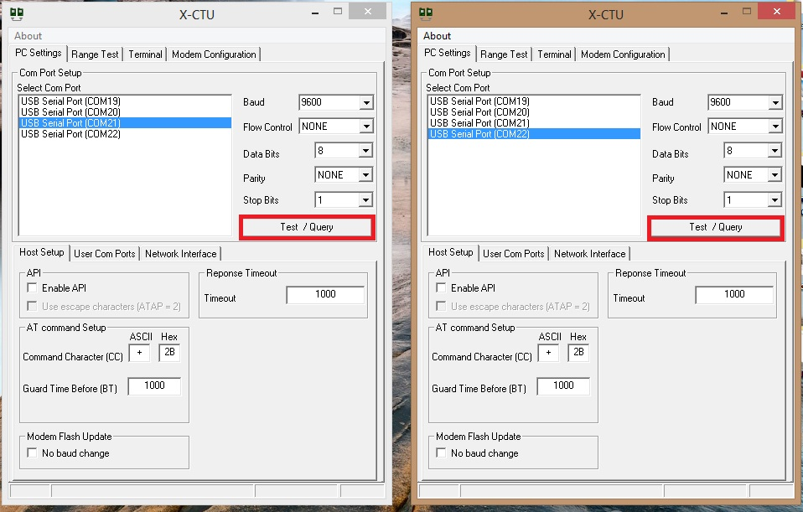

Fig 2.5 Test/Query

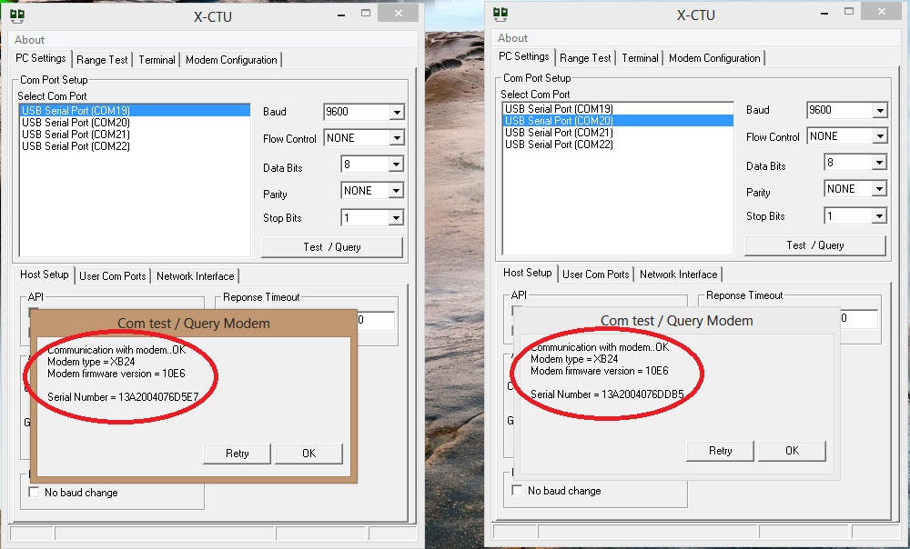

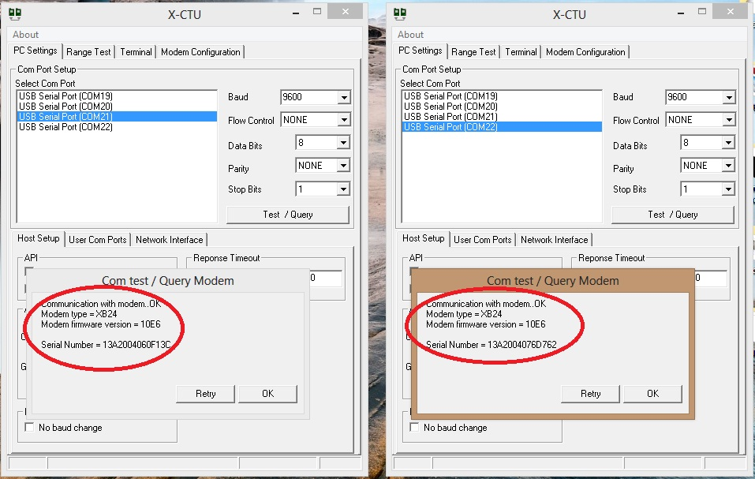

Fig 2.6 serial number verification

**Serial Number:**

**A unique 64-bit IEEE source address is assigned at the factory and can be read with the SL (Serial Number Low) and SH (Serial Number High) commands. Short addressing must be configured manually. A module will use its unique 64-bit address as its Source Address if its MY (16-bit Source Address) value is “0xFFFF” or “0xFFFE”.**

The above figures are for two windows, whereas you’ll have to do it for four windows .One window of one module each.

**Step 4: Reading the module.**

Open modem configuration tab on the X-CTU window and read the modem.

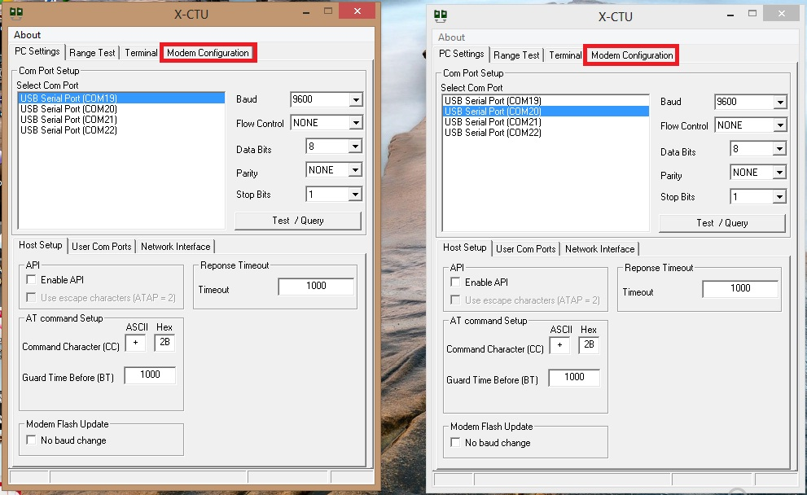

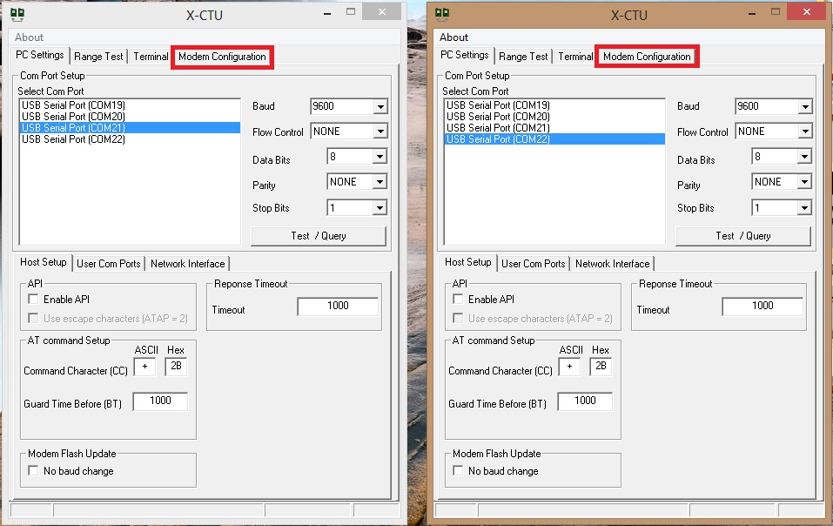

Fig 2.7 Modem Configuration

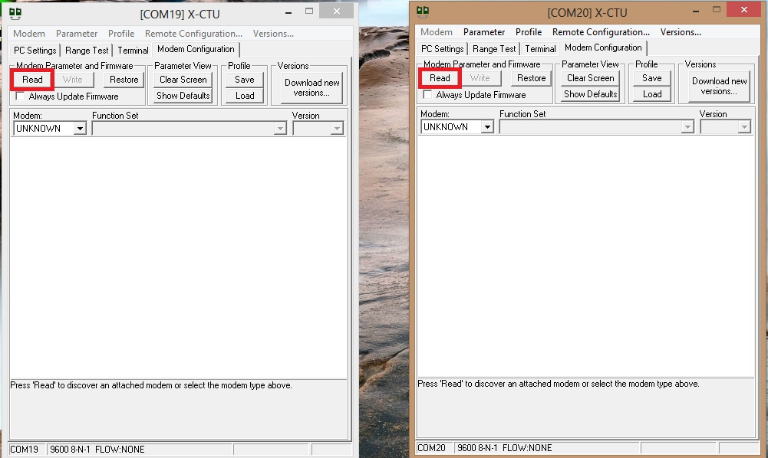

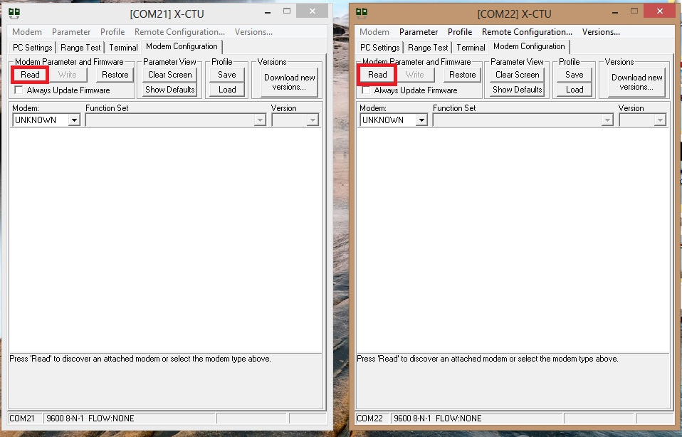

Fig 2.8 Reading the module

The X-CTU will read the pre-configuration of XBEE.

**Step 5: Setting the Network Address.**

In the workspace under Network & Security tab select following settings

|  |  |  |  |
| --- | --- | --- | --- |
| X-CTU(window 1) | X-CTU(window 2) | X-CTU(window 3) | X-CTU(window 4) |
| CH-Channel = C | CH-Channel = C | CH-Channel = C | CH-Channel = C |
| PAN ID = 2222 | PAN ID = 2222 | PAN ID = 2222 | PAN ID = 2222 |
| DH = 0 | DH = 0 | DH = 0 | DH = 0 |
| DL = FFFF | DL = 2 | DL = 2 | DL = 2 |
| MY = 2 | MY = 3 | MY = 4 | MY = 5 |

\**this is a sample address and can be varied.*

* PAN IDs and Channel (CH) of all end users and server must same since they are operating in same network.
* Since we are using 16-bit addressing mode DH of all modules must be 0.
* DL of server should be broadcast address i.e. 0xFFFF.
* DL of end user should be MY (source address) of server if you want end user to communicate back with server else it can be unique.
* MY (source address) of end users should be unique since it should not be able to communicate with themselves.

**Key Terms:**

* **Channel(CH):** 802.15.4 and Zigbee break the 2.4Ghz band into 16 channels. Parameter range for Xbee is 0x0B - 0x1A.
* **Personal Area Network(PAN)** - A data communication network that includes one or more End Devices and optionally a Coordinator.
* **PAN ID**: Each network is defined with a unique PAN identifier (PAN ID). This identifier is common among all devices of the same network.  ZigBee devices are either preconfigured with a PAN ID to join, or they can discovery nearby networks and select a PAN ID to join.

If multiple Zigbee networks are operating within range of each other, each should have unique PAN ID.

* **Destination Address:**
  + **DH: Destination Address High**. Set/Read the upper 32 bits of the 64-bit destination address. When combined with DL, it defines the destination address used for transmission. To transmit using a 16-bit address, set DH parameter to zero and DL less than 0xFFFF. 0x000000000000FFFF is the broadcast address for the PAN.
  + **DL: Destination Address Low**. Set/Read the lower 32 bits of the 64-bit destination address. When combined with DH, DL defines the destination address used for transmission. To transmit using a 16-bit address, set DH parameter to zero and DL less than 0xFFFF. 0x000000000000FFFF is the broadcast address for the PAN.
* **Source Address:**
  + **16-bit(MY):** Set/Read the RF module 16-bit source address. Set MY = 0xFFFF to disable reception of packets with 16-bit addresses
  + **64-bit:** 64-bit source address (serial number) and broadcast address (0x000000000000FFFF) is always enabled.
    - **SH: Serial Number High**. Read high 32 bits of the RF module's unique IEEE 64-bit address. 64-bit source address is always enabled.
    - **SL: Serial Number Low**. Read low 32 bits of the RF module's unique IEEE 64-bit address. 64-bit source address is always enabled.

Note:

* Any RF module within range will accept a packet that contains a broadcast address. When configured to operate in Broadcast Mode, receiving modules do not send ACKs (Acknowledgements) and transmitting modules do not automatically re-send packets as is the case in Unicast Mode. To send a broadcast packet to all modules regardless of 16-bit or 64-bit addressing, set the destination addresses of all the modules as shown below. Sample Network Configuration (All modules in the network)

DL (Destination Low Address) = 0x0000FFFF DH (Destination High Address) = 0x00000000 (default value)

* In the above sample address X-CTU(window 1) will act as server and others will act as end users.

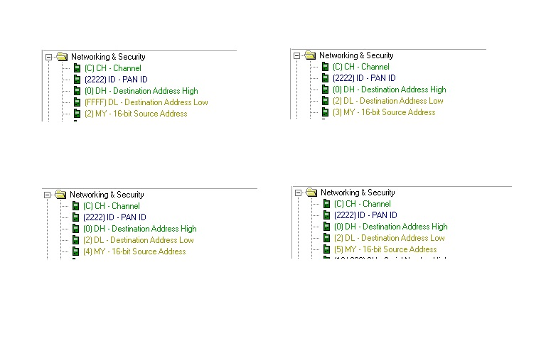

Fig 2.9 Network addressing

X-CTU(window 4)

X-CTU(window 3)

X-CTU(window 2)

X-CTU(window 1)

**Step 6: Writing the module.**

Write this configuration into the module by clicking on write option.

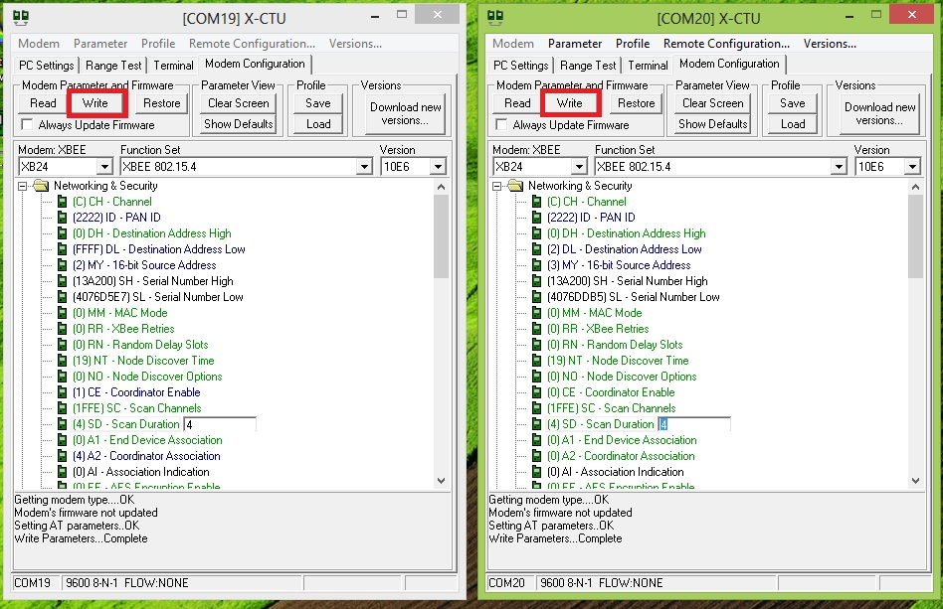

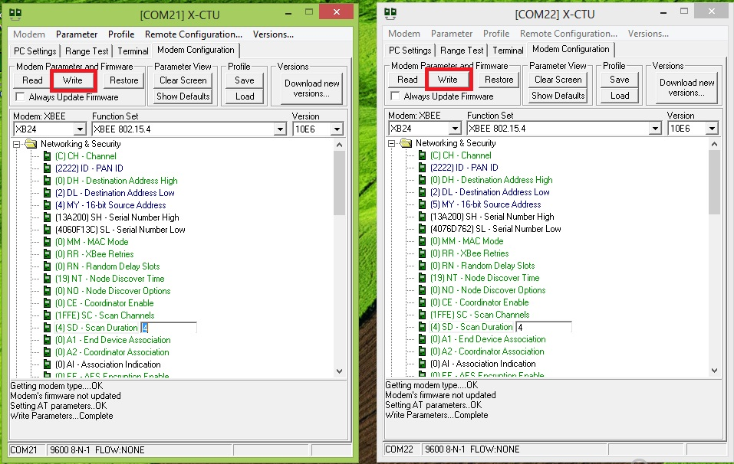

Fig 2.10 writing the module

**Step 7: Verification of Broadcast Network Configuration.**

Go to terminal window and check if the transmission is a valid.

In Terminal Window you can transmit by typing in the workspace.

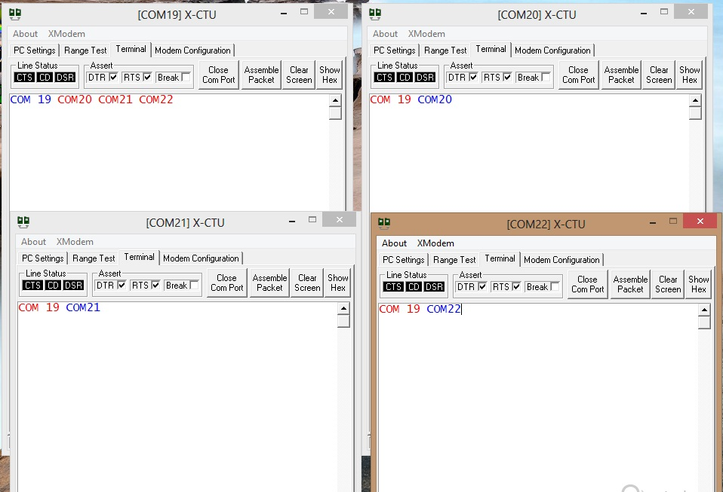

Fig 2.11 verification of Broadcast from terminal window

*In above fig. blue letters are manually written, while red letters are transmitted.

**Conclusion:**

as it is as shown in fig 2.11:

* [com19] is server and [com20][com21][com22] are end user.
* Data sent by server is received at all end user and data transmitted by end users are only received by server.
* Message “com19” was sent by server and is received by all receivers. Message “com20” “com21” “com22” was sent by end users and received only by server.
* This is called ‘Broadcasting’.