**SETTING TWO ZIGBEE MODULE TO CO-ORDINATOR AND END-USER MODE.**

**Step1: Follow the Steps from previous manuals.**

Follow the Steps from previous manual to connect two Zigbee modules and open its X-CTU panels.

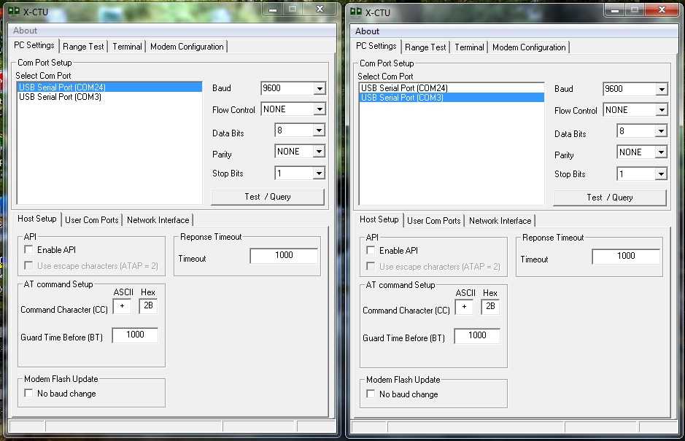

Fig 5.1 X-CTU windows

**Step2: Configure coordinator.**

Go to Modem Configuration tab in one of the above window, read the module and set the following settings there and write,

|  |  |
| --- | --- |
| CE-Coordinator Enable | 1-Coordinator |
| A2-Coordinator Association | 7 - 111B |

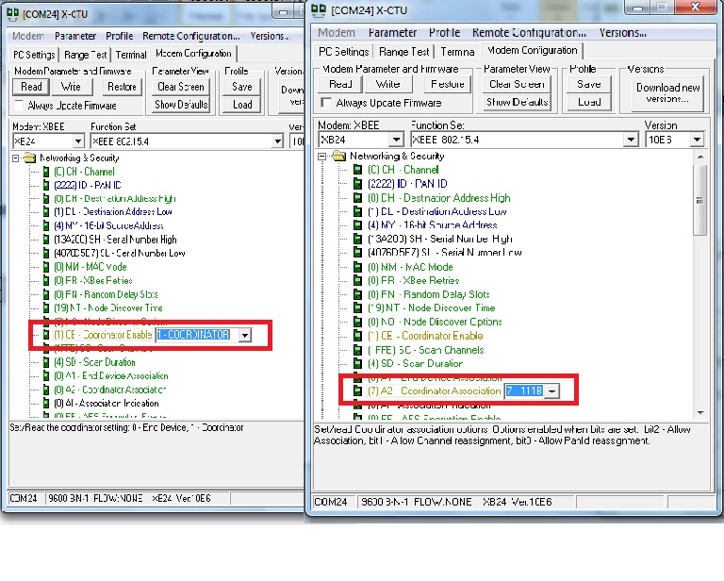

**Fig 5.2 Coordinate enable and Coordinate association**

Note: In the above figure both windows are of same module

**KEY TERMS:**

* **(CE)Coordinate Enable**: To configure a module to operate as a Coordinator, set the CE (Coordinator Enable) parameter to ‘1’. Set the CE parameter of End Devices to ‘0’ (default). Coordinator and End Devices should contain matching firmware versions.
* **(A2)Coordinate Association:** Set/read Coordinator association options. Options enabled when bits are set.
  + bit2 - Allow Association.

The Coordinator will only allow End Devices to associate to it if the A2 parameter “AllowAssociation” flag is set. Once the Coordinator has successfully started, the Associate LED will blink 1 time per second. (The LED is solid if the Coordinator has not started.)

* + bit1 - Allow Channel reassignment.

The Coordinator issues an Energy Scan. The Energy Scan selects one channel and scans for energy on that channel. The duration of the scan is specified by the SD (Scan Duration) parameter. Once the scan is completed on a channel, the Energy Scan selects the next channel and begins a new scan on that channel. This process continues until all channels have been scanned. If an Active Scan was performed (Reassign PANID Flag set), the channels used by the detected PANs are eliminated as possible channels. And the best channel with maximum energy is selected.

* + bit0 - Allow PANID reassignment.

The Coordinator issues an Active Scan. The Active Scan selects one channel and transmits a Beacon Request command to the broadcast address (0xFFFF) and broadcast PAN ID (0xFFFF). It then listens on that channel for beacons from any Coordinator operating on that channel. The ID (PAN ID) parameter setting will be updated to a PAN ID that was not used by any other coordinators.

**Step3: Configure End Device.**

Go to Modem Configuration tab in the other one of the above X-CTU window, read the module and set the following settings there and write,

|  |  |
| --- | --- |
| A1-End Device Association | 7 - 0111B |

Note: Make the MSB of A1 = 1 in indirect transmission which we shall discuss later

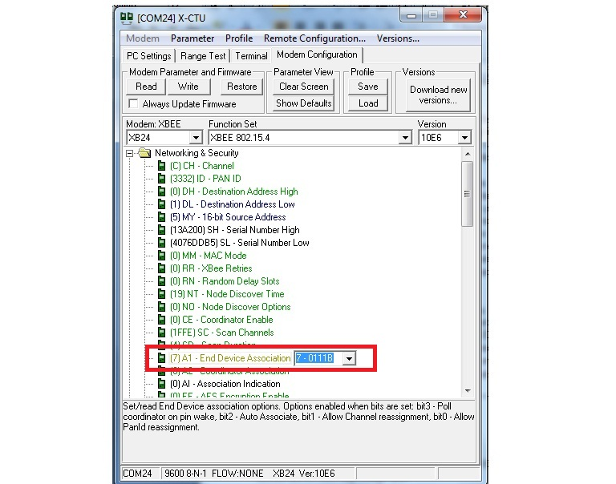

**Fig 5.3 End User Association.**

KEY TERMS:

* End Device Association:

End Device power-up is governed by the A1 (End Device Association) command

* + **bit 2 = 1: AutoAssociate Bit**

End Device will attempt to associate to a Coordinator.

* + **bit 1 = 1: Reassign Channel Bit Set**

End Device can associate with a PAN with any CH value.

* + **bit 0 = 1: Reassign PANID Bit Set**

End Device can associate with a PAN with any ID value.

After applying these filters to the discovered Coordinators, if multiple candidate PANs exist, the End Device will select the PAN whose transmission link quality is the strongest. If no valid Coordinator is found, the End Device will either go to sleep (as dictated by its SM (Sleep Mode) parameter) or retry Association.

**Note** - An End Device will also disqualify Coordinators if they are not allowing association (A2 - AllowAssociation bit); or, if the Coordinator is not using the same NonBeacon scheme as the End Device. (They must both be programmed with NonBeacon code.)

Once a valid Coordinator is found, the End Device sends an AssociationRequest message to the Coordinator. It then waits for an AssociationConfirmation to be sent from the Coordinator. Once the Confirmation is received, the End Device is Associated and the Associate LED will blink rapidly (2 times per second). The LED is solid if the End Device has not associated.

**Step4: First Power up coordinator then the end user**

* Power up the coordinator and then the end user.
* The coordinator will assign itself first to a unused maximum energy PANID and channel.
* Then the end user will scan all the channels and PANIDs and associate itself with the coordinator.
* You can now transmit signals from user to coordinator.
* To transmit signals from coordinator to user you need to make destination id of coordinator as FFFE which is the same as source address of end user.

**Indirect Transmission:**

To configure Indirect Transmissions in a PAN (Personal Area Network), the SP (Cyclic Sleep Period) parameter value on the Coordinator must be set to match the longest sleep value of any End Device. The SP parameter represents time in NonBeacon systems and beacons in Beacon-enabled systems. The sleep period value on the Coordinator determines how long (time or number of bea-cons) the Coordinator will retain an indirect message before discarding it. In NonBeacon networks, an End Device must poll the Coordinator once it wakes from Sleep to determine if the Coordinator has an indirect message for it. For Cyclic Sleep Modes, this is done automatically every time the module wakes (after SP time). For Pin Sleep Modes, the A1 (End Device Association) parameter value must be set to enable Coordinator polling on pin wake-up. Alternatively, an End Device can use the FP (Force Poll) command to poll the Coordinator as needed.

**NOTES:**

* An End Device will also disqualify Coordinators if they are not allowing association (A2 - AllowAssociation bit); or, if the Coordinator is not using the same NonBeacon scheme as the End Device. (They must both be programmed with NonBeacon code.)
* Changing A1, ID or CH parameters will cause the End Device to disassociate and restart the Association procedure. If the End Device fails to associate, the AI command can give some indication of the failure.
* Once a Coordinator has started: Modifying the A2 (Reassign_Channel or Reassign_PANID bits), ID, CH or MY parameters will cause the Coordinator’s MAC to reset (The Coordinator RF module (including volatile RAM) is not reset). Changing the A2 AllowAssociation bit will not reset the Coordinator’s MAC. In a non-beaconing system, End Devices that associated to the Coordinator prior to a MAC reset will have knowledge of the new settings on the Coordinator. Thus, if the Coordinator were to change its ID, CH or MY settings, the End Devices would no longer be able to communicate with the non-beacon Coordinator. Once a Coordinator has started, the ID, CH, MY or A2 (Reassign_Channel or Reassign_PANID bits) should not be changed.
* You don’t need to assign source address and destination address on coordinator or end user. They take of them themselves.
* You can choose settings for scanning only channel or only PANID for coordinator or end user according to your requirement.
* These settings can also be set for more than one end users.