**Connecting the X-BEE modules to the PC in Unicast mode**

**Step1: Inserting XBEE in XBEE adaptor**

After Installation of the X-CTU software connection (which is clearly specified in installation guide of X-CTU ) . Now fix the X-bee module in the X-bee adapter which will help to connect the X-Bee with PC easily, Images clearly explain the fixing of X-Bee to the adapter. Placing it in opposite direction can damage the XBEE.

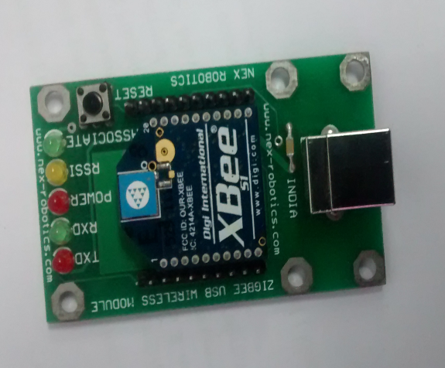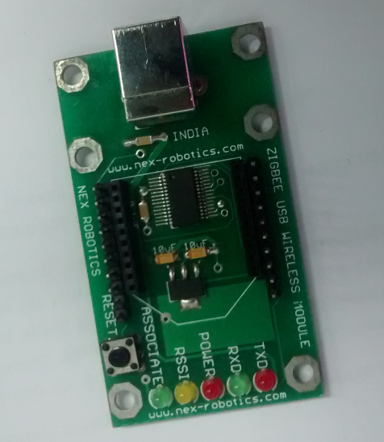

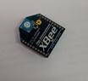

**Fig 1.3 X-bee module fixed in x-bee**

**adapter**

**Fig 1.1 X-bee module**

**Fig1.2 X-bee Adapter**

**Step2: Connecting XBEE module to PC.**

Make the connection between laptop and XBEE module using a USB cable as shown in figure.1.4.Once after the connection is established check for the power led(continuous on) and associate led(blink) in the adapter. If not remove and insert the USB and repeat the step 1

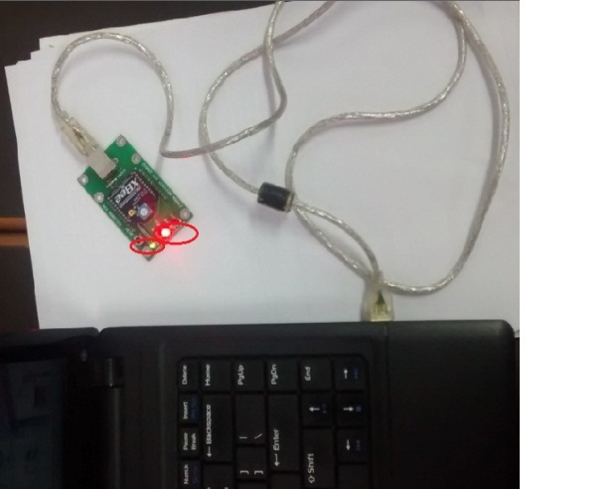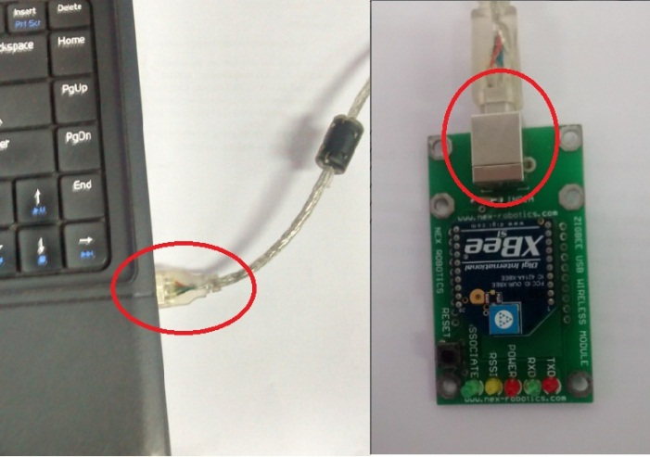

**Fig 1.4 establishing connection between pc and x-bee**

**Fig 1.5Power and Associate LED**

**Step3: Com port settings.**

After connecting X-bee to the PC, Now check whether the necessary com port is assigned to the X-bee this can be done in Device manager. If the com port is not assigned ,You will need to install driver for FT232 USB to serial converter.(Steps to install drives for FT232 USB to Serial Converter are covered in detail in the section 6.5 of the Hardware Manual)

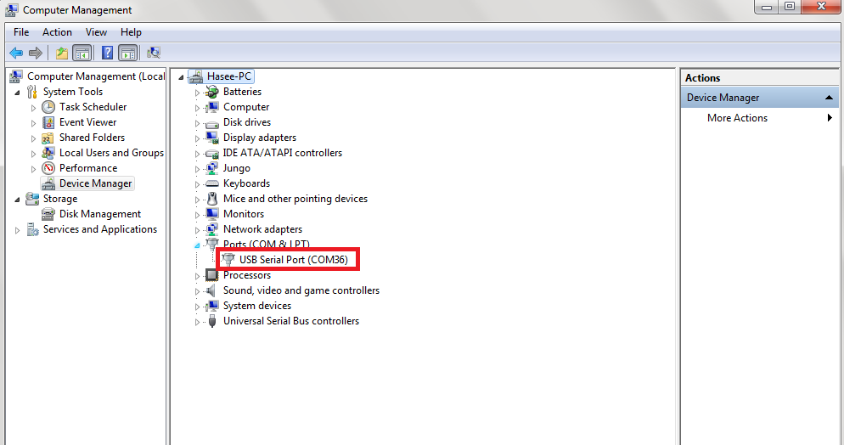

**Fig 1.6 Device manager**

**Step4: Launching X-CTU Software.**

**Fig 1.6 Device manager indicates the USB Serial port**

Now open X-CTU application which you have installed earlier. This can be done in any of the two ways by selecting the icon from desktop or select it from the start menu

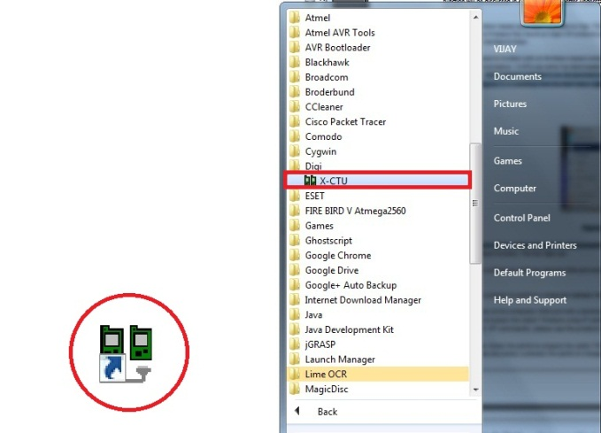

**Fig 1.7 X-CTU icon in desktop and in start menu**

**Step 5: X-CTU window.**

After this X-CTU window will pop up as shown in the figure

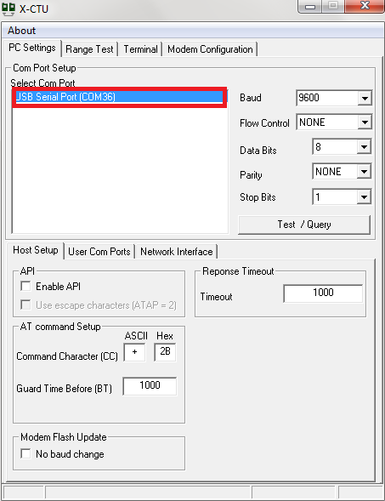

**Fig 1.8X-CTU window**

**Step6: Testing and Querying the Network by Serial number verification.**

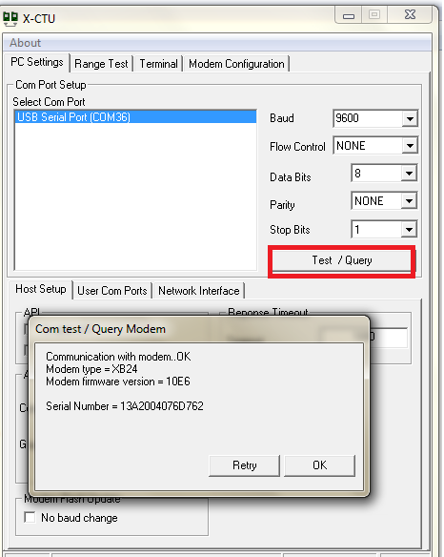 Now we need to read the serial number and the type of modem by clicking on the ‘Test/ Query’ button. Suddenly a window pops with the serial number and type of the modem.

**Fig 1.9 Com test/Query modem**

Once this window pops its fine to work, detailed explanation and function about X-CTU’s various tab is given in**e-Yantra_DVD\Fire Bird V ATMEGA2560 Robot\Accessories\XBee USB Wireless Module\Users Guide XCTU Configuration & Test Utility Software**

End user

Server

**UNICAST MODE:**In unicast mode there is data transfer from one server to end user and this is a bidirectional data transfer from server to end user and vice versa. Unicast is otherwise called as peer to peer communication. There are two ways of transmitting in unicasting

* 16bit address mode
* 64bit address mode

**Step7: Connecting XBEE in unicast mode.**

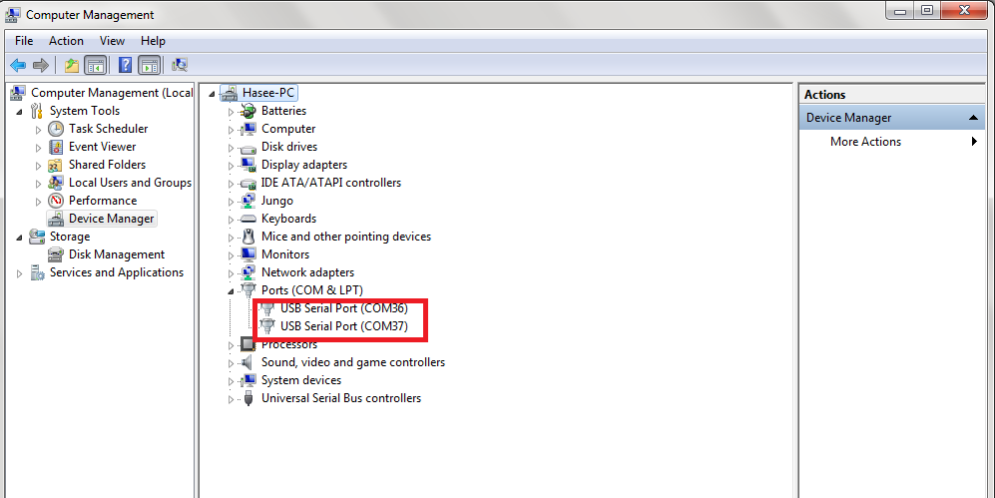  Now connect two X-bee module in the two different USB slots that is one for server and other is for end user follow the above steps to connect to the PC and to check for the Com ports

**Fig 1.10device manager with two ports**

**Step8: Launching 2 X-CTUs.**

Open two instances of X-CTU, in that select the required com port in each X-CTU so that one may act as the server and the other may act as the end user.

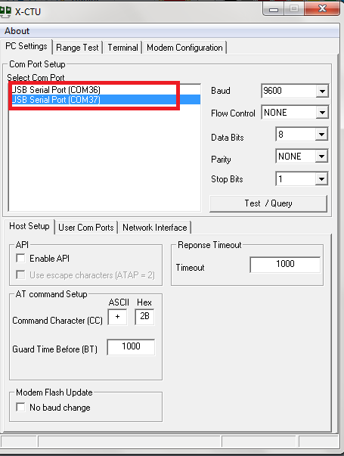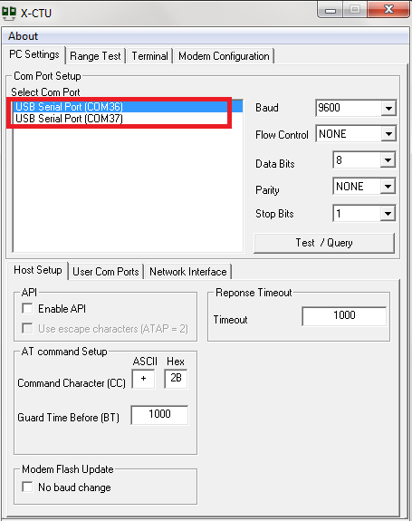

**Fig 1.11 X-CTU with different ports selected**

**Step9: Testing and Querying with serial number check.**

Check for the unique serial id from the X-bee by clicking on the test and query button

**Serial Number:**

A unique 64-bit IEEE source address is assigned at the factory and can be read with the SL (Serial Number Low) and SH (Serial Number High) commands. Short addressing must be configured manually. A module will use its unique 64-bit address as its Source Address if it’s MY (16-bit Source Address) value is “0xFFFF” or “0xFFFE”.

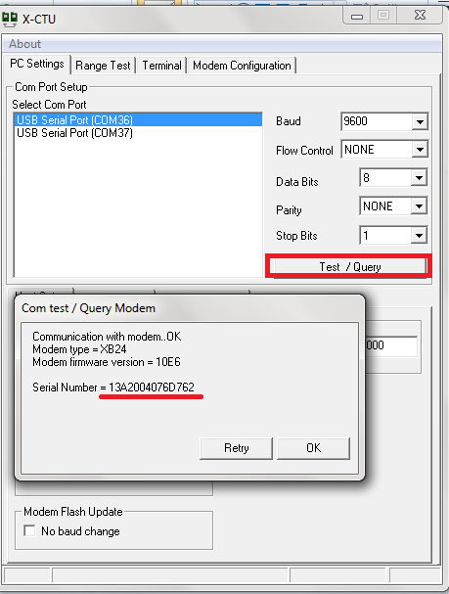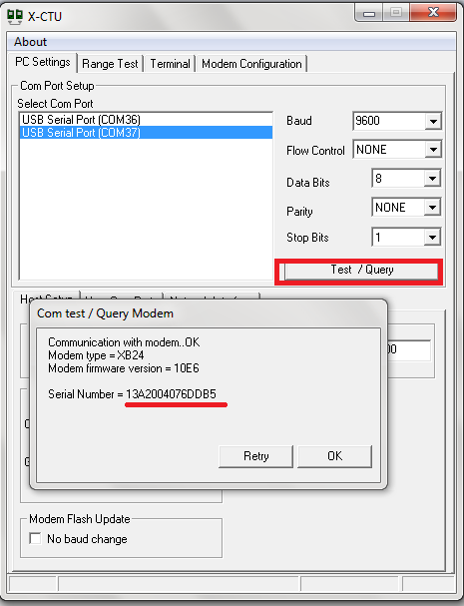

**Fig 1.12X-bee with different serial number**

**Step 10: Reading the module.**

Open modem configuration tab on the X-CTU window and read the modem.

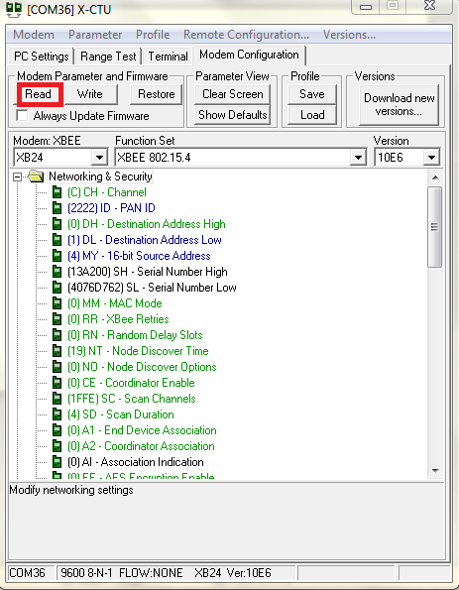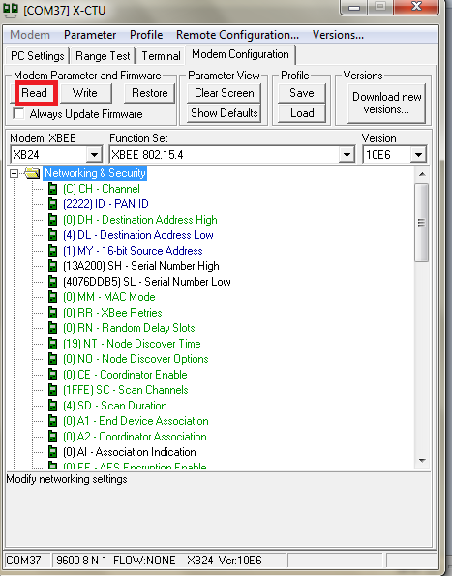

Fig 1.13 Reading existing configuration

The X-CTU will read the pre-configuration of XBEE.

**Step11: Setting the Network Address.**

Now click on the modem configuration on the top of the window to configure the various address location and pan id.

In this case unicast 16 bit mode :

* Make the PAN ID same for both server and end user because they should be in the same network for communication
* Make the destination address of server as the source address of end user.
* Make the destination address of end user as the source address of server.

In case of unicast 64 bit mode:

* Make all PAN ID same.
* Make the destination of server with the serial number of the end user and source as FFFE.
* Make the destination of end user with the serial number of the server and source as FFFE.

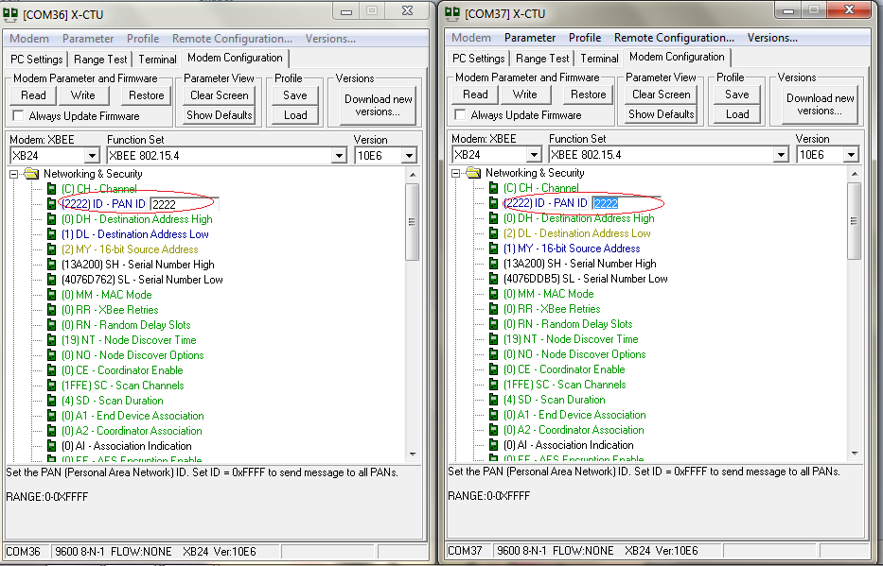

**Fig 1.14 Making the PAN ID same**

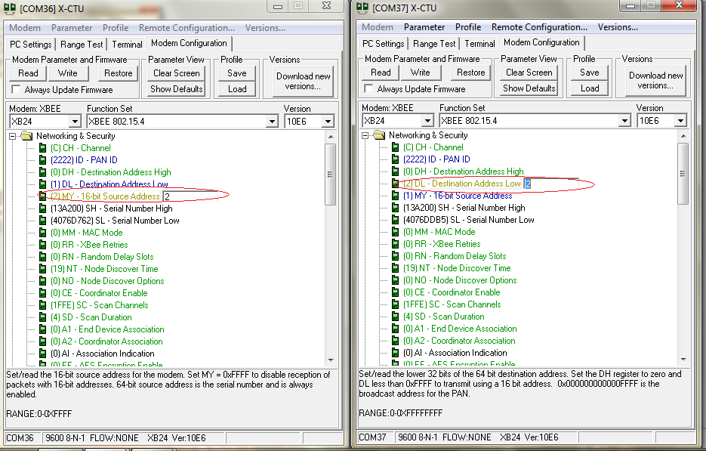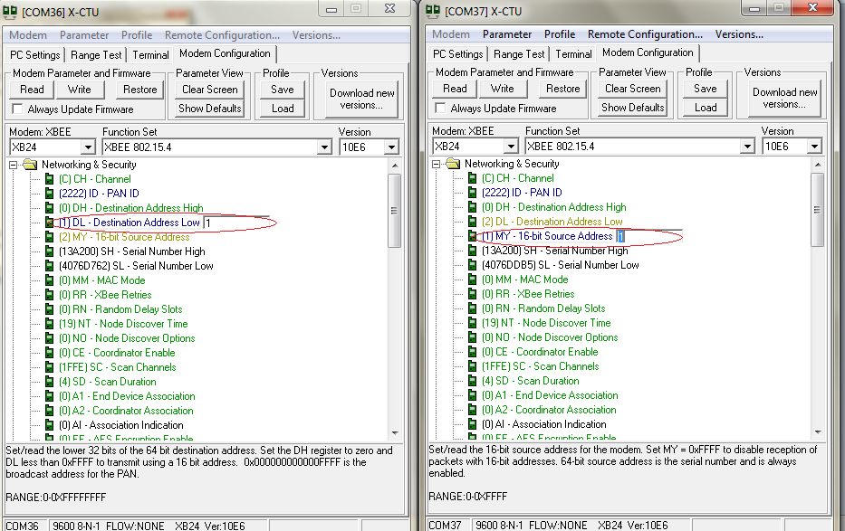

**Fig1.15 make source address of server same as the destination address of end user**

**Fig1.16 make source address of server same as the destination address of end user**

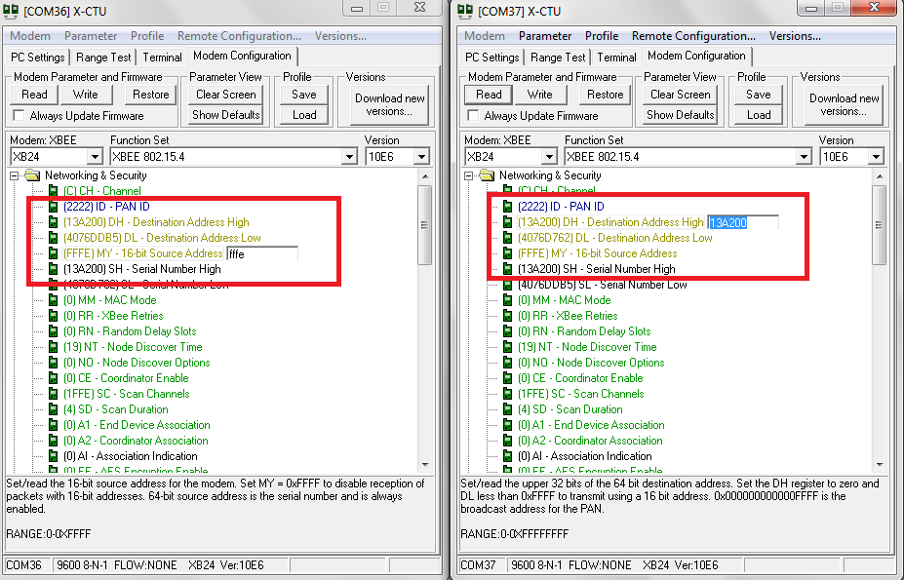

**Fig 1.16 64-bit addressing mode.**

**Key Terms:**

* **Channel(CH):** 802.15.4 and Zigbee break the 2.4Ghz band into 16 channels. Parameter range for Xbee is 0x0B - 0x1A.
* **Personal Area Network(PAN)** - A data communication network that includes one or more End Devices and optionally a Coordinator.
* **PAN ID**: Each network is defined with a unique PAN identifier (PAN ID). This identifier is common among all devices of the same network.  ZigBee devices are either preconfigured with a PAN ID to join, or they can discovery nearby networks and select a PAN ID to join.

If multiple Zigbee networks are operating within range of each other, each should have unique PAN ID.

* **Destination Address:**
  + **DH: Destination Address High**. Set/Read the upper 32 bits of the 64-bit destination address. When combined with DL, it defines the destination address used for transmission. To transmit using a 16-bit address, set DH parameter to zero and DL less than 0xFFFF. 0x000000000000FFFF is the broadcast address for the PAN.
  + **DL: Destination Address Low**. Set/Read the lower 32 bits of the 64-bit destination address. When combined with DH, DL defines the destination address used for transmission. To transmit using a 16-bit address, set DH parameter to zero and DL less than 0xFFFF. 0x000000000000FFFF is the broadcast address for the PAN.
* **Source Address:**
  + **16-bit (MY):** Set/Read the RF module 16-bit source address. Set MY = 0xFFFF to disable reception of packets with 16-bit addresses
  + **64-bit:** 64-bit source address (serial number) and broadcast address (0x000000000000FFFF) is always enabled.
    - **SH: Serial Number High**. Read high 32 bits of the RF module's unique IEEE 64-bit address. 64-bit source address is always enabled.
    - **SL: Serial Number Low**. Read low 32 bits of the RF module's unique IEEE 64-bit address. 64-bit source address is always enabled.

**.**

**Step 6: Writing the module.**

Write this configuration into the module by clicking on write option.

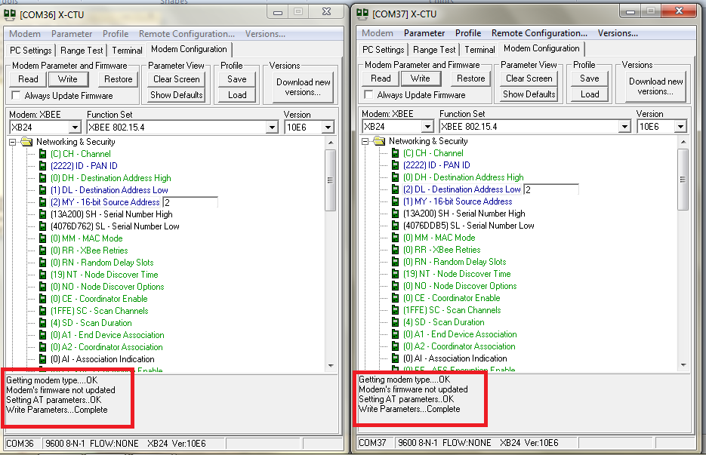

**Fig 1.17 writing the module**

**Step11: Verification of Unicast Network Configuration**

Now to see the output open the terminal window in both X-CTU. Type something in window which gets reflected back in other. The transmitted data will appear in blue while the received data appear in red

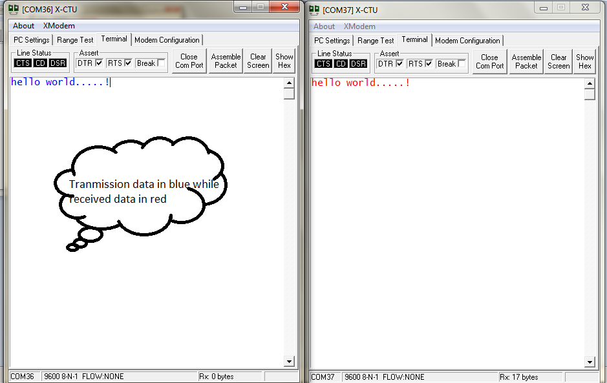

**Fig1.18 Terminal Window**

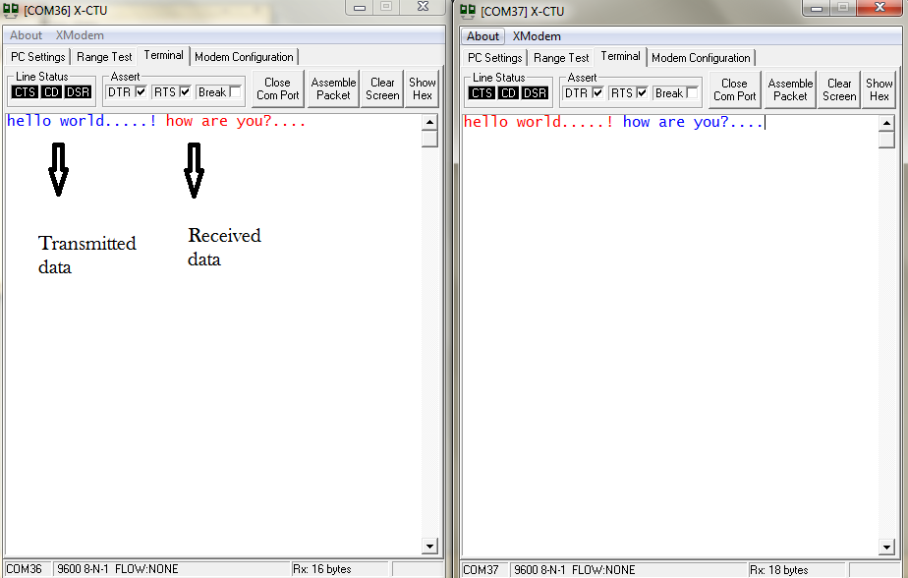

**Fig1.19 Terminal Window**

**Conclusion:**

As it is as shown in Fig 1.19:

* [com36] is server [com37] is end user.
* Data transmitted by server is received at end user and data transmitted by end users are only received by the server.
* Message “hello world!.....” was sent by server [com36] and is received at the end users [com37]. Message “how are you?....” was sent by the end user [com37] and is received at the server [com36].
* This is called ‘Unicast’.