**Cloudera CDH5.5 QuickStart VM Setup**

QuickStart VM is a VM provided by Cloudera that already has Hadoop and other big data frameworks installed and configured.

**You can use this VM **if** you could not get your own CentOS6.7+CDH5.5 VM created correctly!**

Download CDH QuickStart VM 5.5:

<http://www.cloudera.com/content/www/en-us/downloads/quickstart_vms/5-5.html>

Documentation:

<http://www.cloudera.com/documentation/enterprise/latest/topics/rg_vd.html>

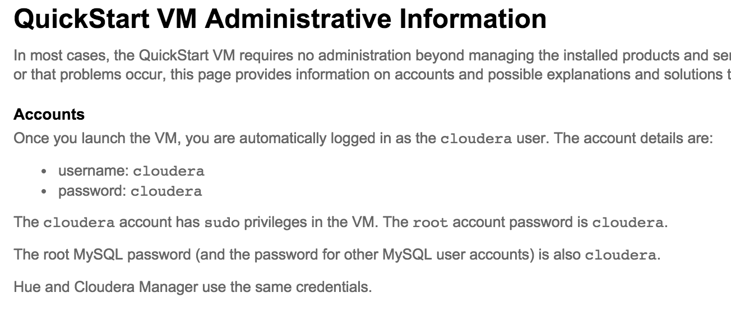

Downloaded archive: **cloudera-quickstart-vm-5.5.0-0-vmware.zip**

Once you download and un-archive the VM – you can open it in your VMWare:

File 🡪 Open 🡪

Browse to and select the

cloudera-quickstart-vm-5.5.0-0-vmware.vmx

Run it

You login as ‘cloudera/cloudera’ user

And usually it opens up a browser with Cloudera Welcome page on startup:

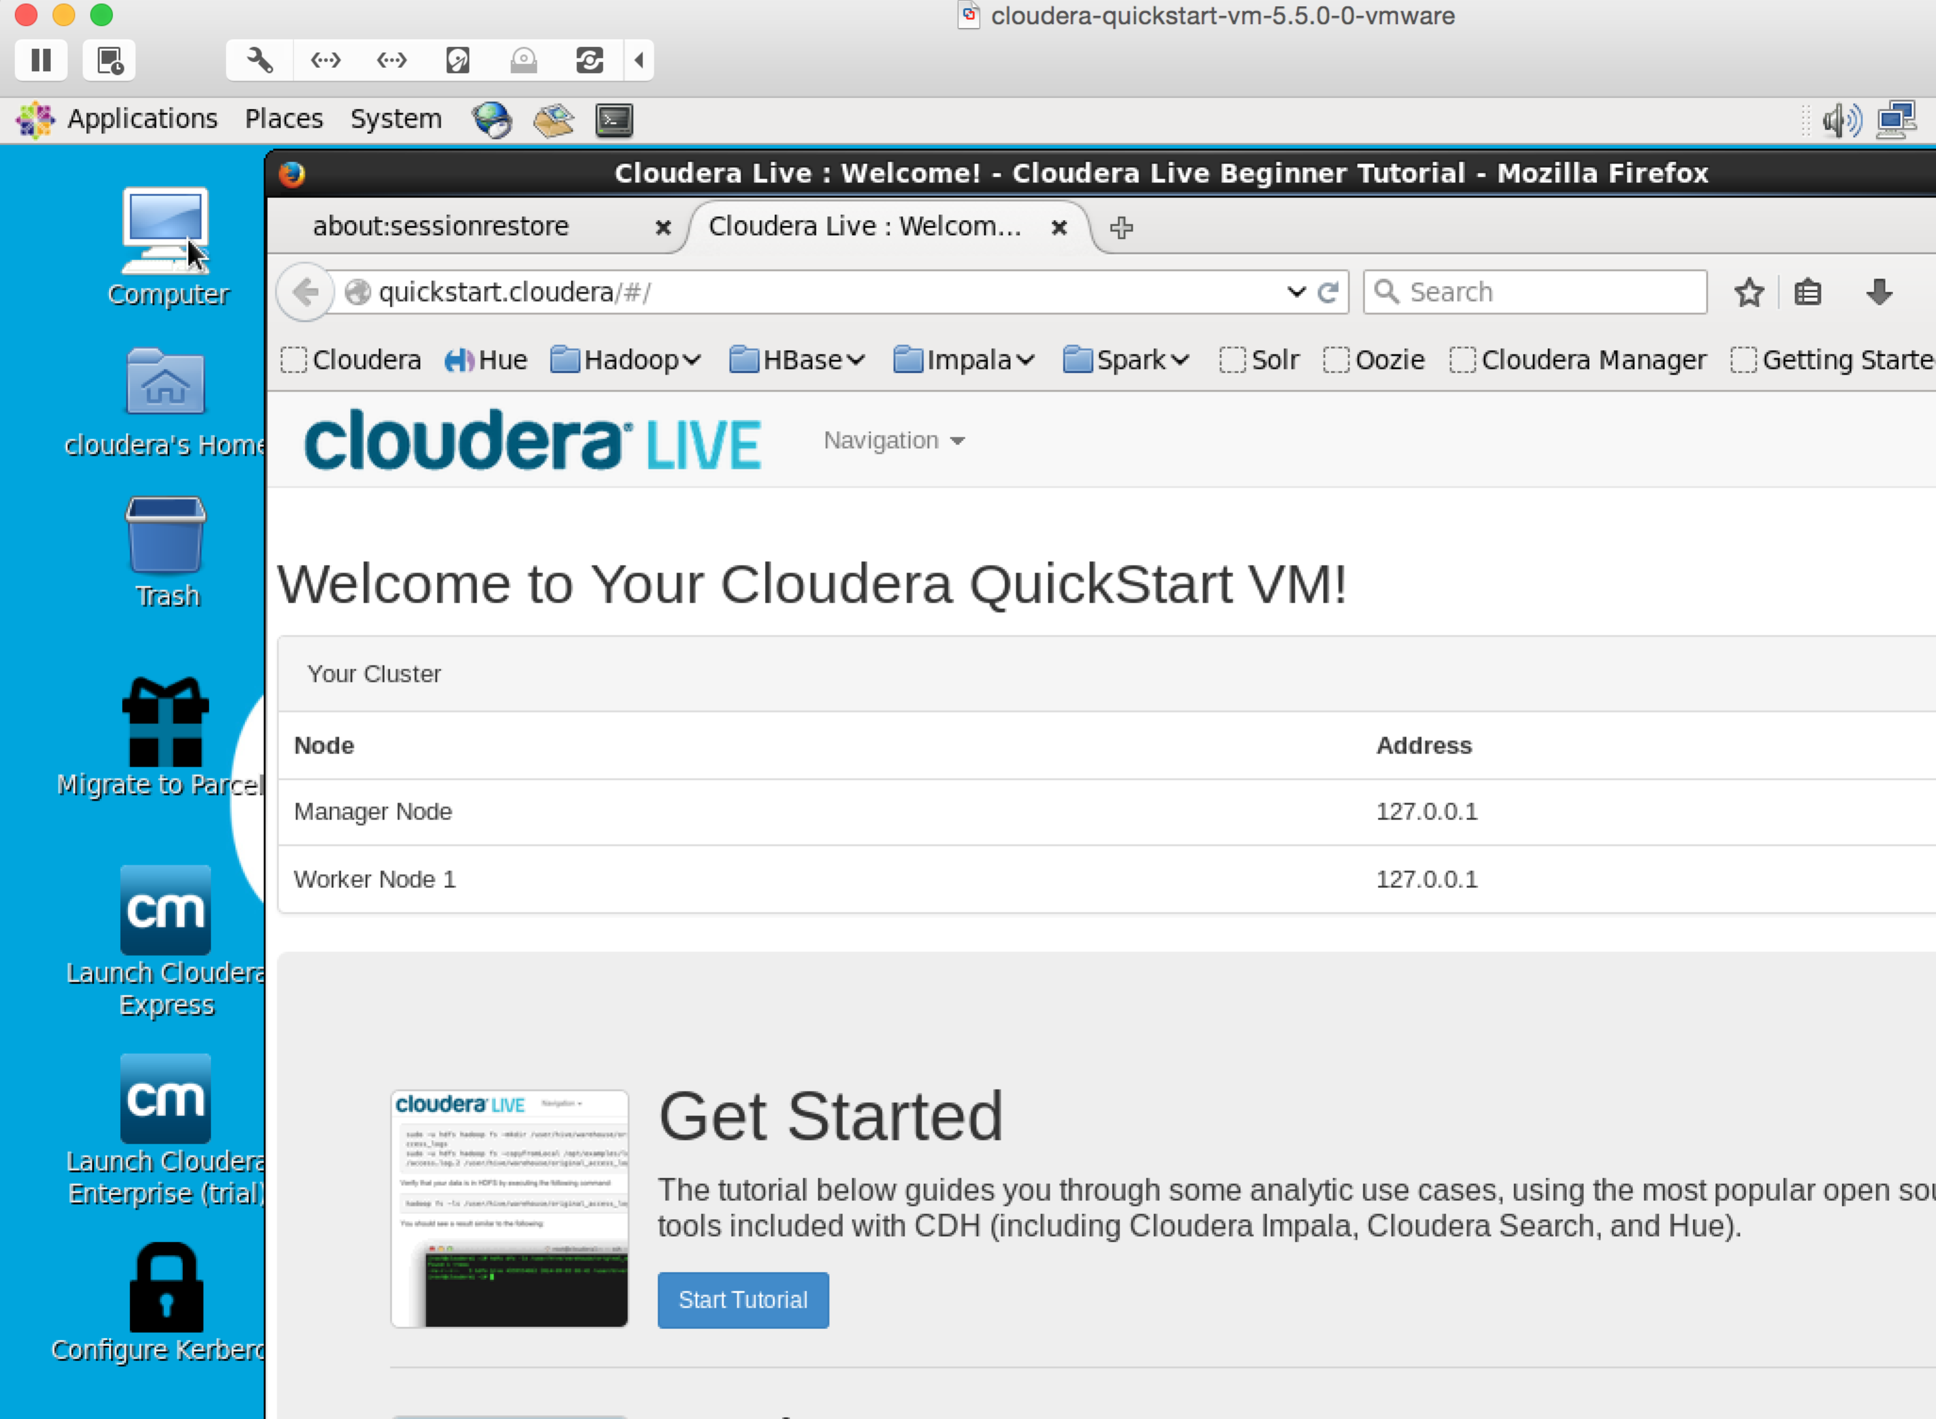

Feel free to explore different frameworks already installed on the VM – Spark, Hadoop, Hive, Impala and others

Open a terminal and make sure you can run hadoop commands:

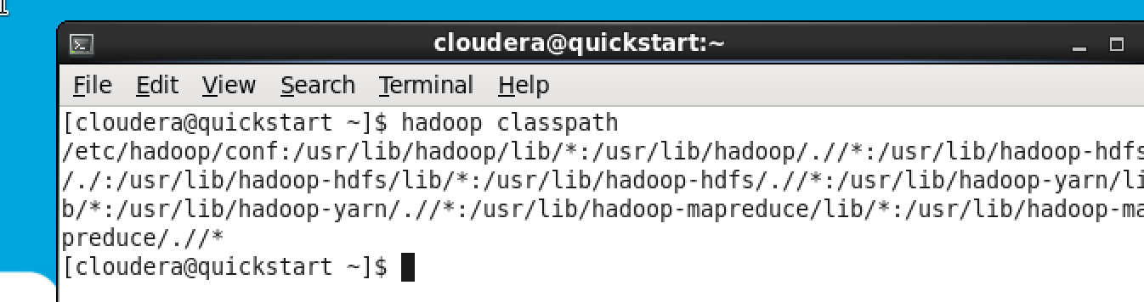

To find out the OS and Java versions:

[cloudera@quickstart ~]$ cat /etc/redhat-release | grep -oE '[0-9]+\.[0-9]+'

6.4

[cloudera@quickstart ~]$ ^C

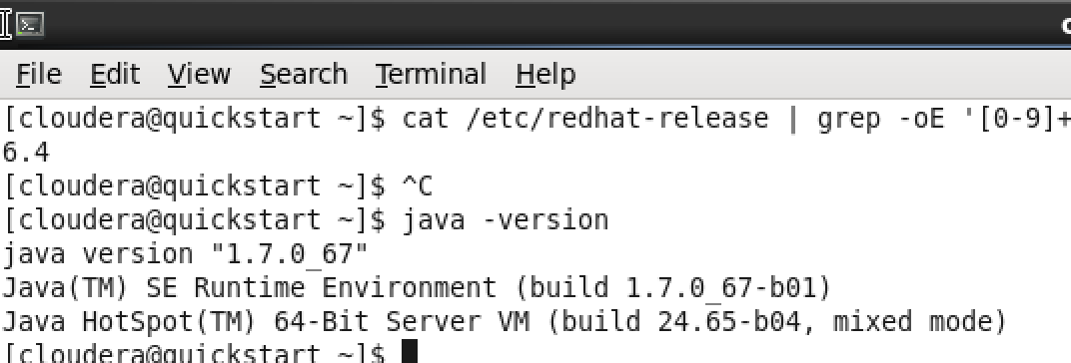

Check what services are running:

[cloudera@quickstart ~]$ sudo service --status-all

There will be lots of output – but most important is to make sure all Hadoop services are running:

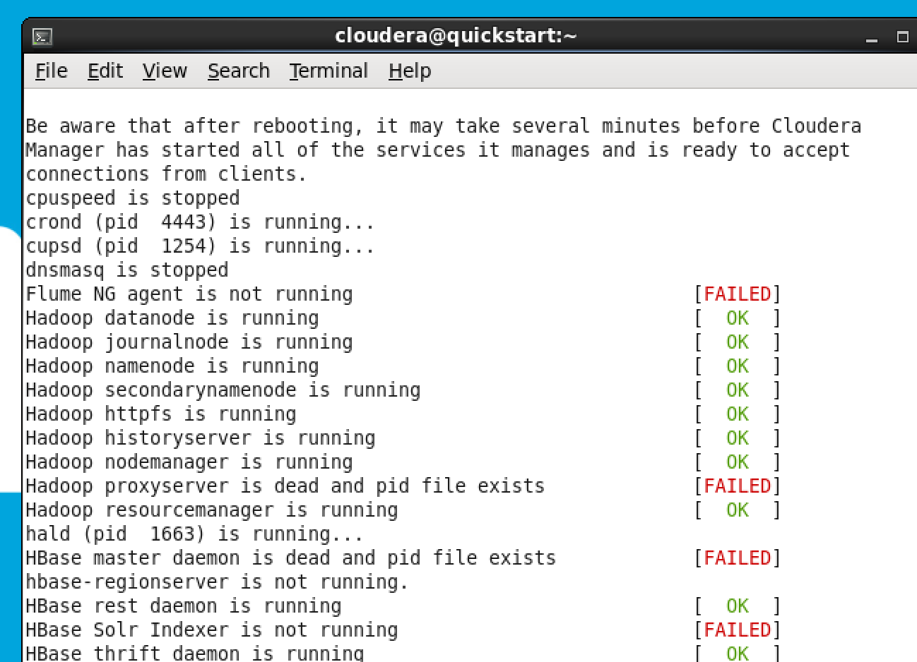

some services are not started – it’s Ok.

Reference for Hadoop FS commands:

[https://hadoop.apache.org/docs/current/hadoop-project-dist/hadoop-common/FileSystemShell.html#rm](https://hadoop.apache.org/docs/current/hadoop-project-dist/hadoop-common/FileSystemShell.html%23rm)

>>>>>>>>>>>>>>>>>>>>>>>>>>>>>>>>>>>>>>>>>>>>>>>>>>>>>>>>