**CDH 5.5 Hadoop Development Environment Setup**

**Get CDH5.5 distribution**

Download the tarbal Hadoop distribution from here:

<http://www.cloudera.com/documentation/enterprise/latest/topics/cdh_vd_cdh_package_tarball.html>

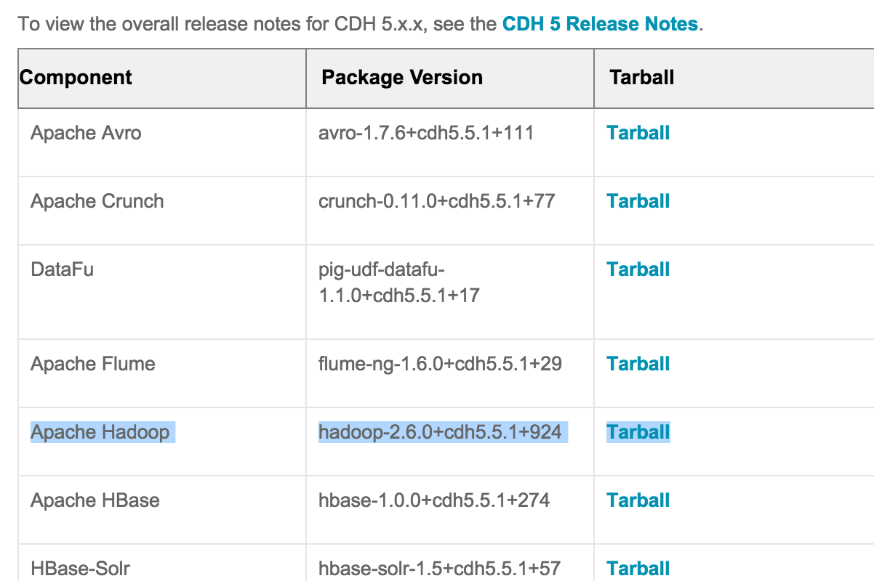

**hadoop-2.6.0-cdh5.5.1.tar.gz**

Untar the archive and explore the content:

achine generated alternative text:
Marina 
Name 
Marina 
hadoop-2.6.O-cdh5.5.1 
.DS Store 
bin 
bin-mapreducel 
cloudera 
etc 
examples 
examples-mapreducel 
include 
lib 
libexec 
LICENSE.txt 
NOTICE-.txt 
README.txt 
sbin 
share 
.DS Store 
doc 
hadoop 
.DS Store 
common 
.DS Store 
hadoop-common-2.6.O-cdh5.5.1 -tests.jar 
hadoop-common-2.6.O-cdh5.5.1 .jar 
hadoop-nfs-2.6.O-cdh5.5.1 .jar 
Macintosh HD 
jdiff 
lib 
sources 
Users 
marinapopova 
Marina 
hadoop-2.6.O-cdh5.5.1 
Tools 

Create new Java User Library with CDH JARs:

achine generated alternative text:
type filter text 
Resource 
Builders 
Java Build Path 
Java Code Style 
Java Compiler 
Java Editor 
Javadoc Location 
Project References 
Refactoring History 
Run/Debug Settings 
Task Repository 
Task Tags 
Validation 
WikiText 
Properties for CSClE63_MRv2 
Java Build Path 
Source 
Projects 
JARs and class folders on the build path: 
Access rules: No rules defined 
External annotations: (None) 
Native library location: (None) 
Libraries 
hadoop-common-2.6.O-cdh5.5.1 .jar - [Users/marinapop 
hadoop-mapreduce-client-core-2.6.O-cdh5.5.1 .jar - /lJst 
commons-cli-l .2.jar - /Users/marinapopova/Marina/Too 
commons-logging-I .1 .3.jar - /Users/marinapopova/Mari 
guava-11.0.2.jar - /Users/marinapopova/Marina/Tools/l•u 
commons-collections-3.2.2.jar - [Users/marinapopova/t\ 
activation-I . 1 .jar - /Users/marinapopova/Marina/Tools/h 
apacheds-il 8n-2.O.O-M15.jar - 
apacheds-kerberos-codec-2.O.O-M15.jar - /Users/marin 
api-asnl -api-l .0.O-M20.jar - /Users/marinapopova/Mari 
api-util-l .0.O-M20.Jar - /Users/marinapopova/Marina/Tot 
asm-3.2.jar - /Users/marinapopova/Marina/Tools/had001 
avro-l .7.6-cdh5.5.1 .jar - /Users/marinapopova/Marina/1 
commons-beanutils-l .7.0.iar - /Users/marinapopova/ME 
Order and Export 
Add JARs... 
Add External JARs... 
Add Variable... 
Add Library... 
Add Class Folder... 
Add External Class Folder... 
Edit... 
Remove 
Migrate JAR File... 
Apply 
Cancel 

**Eclipse Classpath for MRv2**

Add JARs from all following directories to your CDH5.5\_nrv2\_full Lib:

.../hadoop-2.6.0-cdh5.5.1/share/hadoop/common/hadoop-common-2.6.0-cdh5.5.1.jar

.../hadoop-2.6.0-cdh5.5.1/share/hadoop/common/lib/\*

.../hadoop-2.6.0-cdh5.5.1/share/hadoop/mapreduce2/\*

.../hadoop-2.6.0-cdh5.5.1/share/hadoop/yarn/\*