## HU Extension Assignment 09 E63 Big Data Analytics

### Handed out: 04/01/2016 Due by 11:30PM EST on Friday, 04/08/2016

Please, describe every step of your work and present all intermediate and final results in a Word document. Please, copy past text version of all essential command and snippets of results into the Word document with explanations of the purpose of those commands. We cannot retype text that is in JPG images. Please, always submit a separate copy of the original, working scripts and/or class files you used. Sometimes we need to run your code and retyping is too costly. Please include in your MS Word document only relevant portions of the console output or output files. Sometime either console output or the result file is too long and including it into the MS Word document makes that document too hard to read. PLEASE DO NOT EMBED files into your MS Word document. For issues and comments visit the class Discussion Board. You are not obliged to use Java or Eclipse. You are welcome to use any language and any IDE of your choice.

**Problem 1)** Public site GapMinder.org presents many excellent visualizations of data about the World. One such presentation (<http://www.gapminder.org/tools/bubbles#_>) displays average life expectancy in year as a function of average income per person in countries of the world. Countries are represented as circles in different colors depending on their continent, e.g. countries in Europe are yellow, countries in Asia, red, etc. Every country is presented by a circle of area proportional to its population. Radius of the circle is therefore proportional to the square root of population. As the cursor hovers over each country, its name appears over its circle. Data presented in this graph can be found in various Excel files provided by the same site (<http://www.gapminder.org/data/)>. We extracted some files which we believe contain data used in the graph bellow:

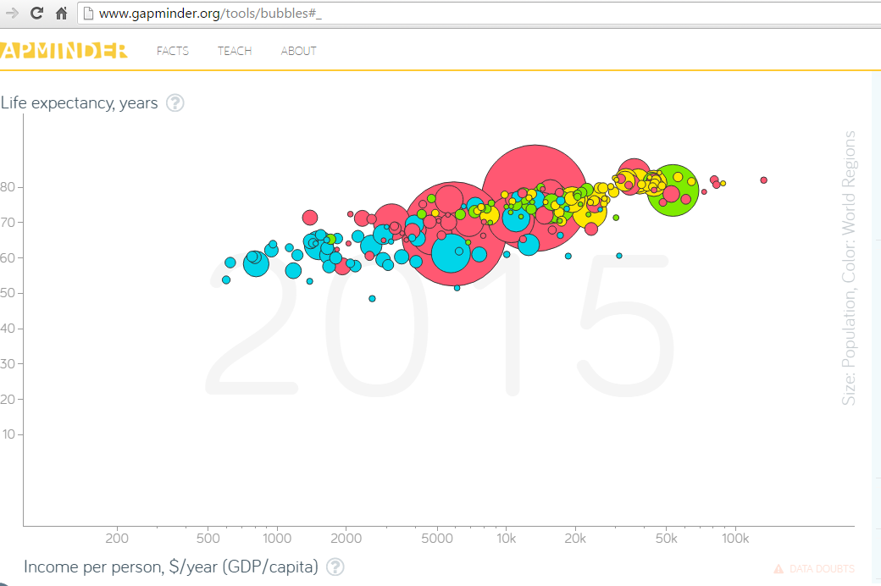

Please recreate above graph using D3 or any similar technology of your choice**.** You do not need all data present in provided Excel files. Select most recent data for every country. If you know what you are doing, keep your data in files on your OS or in a database of your choice. Otherwise, copy relevant data directly into your “HTML/JavaScript” code. Please note that the horizontal axis is logarithmic.

<http://bl.ocks.org/weiglemc/6185069>

Country,Continent,Life expectancy in 2015,Per capita income,Population

Afghanistan,Asia,40,1000,31056997

Albania,Europe,60,10000,3581655

Algeria,Africa,80,100000,32930091

**Problem 2)** Display the graph of population per country as a pie chart. Color countries by the continents and group all countries by the continents. Leave no separation between different countries, however, when you hover over a country change it color to light purple and display its name and population in millions.

https://bl.ocks.org/mbostock/3887235

**For every problem, please provide a working copy of your HTML file including the JavScript (D3) portion*.***