**Name:-Rohan Sharma**

**Branch:-Electrical and Electronics**

**e-mail:-rohan.bgh@gmail.com**

**Date:-03.07.2017**

Design

**\*\*\*\*\*\*\*\*\*\*\*\*\*\*\*\*\*\*\*\*\*\*\*\*\*\*\*\*\*\*\*\*\*\*\*\*\*\*\*\*\*\*\*\*\*\*\*\*\*\*\*\*\*\*\*\*\*\*\*\*\*\*\*\*\*\*\*\*\*\*\*\*\*\*\*\*\*\*\*\*\*\*\*\*\***

**Instructions:**

• There are no negative marks

• **Unnecessary explanation** will lead to less mark even if answer is correct

• Use the same **font and font size** for writing your answer

• If required, Draw the image in a paper with proper explanation and add the snapshot in your

corresponding answer

**\*\*\*\*\*\*\*\*\*\*\*\*\*\*\*\*\*\*\*\*\*\*\*\*\*\*\*\*\*\*\*\*\*\*\*\*\*\*\*\*\*\*\*\*\*\*\*\*\*\*\*\*\*\*\*\*\*\*\*\*\*\*\*\*\*\*\*\*\*\*\*\*\*\*\*\*\*\*\*\*\*\*\*\*\***

Q1: Explain the significance of torque of motor in making the balance bot stable and responsive.

Answer: There is a PID controller which controls the torque of the motors using the feedback from the gyroscope by measuring the error .i.e. the angle with the vertical. In order to balance itself on two wheels the motors should be of high torque. And order to get the proper acceleration of the BOT the torque plays an important role.

Q2: Compare given types of motors for making the balance bot. DC motor, Stepper

and DC motor with encoder.

Answer: Motors are used in robots to actuate something. To select the proper electric motor we have to find the response at a series of unknown parameters including the loading that a specific motor can take, can the selected motor with a specific torque to move the robot without being overloaded, or the rotations per minute of the motor when it is loaded.

1)DC motors:-wide selection is available, easy to control via computer with relays or switches, larger motors can power upto 200 pound bots. The disadvantage is that it require gear reduction to provide torque , which plays the major role in balance bot.

2) Stepper motor:- Does not require gear reduction to power at low speeds , low cost. But in other hand it gives poor performance under varying loads and also not suitable for motion of bot in uneven surface. It also consumes high current.

3)DC motor with encoder:-

Q3.Compare the two designs shown in Figure 1 and Figure 2 in terms of stability, response, construction and programming. 

Figure 1: Stackable design Figure 2: Vertical Design

Answer:

<Please write your answer here.

Write pro and cons for both designs.>

Q4: Where should be the ideal position for center of gravity while constructing a Balance Bot?

Draw a rough sketch of your dream design using the components provided in the kit. Show

the tentative position of center of gravity. Consider the size and weight of all the components

which you will use.

Answer: The ideal position of center of gravity while constructing a balance bot is to keep the center of gravity near the support base and equally in between the two wheels. Also the higher the centre iof gravity the higher will be the moment of inertia which results in slower fall i.e. lower angular acceleration. 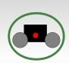

Q5: What will be placement of the tilt sensor(mpu6050) in your dream design? You can show a

rough sketch.

Answer:- The placement of tilt sensor should be as much as possible should be kept in the top of the bot which will allow it to sense the correct tilt angle .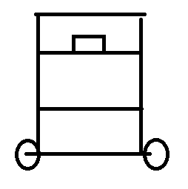

Q6: What will be the effect of diameter of the wheel while making a balance bot in terms of

stability and response?

Answer:Robot with larger wheels inside the frame will have less stability than one with smaller wheels, because the points of contact (contact points of the wheels) can be further apart with small wheels. Also the diameter of the wheel is chosen based on the rpm of the motor. And rubber tires are used to increase the grip on smoth surface.

Q7: Ball and Stick Experiment:-

Consider balancing a meterstick upright on the tip of your finger. After balancing meterstick,

attach a ball at one end and again try to balance the stick. Is it easier to balance with the ball or

without it?

Answer: Balancing a meterstick attached with a ball at one end will be easier .

Below is the equation of the meterstick only.











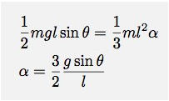

Now,the equation for the meterstick along with the ball attached to one end.

For this, I will assume that the mass on the ball is twice the mass of the meterstick. First, I need to find the new center of mass. The system can be treated as two masses, the stick with a mass m located at the center (l/2) and another mass (2m) . In this case, the center of mass (from the end) would be:



This would give moment of inertia:-

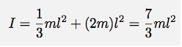

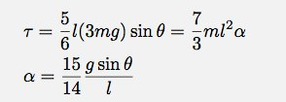

Q8. List any two applications where principle of Balance Bot can be used. Draw a functional block diagram of any one of the applications, indicating input, output, intermediate signals, sensors,controller and actuators.

Answer:-The principle of balance bot is used in segway type vehicle and also in rocket propeller.

***********************************