Jetpunk Quizzes Goal
Goal of this project: to be able to create a handful of Jetpunk quizzes that are regularly updated with the most recent / up-to-date data.

Quiz 1 – Top 100 Public Companies in the World by Market Cap
This will be a Jetpunk quiz where users can guess the top 100 companies by market cap in the world. This should be updated DAILY at 6 pm ET (i.e., when most world markets are closed).
What it should have: Similar to this site (https://companiesmarketcap.com/) I want the following details:
- Rank
- Logo
- Name of Company
- Stock Ticker
- Market Cap (as of last check)
- Country

Checks: You should check that the data tallies from at least three independent sources, one of which should be https://companiesmarketcap.com/.
Programmatic update to Jetpunk quiz: Use Browser Automation tools (probably Playwright) to update the quiz automatically. You should use the “Edit HTML” feature to do this automatically.
I also want the ability to launch a new update “live”. So like you have a daily update at 6 pm ET, you can also perform a live update. Basically create an HTML file or some such which I can open. Then if I press a button on the html page, it triggers an action to run all the steps to run the update (which would have happened automatically at 6 pm ET anyway). Understand?

We’ll do more quizzes later. Let’s start with this one to start with.

This is what the edit answers functionality looks like on the Jetpunk Edit Quiz online.

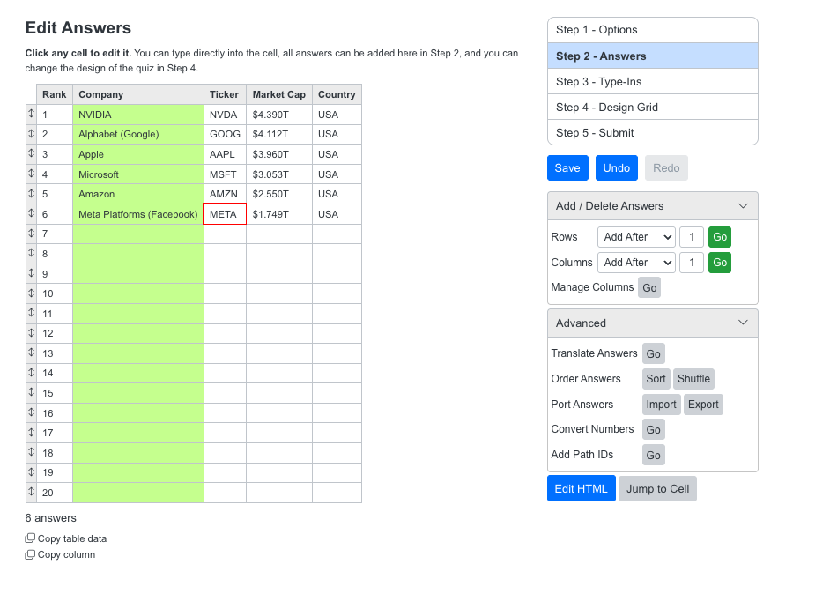Note that the easiest way to copy paste data into the table is by having a comma delimited

Phase II – Hosting Quizzes at rohansampath.com/quizzes
Secondarily, I’d also like to host the same quizzes on rohansampath.com/quizzes (basically recreate the Jetpunk functionality but not be hamstrung by its clunky UI etc.). Please create a plan for that too. It doesn’t have to be pushed to rohansampath.com right now, just localhost is fine for the moment. Again, for the moment it’s okay to just have the Top 100 Companies Quiz I mentioned above.

