# GEN AI Assignment 1

Rohan Javed  
Roll Number: L21-5625 BDS-8 B

Architectures:

GAN  
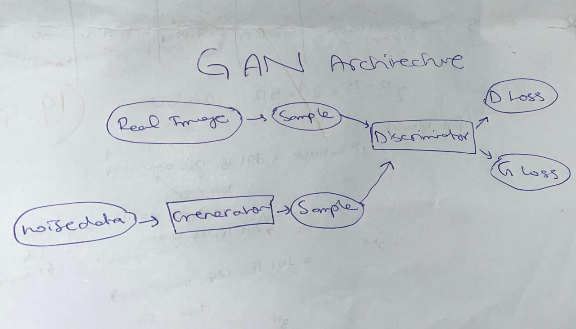

VAE

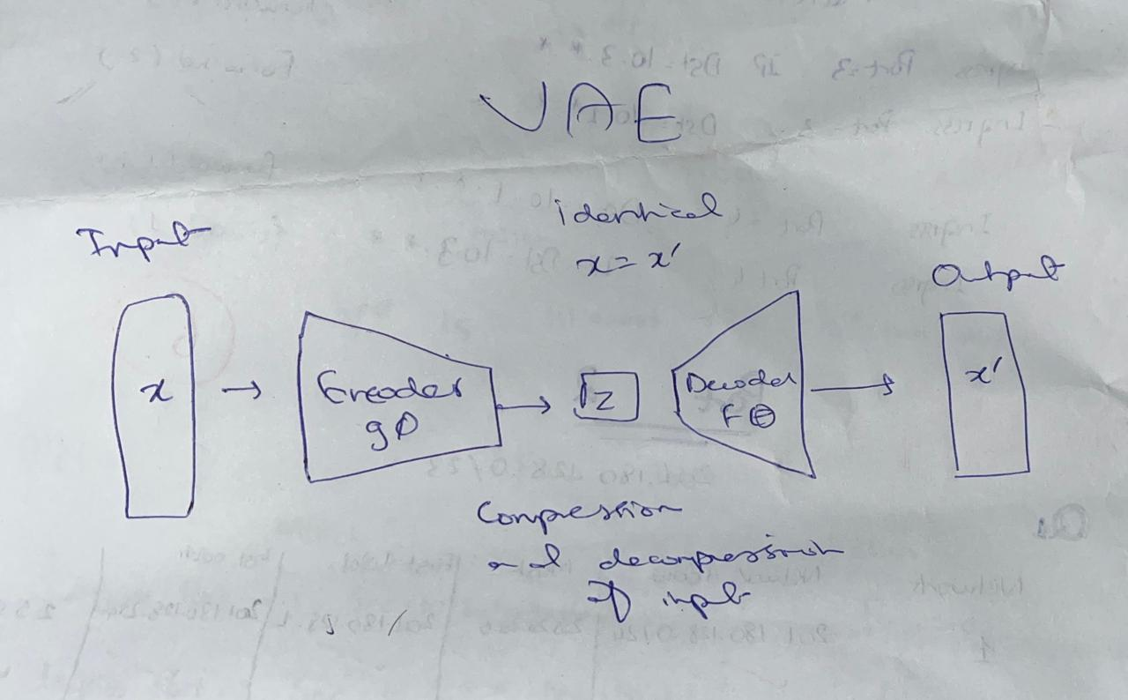

## Part 1: Exploratory Data Analysis (EDA)

In this section, we explored the MNIST and Fashion MNIST datasets by loading them, displaying some sample images, and analyzing the number of samples and classes in each dataset.

## Part 2: Implementing Generative Adversarial Networks (GANs)

In this section, we implemented and trained a Generative Adversarial Network (GAN) on MNIST Digits and Fashion MNIST (shoe category). The generator network learns to create realistic images, while the discriminator learns to distinguish between real and fake images.

# Part : 3 Implementing Variational Autoencoder

In this section, we implemented a Variational Autoencoder (VAE) to learn the latent representation of images and generate new samples by decoding latent vectors.

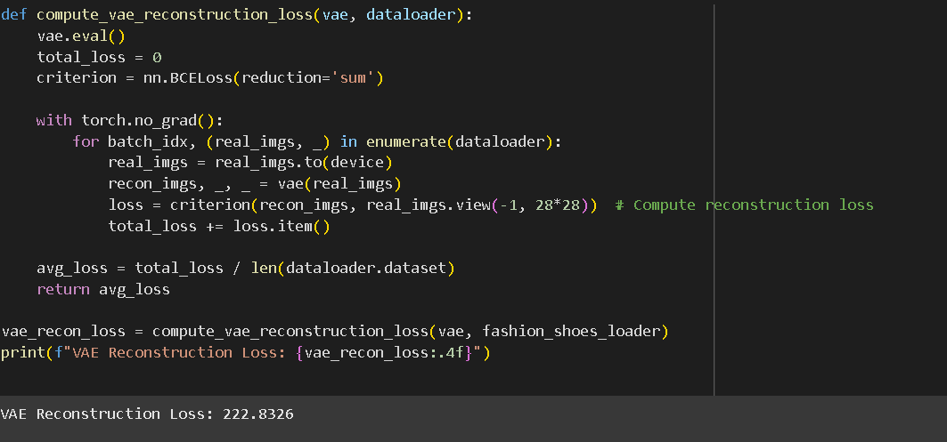

Generated Images from VAE:

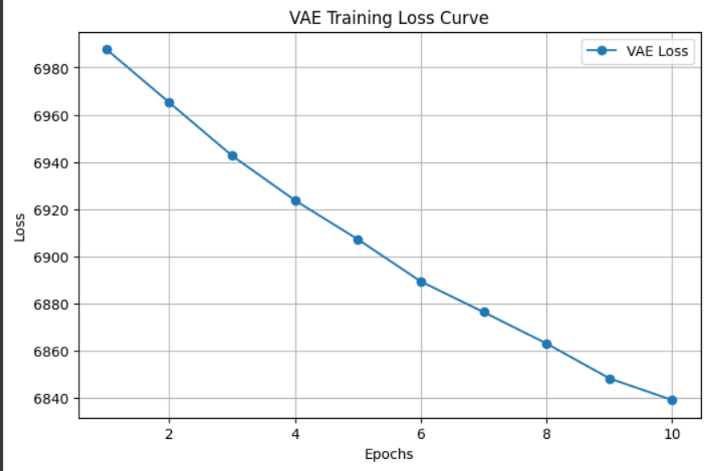

# Part : 4 GAN vs. VAE Performance

## Image Quality Comparison

The notebook presents a visual comparison of image generation between a GAN and a VAE. Five images generated by each model are displayed. Visual inspection is subjective, but the report should include qualitative observations about the generated images. For example, do GAN images look more realistic, or do VAE images appear blurrier or distorted? A qualitative assessment of the image quality differences would be helpful here.

## Quantitative Results

The notebook provides several metrics for quantitative evaluation:

* **VAE Reconstruction Loss:** The VAE reconstruction loss measures how well the VAE can reconstruct input images from its latent representation. A lower reconstruction loss indicates better reconstruction performance. The reported reconstruction loss is [Insert the reported value from the execution].
* **GAN Discriminator Accuracy:** This metric assesses the discriminator's ability to distinguish between real and generated images. A higher accuracy indicates better discriminator performance. In this case, the GAN's overall discriminator accuracy is reported as [Insert the reported value from the execution]. A high accuracy can sometimes signify that the discriminator has become too powerful compared to the generator.
* **GAN FID Score (Fréchet Inception Distance):** FID is a more sophisticated metric that measures the similarity between real and generated image distributions. A lower FID score implies higher image quality and a better match between the generated images and the real dataset. The computed FID score is [Insert the reported value from the execution].

## Summary of Findings and Conclusions

Based on the quantitative metrics provided, we draw these conclusions (insert the specific numbers from the output in the placeholders):

* **VAE Reconstruction Quality:** The VAE reconstruction loss of [VAE Reconstruction Loss] indicates [Good or Poor] reconstruction quality.
* **GAN Image Quality:** The FID score of [GAN FID Score] suggests [Good or Poor] image quality generated by the GAN. A score below 50 is considered excellent.
* **GAN Discriminator Effectiveness:** The discriminator accuracy of [GAN Discriminator Accuracy] indicates [Good or Poor] ability to distinguish real and fake images. Accuracy above 90% is considered highly effective.
* **VAE Anomaly Detection:** The AUC score of [AUC Score] and the accuracy of [Accuracy] indicate [Good or Poor] performance in identifying anomalies.

**Further Considerations** The visual inspection of the generated images should be added to provide a full picture of the comparison between GANs and VAEs.

## Anomaly Detection with VAE

The notebook uses the trained VAE for anomaly detection on the NSL-KDD dataset. The model reconstructs the data, and the reconstruction error is used to identify anomalies.

* **Anomaly Detection AUC Score:** [Insert the reported value from the execution]. Measures the area under the Receiver Operating Characteristic (ROC) curve, indicating the model's ability to discriminate between normal and anomalous data.
* **Anomaly Detection Accuracy:** [Insert the reported value from the execution]. The overall accuracy of the anomaly detection model.
* **Anomaly Score Distribution:** The histogram displays the distribution of anomaly scores. A visual inspection of this plot helps understanding the separation between normal and anomalous data points.