**Network Tab Evidence  
1. Signup**

* **OTP generation for authentication.  
  “/auth/generate-otp”**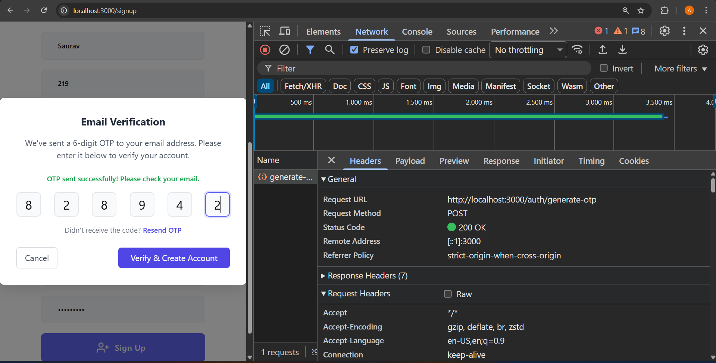
* **OTP verification.**

**“/auth/verify-otp”**

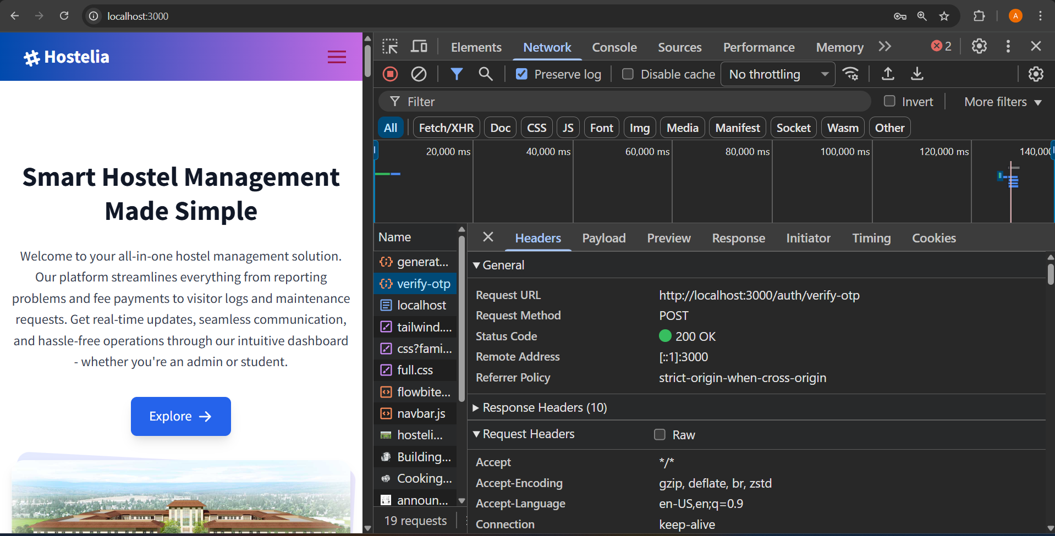

**2.Logout/Login**

* **“auth/logout”**

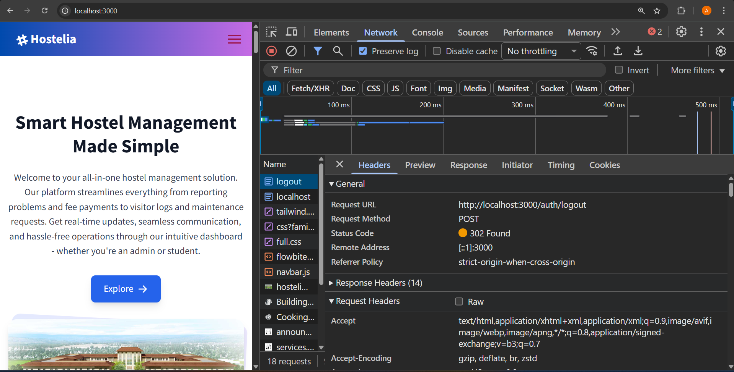

* **“auth/login”**

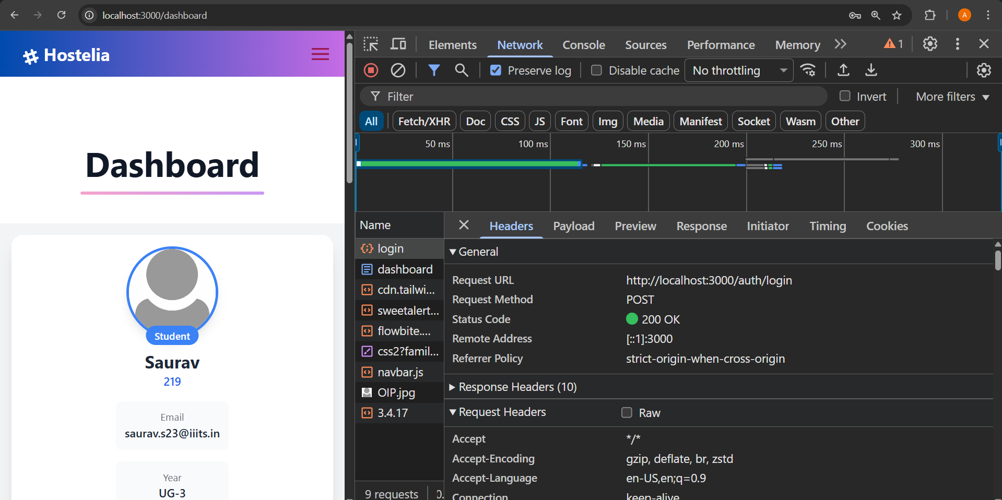

**3.Services**

* **“/services/problems/add”** 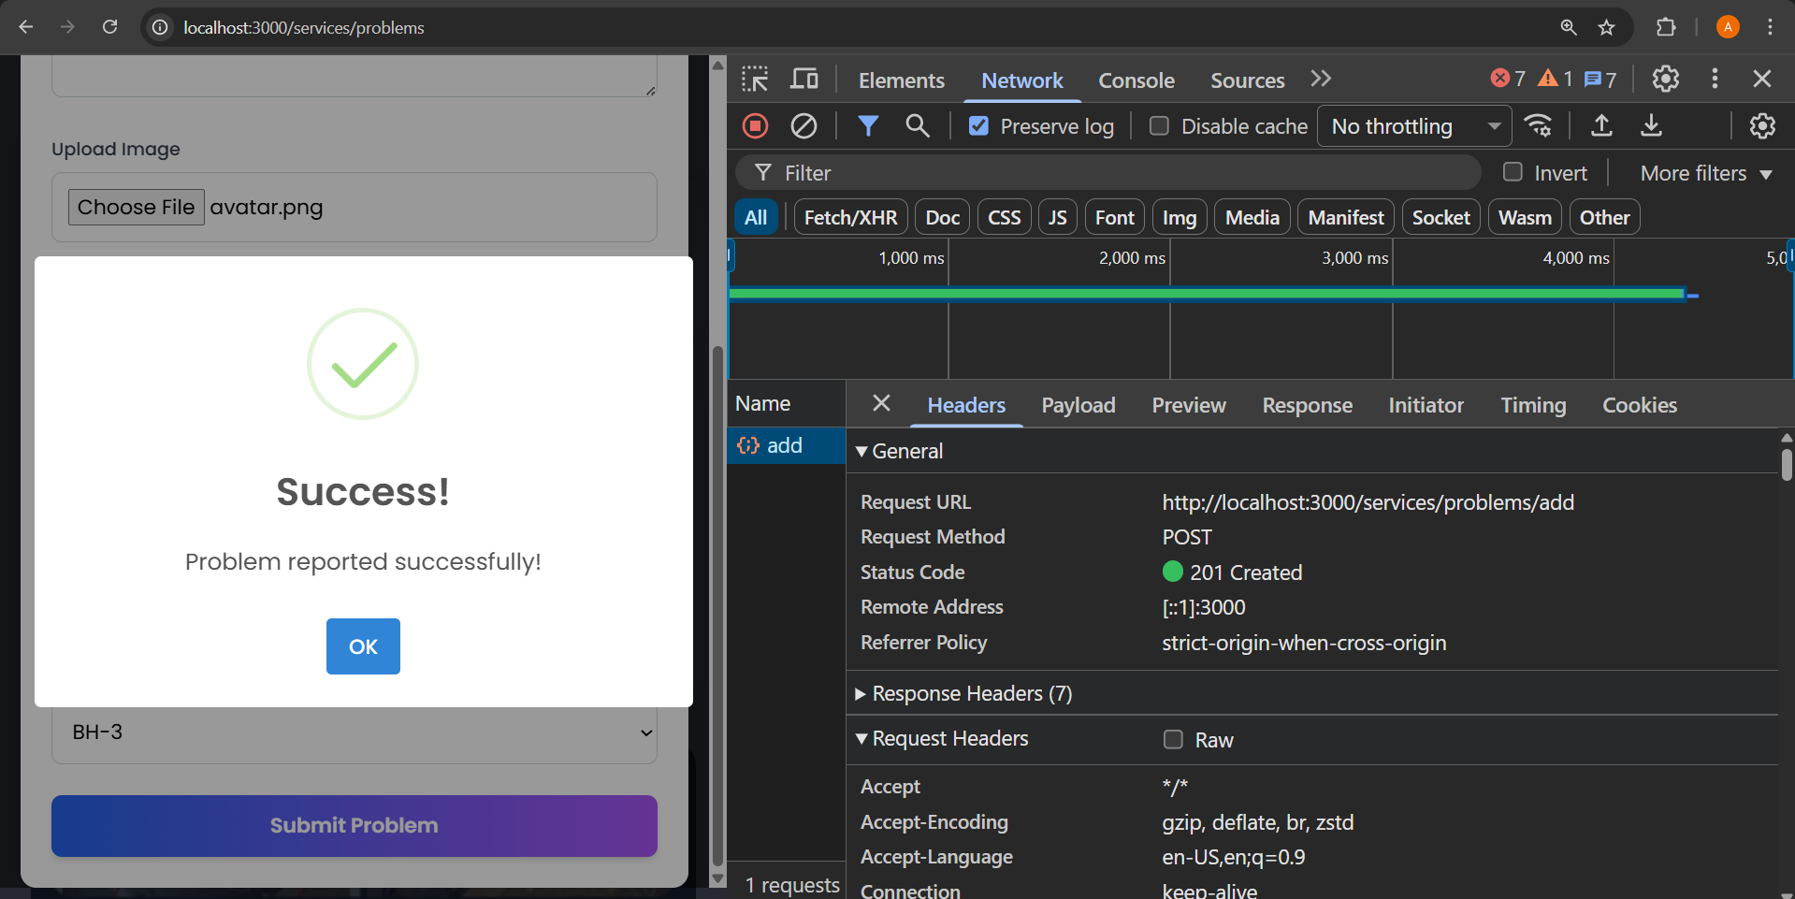
* **Problems Status – “/services/problems/statusChange”**

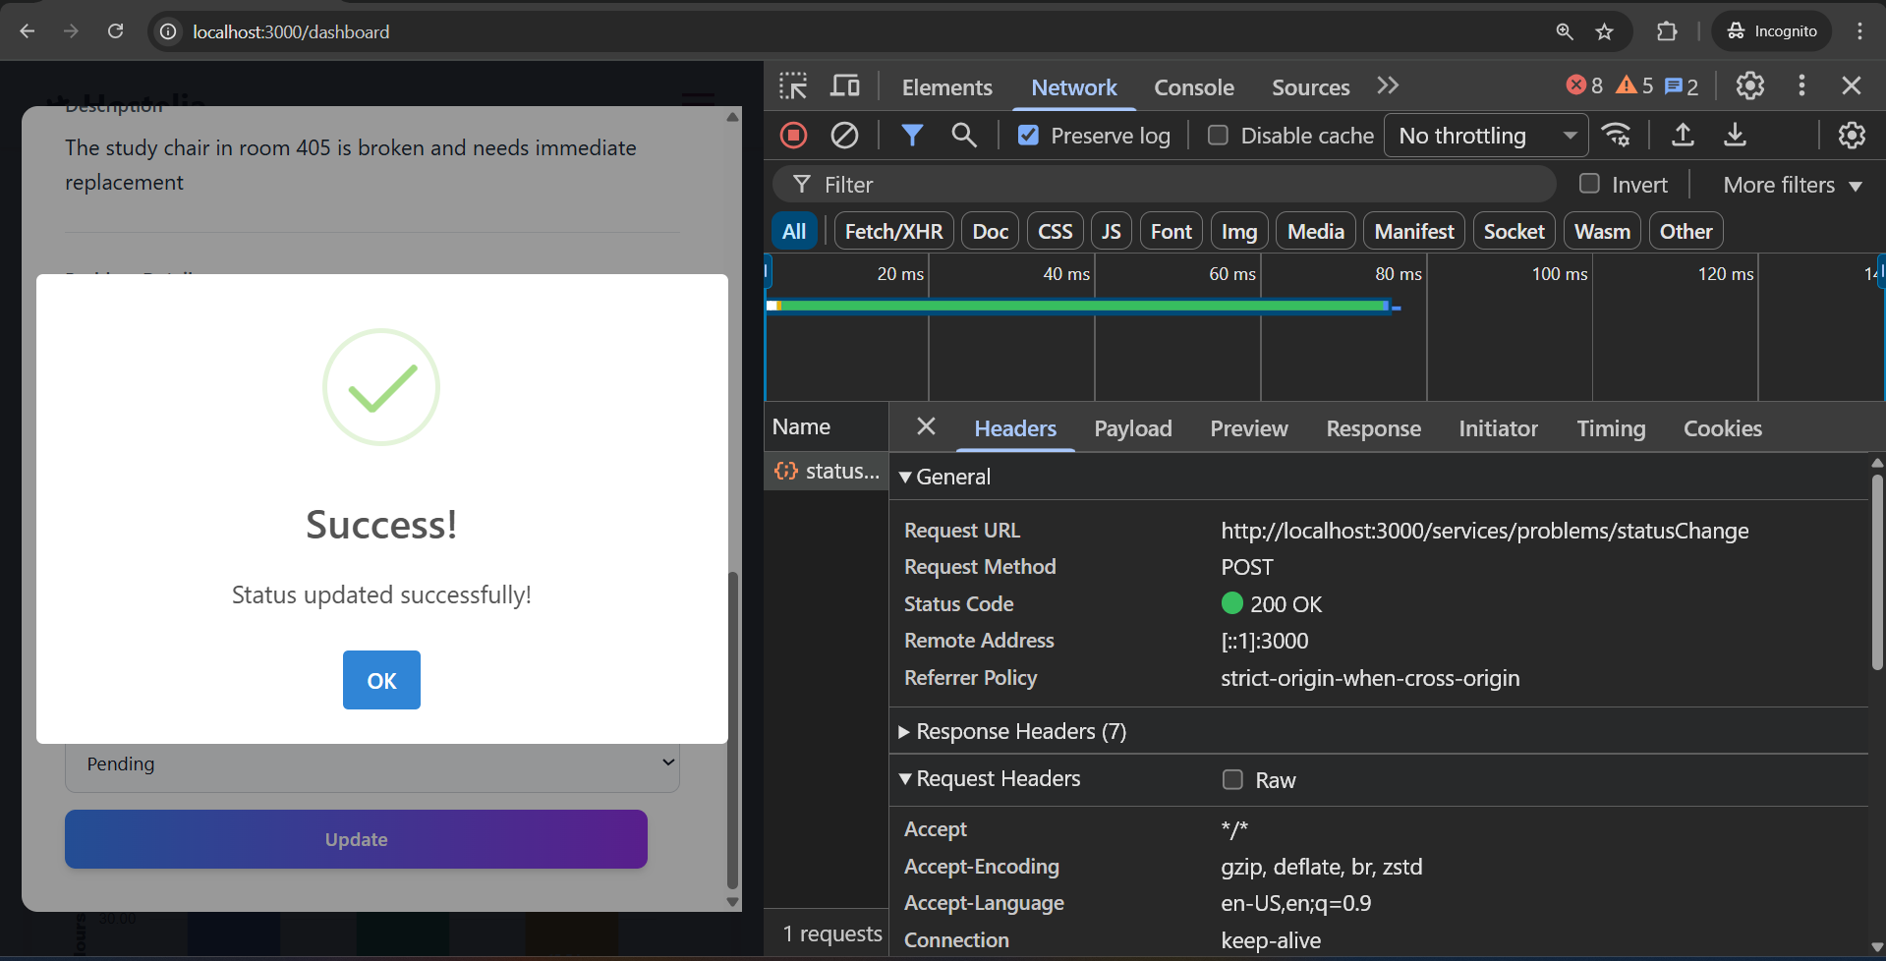

* **Hostel Entry/Exit – “/services/transit”**

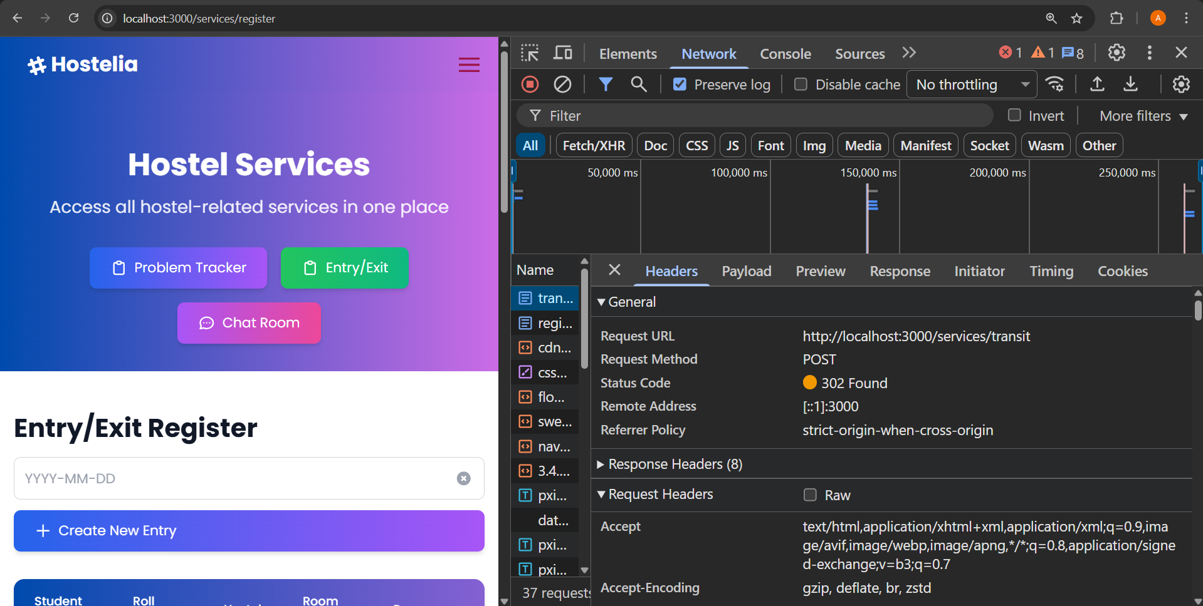

* **Chat room creation – “services/chatRoom/create”**

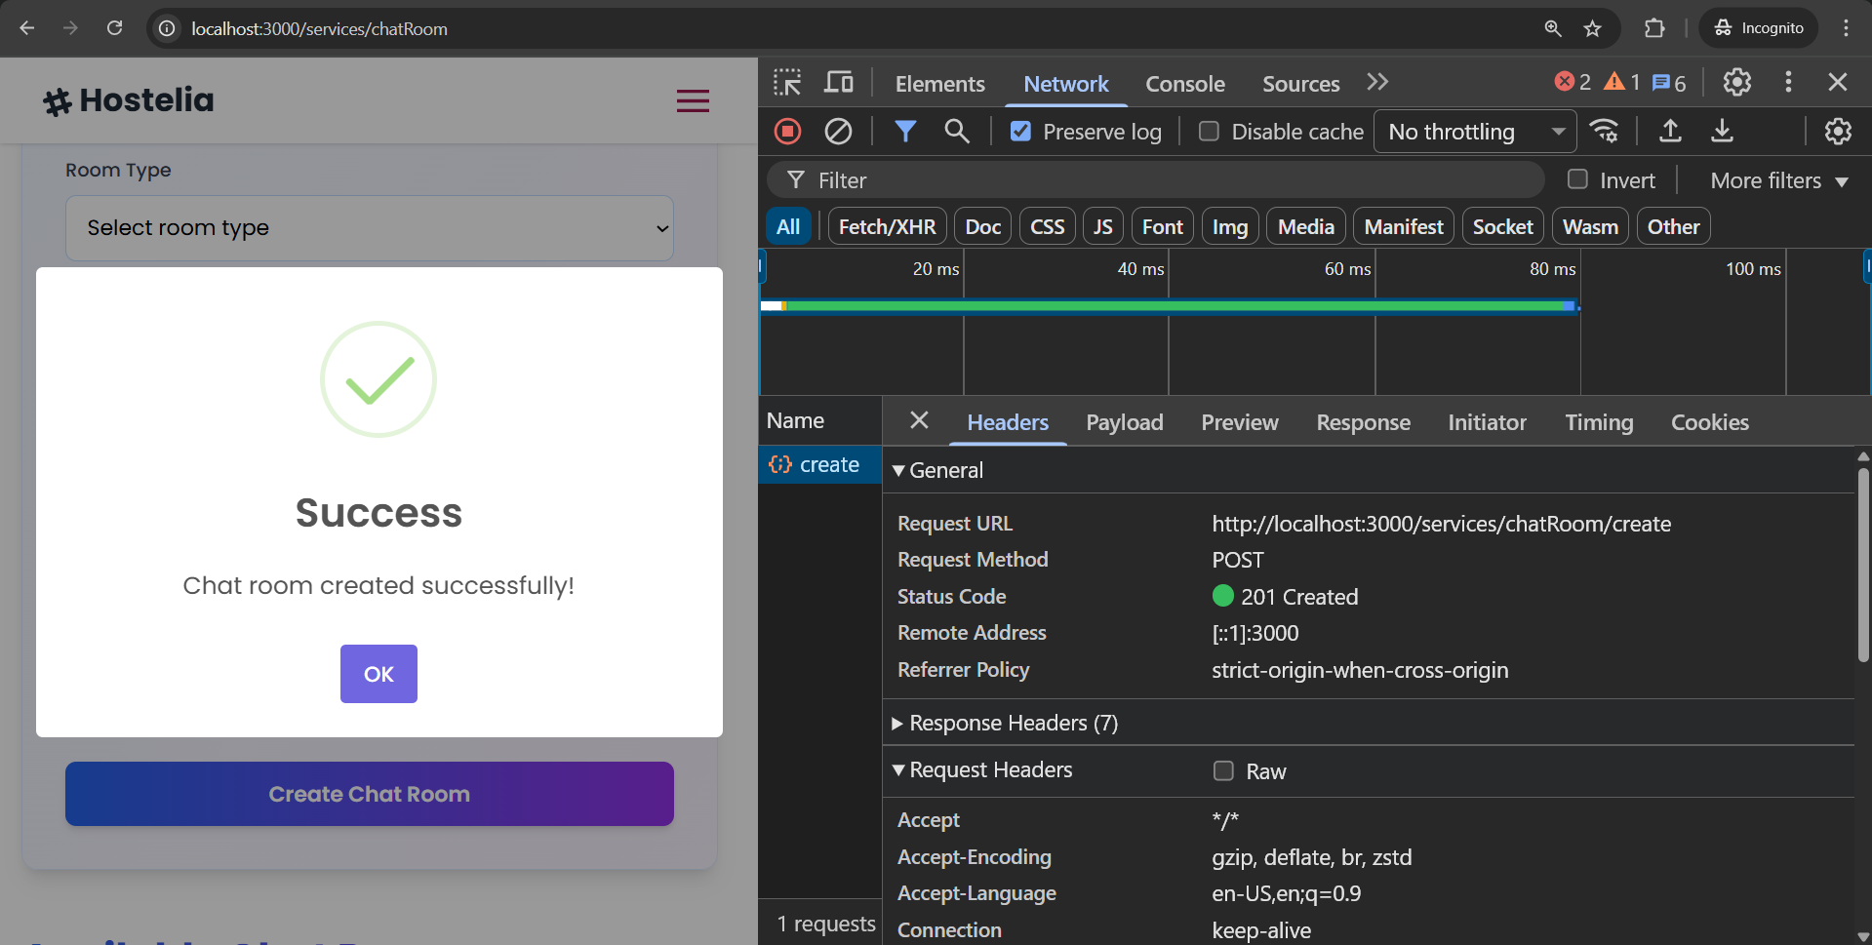

* **Chat room deletion – “/services/chatRoom/delete/:id”**

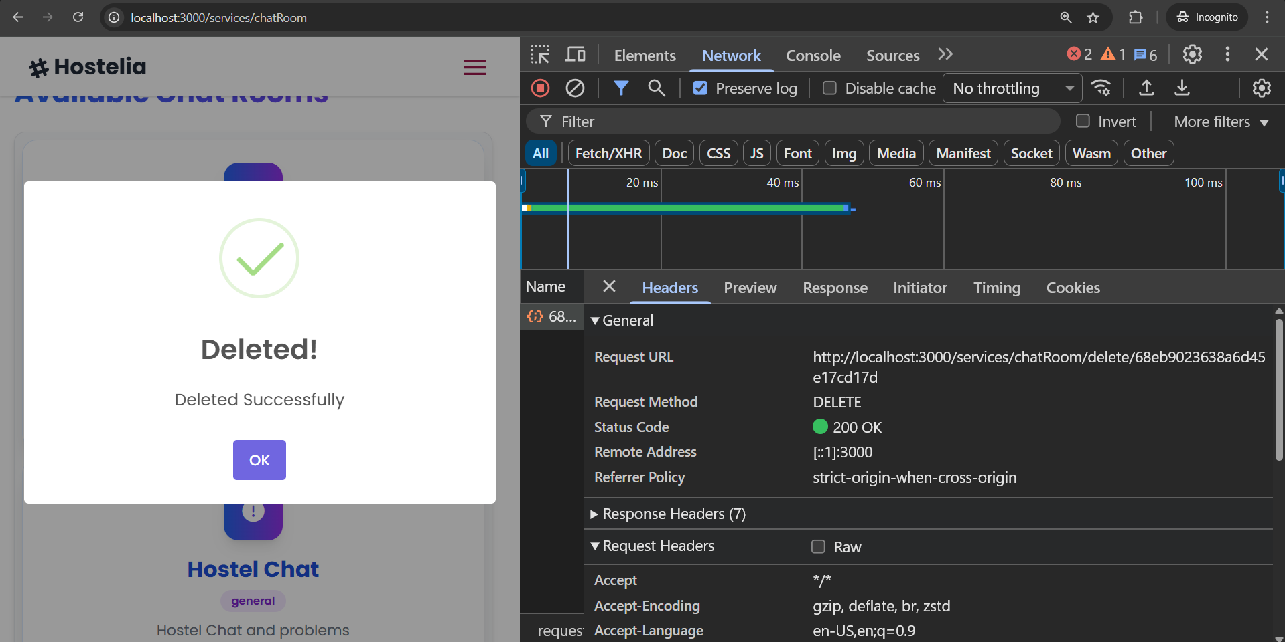

* **Mess menu feedback – “/feedback”**

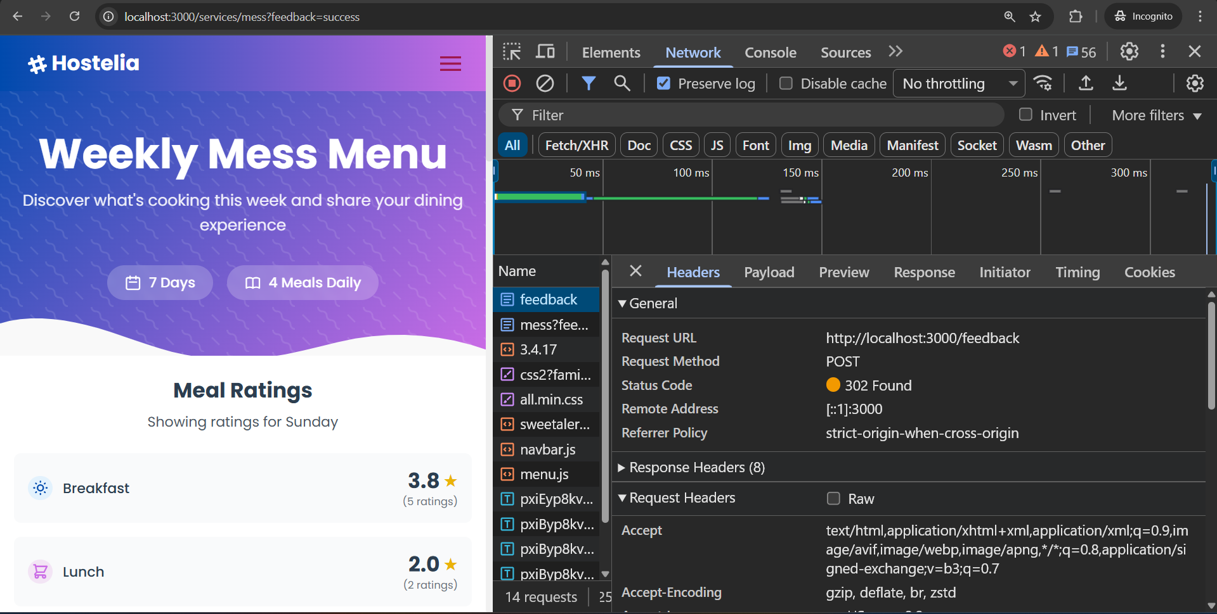

* **Fees Confirmation –**

**“/services/fee-status”**

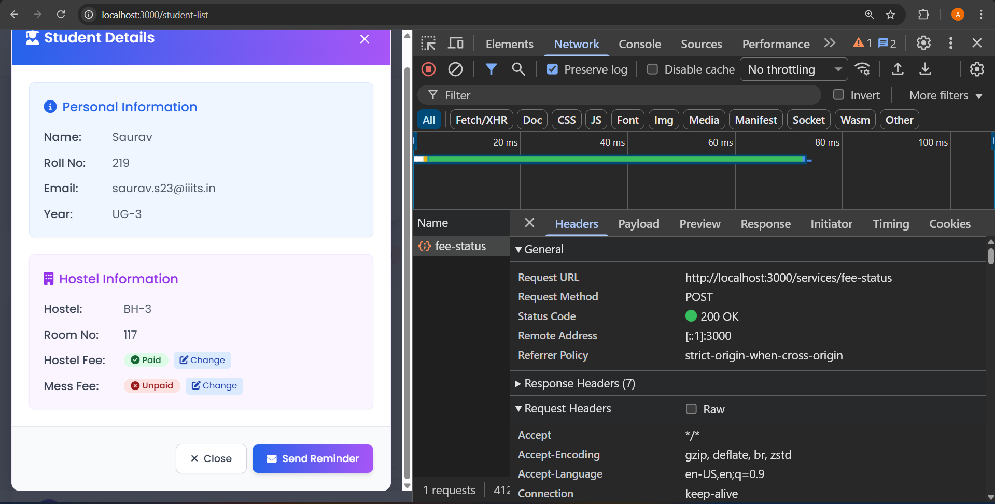

* **Fees Reminder – “send-fee-reminder”**

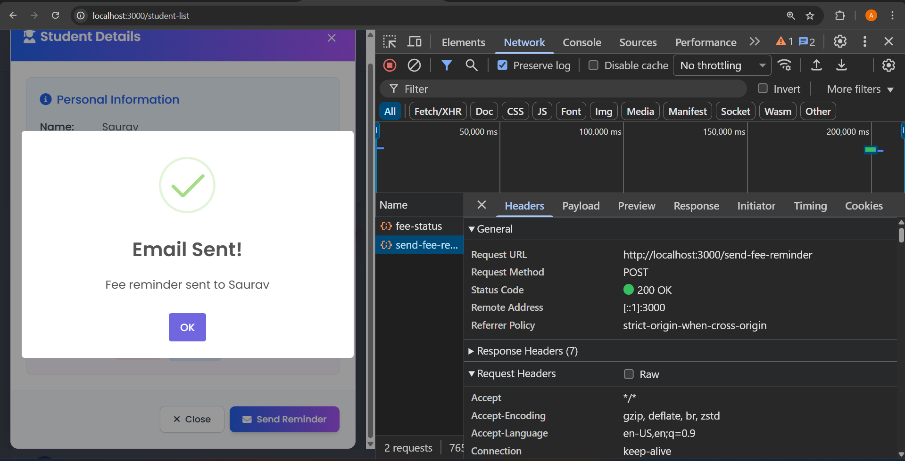

* **Creating Wardens (Only by admins) –**

**“/services/users/add-warden”**

