**INTERACTIVE DATA VISUALIZATION ON IPL-ANALYSIS-2008-2018**

**STUDENT NAME: KSHTIJ MISHRA**

**STUDENT ID: 10385164**

**STUDENT NAME: ROHAN KULKARNI**

**STUDENT ID: 10505302**

**MODULE: DATA VISUALIZATION**

**LECTURAR: BASEL MAGABLEH**

**TOOL FOR VISUALIZATION: PYTHON, JUPYTER**

**DUBLIN BUSINESS SCHOOL**

**Dataset: IPL-ANALYSIS-2008-2018**

In this python notebook, analysis of IPL matches from 2008 to 2018 is done using python packages like pandas, matplotlib and seaborn. This Exploratory Data Analysis will help us to find patterns in data, determining relationships in data. We will try to identify the team that has more chance to win the upcoming seasons by finding observations like success rate of each team, identify the team that has won maximum seasons, best defending and chasing team and analyses the toss decisions etc.

. Data can be found on <https://www.kaggle.com/nowke9/ipldata>

**GitHub Repository :**

<https://github.com/rohan1818kulkarni/IPL-Analysis-2008-2018>

**Data fields**

Here's a brief version of what you'll find in the data description file.

**Columns**

* The dataset consists of the information about IPL matches held from 2008 to 2018.
* The dataset comprises of **696 observations of 18 columns**. Below is a table showing names of all the columns and their description.

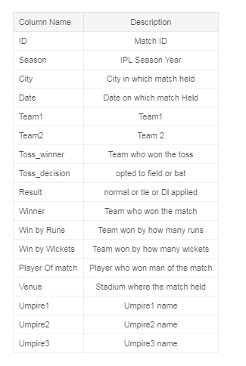

***Some Background Information***

The Indian Premier League (IPL), is a professional Twenty20 cricket league in India contested during April and May of every year by teams representing Indian cities and some states from 2008 to 2018.

**Initial Analysis Questions**

## Table of Contents

[**Problem Statement**](https://www.kaggle.com/anitha136/ipl-analysis-2008-2018#section1)

[**Questions**](https://www.kaggle.com/anitha136/ipl-analysis-2008-2018#section4)

* + [Number of matches held season wise](https://www.kaggle.com/anitha136/ipl-analysis-2008-2018#section401)
  + [Number of matches won by each team at each season](https://www.kaggle.com/anitha136/ipl-analysis-2008-2018#section402)
  + [Success Rate of each team?](https://www.kaggle.com/anitha136/ipl-analysis-2008-2018#section406)
  + [Each Season Winner](https://www.kaggle.com/anitha136/ipl-analysis-2008-2018#section407)
  + [Which team won maximum seasons ?](https://www.kaggle.com/anitha136/ipl-analysis-2008-2018#section408)
  + [Teams won by maximum runs](https://www.kaggle.com/anitha136/ipl-analysis-2008-2018#section409)
  + [Team won by marginal runs](https://www.kaggle.com/anitha136/ipl-analysis-2008-2018#section410)
  + [Best Defending Teams](https://www.kaggle.com/anitha136/ipl-analysis-2008-2018#section411)
  + [Team won by maximum wickets](https://www.kaggle.com/anitha136/ipl-analysis-2008-2018#section412)
  + [Team won by minimum wickets](https://www.kaggle.com/anitha136/ipl-analysis-2008-2018#section413)
  + [Best Chasing Teams](https://www.kaggle.com/anitha136/ipl-analysis-2008-2018#section414)
  + [Top 10 high performing Players](https://www.kaggle.com/anitha136/ipl-analysis-2008-2018#section415)
  + [Toss winning success rate of each team](https://www.kaggle.com/anitha136/ipl-analysis-2008-2018#section416)
  + [Toss Decision across matches](https://www.kaggle.com/anitha136/ipl-analysis-2008-2018#section417)
  + [Toss Decision across seasons](https://www.kaggle.com/anitha136/ipl-analysis-2008-2018#section418)
  + [How does Toss decision varied Season wise by each team ?](https://www.kaggle.com/anitha136/ipl-analysis-2008-2018#section419)
  + [How toss winning affects the match winner](https://www.kaggle.com/anitha136/ipl-analysis-2008-2018#section420)
  + [Toss Decision in which Toss winner is the game winner](https://www.kaggle.com/anitha136/ipl-analysis-2008-2018#section421)
  + [Top 10 Cities to hold match](https://www.kaggle.com/anitha136/ipl-analysis-2008-2018#section422)
  + [In which city does each team has won more matches ?](https://www.kaggle.com/anitha136/ipl-analysis-2008-2018#section423)
  + [Top 10 Venues to hold match](https://www.kaggle.com/anitha136/ipl-analysis-2008-2018#section424)

[**Conclusions**](https://www.kaggle.com/anitha136/ipl-analysis-2008-2018#section5)

### Problem Statement

In this python notebook, analysis of IPL matches from 2008 to 2018 is done using python packages like pandas, matplotlib and seaborn. This Exploratory Data Analysis will help us to find patterns in data, determining relationships in data. We will try to identify the team that has more chance to win the upcoming seasons by finding observations like success rate of each team, identify the team that has won maximum seasons, best defending and chasing team and analyse the toss decisions etc.

[**Number of matches held season wise**](https://www.kaggle.com/anitha136/ipl-analysis-2008-2018#section401)

A team has to play a minimum of 14 matches and can play a maximum of 17. There are 56 league stage matches followed by 4 playoff matches. So essentially each season 4 teams will play just 14 matches, one team will play 15 matches, two teams will play 16 matches and only one team will play 17 matches. Teams which do not qualify for the playoffs play just 14 matches. Team which loses in the eliminator plays 15 matches (14+ eliminator )Team which goes to the final via first qualifier plays 16 matches (14+ qualifier 1 + final)Team which loses in the qualifier 2 also plays 16 matches (14+ qualifier 1/eliminator + qualifier 2)The team which wins the qualifier 2 plays a total of 17 matches. (14+ qualifier1/eliminator + qualifier 2 + the final)

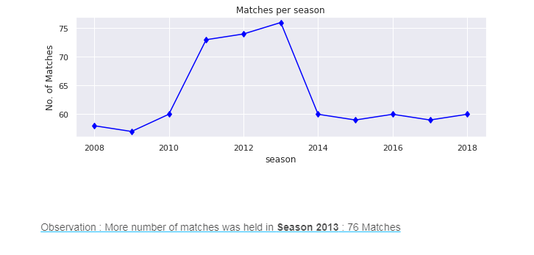

The 2013 season of the [Indian Premier League](https://en.wikipedia.org/wiki/Indian_Premier_League), abbreviated as IPL 6 or Pepsi IPL 2013, was the sixth season of the IPL, established by the [Board of Control for Cricket in India](https://en.wikipedia.org/wiki/Board_of_Control_for_Cricket_in_India) (BCCI) in 2007. The tournament featured nine teams and was held from 3 April to 26 May 2013. The opening ceremony was held at the [Salt Lake Stadium](https://en.wikipedia.org/wiki/Salt_Lake_Stadium) in [Kolkata](https://en.wikipedia.org/wiki/Kolkata) on 2 April 2013. This was the first season with [PepsiCo](https://en.wikipedia.org/wiki/PepsiCo) as the title sponsor. The [Kolkata Knight Riders](https://en.wikipedia.org/wiki/Kolkata_Knight_Riders) were the defending champions, having won the [2012 season](https://en.wikipedia.org/wiki/2012_Indian_Premier_League). A [spot fixing case](https://en.wikipedia.org/wiki/2013_Indian_Premier_League_spot-fixing_case) was revealed by [Delhi Police](https://en.wikipedia.org/wiki/Delhi_Police), leading to arrest of three cricketers from [Rajasthan Royals](https://en.wikipedia.org/wiki/Rajasthan_Royals) and other persons. [Mumbai Indians](https://en.wikipedia.org/wiki/Mumbai_Indians) won the tournament for the first time, defeating [Chennai Super Kings](https://en.wikipedia.org/wiki/Chennai_Super_Kings) in the [final](https://en.wikipedia.org/wiki/2013_Indian_Premier_League_Final) by 23 runs.

[**Number of matches won by each team at each season**](https://www.kaggle.com/anitha136/ipl-analysis-2008-2018#section402)

### RR Season-by-Season Performance

* **2008: Champions (Won 13, Lost 3; Finished first in league stage)**
* 2009: Failed to reach knockouts (Won 6, Lost 7; Finished sixth in league stage)
* 2010: Failed to reach knock-outs (Won 6, Lost 8; Finished seventh in league stage)
* 2011: Failed to reach play-offs (Won 6, Lost 7; Finished sixth in league stage)
* 2012: Failed to reach play-offs (Won 7, Lost 9; Finished seventh in league stage)
* 2013: Third (Won 11, Lost 7; Finished third in league stage)
* 2014: Failed to reach play-offs (Won 7, Lost 7; Finished fifth in league stage)
* 2015: Fourth (Won 7, Lost 6; Finished fourth in league stage)
* 2018: Fourth (Won 7, Lost 8; Finished fourth in league stage)

### DC(DELHI DAREDEVILS) Season-by-Season Performance

* 2008: Semi-finalists (Won 7, Lost 7; Finished fourth in league stage)
* 2009: Semi-finalists (Won 10, Lost 5; Finished first in league stage)
* 2010: Failed to reach knockouts (Won 7, Lost 7; Finished fifth in league stage)
* 2011: Failed to reach play-offs (Won 4, Lost 9; Finished last in league stage)
* 2012: Third (Won 11, Lost 7; Finished first in league stage)
* 2013: Failed to reach play-offs (Won 3, Lost 13; Finished last in league stage)
* 2014: Failed to reach play-offs (Won 2, Lost 12; Finished last in league stage)
* 2015: Failed to reach play-offs (Won 5, Lost 8; Finished seventh in league stage)
* 2016: Failed to reach play-offs (Won 7, Lost 7; Finished sixth in league stage)
* 2017: Failed to reach play-offs (Won 6, Lost 8; Finished sixth in league stage)
* 2018: Failed to reach play-offs (Won 5, Lost 9; Finished last in league stage)

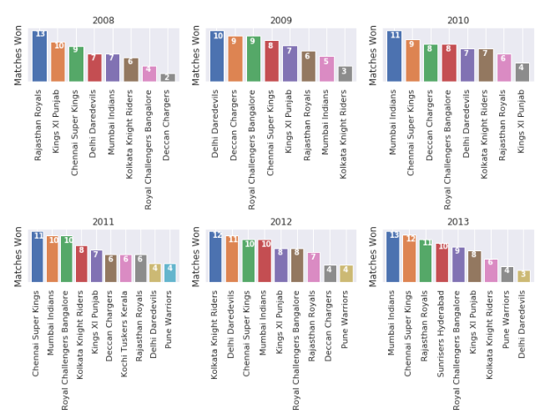

### MI Season-by-Season Performance

* 2008: Failed to reach knockouts (Won 7, Lost 7; Finished fifth in league stage)
* 2009: Failed to reach knockouts (Won 5, Lost 8; Finished seventh in league stage)
* 2010: Runners-up (Won 11, Lost 5; Finished first in league stage)
* 2011: Third (Won 10, Lost 6; Finished fourth in league stage)
* 2012: Fourth (Won 10, Lost 7; Finished third in league stage)
* **2013: Champions (Won 13, Lost 6; Finished second in league stage)**
* 2014: Fourth (Won 7, Lost 8; Finished fourth in league stage)
* **2015: Champions (Won 10, Lost 6; Finished second in league stage)**
* 2016: Failed to reach play-offs (Won 7, Lost 7; Finished fifth in league stage)
* **2017: Champions (Won 12, Lost 5; Finished first in league stage)**
* 2018: Failed to reach play-offs (Won 6, Lost 8; Finished fifth in league stage)

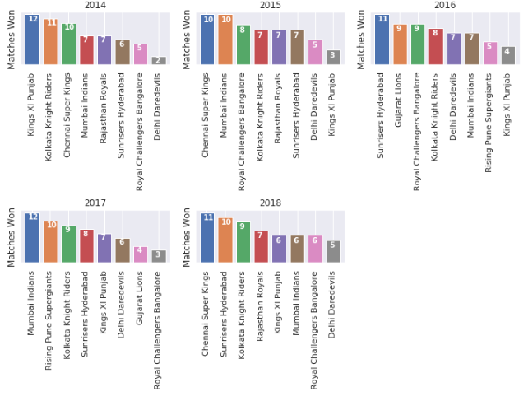

Observation : **Mumbai Indians** and **Chennai super kings** has won maximum matches

### CSK Season-by-Season Performance

* 2008: Runners-up (Won 9, Lost 7; Finished third in league stage)
* 2009: Semi-finalists (Won 8, Lost 6; Finished second in league stage)
* **2010: Champions (Won 9, Lost 7; Finished third in league stage)**
* **2011: Champions (Won 11, Lost 5; Finished second in league stage)**
* 2012: Runners-up (Won 10, Lost 8; Finished fourth in league stage)
* 2013: Runners-up (Won 12, Lost 6; Finished first in league stage)
* 2014: Third (Won 10, Lost 6; Finished third in league stage)
* 2015: Runners-up (Won 10, Lost 7; Finished first in league stage)
* **2018: Champions (Won 11, Lost 5; Finished second in league stage)**

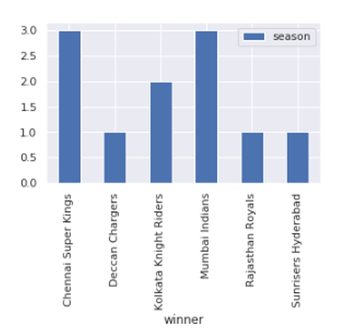Observation: CSK & MI won 3 seasons

### KKR Season-by-Season Performance

* 2008: Failed to reach knockouts (Won 6, Lost 7; Finished sixth in league stage)
* 2009: Failed to reach knockouts (Won 3 Lost 10; Finished last in league stage)
* 2010: Failed to reach knockouts (Won 7, Lost 7; Finished sixth in league stage)
* 2011: Fourth (Won 8, Lost 7; Finished fourth in league stage)
* **2012: Champions (Won 12, Lost 5; Finished second in league stage)**
* 2013: Failed to reach play-offs (Won 6, Lost 10; Finished seventh in league stage)
* **2014: Champions (Won 11, Lost 5; Finished second in league stage)**
* 2015: Failed to reach play-offs (Won 7, Lost 6; Finished fifth in league stage)
* 2016: Fourth (Won 8, Lost 7; Finished fourth in league stage)
* 2017: Third (Won 9, Lost 7; Finished fourth in league stage)
* 2018: Third (Won 9, Lost 7; Finished third in league stage)

### KXIP Season-by-Season Performance

* 2008: Semi-finalists (Won 10, Lost 5; Finished second in league stage)
* 2009: Failed to reach knockouts (Won 7, Lost 7; Finished fifth in league stage)
* 2010: Failed to reach knockouts (Won 4, Lost 10; Finished last in league stage)
* 2011: Failed to reach play-offs (Won 7, Lost 7; Finished fifth in league stage)
* 2012: Failed to reach play-offs (Won 8, Lost 8; Finished sixth in league stage)
* 2013: Failed to reach play-offs (Won 8, Lost 8; Finished sixth in league stage)
* 2014: Runners-up (Won 12, Lost 5; Finished first in league stage)
* 2015: Failed to reach play-offs (Won 3, Lost 11; Finished last in league stage)
* 2016: Failed to reach play-offs (Won 4, Lost 10; Finished last in league stage)
* 2017: Failed to reach play-offs (Won 7, Lost 7; Finished fifth in league stage)
* 2018: Failed to reach play-offs (Won 6, Lost 8; Finished seventh in league stage)

### SRH Season-by-Season Performance

* 2013: Fourth (Won 10, Lost 7; Finished fourth in league stage)
* 2014: Failed to reach play-offs (Won 6, Lost 8; Finished sixth in league stage)
* 2015: Failed to reach play-offs (Won 7, Lost 7; Finished sixth in league stage)
* **2016: Champions (Won 11, Lost 6; Finished third in league stage)**
* 2017: Fourth (Won 8, Lost 6; Finished third in league stage)
* 2018: Runners-up (Won 10, Lost 7, Finished first in league stage)

### RCB Season-by-Season Performance

* 2008: Failed to reach knockouts (Won 4, Lost 10; Finished seventh in league stage)
* 2009: Runners-up (Won 9, Lost 7; Finished third in league stage)
* 2010: Semi-finalists (Won 7, Lost 8; Finished fourth in league stage)
* 2011: Runners-up (Won 10, Lost 6; Finished first in league stage)
* 2012: Failed to reach play-offs (Won 8, Lost 7; Finished fifth in league stage)
* 2013: Failed to reach play-offs (Won 9, Lost 7; Finished fifth in league stage)
* 2014: Failed to reach play-offs (Won 5, Lost 9; Finished seventh in league stage)
* 2015: Third (Won 8, Lost 6; Finished third in league stage)
* 2016: Runners-up (Won 9, Lost 7; Finished second in league stage)
* 2017: Failed to reach play-offs (Won 3, Lost 10; Finished eighth in league stage)
* 2018: Failed to reach play-offs (Won 6, Lost 8; Finished sixth in league stage

[**Success Rate of each team?**](https://www.kaggle.com/anitha136/ipl-analysis-2008-2018#section406)

### CSK Overall Win-Loss Record in IPL

*Matches Played: 149, Wins: 90, Losses 57, No Result: 2, Win Rate: 61.2%*

### MI Overall Win-Loss Record in IPL

*Matches Played: 172, Wins: 98, Losses: 73, No Result: 1, Win Rate 57.3%*

### SRH Overall Win-Loss Record in IPL

Matches Played: 94, Wins: 52, Losses: 41, No Result: 1, Win Rate: 55.9%

### RR Overall Win-Loss Record in IPL

*Matches Played: 136, Wins: 70, Losses: 62, No Result: 4, Win Rate 52.6%*

### KKR Overall Win-Loss Record in IPL

*Matches Played: 168, Wins: 86, Losses: 78, No Result: 4, Win Rate: 52.4%*

### RPS Overall Win-Loss Record in IPL

*Win Rate 50.0%*

### RCB Overall Win-Loss Record in IPL

*Matches Played: 168, Wins: 78, Losses: 95, Nos Result: 3, Win Rate 47.6%*

### KXIP Overall Win-Loss Record in IPL

*Matches Played: 162, Wins: 76, Losses: 86, Win Rate: 46.9%*

### GL Overall Win-Loss Record in IPL

*Win Rate: 43.3%*

### KTK Overall Win-Loss Record in IPL

*Win Rate: 42.9%*

### DC Overall Win-Loss Record in IPL

*Matches Played: 162, Wins: 67, Losses: 92, No Result: 3, Win Rate: 41.6%*

### DC(Deccan chargers) Overall Win-Loss Record in IPL

*Win Rate: 38.7%*

### *Pune Warriors* Overall Win-Loss Record in IPL

*Win Rate: 26.1%*

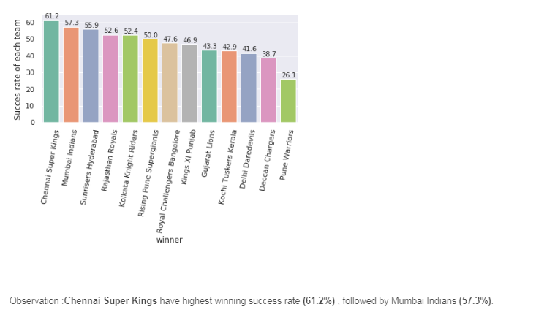

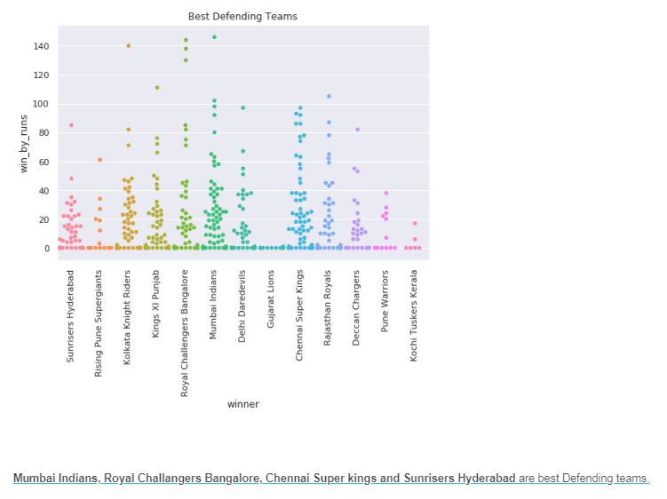

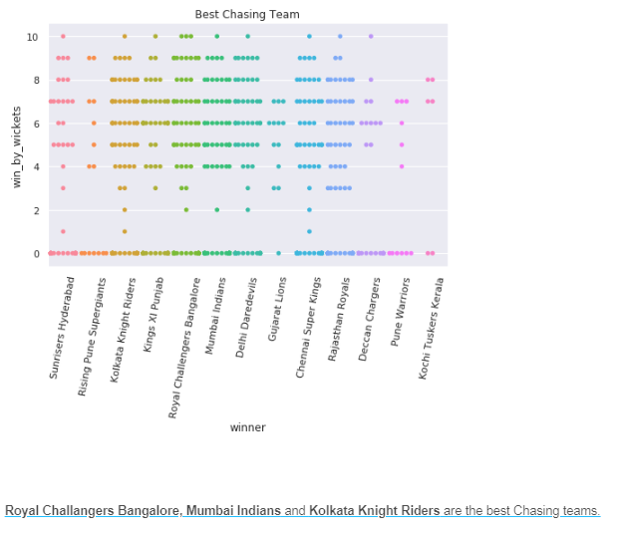

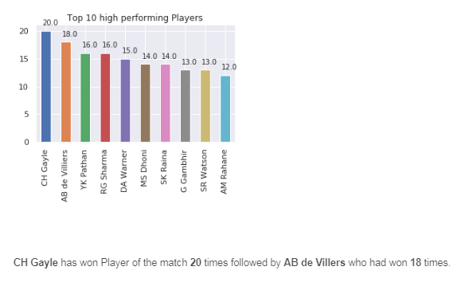

**CH Gayle**

* CH Gayle has won Player of the match 20 times
* Most IPL centuries (6)
* Fastest Batsman to score 4000 runs in [IPL](https://en.wikipedia.org/wiki/Indian_Premier_League)
* First batsman to hit 300 sixes in IPL
* Highest individual score in T20 with 175* (off 66 balls) against Pune Warriors India, which he made as opener
* Joint record, along with Yuvraj Singh, for fastest T20 half century, in 12 balls

**AB de Villiers**

* AB has won Player of the match 18 times
* In 152 matches so far, he has scored 4384 runs with an average of 40.59 and strike rate of 151.17. He has scored 3 centuries and 33 fifties, his highest score is 133 runs.

**YK Pathan**

* YK pathan has won Player of the match 16 times
* On 24 May 2014, Yusuf hit the second-fastest 50 in IPL history doing it in a mere 15 balls. As a result, [Kolkata Knight Riders](https://en.wikipedia.org/wiki/Kolkata_Knight_Riders) ended up 2nd in the league table and won the title for the season.
* YK Pathan has been a famous allrounder of the game with more than 3000 runs and 40 plus wickets

Followed by RG Sharma, DA Warner, MS Dhoni, SK Raina, G Gambhir SR Watson And AM Rahane



In the last week of March this year, Chennai Super Kings lost the toss in two successive matches, bringing a brief break to an incredible run of luck. Either side of those two lost tosses, spanning IPL seasons, are winning streaks of eight and nine with the coin.** They have lost just six of this run of 19 matches overall. At the bottom of the IPL 2019 points table, Royal Challengers Bangalore have won just three of their 13 tosses this season.

Super Kings have won 10 tosses this season; they have three to five matches remaining, which means they have a good shot at going past the record for one season: 12.

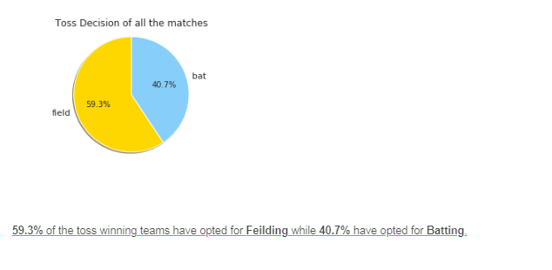

You can't take credit away from Super Kings for knowing what to do after winning those tosses and doing it well, but you also know the toss is more important here than in ODIs from the clear formula developing: chase, rare circumstances aside - which is the exact opposite of Tests. Champions in eight of the 11 previous editions of the IPL have also been sides that had won the most tosses in that season.

Super Kings have played those 19 matches mentioned earlier over eight venues, but on the 17 occasions that they have had the right to choose what they want to do first, they have batted only on three occasions. Yet, when the IPL started, it followed the traditional wisdom of cricket: runs on board, scoreboard pressure when chasing etc. It was only 2014 onwards that sides began to prefer chasing consistently.

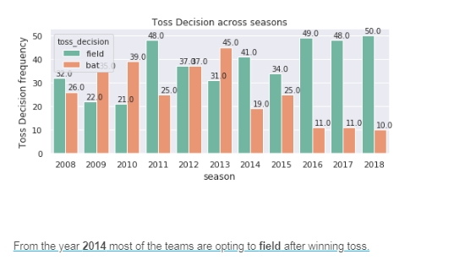

As you would expect, teams were wary of dew at the start of IPL, which explains a higher preference for chasing in 8pm games in the early years. Yet there was this year - 2013 - when they chased only in 39% of the night games. Then in 2014 the penny dropped.

There is no particular event that marks a turning point in the attitude of the sides. It was more a gradual realisation that 40 overs is too short a time for the conditions to bring their whole gamut into play. Teams began to understand that the availability of disproportionate wicket resources over 20 overs meant you never knew what the chasing side could do with its resources. Often teams batting first lost only two or three wickets in their innings, but that target would be chased down. They just didn't know how hard to go when batting first, so they began to chase.

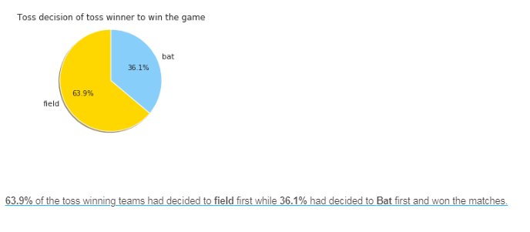

There was a theory that sides preferred to begin batting first as the season wore on and pitches grew tired, and that was the only consideration holding chase numbers back in the earlier years. However, that deviation is not big, especially in recent seasons. In 2014, you will see sides chased more as the season went on, but that is because it began in the UAE before coming to chase-friendly Indian conditions.

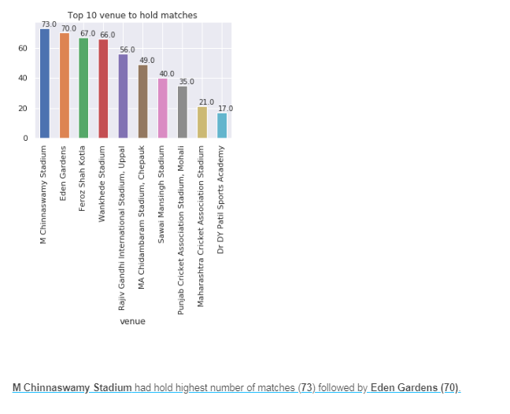

**Location:** Bangalore

**Capacity:**40,000

**IPL Team:**Royal Challengers Bangalore

Built in 1969 and originally called the Karnataka State Cricket Association Stadium, the ground now known as the equally snappy M. Chinnaswamy Stadium has witnessed some classic cricket moments over the years.

The first-ever Test there featured the debuts of West Indian legends Viv Richards and Gordon Greenidge while centuries for Michael Clarke and Inzamam on their respective first and 100th appearances were also worth the price of admission alone.

Of late, the pitch has refreshingly offered pace and bounce, which can favour both batsmen and bowlers as shown by the Royal Challengers' Chris Gayle's destructive [175 off just 66 balls](http://www.youtube.com/watch?v=vWavW9biNZ4) last season.

**Interesting fact:**

The stadium hosted the 1996 Miss World competition!

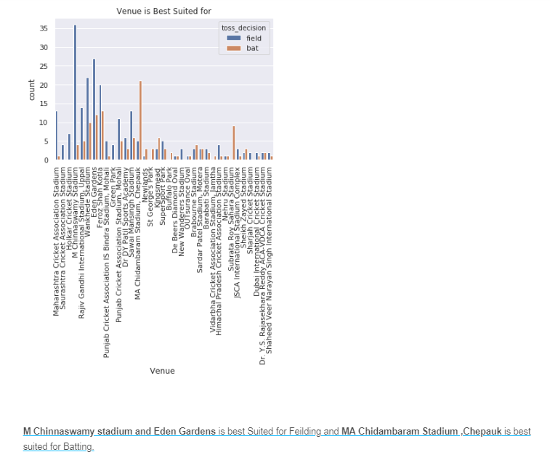

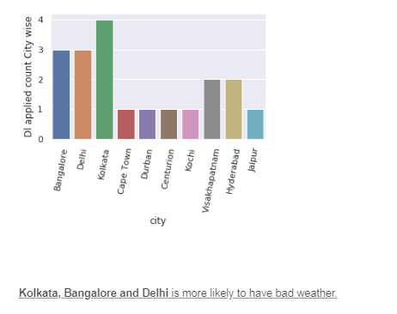

IPL Weather: Chances of Rain during RCB-RR Match Today

30 May 2019

Bengaluru will host today’s IPL encounter between the home team, the Royal Challengers Bangalore (RCB) and Rajasthan Royals (RR), at the M. Chinnaswamy Stadium at 8 pm IST. Both the teams have performed impressively well in their last five matches, losing only two games in five. However, neither has managed to improve their current standing in the Indian Premier League (IPL) table. Let’s have a look at what the weather holds in store for the match.

The regional IMD office in Bengaluru has forecast that the weather in the city will likely remain partly cloudy with one or two spells of rains and thundershowers. The IMD expects this weather to continue until Wednesday, after which, chances of rain will reduce. Cloudy skies, though, are likely to remain until Sunday.

A look at the hourly weather data on The Weather Channel shows an increased risk of rain and scattered thunderstorms from about 5.30 pm IST today. Just before the match starts, there is a 50% chance of rain. However, the risks gradually reduce after 9.30 pm local time, and drier conditions could set in late at night.

### Conclusion

* This dataset contains data about IPL matches from season 2008 to 2018
* Totally 13 teams has participated in IPL History and few teams like Pune Warriors,Kochi Tuskers Kerala,Rising Pune Supergiants, Gujarat Lions has been only in 2 seasons but the success rate of **Rising Pune Supergiants** is good comparatively among the new teams (**From: Section 4.6**)
* **Mumbai Indians, Royal Challangers Bangalore and Chennai Super kings** are best Defending teams (**From: Section 4.11**)
* **Royal Challangers Bangalore, Mumbai Indians** and **Kolkata Knight Riders** are the best Chasing teams (**From: Section 4.14**)
* From the year 2014 most of the teams are opting to field after winning toss and are also successful in winning the match. (**From: Section 4.18 and 4.19**)
* Overall **Chennai Super Kings** and **Mumbai Indians** have high success rate and these two teams are the most successful teams in the tournament with 3 season wins each (**From: Section 4.2 ,4.6 and 4.8**)
* From the analysis, it was concluded that **Chennai Super Kings** and **Mumbai Indians** are more likely to win upcoming IPL seasons (**Collectively From: 4.5, 4.6, 4.8 and 4.11**)