NEON FUND

Agentic Infra Event Report
March 21, 2026 | Bangalore

Confidential — Internal Use Only

1. Executive Summary
Metric | Value
Registrations | 29 (22 external, 7 Neon)
Invite → Registration | 27% (29/107)
AI Builders | 87% of those who shared
Agentic AI Founders | 6
Seeking Investors | 12
Unique Companies | 24

- AI-dominant, 100% B2B crowd. 6 agentic AI founders, full stack represented from trust layer to vertical apps.
- Strong investor demand. 12 founders actively seeking; 9 with dual investor pattern (seeking + offering).
- Deployment issues. OTP spam, accidental batch send (critical), generic match quality. All addressed.
- Clear v2 path. Better algorithm (use what_building + LLM), email warm-up, safe batch send, admin dashboard.

2. Event Funnel
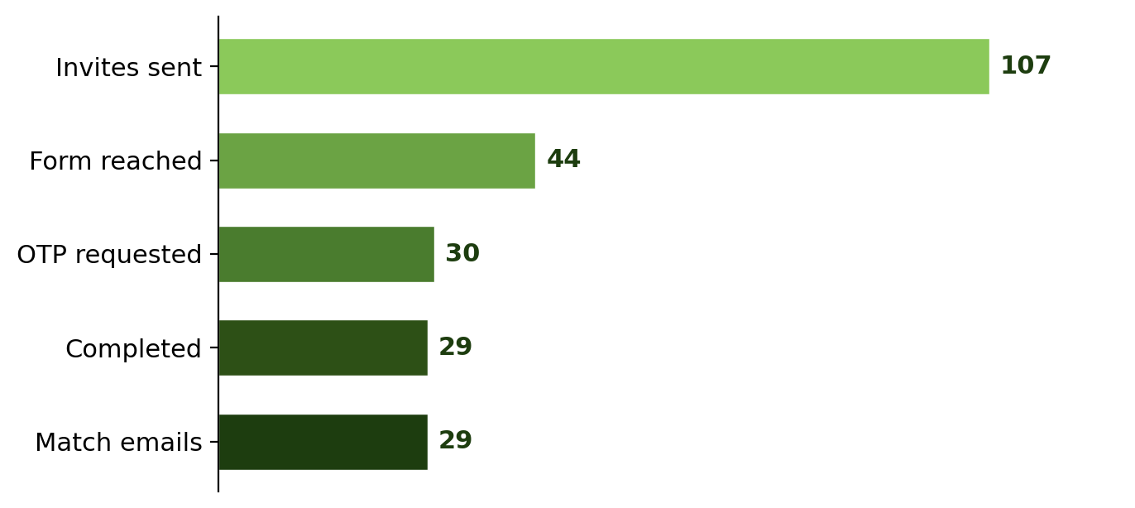

Stage | Count | Rate
Luma invites sent | 107 | —
Form link reached | 44 | 41% of invites
Email clicks / QR scans | 24 / 20
OTP requested | 30 | 68% of reach
Completed registration | 29 | 97% of OTP
Abandoned | 2 | aprohith, martipradyumna
Match emails sent | 29 | 100%

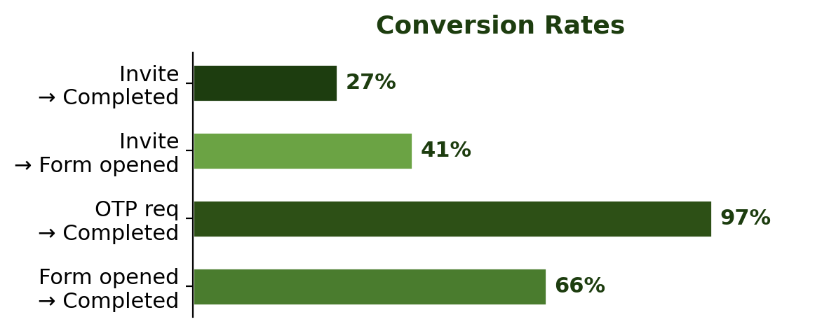

3. Attendee Breakdown
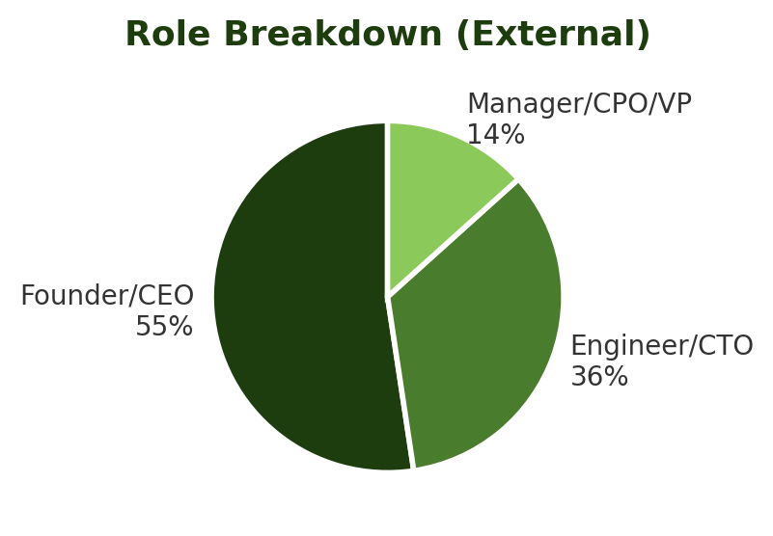

Full List
# | Name | Company | Role
1 | Srinivas Venkatesan | Cogniqa | CEO
2 | Raveen Beemsingh | Luminary Lanr | CEO, Co-Founder
3 | Deepam Patel | WizCommerce | Sr. Engg Manager
4 | Arunima V. Jayadevan | Bridge AI | CEO & Cofounder
5 | Sagar Hugar | Joist AI | AI Product Manager
6 | Ravish Kumar Agarwal | Wizcommerce | CPO
7 | Anshum Jani | Automation Anywhere | ML Ops Engineer
8 | Prathmesh Vhatkar | JUSPAY | SDE
9 | Harshil Kumar P. | CoStrategix | DevOps Engineer
10 | Mukesh KG | Friday Intellytics | CEO & Founder
11 | Milon Bhattacharya | Raasta.io / Disney | Founding Engineer
12 | Anuraag Gutgutia | TrueFoundry | Co-founder & COO
13 | Veer Porwal | Tunegrid | CEO & Co-founder
14 | Manish Kumar | Checksum Labs | CTO & Co-founder
15 | Shivam Khandelwal | Millennium | Software Engineer
16 | Amit Kumar | Grovio AI | Co-founder
17 | Nikhil Gundawar | Stealth | Founder, CEO
18 | Saurabh Jain | Vink | Founder
19 | Sourabh Kapure | navsi.ai | CEO & Co-founder
20 | Jyothish Vijay | Refringence | CEO
21 | Punith VS | VS | AI Engineer
22 | Shubhani Jindal | Neon Fund | Investments
23 | Prasanth Garapati | Neon Fund | VP
24 | Nansi Mishra | Neon | Co-founder
25 | Siddhartha | Neon Fund | Managing Partner
26 | Shikhar | Neon | Content & Community
27 | Rohan Verma | Neon Fund | Tech
28 | Miya* | Neon Fund | Team
29 | Rohith* | Neon Fund | Team
* Late registrations

4. What They’re Building
15/22 external shared (68%). 87% AI builders. 100% B2B.
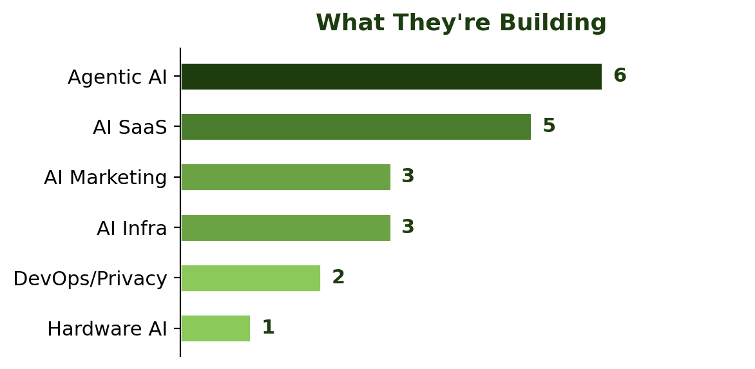

Agentic Stack Layers
Layer | Function | Company
Trust | Verification & safety | Cogniqa
Gateway | MCP routing & orchestration | TrueFoundry
SDK | Agent dev framework | navsi.ai
Workflow | Business automation | Wizcommerce
Apps | End-user products | Stealth, Grovio

5. Demand vs Supply
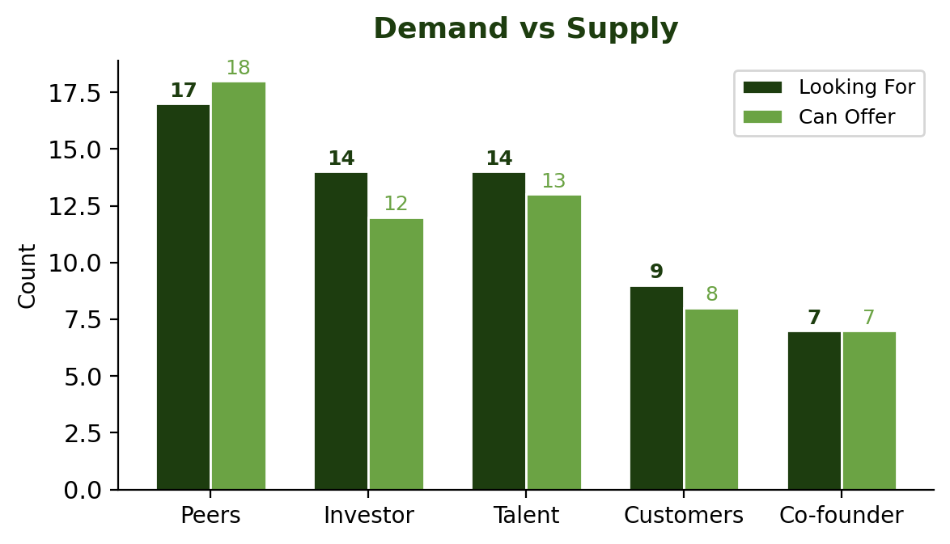

Category | Looking For | Can Offer | Gap
Peers | 17 (59%) | 18 (62%) | Balanced
Investor | 14 (48%) | 12 (41%) | +2 demand
Talent | 14 (48%) | 13 (45%) | Balanced
Customers | 9 (31%) | 8 (28%) | Balanced
Co-founder | 7 (24%) | 7 (24%) | Balanced

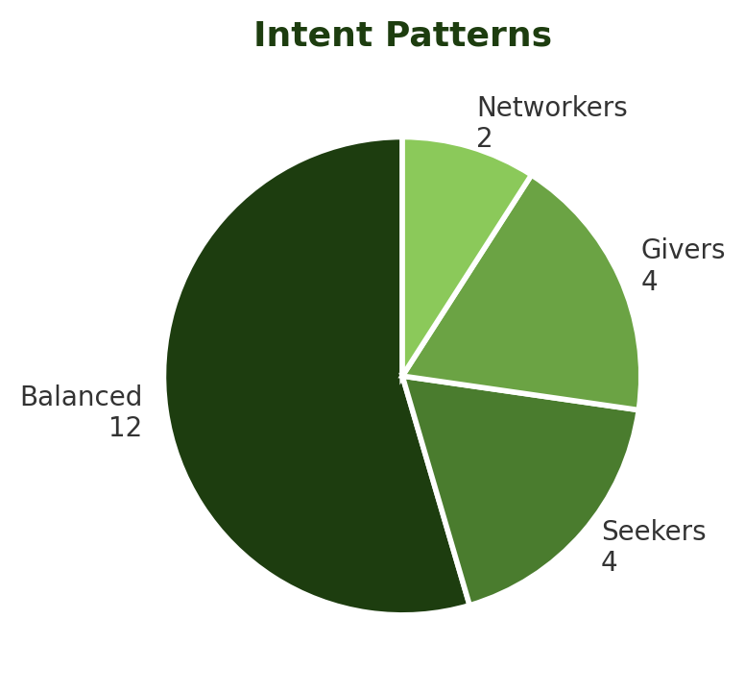

- 10 can connect to investors. 4 seeking co-founders. 6 founders hiring. 3 high-intent (4+ selections).
- 9 dual investor pattern (both seeking + offering) — likely angel/operators.

6. VC Deal Pipeline
12 founders actively seeking investors:
Founder | Company | Building
Srinivas Venkatesan | Cogniqa | Trust Infra for Agentic Web
Raveen Beemsingh | Luminary Lanr | AI CMO 24x7
Arunima V. Jayadevan | Bridge AI | —
Anshum Jani | Automation Anywhere | —
Mukesh KG | Friday Intellytics | AI Data Analytics Assistant
Veer Porwal | Tunegrid | —
Manish Kumar | Checksum Labs | —
Amit Kumar | Grovio AI | AI agentic marketing
Nikhil Gundawar | Stealth | Agentic AI Analytics
Saurabh Jain | Vink | —
Sourabh Kapure | navsi.ai | Agentic AI infra for B2B SaaS
Jyothish Vijay | Refringence | AI hardware design suite

7. What Went Wrong
# | Issue | Severity | Root Cause | Fix
1 | OTP in spam | HIGH | DNS added night before, no warm-up | Add DNS 1wk early, warm up domain
2 | Low email usage | MED | Luma email ignored vs QR | Use WhatsApp, bigger QR
3 | Batch send to all | CRIT | No targetEmail filter | Filter fixed, add dryRun + confirm
4 | OTP delayed 1hr | HIGH | Brevo free tier, shared IP | Upgrade provider, manual override
5 | Generic matches | HIGH | Only 5 chips, no text match | Use what_building + LLM reasoning

8. v2 Roadmap

P0 — Must Have
- Better algorithm — semantic similarity + LLM match reasoning
- Email warm-up — DNS 1wk early, test emails daily for 5 days
- Safe batch send — dryRun, confirm step, send_log, rate limit
- Manual OTP override — admin fallback for delayed emails

P1 — Should Have
- More form fields — industry, stage, interests, existing connections
- WhatsApp distribution — broadcast or SMS for higher open rate
- Admin dashboard — live registrations, trigger sends, monitor delivery
- Custom domain — match.neon.fund

P2 — Nice to Have
- Post-event feedback — match quality rating 24h after
- Match scoring — track clicks, A/B test
- Chat revival — Groq LLM for post-match Q&A
- Multi-event — reuse profiles, loyalty

9. Technical Debt
Item | Action
Legacy endpoints | Remove trigger-my-matches, send-matches
send_log table | Audit trail for every email sent
Error monitoring | Sentry + Brevo quota alerts
Test suite | Unit + integration for match algo
Env validation | Fail fast on missing vars
Logo | Get original from design team

10. Event Ops Playbook

1 Week Before
- Upload Luma CSV to luma_list
- Verify DNS green in Brevo
- Start domain warm-up (10-20 emails/day)
- Test full flow: form → OTP → verify → wait
- Prepare QR code

1 Day Before
- 20+ warm-up emails, confirm inbox delivery
- Verify Brevo quota, Vercel healthy
- Truncate profiles, share form link, print QR

Day Of — Morning
- Monitor registrations in Supabase
- Check Brevo delivery, have OTP override ready

Day Of — Match Time
- Run compute-matches, review in Supabase
- dryRun send, test email to organizer Gmail
- Confirm mobile + desktop, trigger batch send

After Event
- Export CSV, check Brevo logs
- Feedback email 24h later, generate report

