CUSTOMER SUPPORT TICKET PRIORITY PREDICTION AND AUTOMATED ASSIGNMENT SYSTEM USING AGENTFORCE
Salesforce Implementation
Project Documentation
Submitted by: Rohan Verma
Program: Salesforce Administrator with Agentforce (Skillwallet)
Platform: Salesforce Developer Edition Org
Date: October 2026

User Story
Support teams get many tickets every day, and someone has to read each one to decide which should be handled first. This takes time, and different people decide differently, so an urgent ticket can end up waiting in the queue.
In this project I built a small system in Salesforce to do that first check automatically. Tickets are stored in a custom object. A Flow reads the latest ticket of an account and marks it High, Medium or Low using the words in the description. If the ticket is High, the Flow also creates a Task. An Agentforce agent runs the Flow, so the user only has to type the account name. I also made two reports, a dashboard and a Lightning App so a manager can see the tickets.

1. Introduction

1.1 Project Overview
This is a Salesforce project for handling customer support tickets. It keeps the tickets in one place and sets their priority automatically. I built and tested it in a Salesforce Developer Edition org.
The main parts are a custom object, an auto-launched Flow, an Agentforce agent, two reports, a dashboard and a Lightning App. I loaded 20 sample tickets with the Data Import Wizard and then tested the agent with three accounts named ABC, XYZ and Nova.

1.2 Purpose
The purpose of the project is to keep all ticket details in one object, to set the priority without reading every ticket by hand, to create a Task for urgent tickets, and to let support staff check a ticket by chatting with an agent. It also gives managers reports and a dashboard so they can see how many tickets are High, Medium or Low.

2. Ideation Phase

2.1 Problem Statement
PS | I am | I'm trying to | But | Because | Which makes me feel
PS-1 | Support Agent | go through my tickets in the right order | all the tickets look the same | I have to read each one to know how urgent it is | stressed
PS-2 | Support Manager | make sure urgent tickets are handled first | an urgent ticket can wait behind a small query | tickets are not ranked automatically | worried
PS-3 | Support Manager | see how many tickets there are and how urgent they are | I have no single view | the data is in separate records | not sure how to plan the work
PS-4 | Customer | get my problem solved quickly | I don't know when someone will look at it | the priority is decided by hand | frustrated

2.2 Empathy Map Canvas
The persona for this project is a support agent who reads new tickets and decides what to handle first.
- Thinks and feels: is afraid of missing a ticket that cannot wait.
- Hears: customers who want quick answers, and managers who ask about response times.
- Sees: a long queue of tickets with no clear order.
- Says and does: opens each ticket, reads it, decides the priority and follows up manually.
- Pain: sorting the same way again and again, and priorities that change from person to person.
- Gain: a priority that is already set and an easy way to check the latest ticket of a customer.

2.3 Brainstorming and Idea Prioritization
Idea | What it means | Problem with it
Manual register | Write tickets and priorities in a register | Slow and easy to make mistakes
Spreadsheet | Keep a sheet with a priority column | No automation and no live view
Separate portal | Build a new ticket application | Takes a lot of effort to build
Salesforce with Agentforce | Store tickets in Salesforce, use a Flow for priority and an agent to run it | Needs careful setup and testing

I chose Salesforce with Agentforce because the automation, the reports and the chat agent are all available on one platform, and it can handle more accounts and tickets later.

3. Requirement Analysis Phase

3.1 Customer Journey Map
Stage | Step | What happens
1 | Issue reported | A customer reports a problem and a ticket is saved for their account.
2 | Ticket stored | The ticket is saved with issue type, description, status and account.
3 | Check requested | A support user types the account name in the Agentforce chat.
4 | Priority set | The Flow takes the newest ticket of the account and marks it High, Medium or Low.
5 | Follow-up | For a High ticket a Task is created. The agent shows the result in the chat.
6 | Monitoring | The manager looks at the reports and the dashboard.

3.2 Solution Requirements

Functional requirements
FR No | Requirement
FR-1 | Store each support ticket as a record.
FR-2 | Link each ticket to a customer account.
FR-3 | Set the priority automatically from the description.
FR-4 | Create a Task for High priority tickets.
FR-5 | Return a message and the assigned agent.
FR-6 | Let an Agentforce agent start the check from an account name.
FR-7 | Reports by priority and by status.
FR-8 | A dashboard and a Lightning App.
FR-9 | Load sample data with the Data Import Wizard.

Non-functional requirements
Requirement | Description
Usability | The Lightning App and the chat agent are easy to use.
Security | Access is controlled with profiles and field-level security.
Reliability | The Flow returns a result for every account that has a ticket.
Performance | The Flow and the agent action finish in about one second.
Scalability | More accounts and tickets can be added without changes.
Maintainability | The keywords can be changed in Flow Builder without code.
Data quality | Restricted picklists do not allow wrong values.

3.3 Data Flow Diagram
The user types an account name in the agent. The agent action passes the name to the Flow. The Flow finds the account and then the newest ticket for that account. It checks the description against the High and Medium keywords, sets the priority, and for a High ticket creates a Task. The Flow then returns the account Id, ticket Id, priority, assigned agent and message, and the agent shows them in the chat. The reports and the dashboard read the same ticket records for the manager.

3.4 Technology Stack
Layer | Technology
Platform | Salesforce Developer Edition
Interface | Lightning App
Data | Custom object Support Ticket Intelligence, with lookups to Account, Contact and User
Logic | Auto-launched Flow
AI | Agentforce (Default) agent with a subagent and a Flow action
Data loading | Data Import Wizard
Analytics | Reports and Dashboards
Security | Profiles and field-level security

4. Project Design Phase

4.1 Problem-Solution Fit
Problem | Solution | Benefit
Sorting tickets by hand is slow | The Flow sets the priority with the same rules every time | Same result every time
Urgent tickets can be missed | A Task is created for High tickets | Urgent work is seen first
Staff search records manually | The agent runs the Flow from the account name | One message gives the answer
Managers have no overview | Two reports and a dashboard | Easy to see the ticket mix
Ticket data is scattered | One custom object linked to Account and Contact | All tickets in one place

4.2 Proposed Solution
The proposed solution is a Salesforce custom object for tickets, an auto-launched Flow that sets the priority, and an Agentforce agent that runs the Flow from a chat. The idea is to remove the manual sorting step, so urgent tickets are found faster and managers can see the result in reports.

4.3 Solution Architecture
The solution has these components: the custom object Support Ticket Intelligence with its fields and tab, the auto-launched Flow, the Agentforce agent with the subagent Support Ticket Priority Analysis and its Flow action, the reports Tickets by Priority Level and Tickets by Status, the Support Ticket Intelligence Dashboard, and the Support Ticket Intelligence Lightning App. The sample data was loaded with the Data Import Wizard.

5. Project Planning and Scheduling

5.1 Project Planning
I planned the work in four sprints using the Agile method, with user stories and story points. I was the only team member, so every story is assigned to me.

Product backlog and sprint schedule
Sprint | Epic | User story | Task | Story points | Priority | Team member
Sprint-1 | Requirements | US-01 | As a manager, I want the problem and scope written down so the work has a clear target. | 3 | High | Rohan Verma
Sprint-1 | Data model | US-02 | As an agent, I want a ticket object, fields and a tab so tickets are in one place. | 5 | High | Rohan Verma
Sprint-2 | Automation | US-03 | As an agent, I want a Flow that sets the priority so urgent tickets are easy to see. | 8 | High | Rohan Verma
Sprint-2 | Agentforce | US-04 | As an agent, I want an agent that runs the Flow so I can check a ticket in a chat. | 5 | High | Rohan Verma
Sprint-3 | Data migration | US-05 | As a manager, I want sample tickets loaded so the system can be tested. | 5 | High | Rohan Verma
Sprint-4 | Testing | US-06 | As an agent, I want the Flow and the agent tested for High, Medium and Low. | 5 | High | Rohan Verma
Sprint-4 | Reports and UI | US-07 | As a manager, I want reports, a dashboard and an app to follow the tickets. | 5 | Medium | Rohan Verma
Sprint-4 | Documentation | US-08 | As a reviewer, I want documentation and a demo to check the work. | 3 | Medium | Rohan Verma

Sprint tracker
Sprint | Total story points | Duration | Start date | End date | Points completed | Release date
Sprint-1 | 8 | 3 days | 17 Oct 2026 | 19 Oct 2026 | 8 | 19 Oct 2026
Sprint-2 | 13 | 2 days | 20 Oct 2026 | 21 Oct 2026 | 13 | 21 Oct 2026
Sprint-3 | 5 | 2 days | 22 Oct 2026 | 23 Oct 2026 | 5 | 23 Oct 2026
Sprint-4 | 13 | 3 days | 24 Oct 2026 | 26 Oct 2026 | 13 | 26 Oct 2026

6. Project Development Phase

Phase 1: Requirement Analysis and Planning
I started by understanding how a support team handles many tickets and why manual priority setting causes delays. After that I wrote the scope: a ticket object, a Flow that sets High, Medium or Low from the description, a Task for High tickets, an Agentforce agent to run it, and reports and a dashboard for the manager. The users I considered were support agents, managers and customers.
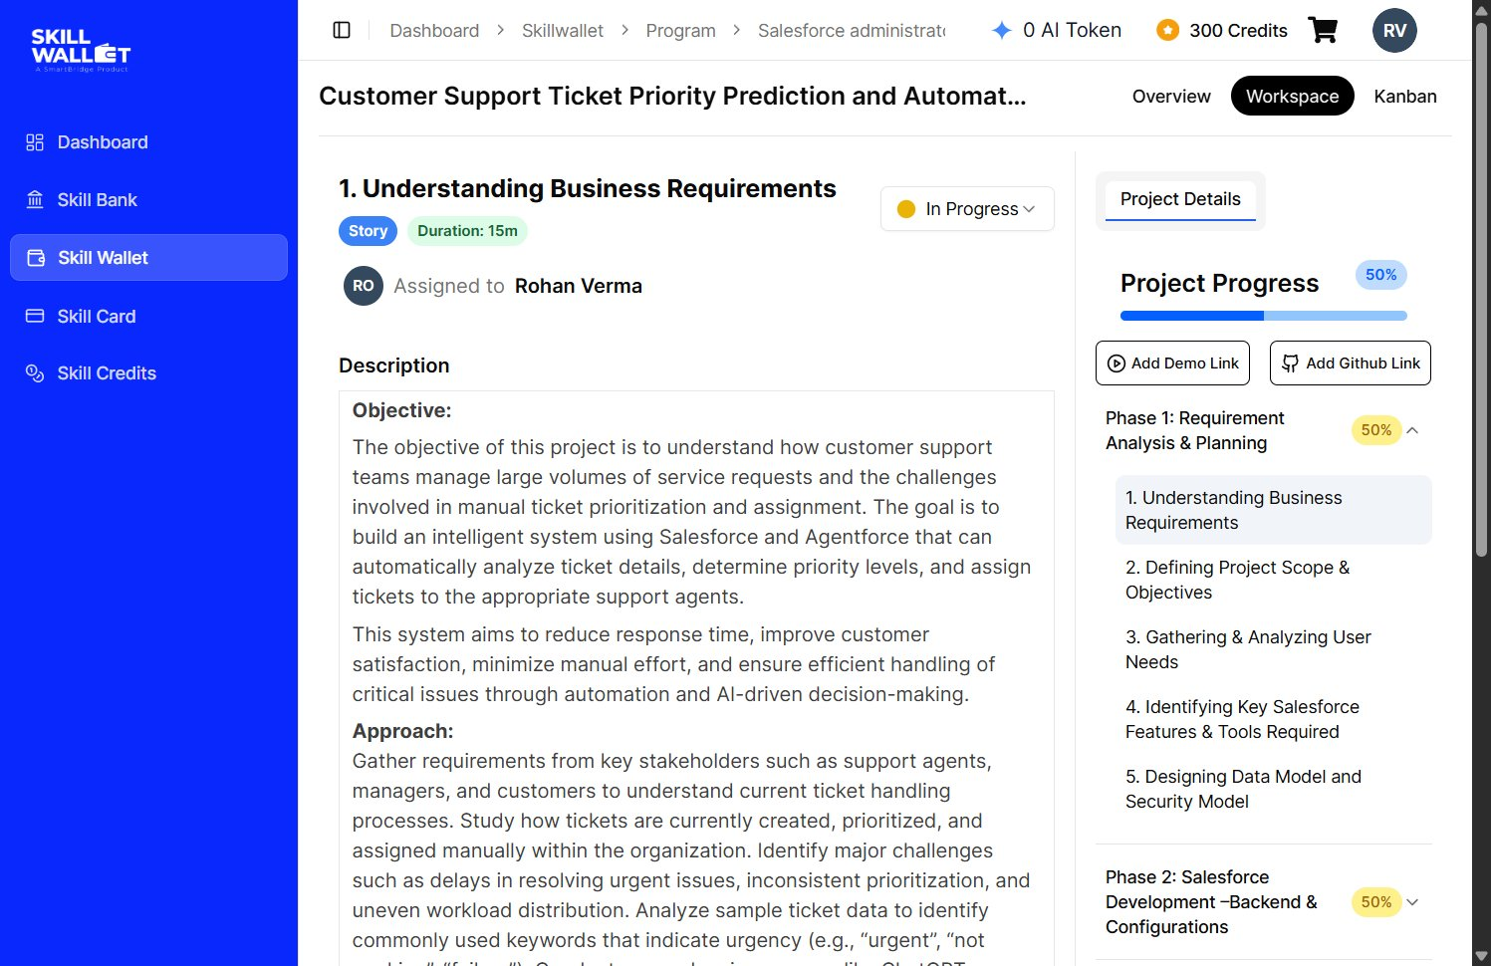
Figure 1: Phase 1 task: understanding business requirements, with project progress on Skillwallet

Phase 2: Backend Development and Configurations

Milestone 1: Salesforce account
I created a Salesforce Developer Edition org and verified the email. All the work in this project was done in this org.
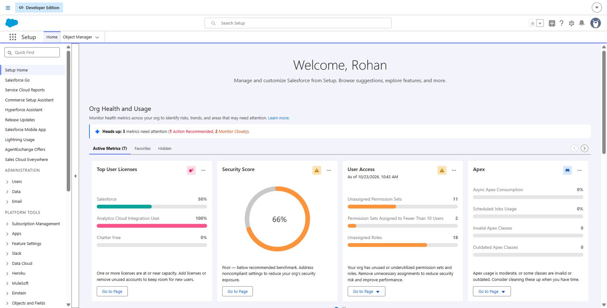
Figure 2: Salesforce Setup home of the Developer Org

Milestone 2: Custom object
I created a custom object called Support Ticket Intelligence (API name Support_Ticket_Intelligence__c) to store the tickets. Reports and field history tracking are turned on for it.
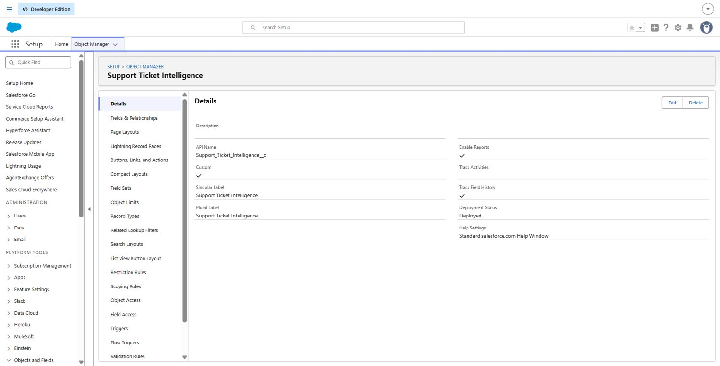
Figure 3: Support Ticket Intelligence object details

Milestone 3: Fields and relationships
The object has lookup fields for Customer (Account), Contact and Assigned User. Issue Type, Priority Level and Status are picklists. The other fields are Description (long text), Created Date, SLA Breach Risk (checkbox), Resolution Time in hours (number) and an auto-number Ticket number.
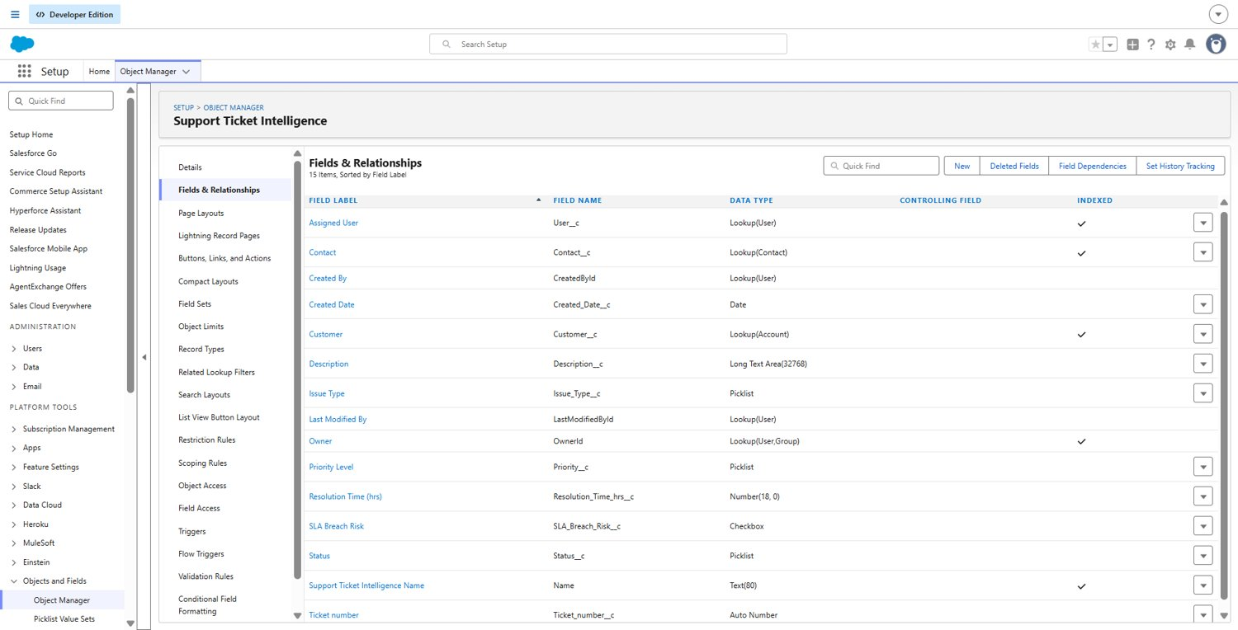
Figure 4: Fields and relationships of the Support Ticket Intelligence object

Milestone 4: Tab
I made a custom tab for the object so the tickets can be opened from the Lightning App.
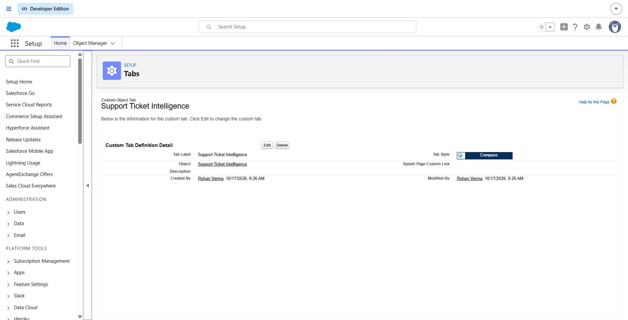
Figure 5: Custom tab definition for Support Ticket Intelligence

Milestone 5: Auto-launched Flow
The Flow is the main part of the project. It has no trigger and is started by the agent. It takes the account name as input and gives back five values: account Id, ticket Id, priority level, assigned agent and message.
First the Flow finds the account with that name and then the newest ticket linked to the account. Then a Decision element checks the ticket description. If the description contains "urgent", "not working" or "failure", the ticket is High. If it contains "issue", "slow" or "delay", it is Medium. Otherwise it is Low. I put High first so that a ticket like "urgent issue" is not marked Medium. For a High ticket the Flow creates a Task named "Urgent Ticket Handling" with High priority and Not Started status, and sets the assigned agent to Senior Support Agent. Every path ends by setting a message for the user.
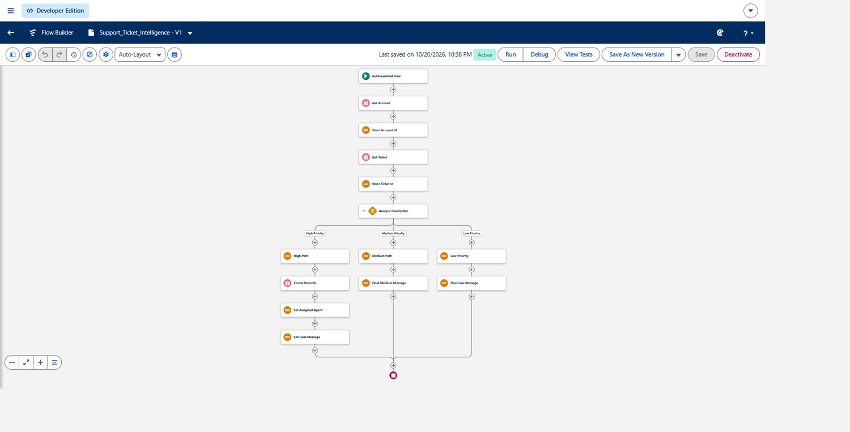
Figure 6: Overall structure of the Support Ticket Intelligence Flow
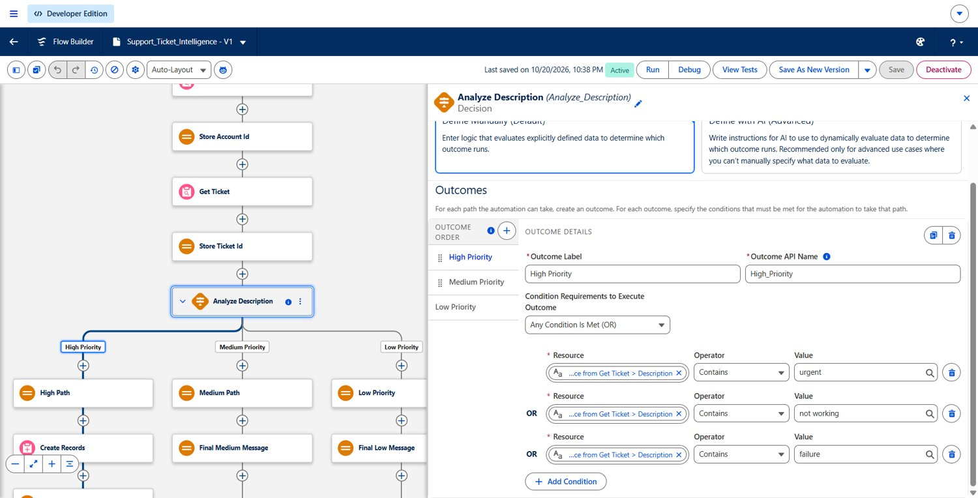
Figure 7: Decision element that checks the ticket description (High priority outcome)
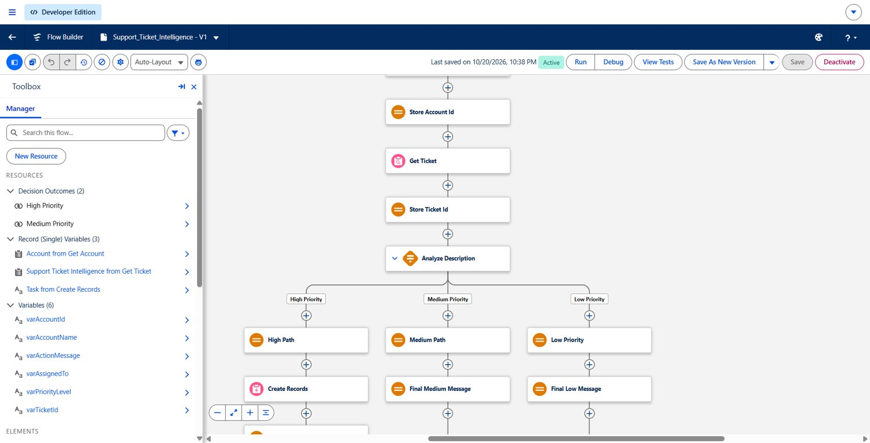
Figure 8: Flow resources: input variable, output variables and record variables
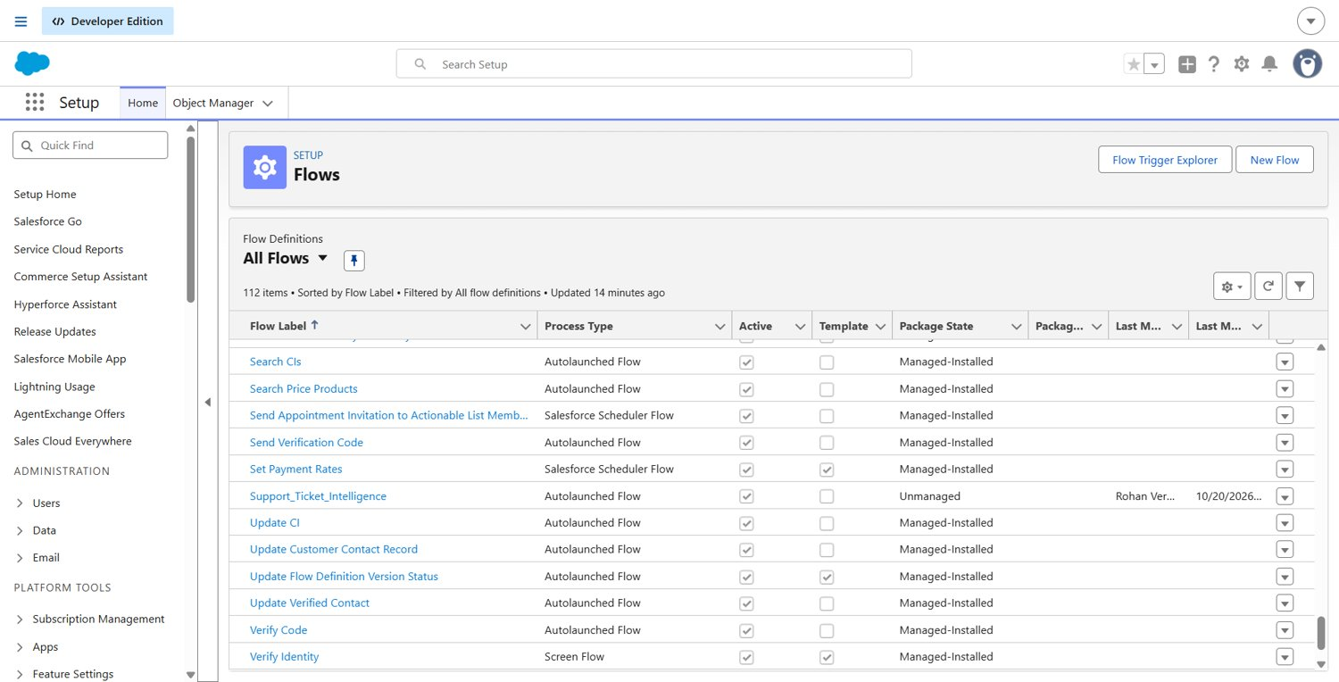
Figure 9: Flow shown as active in Setup

Milestone 6: Agentforce configuration
I activated the default Agentforce agent and added a subagent called Support Ticket Priority Analysis. The subagent only analyses ticket descriptions and sets the priority, and it does not answer unrelated questions such as billing. Its instructions say to ask for the account name if it is missing, run the Flow, and show the message returned by the Flow.
I then added an action based on the Flow. The account name is a required input that the agent asks from the user, and the five Flow outputs are shown in the conversation.
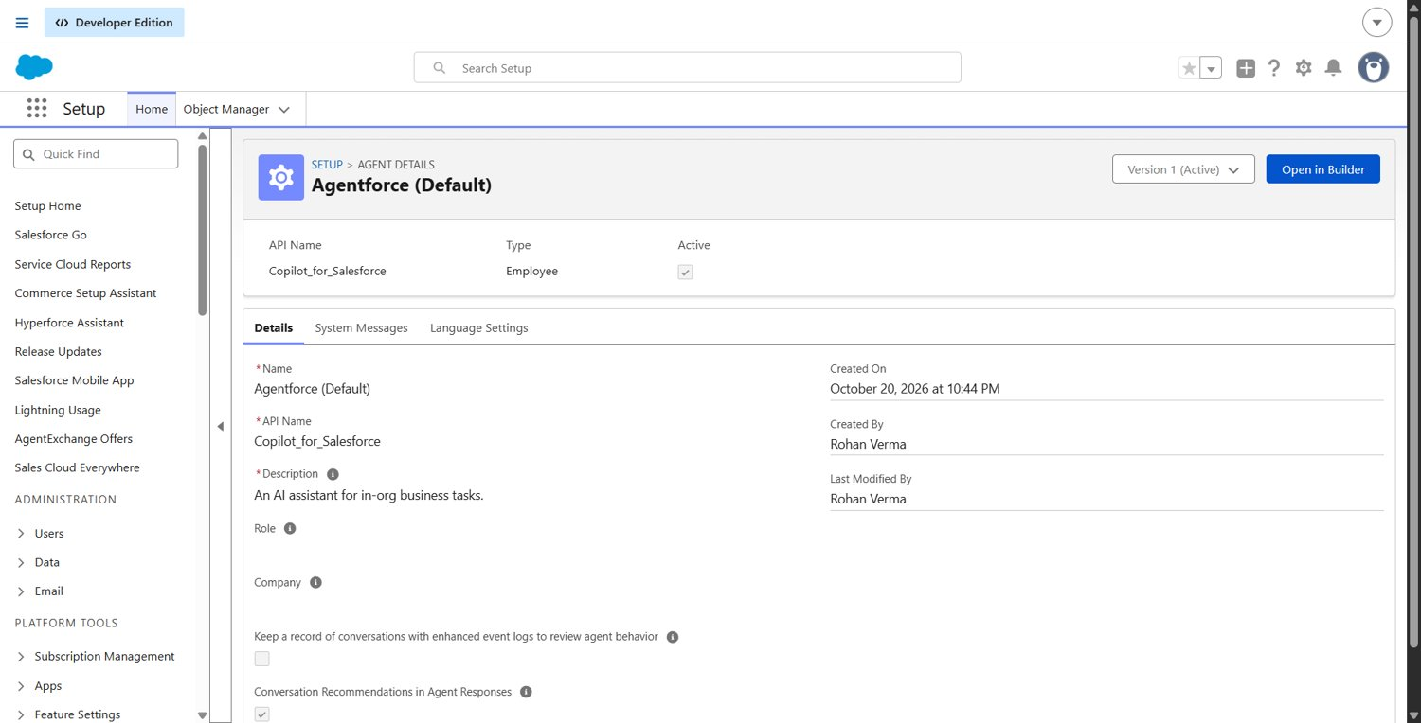
Figure 10: Agentforce (Default) agent, active, version 1
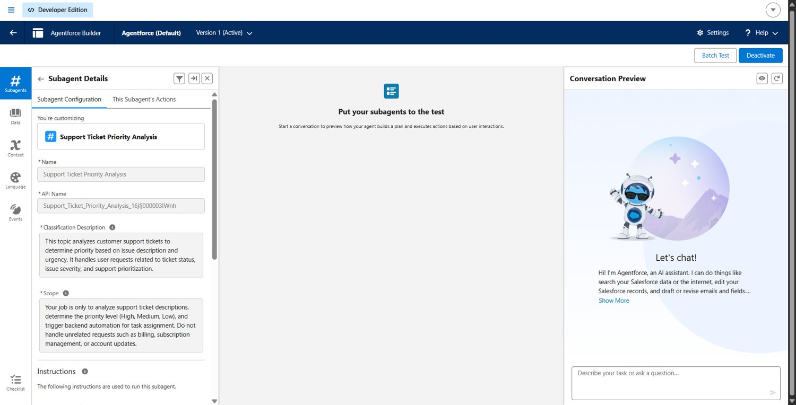
Figure 11: Subagent Support Ticket Priority Analysis with classification description and scope
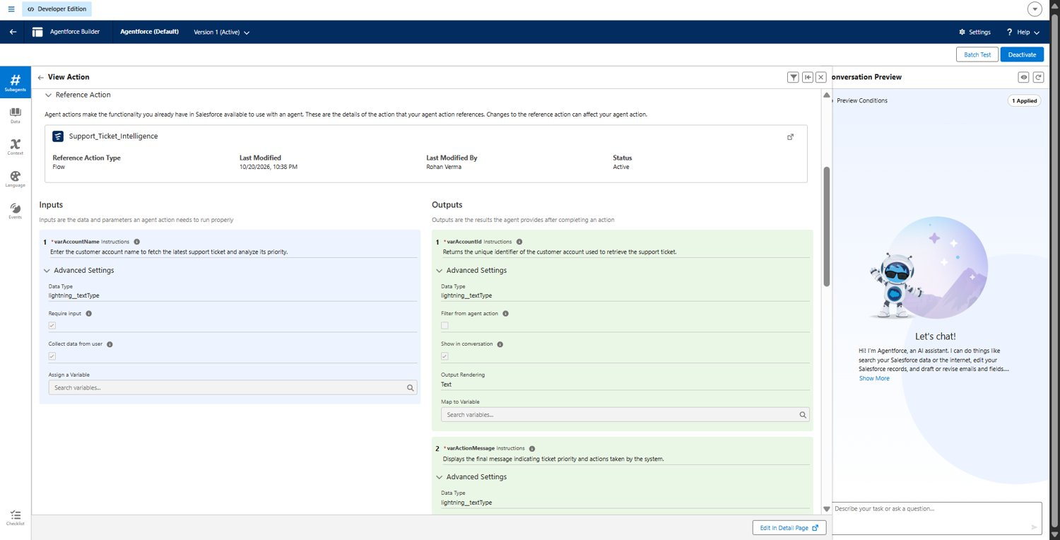
Figure 12: Agent action linked to the Flow, with input and output variables

Phase 3: UI/UX Development and Customization

Milestone 7: Reports, dashboard and Lightning App
I made two reports on the Support Ticket Intelligence report type. Tickets by Priority Level is grouped by priority and shows a donut chart. Tickets by Status is grouped by status and shows a funnel chart. The dashboard shows both charts together. The Lightning App has the ticket object, Reports and Dashboards in one navigation bar.
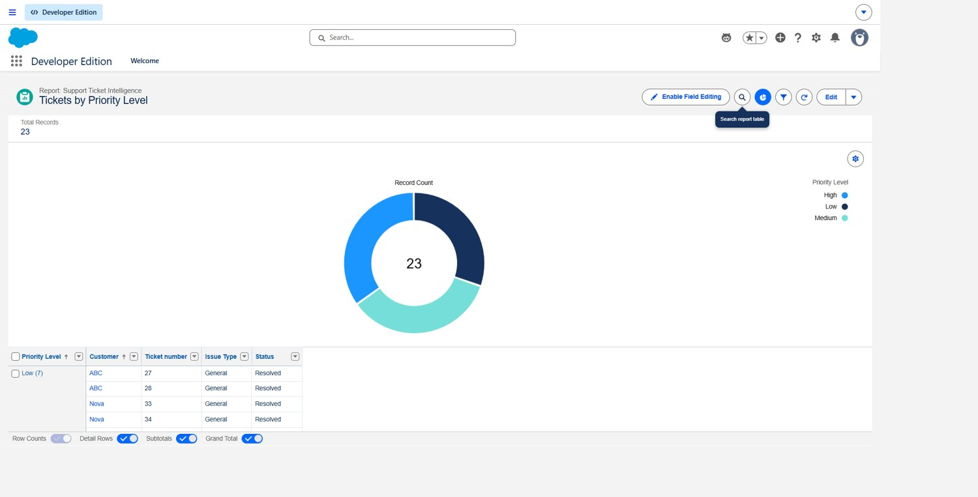
Figure 13: Report: Tickets by Priority Level
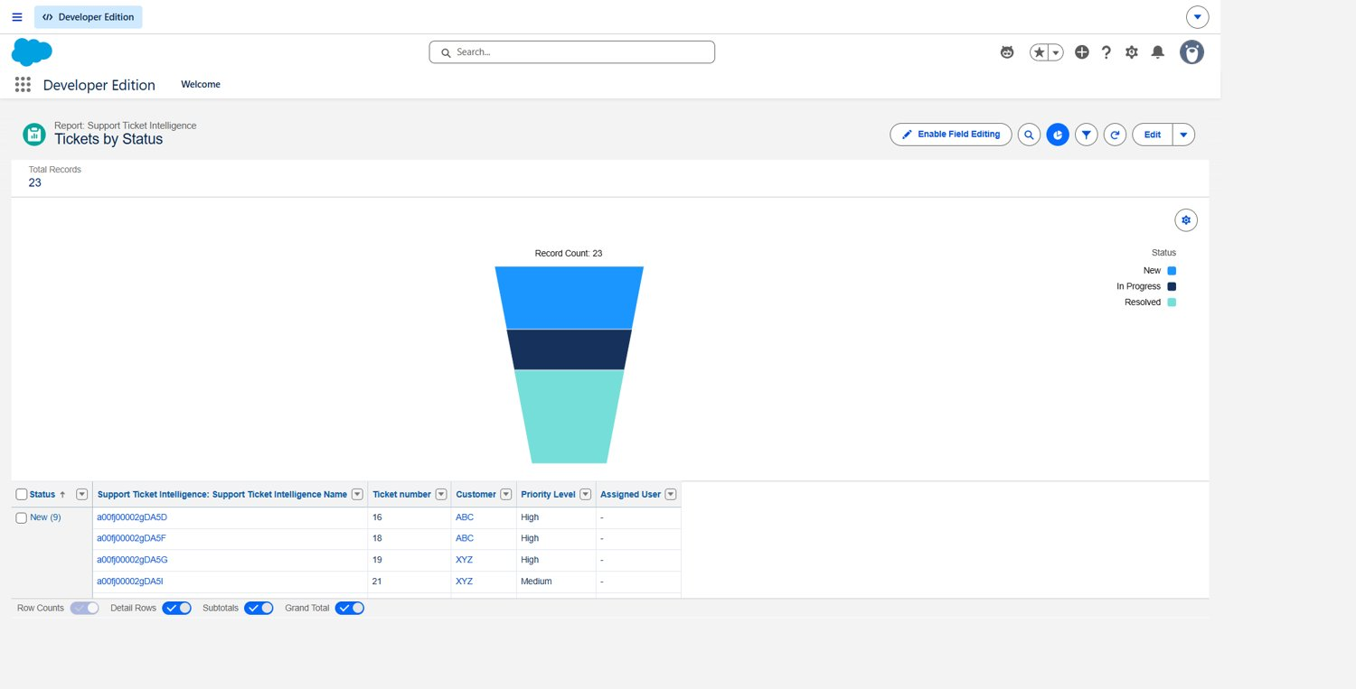
Figure 14: Report: Tickets by Status
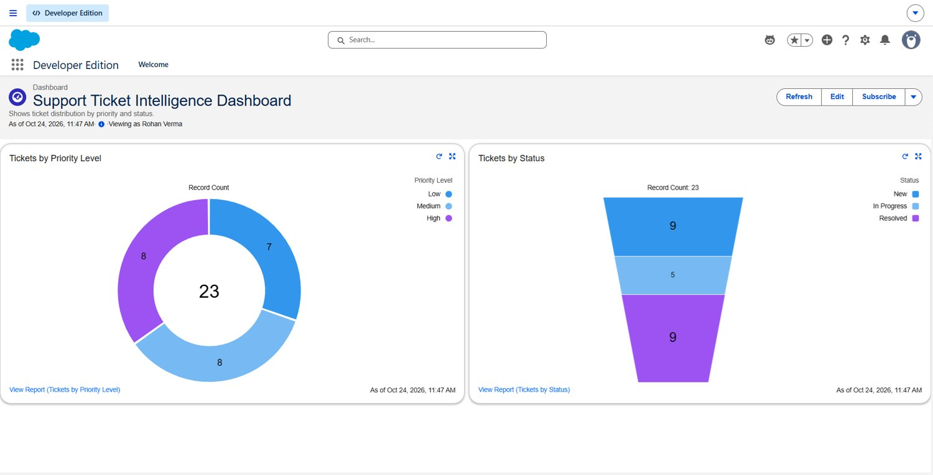
Figure 15: Support Ticket Intelligence Dashboard
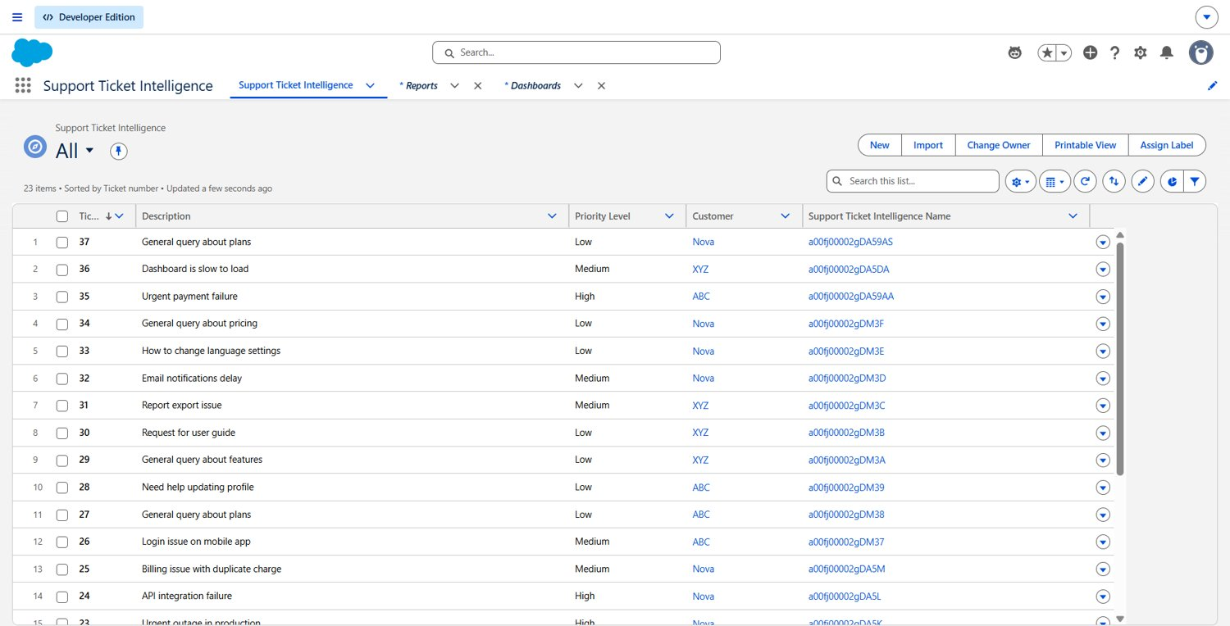
Figure 16: Support Ticket Intelligence Lightning App with navigation tabs

Phase 4: Data Migration, Testing and Security

Data migration
I prepared a CSV file with 20 sample tickets for three accounts (ABC, XYZ and Nova), with a mix of High, Medium and Low descriptions, and loaded it with the Data Import Wizard. My first attempts failed. One problem was the date format, and the other was that the Status picklist had the value "Resolve" while my file used "Resolved". After I fixed both, the records were imported. The wizard could not map the Customer lookup, so I set the customer on the tickets after the import. I also added three tickets by hand so that the newest ticket of each account was a known High, Medium or Low case.
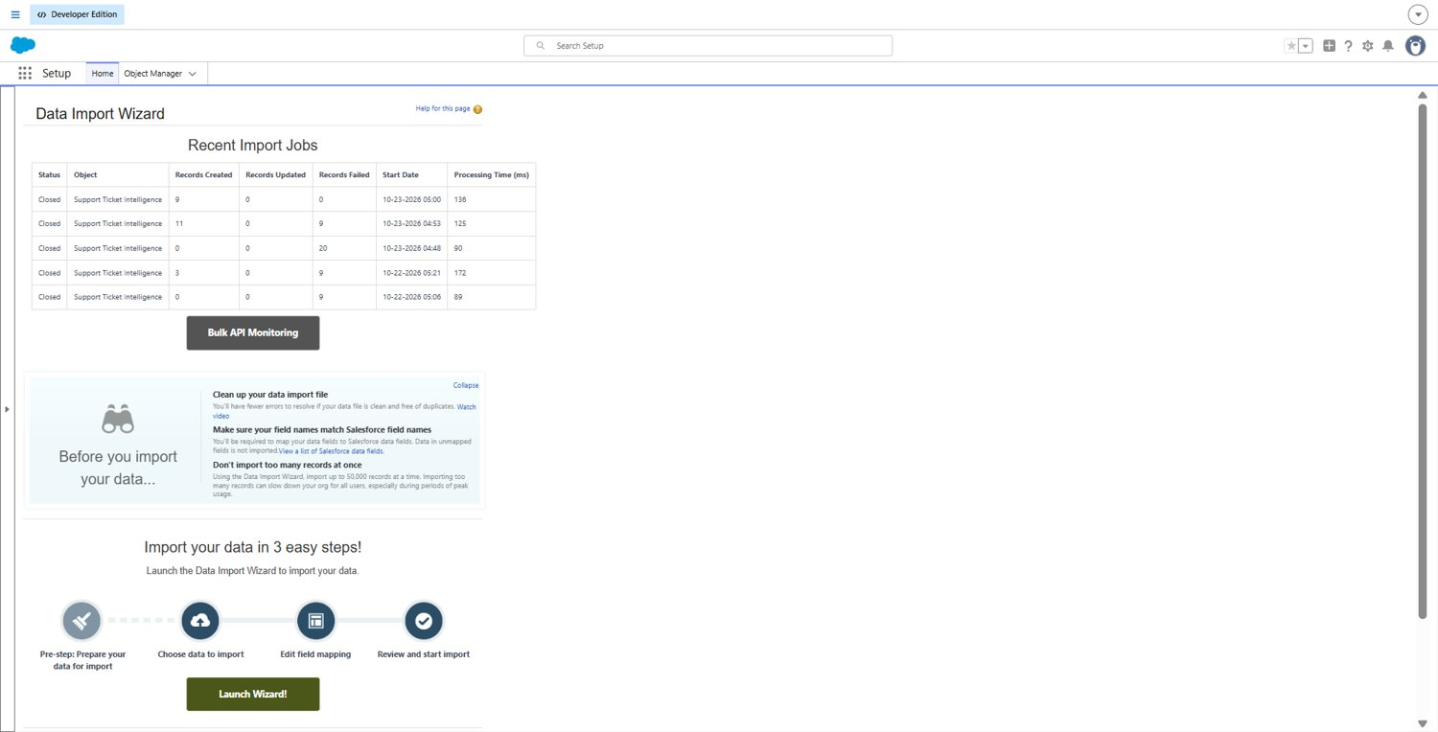
Figure 17: Data Import Wizard jobs for the Support Ticket Intelligence object
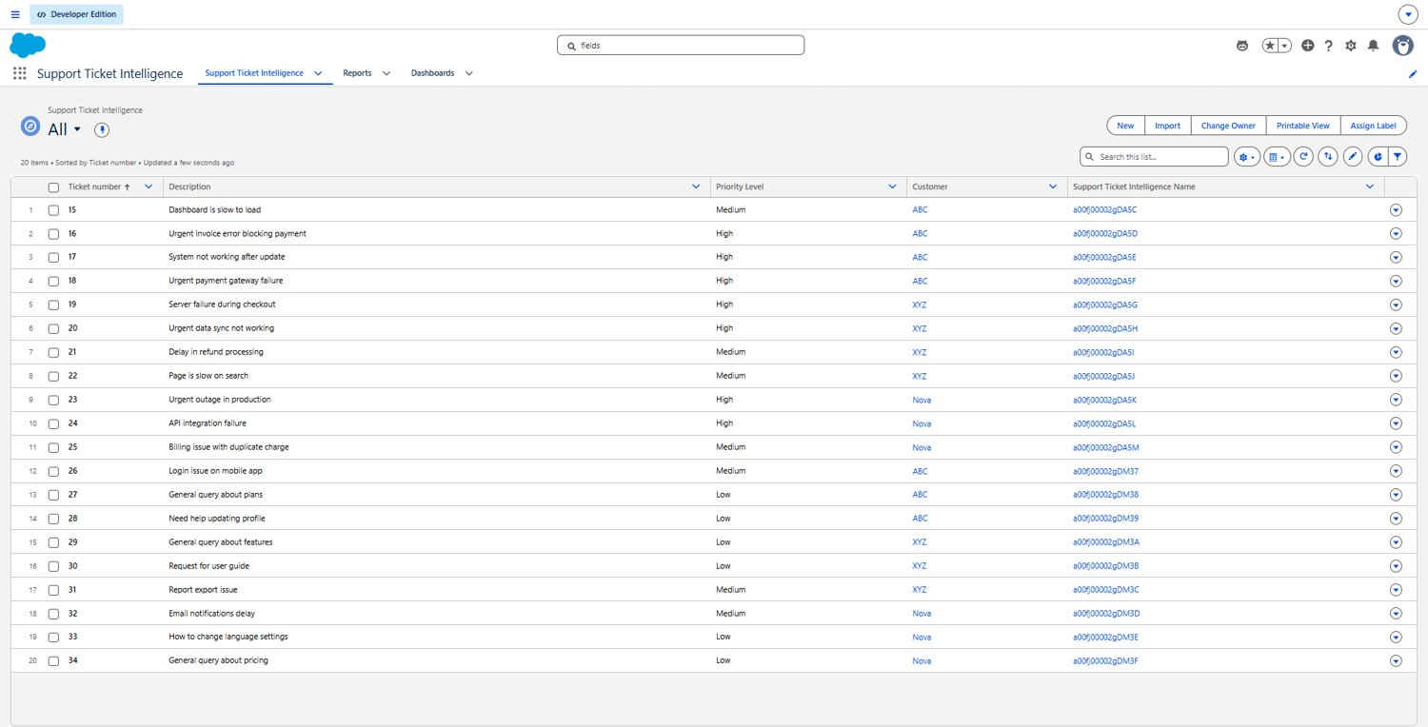
Figure 18: Ticket list view with description, priority and customer

Security
Access to the object and fields is controlled by profiles and field-level security. The System Administrator profile can see all the fields, including the Customer lookup. The picklists are restricted, which stops wrong values from being saved.

Validation rules and approvals
I did not create validation rules or an approval process in this project. Data quality is handled by the restricted picklists, and the only automation is the priority Flow. I have listed both as future work.

Phase 5: Deployment, Documentation and Maintenance
The project was built and tested only in a Developer Edition org. I did not deploy it to production because a Developer org is not linked to a production org. In a real project the work would go through a sandbox using Change Sets, Salesforce DX or a CI/CD pipeline.
After deployment the system would need some maintenance, for example checking failed Flow runs, keeping the ticket data clean, updating the keywords when customers write differently, and checking the agent replies from time to time.

7. Functional and Performance Testing

Testing approach
I tested the project in five ways. I checked the import jobs for created and failed records. I used the Debug option in Flow Builder to follow each step of the Flow. I tested the agent in Conversation Preview with three accounts whose newest tickets were High, Medium and Low. I opened the Task to check its subject, priority and status. Finally I refreshed the reports and the dashboard and compared the numbers with the ticket list.

Test results
Account | Newest ticket description | Expected | Result
ABC | Urgent payment failure | High | High. The message said it was assigned to a senior agent and a Task was created.
XYZ | Dashboard is slow to load | Medium | Medium. The message said it would be handled shortly.
Nova | General query about plans | Low | Low. The message said it was queued for processing.

At the end of testing there were 23 tickets (20 imported and 3 added by hand). This matches the totals on both reports and the dashboard: 8 High, 8 Medium and 7 Low.
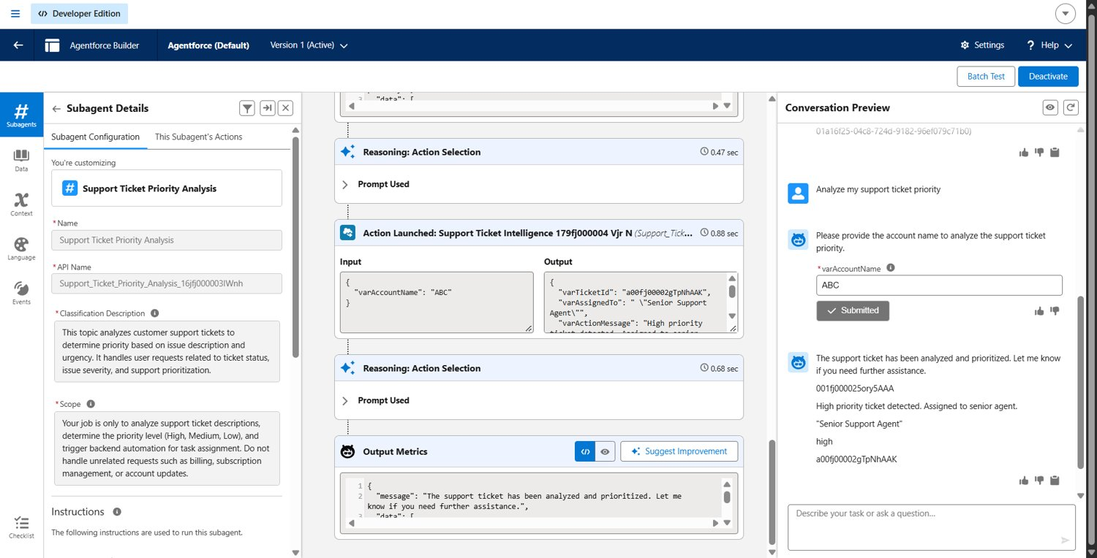
Figure 19: Agent test for account ABC (High priority)
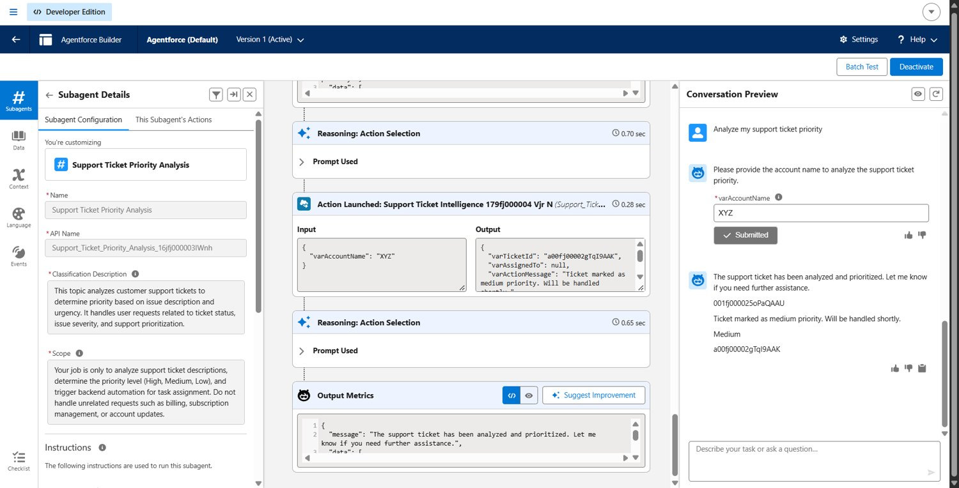
Figure 20: Agent test for account XYZ (Medium priority)
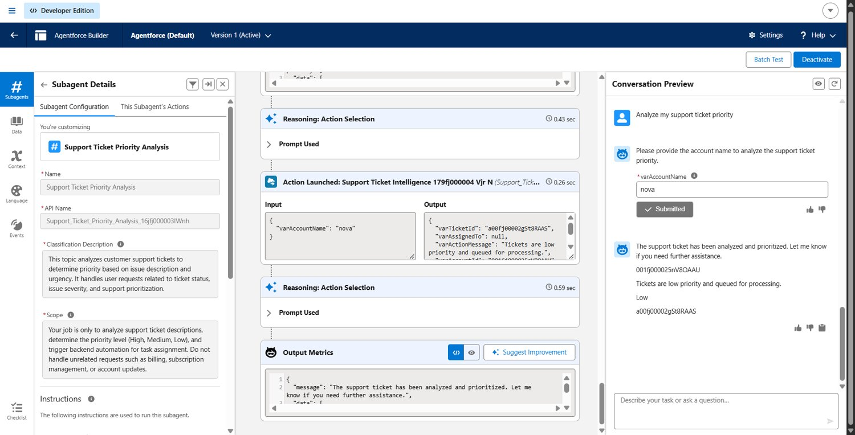
Figure 21: Agent test for account Nova (Low priority)
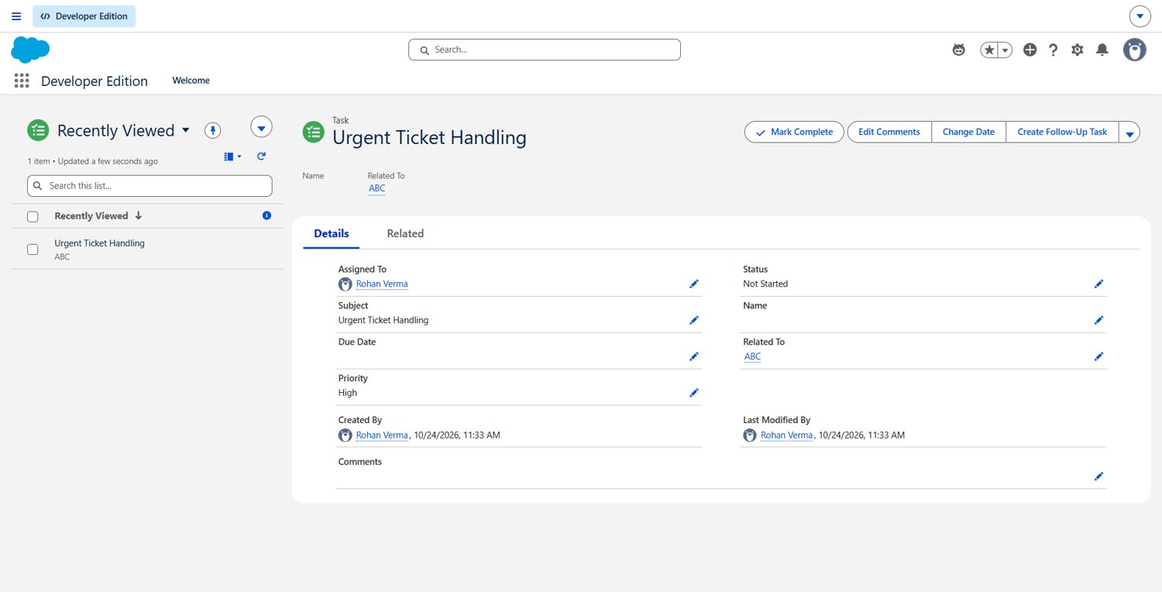
Figure 22: Task created for the High priority ticket

Performance
The Flow ran in about one second in Debug, and the agent action returned its output in less than a second in the preview trace.

Problems found during testing
Problem | How I fixed it
The import failed because of the date format | I removed the Created Date column from the file because it is not required.
Records with Status "Resolved" were rejected | The picklist value was "Resolve". I corrected it to "Resolved" and imported the failed rows again.
Every ticket became Low | The Medium outcome needed all three keywords together. I changed it to match any one keyword.
The Task was not created for High tickets | I turned on activities for the custom object.
The Customer lookup could not be mapped in the import | I set the customer on the tickets after the import.

8. Advantages and Disadvantages

Advantages
- All tickets are stored in one object.
- The priority is set with the same rules every time.
- High tickets get a Task automatically.
- A user can check a customer's latest ticket by chatting with the agent.
- Managers can see the ticket mix in the reports and dashboard.
- It is built with clicks, so it can be changed without code.

Disadvantages
- The priority is based on keywords, not machine learning, so unusual wording can be marked wrongly.
- Only the newest ticket of an account is checked.
- The assigned agent is only a text label, not a real user.
- It was built in a Developer org and was not deployed to production.
- The keywords and the agent instructions need regular updates.

9. Conclusion
In this project I used Salesforce Flow and Agentforce to automate the first step of handling support tickets. The tickets are stored in a custom object, the Flow sets the priority, and a Task is created for urgent tickets. The agent lets a user do this from a short chat, and the reports and dashboard show the result to managers.
I tested it with the accounts ABC, XYZ and Nova and all three priority cases worked. I also had to fix some problems on the way, such as the import errors and the keyword logic. The project works in a Developer org and was not deployed to production, but it can be improved further.

10. Future Scope
- Add a chatbot so customers can raise and check tickets.
- Use AI to suggest the priority instead of fixed keywords.
- Assign tickets to real users based on workload.
- Update the ticket's own priority field when the Flow runs.
- Add validation rules and an approval step for closing High tickets.
- Add SLA timers and escalation.
- Deploy to production through a sandbox.

11. Appendix
- A. Custom object: Support Ticket Intelligence, with fields and tab.
- B. Auto-launched Flow for priority and Task creation.
- C. Agentforce agent, subagent and Flow action.
- D. Reports and dashboard.
- E. Lightning App.
- F. Data Import Wizard with sample tickets.
- G. Testing: Flow debug runs and agent tests.
Thank You

