

**VIRGINIA COMMONWEALTH UNIVERSITY**

**Statistical analysis and modelling (SCMA 632)**

**A3 Part B**

**Rohan Arpit Dungdung**

**V01108247**

**Date of Submission: 15-07-2024**

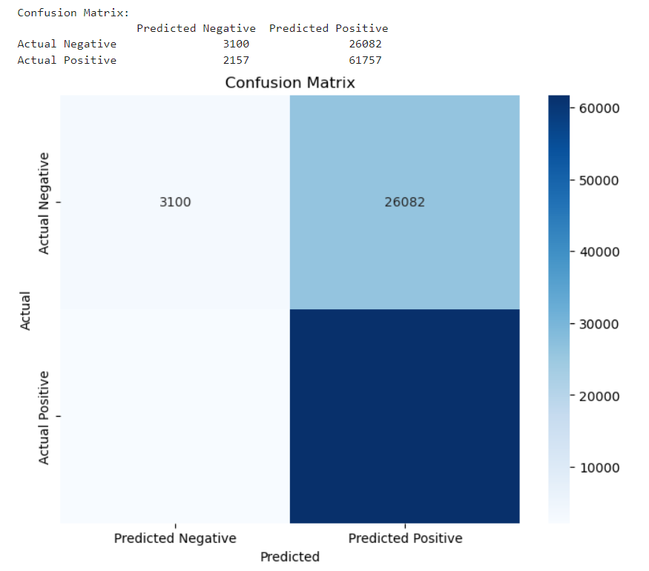

Interpretation

The model shows a high recall rate, indicating it is good at identifying positive instances e.g., correctly identifying non-vegetarians. However, the precision is lower, suggesting a fair number of false positives The specificity is quite low, indicating that the model struggles to identify true negatives accurately. This could be problematic if identifying negatives e.g., vegetarians is critical for the application. Overall, the accuracy is moderate, but the high number of false positives might indicate an imbalance or a need for threshold adjustment or further model tuning.

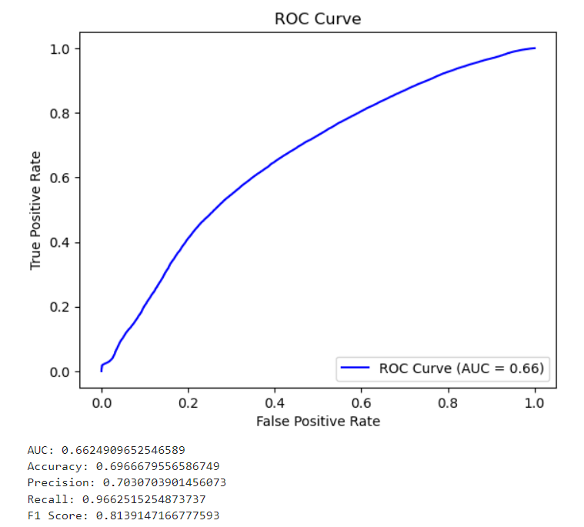

Interpretation

The ROC curve and AUC value suggest that the model has a reasonable, though not exceptional, ability to distinguish between the positive and negative classes. The high recall indicates that the model is particularly good at identifying positive instances, which may be useful if the cost of missing positive cases is high. However, the lower precision suggests that there is a notable number of false positives, indicating that while the model captures many true positives, it also incorrectly classifies a significant number of negatives as positives. The accuracy and F1 score provide a balanced view, suggesting overall decent model performance but highlighting areas for potential improvement, such as reducing false positives.