

**VIRGINIA COMMONWEALTH UNIVERSITY**

**Statistical analysis and modelling (SCMA 632)**

**A4c- Apply Multidimensional Scaling and interpret the results**

**Rohan Arpit Dungdung**

**V01108247**

**Date of Submission: 15-07-2024**

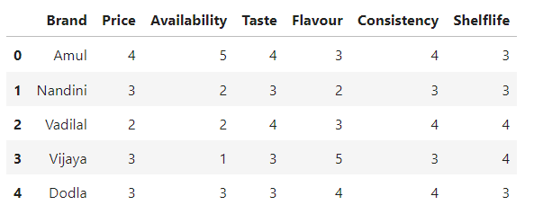

Interpretation

Each brand has its strengths and weaknesses. For instance, Amul excels in availability, while Vijaya offers a diverse range of flavours. Vadilal is notable for its affordability and good taste, despite low availability. Nandini and Dodla offer more balanced characteristics, though neither excels in any specific attribute. These differences highlight the unique positions each brand holds in the market, appealing to different customer preferences based on price, availability, and specific attributes like taste and flavour variety.

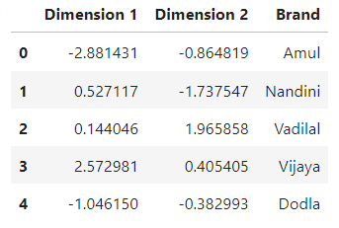

Interpretation

The MDS plot visualizes the brands in a two-dimensional space, allowing us to see the relative similarities and differences among them. Brands that are closer to each other, like Dodla and Amul, share more similar characteristics. In contrast, brands like Vadilal and Vijaya, positioned further apart, differ more significantly in their attributes.

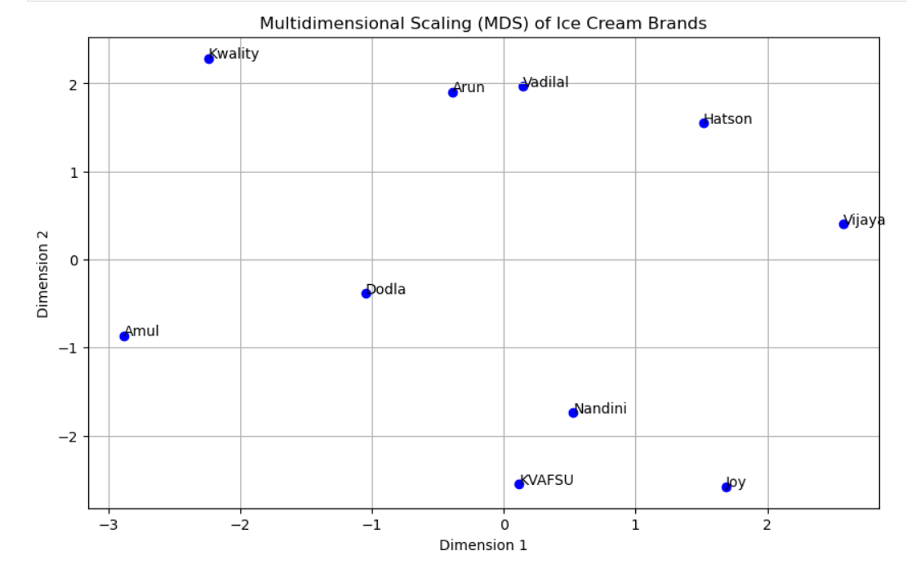

Interpretation

The MDS plot provides a visual summary of how different ice cream brands compare based on their attributes. Brands closer together are more similar, while those further apart are more distinct. This visualization helps in understanding the competitive landscape and positioning of these brands in the market, potentially guiding marketing strategies and product development based on the unique attributes of each brand.

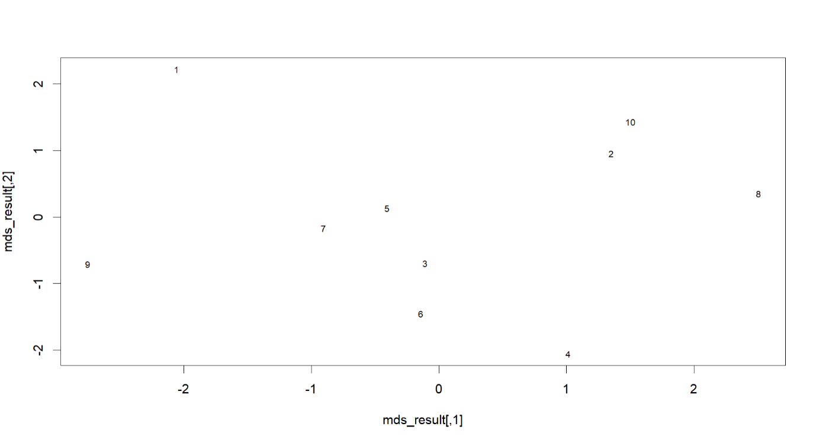

Interpretation

The axes represent the first two dimensions resulting from the MDS analysis. These dimensions are derived from the data and capture the most significant variance in preferences or perceptions.

The specific interpretation of these dimensions depends on the context of the data and the attributes analyzed. For instance, they might represent underlying factors like "Quality vs. Price" or "Flavor Intensity vs. Healthiness," depending on the attributes used in the conjoint analysis.

Each point represents a different product profile or a combination of attribute levels used in the conjoint analysis.

The numbers 1 to 10 correspond to different profiles that were evaluated by respondents.

Points that are closer together are perceived similarly by respondents. For example, if profile 1 and profile 2 are close, respondents likely viewed these profiles as similar.

The distance between points reflects the dissimilarity in respondents' perceptions. Profiles that are far apart, like 1 and 8, are perceived as very different.

If there are clear clusters, these indicate groups of profiles that are perceived similarly. For example, if profiles 3, 5, and 10 are close together, they may share common attributes that respondents favor or disfavor similarly.

Outliers or isolated points, such as profile 9, indicate unique or distinct profiles that do not share similarities with others.