(a) What Unicode character does chr(0) return?
Answer: Unicode character ‘\x00’ for the code point ‘0’. Chr(0) represents “no character”, or “absence of character”
(b) How does this character’s string representation (__repr__()) differ from its printed representation?
Answer : precise representation is displayed by __repr__() and it outputs machine readable format, print() uses string representation, user friendly format by using __str__() and it prints nothing

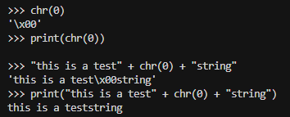

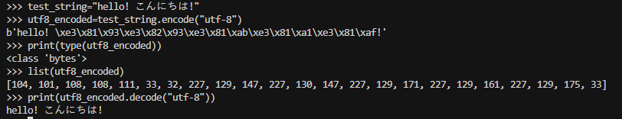
By converting our Unicode codepoints into a sequence of bytes (e.g., via the UTF-8 encoding), we are essentially taking a sequence of codepoints (integers in the range 0 to 154,997) and transforming it into a sequence of byte values (integers in the range 0 to 255). The 256-length byte vocabulary is much more manageable to deal with. When using byte-level tokenization, we do not need to worry about out-of vocabulary tokens, since we know that any input text can be expressed as a sequence of integers from 0 to 255

What are some reasons to prefer training our tokenizer on UTF-8 encoded bytes, rather than UTF-16 or UTF-32? It may be helpful to compare the output of these encodings for various input strings
Answer: Training on UTF-8 bytes keeps the tokenizer’s vocabulary small (only 256 possible byte values), making it faster and more memory-efficient. UTF-16/32 would blow up the vocabulary size for no real benefit.
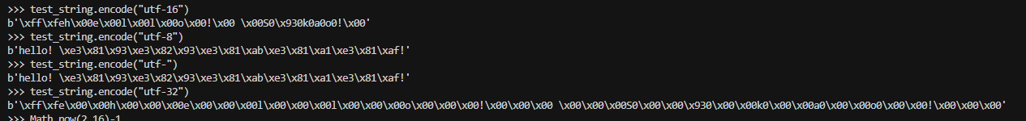

2.3 Subword Tokenization:
- While byte-level tokenization can alleviate the out-of-vocabulary issues faced by word-level tokenizers, tok enizing text into bytes results in extremely long input sequences. This slows down model training, since a 5 sentence with 10 words might only be 10 tokens long in a word-level language model, but could be 50 or more tokens long in a character-level model (depending on the length of the words). Processing these longer sequences requires more computation at each step of the model.
- propose to use byte-pair encoding (BPE; Gage, 1994), a compression algorithm that iteratively replaces (“merges”) the most frequent pair of bytes with a single, new unused index. Note that this algorithm adds subword tokens to our vocabulary to maximize the compression of our input sequences—if a word occurs in our input text enough times, it’ll be represented as a single subword unit.

2.4 BPE Tokenizer Training
Pre-tokenization: Once you have a vocabulary, you could, in principle, count how often bytes occur next to each other in your text and begin merging them starting with the most frequent pair of bytes. However, this is quite computationally expensive, since we’d have to go take a full pass over the corpus each time we merge. In addition, directly merging bytes across the corpus may result in tokens that differ only in punctuation (e.g., dog! vs. dog.).
however, you should use re.finditer to avoid storing the pre-tokenized words as you construct your mapping from pre-tokens to their counts.

import regex as re

PAT=r"""'(?:[sdmt]|ll|ve|re)| ?\p{L}+| ?\p{N}+| ?[^\s\p{L}\p{N}]+|\s+(?!\S)|\s+"""

matches=re.findall(PAT,"some text that i'll pre-tokenize")
print(matches)

matches = re.finditer(PAT,"some text that i'll pre-tokenize")

for match in matches:
print(match.group(),end=",")
print()

greatest_pair= max([("A", "B"), ("A", "C"), ("B", "ZZ"), ("BA", "A")])
print(f"greatest_pair is {greatest_pair}")
