**Documentation Regarding Project Implementation of**

**Capital Market Forecasting**

**&**

**Computerized Adaptive Test**

**Predicting Market Sentiment of Company**

* Installation of libraries for effective prediction and calculation of market sentiment. Libraries such as:

1. **twitteR** - Provides an interface to the Twitter web API
2. **RCurl** - This allows us to download files from Web servers, post forms, use HTTPS (the secure HTTP), use persistent connections, upload files, use binary content, handle redirects, password authentication, etc.
3. **bitops** - Functions for bitwise operations on integer vectors.
4. **Wordcloud** – Create pretty word clouds.
5. **Tm** - A framework for text mining applications within R.
6. **Plyr** - A set of tools that solves a common set of problems: you need to break a big problem down into manageable pieces, operate on each piece and then put all the pieces back together.
7. **Stringr** - A consistent, simple and easy to use set of wrappers around the fantastic 'stringr' package.

* Setup secure connection to twitter using unique consumer_key, consumer_secret, access_secret and access_token.
* Retrieval of latest 1500 tweets from twitter of a particular company in English.
* Used laply function to get text from every tweet.
* Scan the positive and the negative words from already created files to “pos.words” and “neg.words” variables.
* Then ran the “score.sentiment” function using laply and “passed tweets sentence, pos.words and neg.words” as arguments and receive the output of the function in “result” dataframe.
* Calculated the mean score by applying mean() function on score column of result dataframe.
* Converted the “companytext” character variable into a corpus using corpus function.
* Created the Wordcloud of the tweets using Wordcloud function on companytext.corpus.

**Outputs**

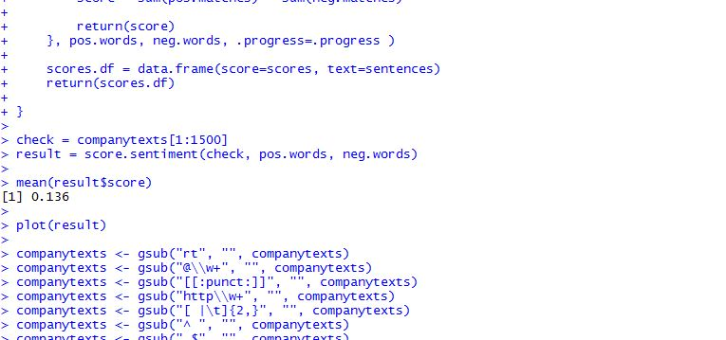

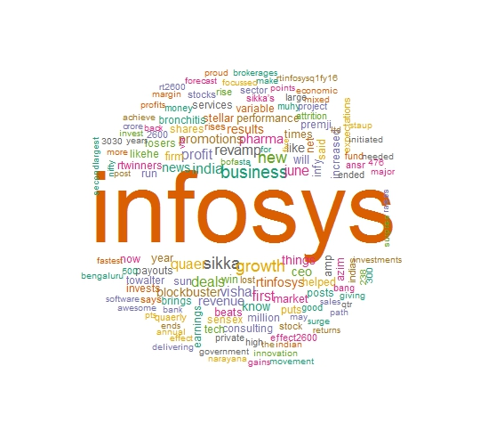

**Exponential Moving Average**

* Installation of libraries for effective prediction and calculation of market sentiment. Libraries such as:

1. **quantmod -** Specify, build, trade, and analyse quantitative financial trading strategies.
2. **xts -** Provide for uniform handling of R's different time-based data classes.
3. **caret -** functions that attempt to streamline the process for creating predictive models.
4. **ggplot2 -** implementation of the grammar of graphics in R
5. **forecast -** displaying and analysing univariate time series forecasts including exponential smoothing.

* Retrieved the trading data of company using yahoo finance API.
* Applied the logic formula for calculating the next day price.

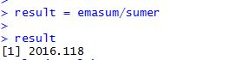

**Simple Moving Average**

* Installation of libraries same as of Exponential Moving Average for effective prediction and calculation of market sentiment.
* Retrieved the trading data of company using yahoo finance api.
* Applied the logic formula for calculating the next day price.

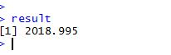

**Support Vector Machine**

* Installation of libraries for effective prediction and calculation of market sentiment. Libraries such as:

1. **e1071 -** Functions for latent class analysis.
2. **caret -** functions that attempt to streamline the process for creating predictive models.
3. **ggplot2 -** implementation of the grammar of graphics in R

* Retrieved the trading data of company using yahoo finance api.
* Split the data in two parts i.e. trainset and testset.
* Then predicted the polarity of stock price on the trainset data.

**Designing the UI for the Computerized Adaptive Testing**

* https://github.com/Xebia-Projects/Computer-Adaptive-Test/tree/master/Front-end