This is a barebones Angular JS/MEAN Stack app that I am creating as a playground for our Side Project.

I will keep experimenting on this for sometime

Changelog

06/28/2016

V1.1. Barebones app created with basic routing using routeProvider
V1.2. Changed the folder structure, will need to improve the structure
V1.3. Added an array in the homeController that contains some arbitrary products

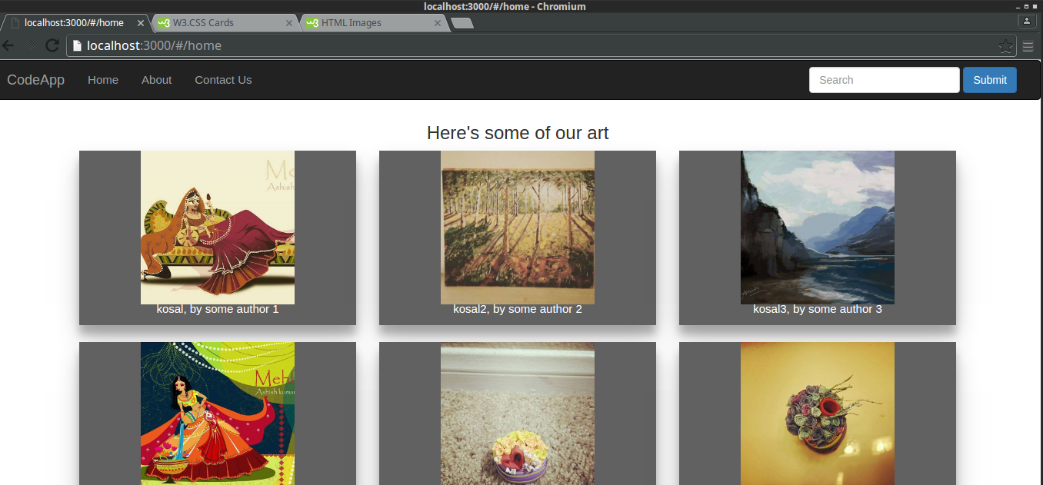

V1.4. Added some images and the W3.CSS file and made the images 100% in width so they look better

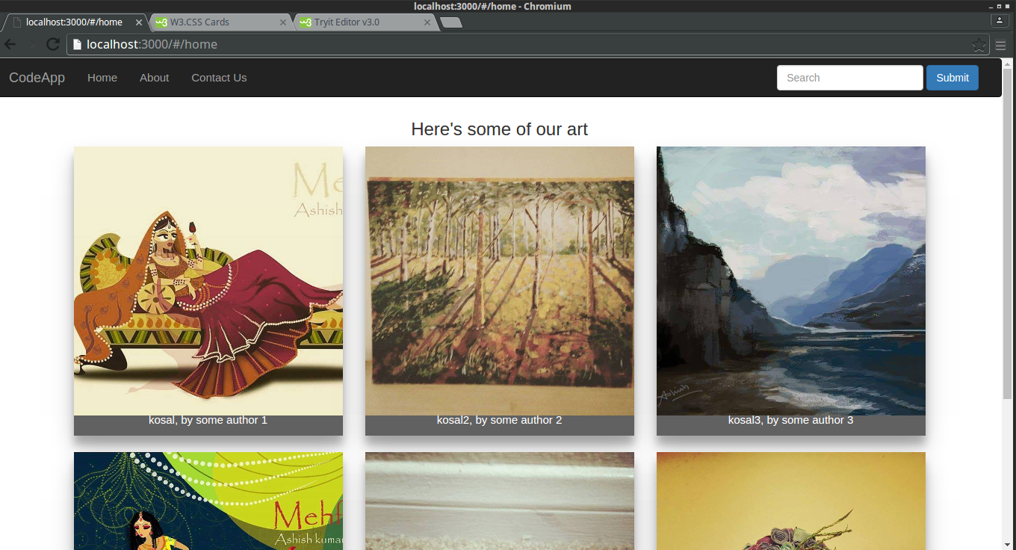

V1.5. Added a floating button that has ‘no functionality’ currently.

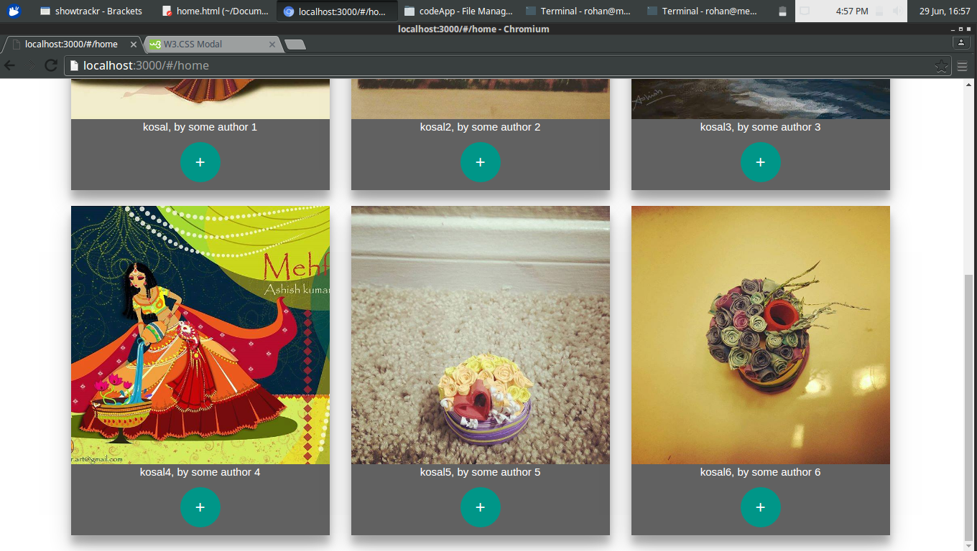

V.1.6. Added image zoom, so clicking on an image will zoom it to full size.
However, there is no angular logic backing this functionality, and hence the
image will always be the first one.

Planned : Implement the $index logic in the controller so that the image will be registered, and that particular image will open

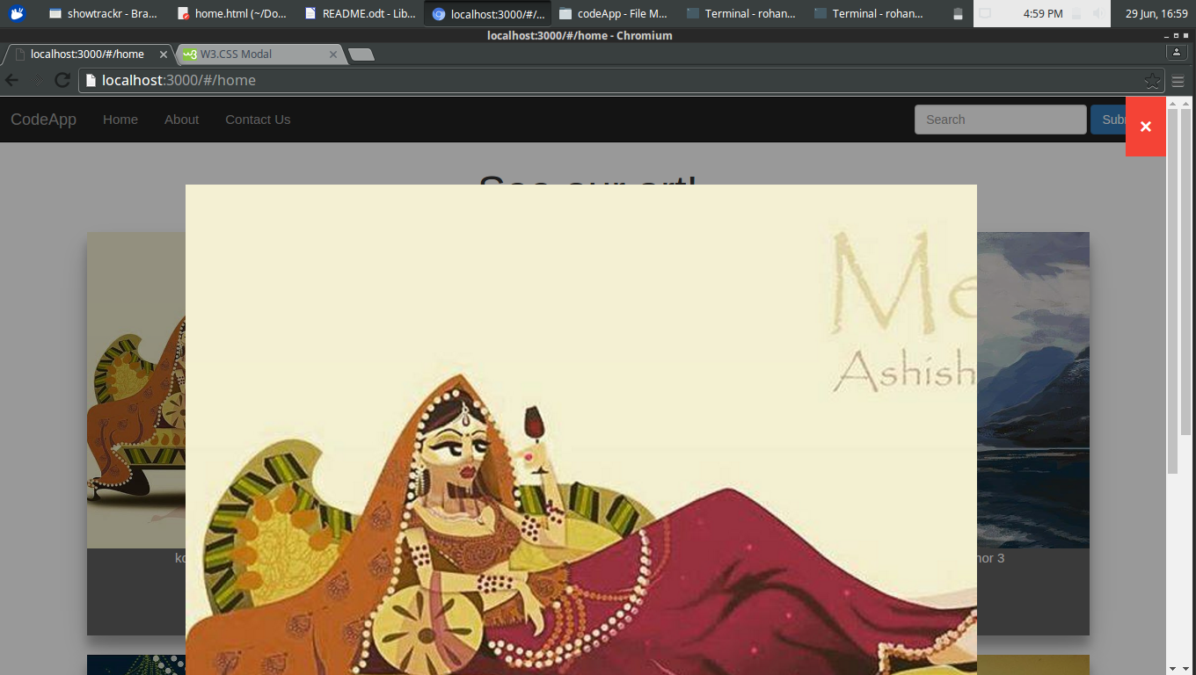

V1.7. Added a naive slideshow to the homepage. This just displays static images for now and there is no angular logic to back it.

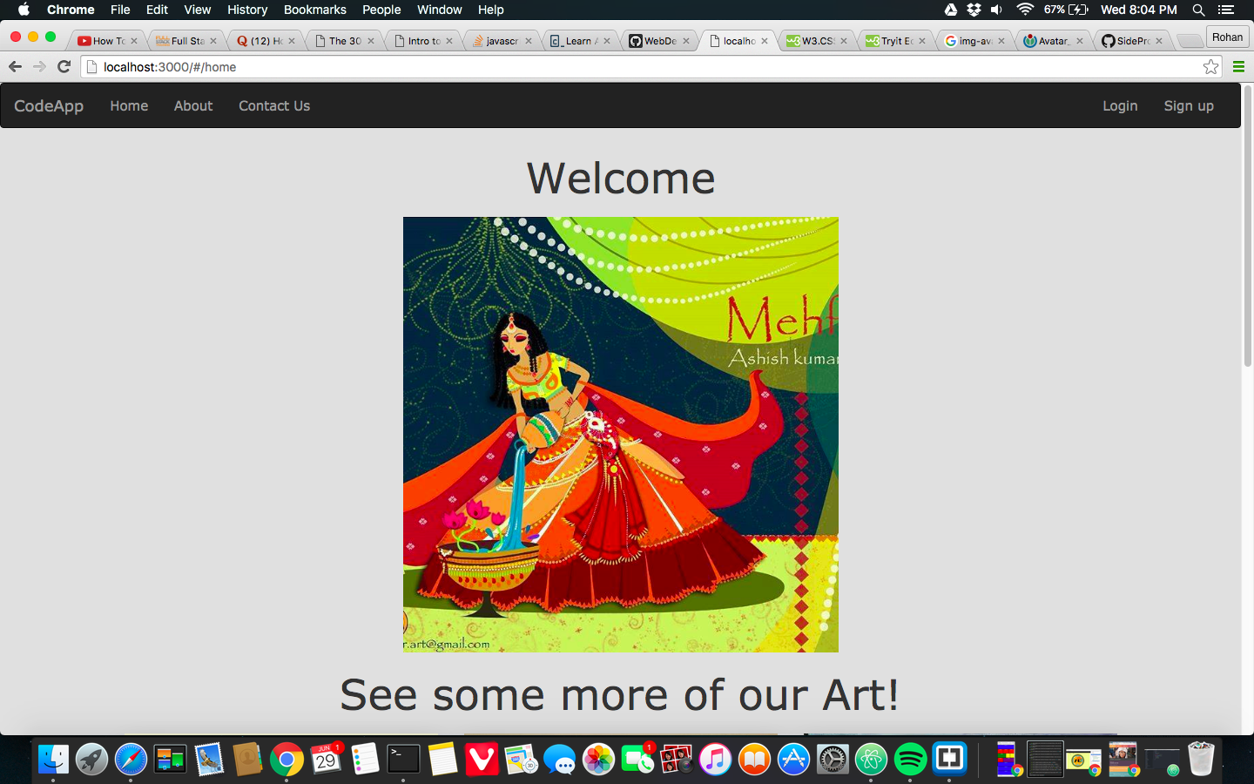

V.1.8. Added Modal for Login

