Why nobody has cracked the lane battler
The genre: the real-time PvP lane battler. Two players, eight cards, a regenerating elixir bar, three towers each, three minutes. Clash Royale invented it in 2016, and ten years on it still has no real rival. Blizzard tried with Warcraft Rumble; Supercell tried twice itself, with Clash Mini and Squad Busters. So this is the brief's second case: not a genre nobody has made money in, but one that is overdue for reinvention, because its one hit can't reinvent itself.
The short answer: the genre isn't saturated. It's stuck, because its revenue engine is the thing its players hate. Clash Royale sells card levels, each a flat stat boost, and every new level has set off a revolt. Supercell can't remove levels without cutting its own income, and every challenger copied them onto a player base too small to hide the pay-to-win. A breakout needs fixed card power in ranked, a deep money sink that sells identity rather than strength, and a plan for the empty queue every new PvP game hits early on.

1. The demand is there
Clash Royale has taken more than $4.9B in player spending [1]. In 2025 its monthly revenue went from about $12M in February to about $68M in September, net of store fees [2], and the year closed at $647M gross, up 149% [1]. Players came back with it: monthly players rose from 52M in June to 75M in December [3], and Supercell reported "a big improvement in returning player retention" [4]. World-finals viewership peaked at 698K, up from 142K a year earlier [5]. The audience is large, and much of it is lapsed rather than gone.

2. Why it hasn't worked

2a. The power treadmill is the business, and players hate it
Clash Royale's balance rule, as its card designer put it at GDC 2017, is that each level adds 10% to HP and damage "so all interactions remain the same" [6]. That's elegant for balance and brutal for players: a level gap doesn't change how a matchup plays, only who wins it. Losing to a higher-level deck feels like losing to a wallet, because it is.
Look at when the game hurt itself. Level 15 (June 2023), after players had been told 14 was the cap, set off boycotts [7]. Level 16 with paywalled Heroes (November 2025) was worse. In August 2026, Supercell's design lead said it plainly: "At the end of last year, we killed Clash Royale" [8]. Monthly revenue fell from about $68M in September to $26M in January, down 62% in four months [2], while monthly players held up: 65M in September, 74M in January [3]. The players stayed; the payers left. The 2025 boom had come from the opposite direction: removing chest timers and keys, letting players choose which cards to upgrade, and handing Evolutions out broadly [2][4].
Even ranked drifted: capped at Level 11 in 2023 [9], Level 16 by 2026 [10]. Supercell's June 2026 promise of no more card levels [8] is as far as it can go, because levels are what the game sells.
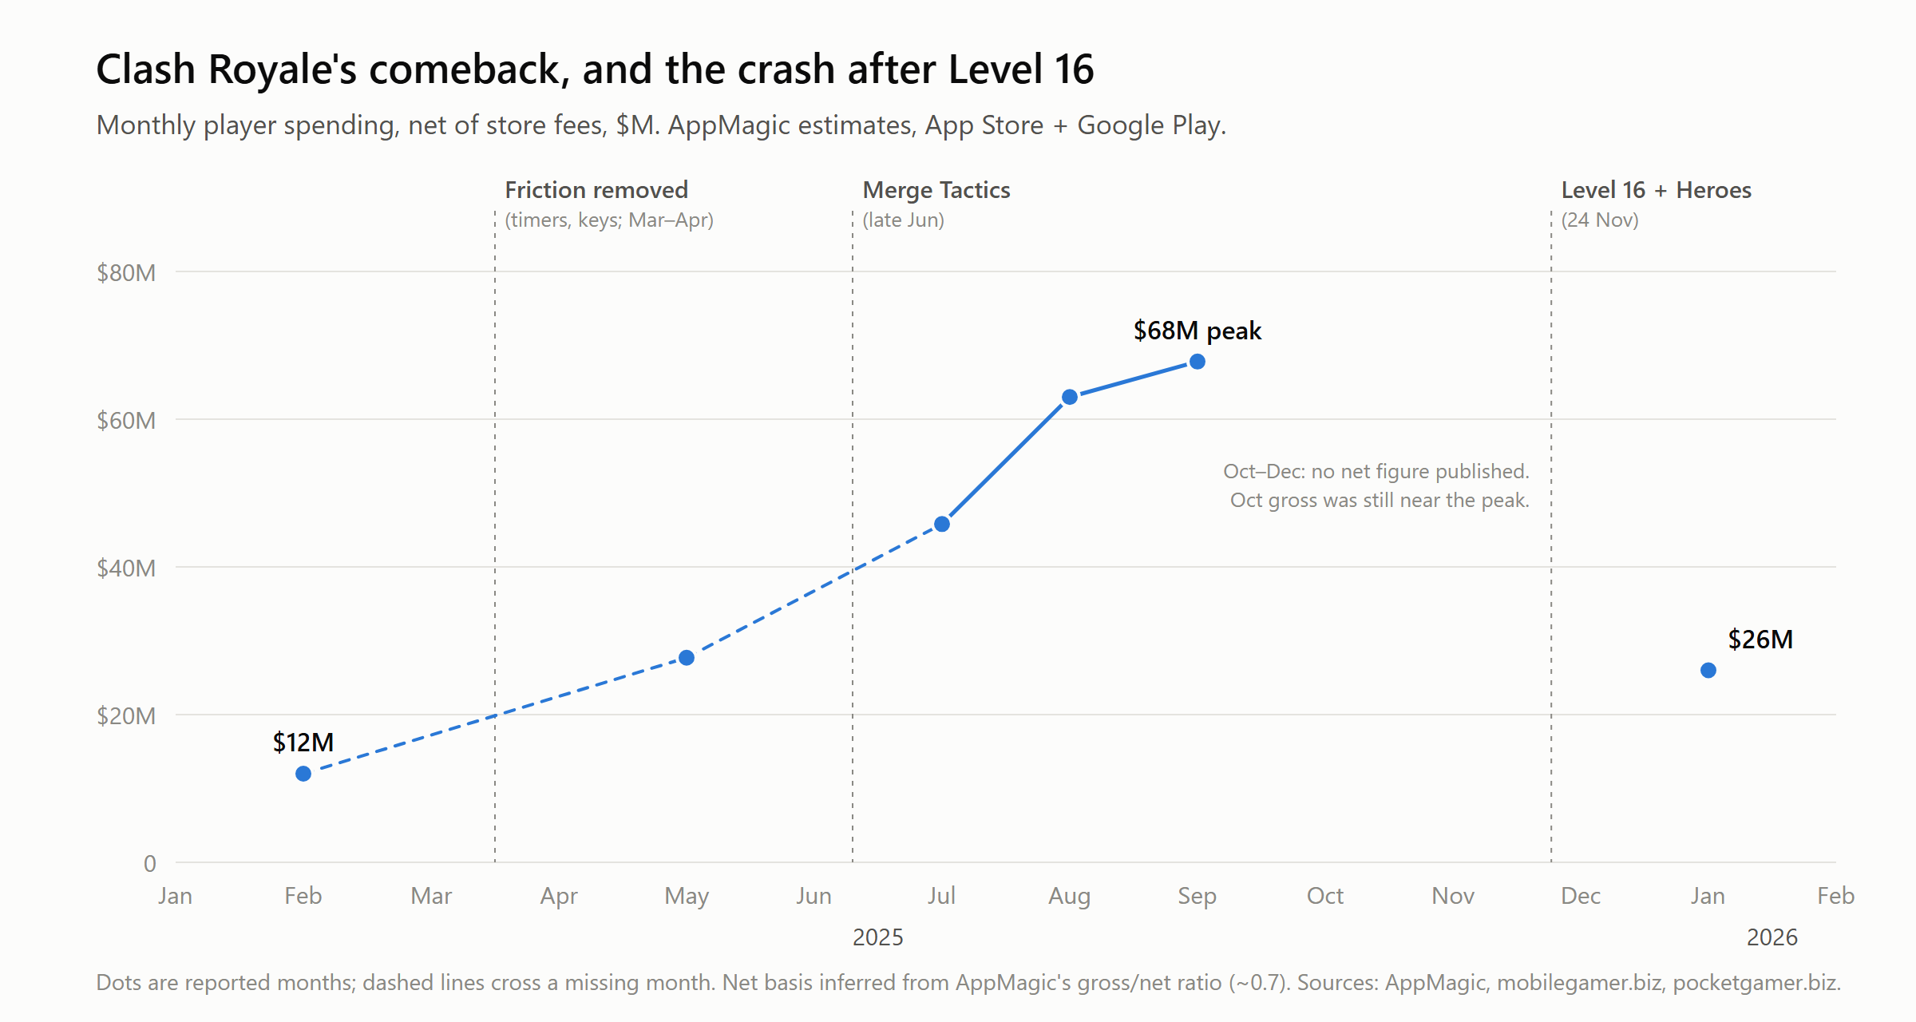
Chart 1: Clash Royale's comeback, and the crash after Level 16

2b. Challengers copied the treadmill onto smaller ladders
Warcraft Rumble shows the problem isn't weak monetization. Its 30-day revenue per download was $7.55, more than double Marvel Snap's $3.41 [11], yet monthly revenue fell about 92% in its first year [12]. Upgrade costs compounded (1.7–2x per step, per a fan teardown [13]), and a small player base forced mismatched pairings, down to cross-region matches [14]. Clash Royale's huge pool hides its pay-to-win: there's almost always someone at your level. A challenger's small pool exposes it, and the crushed mid-tier spenders leave first.
A correction to my own argument: thin ladders don't kill a good game by themselves. Squad Busters had 31M installs in its first week [15], so its queues weren't empty, and Supercell's verdict was that "too few players connected with it deeply enough" [16]. Thin queues make a weak core fail faster. They don't make a strong core weak.

2c. Challengers added complexity where Clash Royale wins on clarity
Rumble became "practically an RTS-lite," with "new mechanic after new mechanic" [17]. Star Wars: Force Arena added a leader hero who respawns after dying, locking you out of deploying cards while you wait [18]. Squad Busters put ten players and a screen full of effects into every match: "difficult to improve at and easy to give up on" (Michael Katkoff) [19]. In Clash Royale's 1v1 you can see why you lost. Players who can see why they lost get better; players who can't, leave.

3. What it would take
Four moves, each one something Clash Royale can't easily copy.
1. Fixed power in ranked. Every card plays at the same level in ranked, drawn from a weekly rotating pool everyone can use. Owning a card buys expression (casual decks, clan modes, cosmetics), never eligibility. The pool rule matters because of Marvel Snap: fixed power didn't cap Snap; selling access to the cards the meta needed did, and it brought back the same revolt [20].
This isn't a leap of faith for real-time PvP. MOBAs already run it on mobile, with money buying mostly heroes and skins rather than levels, and Honor of Kings has been the world's top-grossing mobile game for four years running, at about $2.4B gross in 2025 [21]. But a MOBA is a five-player match of 15 minutes or more. Nobody has brought that economy to the three-minute 1v1, and that's the gap.
2. Sell identity, not strength, and sell it deep. Snap's real ceiling was a shallow sink: about 250 cards at roughly $12 each, and engaged players got what they wanted for "significantly less than $100 per year" [22]. Depth without stats looks like:
- Cosmetic rarity on identical cards. Pokémon TCG Pocket made $1.6B in 18 months, and its rarer card versions differ only in appearance [23].
- High-end cosmetics. League of Legends sells a $435 skin bundle aimed at players "willing to spend $200 a month on their hobbies" [24].
- Sidegrades: card variants that change how a card plays, not how strong it is. Permanent in casual and clan modes, free to everyone when they rotate into ranked.
- Consumables and clans: tournament entries, clan-war tickets, VIP tiers, clan-scale competition with shared cosmetics. The spending depth of a 4X game, on a fair board.
Clash Royale can copy cosmetics overnight. It can't copy fixed power without cutting its own revenue. That's the moat.
3. Stay legible. 1v1, three minutes, two lanes; no hero units, respawns or extra stat layers. Every loss ends on a short replay of the moment the match turned.
4. Fill the empty queue with AI rivals that players know are AI.
- Trained on human play. Imitation learning on soft-launch matches, bucketed by skill, so rivals make human mistakes. Scripted bots don't teach [25]; imitation-trained bots have shipped for low-population matchmaking after days of training [26].
- Disclosed before, revealed after. The queue says "Leagues 1–3 may include AI rivals"; the result screen says "Human" or "AI rival."
- Phased out by liquidity. A rival fills a slot only if no human in range turns up within a few seconds; top leagues and prize modes stay human-only. Publish the AI share per league weekly, so a falling number becomes a public growth story.
- Required now, not just polite. EU AI Act Article 50 has required AI to identify itself since August 2026 [27]; in Skillz v. Papaya, a $420M verdict followed a ruling that "fair" can imply human opponents [28].
- Creator ghosts. Opt-in AI models of creators' playstyles ("Beat [creator]'s ghost"), with a revenue share and a revoke button: Forza's Drivatars applied to creators [29]. Creators bring installs, not retention, so this is a channel, not a fix.
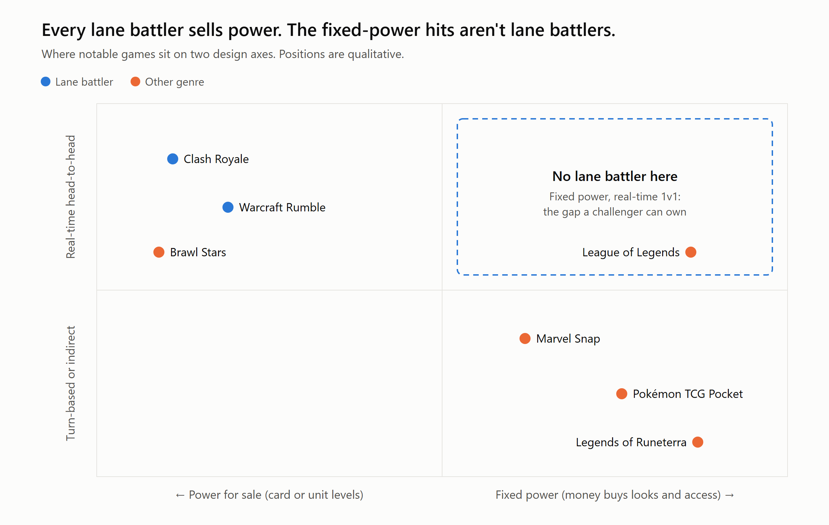
Chart 2: Every lane battler sells power. The fixed-power hits aren't lane battlers.

4. Risks, and how I'd test them
- Spending depth. Fixed power has failed to earn before: Snap, and Legends of Runeterra, which "cost significantly more to develop and support than it generates" [30]. The test is 30-day revenue per download in soft launch. Snap reached $3.41 and Rumble, selling power, reached $7.55 [11]. My target is $5. Kill the project if it is still at or below Snap's $3.41 after two rounds of economy changes.
- Decay. TCG Pocket's revenue fell 51% in its second half-year [23]. Plan a faster content cadence than Snap's, plus monthly sidegrades, before launch rather than after the first dip.
- A weak core. Test with a cohort that plays only AI rivals before any marketing spend. If D1 and D7 aren't there, liquidity won't fix it.
- Soft-launch numbers to watch: D7; 30-day revenue per download; AI share per league (it should fall); ranked participation.

Assumptions
- Revenue and download figures are third-party estimates (mostly AppMagic, App Store + Google Play only) unless marked as company figures. Gross means player spending; net is after store fees.
- Player counts are AppMagic monthly active users, as published by Udonis.
- "Lane battler" here means real-time PvP with deck deployment, a regenerating resource, lanes and towers. MOBAs share the lanes but not the format (five players, long matches, one hero each), so I treat them as a separate genre.
- The $5 revenue-per-download target is my own number, set between the two published benchmarks; the kill line is Snap's $3.41.
- I haven't seen internal data from any studio named. Causal claims about why games declined are my reading of public evidence, not their post-mortems.

Sources
1. pocketgamer.biz, "Clash Royale celebrates 10 years and $4.9bn in player spending" (AppMagic; includes 2025 total, $646.8M gross). https://www.pocketgamer.biz/clash-royale-celebrates-10-years-and-49bn-in-player-spending-after-resurgence/
2. AppMagic, "Clash Royale's comeback" (Feb–Sep 2025, net basis inferred). https://appmagic.rocks/blog/ClashRoyale-Comeback · mobilegamer.biz, January 2026 top-grossing games (AppMagic, net). https://mobilegamer.biz/januarys-top-grossing-mobile-games-2
3. Udonis, "Clash Royale player count" (AppMagic monthly active users, Jun 2025 – Jun 2026; updated 2 Jul 2026). https://www.blog.udonis.co/mobile-marketing/mobile-games/clash-royale-player-count
4. mobilegamer.biz, "Supercell explains Clash Royale's big comeback" (GDC 2026). https://mobilegamer.biz/supercell-explains-clash-royales-big-comeback/
5. Esports Insider, CRL World Finals 2025 viewership. https://esportsinsider.com/2025/11/clash-royale-league-crl-world-finals-2025-viewership
6. Stefan Engblom, "Quest for the Healthy Metagame," GDC 2017. https://gdcvault.com/play/1024272/Quest-for-the-Healthy-Metagame
7. Supercell, Level 15 upgrade costs. https://supercell.com/en/games/clashroyale/blog/news/level-15-upgrade-costs-2
8. mobilegamer.biz, "How did we misjudge this so badly?" (James Back, Gamescom Dev, 24 Aug 2026). https://mobilegamer.biz/how-did-we-misjudge-this-so-badly-what-supercell-learned-from-its-fierce-clash-royale-community/
9. Supercell, Mega Draft in Path of Legends. https://supercell.com/en/games/clashroyale/blog/news/mega-draft-in-path-of-legends
10. timesaver.gg, Clash Royale card levels explained, Sep 2026 (secondary). https://timesaver.gg/blog/clash-royale-card-levels-explained-september-2026
11. Naavik, "Warcraft trembling on mobile." https://naavik.co/digest/warcraft-trembling-on-mobile/
12. pocketgamer.biz, "Warcraft Rumble… monthly mobile earnings down 92% in first year" (AppMagic; $24.6M Nov 2023 → $2M Oct 2024). https://www.pocketgamer.biz/warcraft-rumble-is-making-the-move-to-pc-with-monthly-mobile-earnings-down-92-in-first-year
13. WarcraftRumble.gg, progression teardown (anonymous fan analysis). https://warcraft-rumble.pages.dev/blog/78cad2nj6CTqdMw20waKkp
14. Blizzard forums, "Unhealthy PvP environment caused by cross-region matches." https://us.forums.blizzard.com/en/warcraftrumble/t/unhealthy-pvp-environment-caused-by-cross%E2%80%91region-matches-and-lack-of-balance-patches/6156
15. mobidictum, "Squad Busters: why a 50% revenue drop?" https://mobidictum.com/squad-busters-why-a-50-revenue-drop/
16. Supercell, Squad Busters development ending (FAQ). https://supercell.com/en/news/squad-development-ending/
17. mobilegamer.biz, "Blizzard's Warcraft Rumble: hit or miss?" https://mobilegamer.biz/blizzards-warcraft-rumble-hit-or-miss/
18. Wikipedia, "Star Wars: Force Arena" (leaders, respawn penalty; Netmarble, shut down 2019). https://en.wikipedia.org/wiki/Star_Wars:_Force_Arena
19. Deconstructor of Fun, Squad Busters (Michael Katkoff, May 2025). https://www.deconstructoroffun.com/blog/2025/5/15/1hiy6vqzg7b3vvvc05wam0nabi3gp6
20. spilled.gg, Marvel Snap players revolt over new card pricing. https://spilled.gg/marvel-snap-players-revolt-new-card-system-pricing
21. pocketgamer.biz, "The top grossing mobile games of 2025" (AppMagic, gross; Honor of Kings #1 for the fourth year). https://www.pocketgamer.biz/the-top-grossing-mobile-games-of-2025/
22. Deconstructor of Fun, Marvel Snap deconstructions (Nov 2022, May 2023). https://www.deconstructoroffun.com/blog/2022/11/24/marvel-snap-the-one-deconstruction-to-rule-them-all · http://www.deconstructoroffun.com/blog/2023/5/23/marvel-snap-the-definitive-deconstruction
23. pocketgamer.biz, Pokémon TCG Pocket revenue; Bulbapedia, TCG Pocket rarity. https://www.pocketgamer.biz/pokemon-tcg-pocket-makes-16bn-in-15-years/ · https://bulbapedia.bulbagarden.net/wiki/Rarity_(TCG_Pocket)
24. PC Gamer, League of Legends Faker Ahri skin. https://pcgamer.com/games/moba/according-to-the-games-director-the-dollar500-league-of-legends-ahri-skin-wasnt-meant-for-the-average-fan-but-instead-players-who-are-willing-to-spend-dollar200-a-month-on-their-hobbies
25. Riot Games, "Leveling up bots." https://www.leagueoflegends.com/en-gb/news/dev/dev-leveling-up-bots/
26. arXiv 2501.00078 (imitation-learned bots for low-population matchmaking). https://arxiv.org/html/2501.00078v1
27. EU AI Act, Article 50. https://artificialintelligenceact.eu/article/50/
28. Regulatory Oversight, "When 'skill-based' isn't: the Papaya Gaming verdict" (Jul 2026). https://www.regulatoryoversight.com/2026/07/when-skill-based-isnt-the-papaya-gaming-verdict-and-its-implications-for-mobile-gaming-operators/
29. How Forza's Drivatar works. https://www.jikguard.com/news/how-forzas-drivatar-actually-works
30. Game Developer, Riot layoffs and Legends of Runeterra. https://www.gamedeveloper.com/business/riot-games-overreached-with-big-bets-and-now-530-people-are-losing-their-jobs

How AI was used
I used Claude (Anthropic's Claude Opus, in Claude Code) throughout, including sub-agents that ran research in parallel.
- Choosing the genre: Claude built two evidence-backed shortlists, first 5 genres and then 22. I picked lane battlers.
- The thesis: Claude proposed three possible theses from the research. I chose the one argued here, with the AI-rivals launch plan from another.
- Testing it: I had Claude research the strongest counter-arguments (Marvel Snap, Legends of Runeterra, whether cosmetics can sustain big spenders, and whether MOBAs already fill the gap). That research changed the argument: the "thin ladders" point is now a correction rather than a cause, and the money-sink pillar exists because of Snap.
- Outline and draft: Claude wrote an outline. I set the title, scope and charts, then Claude drafted the text and built both charts from the verified data. I reviewed the final text.
- Checking: every figure is traced to a linked page, and the key quotes were checked on the page itself. Checking caught real errors in earlier AI output, which were fixed or removed:
  - a monthly revenue figure that wasn't on its cited page;
  - an "80% revenue drop" that didn't hold up;
  - a "players down a third" claim that measured against an all-time peak figure, not the 2025 high (on the 2025 numbers, players actually held up while revenue fell);
  - two player-count sources that disagreed, now reduced to one;
  - a lifetime revenue figure that was $10M too high;
  - a widely repeated quote that couldn't be found at its source.
- Not done: I make no first-hand play claims here. All market figures are third-party estimates (see Assumptions).

