

## Developing User-centric website for

## John W. Hereford Boys and Girls club of Huntington, WV

Instructors:

Prof. Sameer Shaikh

Prof. Sally-Ann Newnham

Project By: Smit Patel, Viranchi Patel, Abhishek Desai, Rohan Patel

Table of Contents

Developing User-centric website for 1

John W. Hereford Boys and Girls club of Huntington, WV 1

Introduction 2

Objective 3

Tools and Platform 4

Project Model 4

Recognition of need 4

Data collection and Analysis 5

Design 5

Coding 6

Testing 7

Site map 7

Instruction to User 8

Future Developments 10

# 

# Introduction

The John W. Hereford Boys and Girls club of Huntington, WV was founded in 1959. The club works to help Huntington’s youth by offering exiting programs and environment to grow them to their full potential as healthy, productive, responsible and caring citizen.

The boys and girls club of Huntington offers after school and summer programs for children ages 6-18 to achieve healthy lifestyle, academic success and strong character and citizenship. B&G club provide a safe, positive, and engaging environment for kids with a focus on helping them reach their full potential.

Club programs and services promote and enhance the development of boys and girls by instilling a sense of competence, usefulness, belonging and influence. Club plays an important role in providing a safe space to exercise, compete in team sports and establish lifelong friendships.

Club has a website that share club’s information like club's history, recent program and activities on internet. However, current website fails to offer user centric and appealing interface for website users. Website should offer effective navigation and well organized information to provide ease of accessing club’s information.

# Objective

The primary purpose of this project is to develop appealing and user centric website which should be accessible to all users. While developing this website our main focus was to build a website that provide informative architecture for all user.

Possible users and audience for this website would be children’s parents and sponsors/donors for club. Website should be able to provide club’s information like club’s history, club’s current activity, club’s programs and club’s sponsor details. Website should provide information to parents about how club would help their children to achieve their goal. Further, website should provide financial information regarding how funding being utilized and how their donation helping club.

In order to provide seamless user experience website should provide,

* effective navigation that allows user to easily navigate through website
* organized information architecture
* Online application forms for members, employees and volunteers
* Browser Consistency and Mobile Compatibility
* Modern yet simple Design and color contrast
* Electronic payment gateway for online donation

# Tools and Platform

This project is developed using standard website development tools like,

* HTML
* Cascading Style Sheet
* JavaScript

Currently website does not have any Database connectivity.

For providing online application forms we have used “Google forms” tools that allows admin side to receive user submitted data to any Gmail account. Further, we have used “Google map” that allows user to get B&G club, Huntington’s direction from any place.

# Project Model

For the development of this project we have used “Iterative Waterfall model” that provides iterative development process for developing website. This model allowed us to take feedback and requirement analysis at each development stage. Further, it allowed updating as each development stage and backtracking was possible to resolve the error at any stage.

# Recognition of need

While developing this site, from the previous website analysis and client’s requirements we identified several requirements with this project.

* Previous website had several issues with informative architecture and website content. We realized that website should follow consist layout and color theme to provide consistency throughout website.
* Website should be able to provide all club’s information like club’s history, their programs and activity and achievements.
* Website should be convincing enough for parents that club will be right place for their children to grow.
* Further, website should provide their sponsors and donors financial details about how their money being utilized.

# Data collection and Analysis

For website contents, we have collected data from several sources.

We have collected information about club’s mission, logo, images and videos from club’s Facebook page. Additionally, we have analyzed several B&G club websites of other cities to provide consistency with their design and information architecture.

Following information was collected from Boys & Girls Club, Huntington,

* Club’s History, mission, vision
* Information about club’s program and events
* Club’s contribution towards youth development in Huntington
* Club’s partner and major sponsor information

# Design

During this phase of developing website, our primary objective was to create simple yet appealing website design that attracts the users and proved user centric.

First, we developed couple of page layout based on client’s requirements and our analysis from B&G club websites. We finalized one layout design and started designing other web pages for website. We followed traditional Blue and white color theme like most of the B&G clubs of America has.

While designing Home page for website, we made sure that it provides overall summary for entire website effectively. Website logo and social media links were included in header area. Followed by image slider, club program. Club gallery and recent activity sections were also included in Home page. Footer area includes club’s contact information and timing.

We have tried to design simple and informative navigation bar to help user easily navigate through website. Further, website navigation bar is consistent throughout every page of website hence user can navigate every other page from any page.

Overall, we followed single layout and same color scheme throughout the website to provide overall design consistency.

# Coding

We have developed this project using different web design technologies and tools to make the website user centric and appealing.

We have developed website using,

* HTML5
* Cascading Style Sheet
* JavaScript

While developing this website mostly we have used HTML programming language. For providing Styling and color scheme in web pages we have used Cascading Style Sheet. We have also used JavaScript for performing functionalities like Image slider, Button functionalities, video popup, gallery popup, menu style.

On the Home page, we embedded video related to B&G club activity directly from YouTube.

On “Join Us” page we have used “Google form” tool code to provide application forms for member, volunteer and employee. Further, we have used “Google Map” tools code too set up location direction for B&G club using Google map.

For providing Electronic Payment facility for client and members we have used PayPal gateway tools code inside Donation Page.

# 

# Testing

After completion of coding phase, we started testing our implementation with different test cases. During testing, we tested our website functionality with different web browsers. Website functionality testing was successful with latest browsers like Google Chrome, Internet Explorer, Mozilla Firefox, Apple Safari.

Further, we tested Mobile and Tablet view to check website compatibility with modern devices.

# 

# Site map

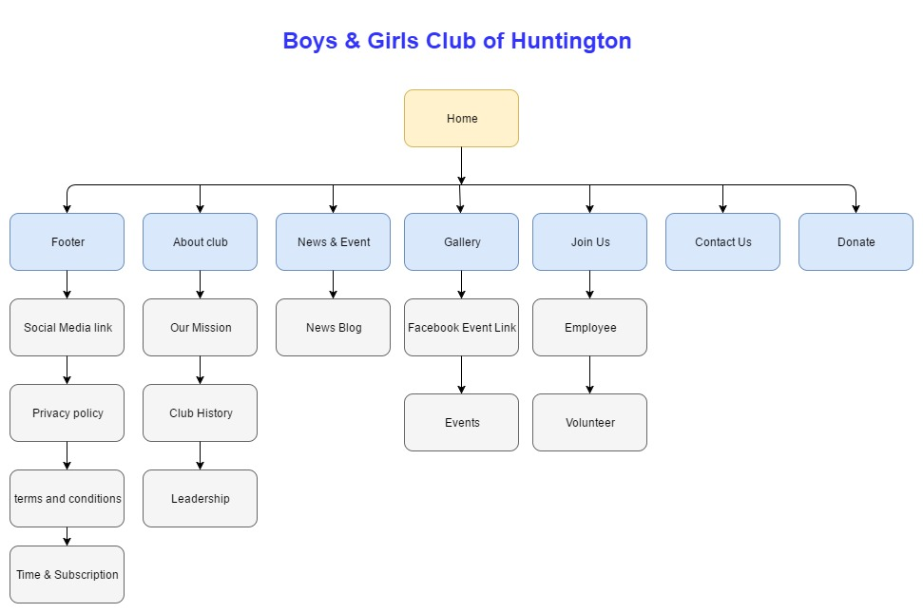

# 

# Instruction to User

User can be able to update website content with few simple steps. Website content can be changed using HTML file of particular page. All website images are stored in “img” folder. Video like can be changed with replacing current “YouTube” link with new link.

Home Page:

* To change any content of Home page, open “index.html” file and follow the label inside comments to change any section content inside Home page.
* To change 'Image Slider’ images, please go to “imageSlider” folder inside “img” folder and replace new images with previous one. Kindly note that image name should be kept same as previous name.
* To change 'Club Photos’ section images, please go to “img” folder and replace new images with previous one. Kindly note that image name should be kept same as previous name.
* Home page Video streams through YouTube website. To change the video, kindly open “index.html” file and inside   
  “about section” using <div class="about-vedio-btn"> YouTube link needs to change.

About Club Page:

* To change any content of About Club page, open “our mission.html” and “club history.html” file and follow the label inside comments to change any section content inside About Club page.
* To change “Our Team” section content in About Club page, inside “club history.html” file change at “popular blog section”.

News & Event Page:

* To change “member of the month” section content, open “news & event.html” inside blog section using <div class="about-content"> changes can be made.
* To change “partner of the month” section content, open “news & event.html” inside blog section using <div class="about-content"> changes can be made.

Gallery

* To change images inside gallery page open “event1.html” file, inside “main gallery section” images can be replaced in <img> </img> tags.

# Future Developments

* Admin side could be developed to change website content (Updating Events photos and videos)
* More dynamicity with back-end side development
* Database connectivity for storing data and increase website performance
* Electronic payment with credit/debit card and internet banking