PROJECT REPORT
ChurnSight
Customer Retention & Revenue Intelligence Dashboard
Turning raw subscription data into business decisions using Python, machine learning and an interactive dashboard.

Prepared by: Rohan Singh
Institution: Institute of Engineering and Management
Tech stack: Python, pandas, scikit-learn, Plotly, Streamlit

1. Problem Statement
A telecom and broadband provider adds new customers every month, yet a growing share of them leave. Monthly recurring revenue (MRR) has started to flatten because churn is now catching up with new sign-ups. Leadership does not need another spreadsheet. They need to know what is happening, why customers leave, who is likely to leave next, and what the company should do about it.
This project builds a business-intelligence dashboard that follows the path Data → Information → Insight → Decision → Action, so that every chart leads towards a concrete management decision.

2. Objectives
- Clean raw customer data and compute a small set of meaningful KPIs.
- Show clear trends in revenue, sign-ups and churn.
- Identify the key drivers of churn using analysis and a machine-learning model.
- Predict which active customers are most likely to leave and how much revenue that puts at risk.
- Recommend actions and let managers test a retention campaign before spending money.

3. Dataset
The dataset contains 5,025 raw rows and 16 columns (5,000 unique customers after cleaning). It is synthetic, generated reproducibly by the generate_data() function in app.py with seed 42, and it is different from the dataset used in the master classes. The raw file is deliberately imperfect (missing values and duplicate rows) so that the cleaning step is meaningful. The same code accepts a real CSV with the same columns through the sidebar upload.
Column | Type | Description
customer_id | Text | Unique customer identifier
signup_date, churn_date | Date | Start of service; end of service (blank if still active)
region | Category | North, South, East, West, Central
plan, service, contract | Category | Basic/Standard/Premium; Fiber/5G/Broadband; Month-to-Month/1 Year/2 Year
payment_method | Category | UPI, Credit Card, Net Banking, Auto-debit
monthly_charges | Number | Monthly bill in rupees
support_tickets, late_payments, add_ons | Number | Service and billing behaviour
avg_satisfaction, data_usage_gb, age | Number | Satisfaction (1–5), usage, customer age
churned | 0 / 1 | Target variable: 1 if the customer left

4. Methodology

4.1 Data cleaning and feature engineering
- Removed 25 duplicate customer records.
- Parsed dates; filled missing numeric values with the median and missing categories with the mode (about 1.5% of satisfaction and 1% of usage values were missing).
- Clipped satisfaction scores to the valid 1–5 range.
- Created tenure in months, lifetime revenue, support-ticket bands and satisfaction bands.

4.2 KPI selection
Six KPIs were chosen because together they describe the health of a subscription business without overwhelming the reader: Active Customers, MRR, Churn Rate, ARPU, Average Satisfaction and Revenue at Risk.

4.3 Churn prediction model
A Random Forest classifier (250 trees, depth 8, class-balanced) was trained on a stratified 75/25 split. Customer tenure was excluded on purpose, because it is calculated from the churn date and would leak the answer. Revenue at risk is estimated as monthly charge × 12 × predicted churn probability for every active customer.
Accuracy | ROC-AUC | Precision | Recall
0.72 | 0.79 | 0.44 | 0.68

The model is tuned to favour recall. Missing a customer who is about to leave costs more than sending a retention offer to someone who would have stayed, so a moderate precision is an acceptable trade-off. The risk list should be used to prioritise outreach, not as a certainty.

5. System Design
The whole project lives in one Python file, app.py, organised in clear layers:
- Data layer: load CSV (or generate it), clean and engineer features.
- Model layer: train the Random Forest, score every customer, compute driver importance.
- Business layer: KPIs, monthly trends, automatically generated risk, opportunity and action statements.
- Presentation layer: Streamlit pages with Plotly charts, region and plan filters, and a CSV export of the at-risk list.

6. Dashboard Output
The screenshots below were captured from the running application. The pages are separated so that each audience can find its answer quickly.

6.1 Executive Overview
For the CEO: what is happening right now. MRR grew steadily since 2022 but has flattened, and the monthly churn count is closing in on new sign-ups.
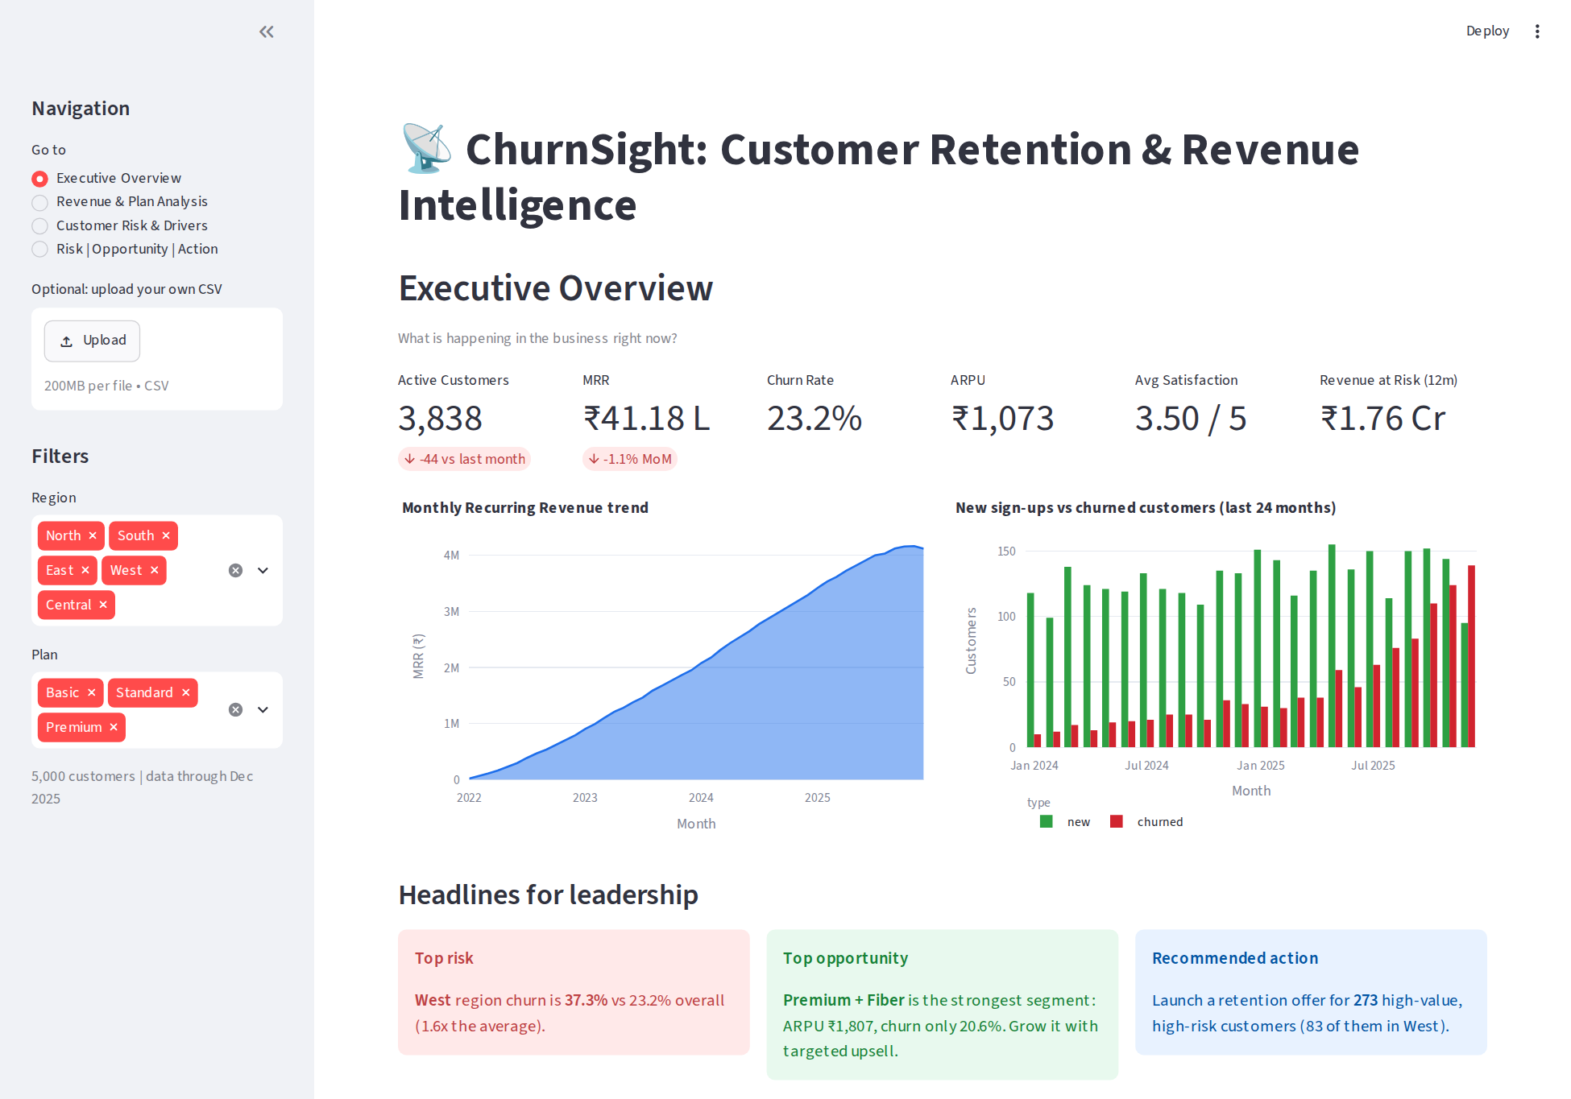
Figure 1. Executive Overview: six KPIs, MRR trend, sign-ups versus churn, and leadership headlines.

6.2 Revenue & Plan Analysis
For the sales team: Standard and Premium plans generate 74% of MRR. Premium customers pay nearly three times as much as Basic customers, but they also churn the most (26.8% versus 20.8% for Basic).
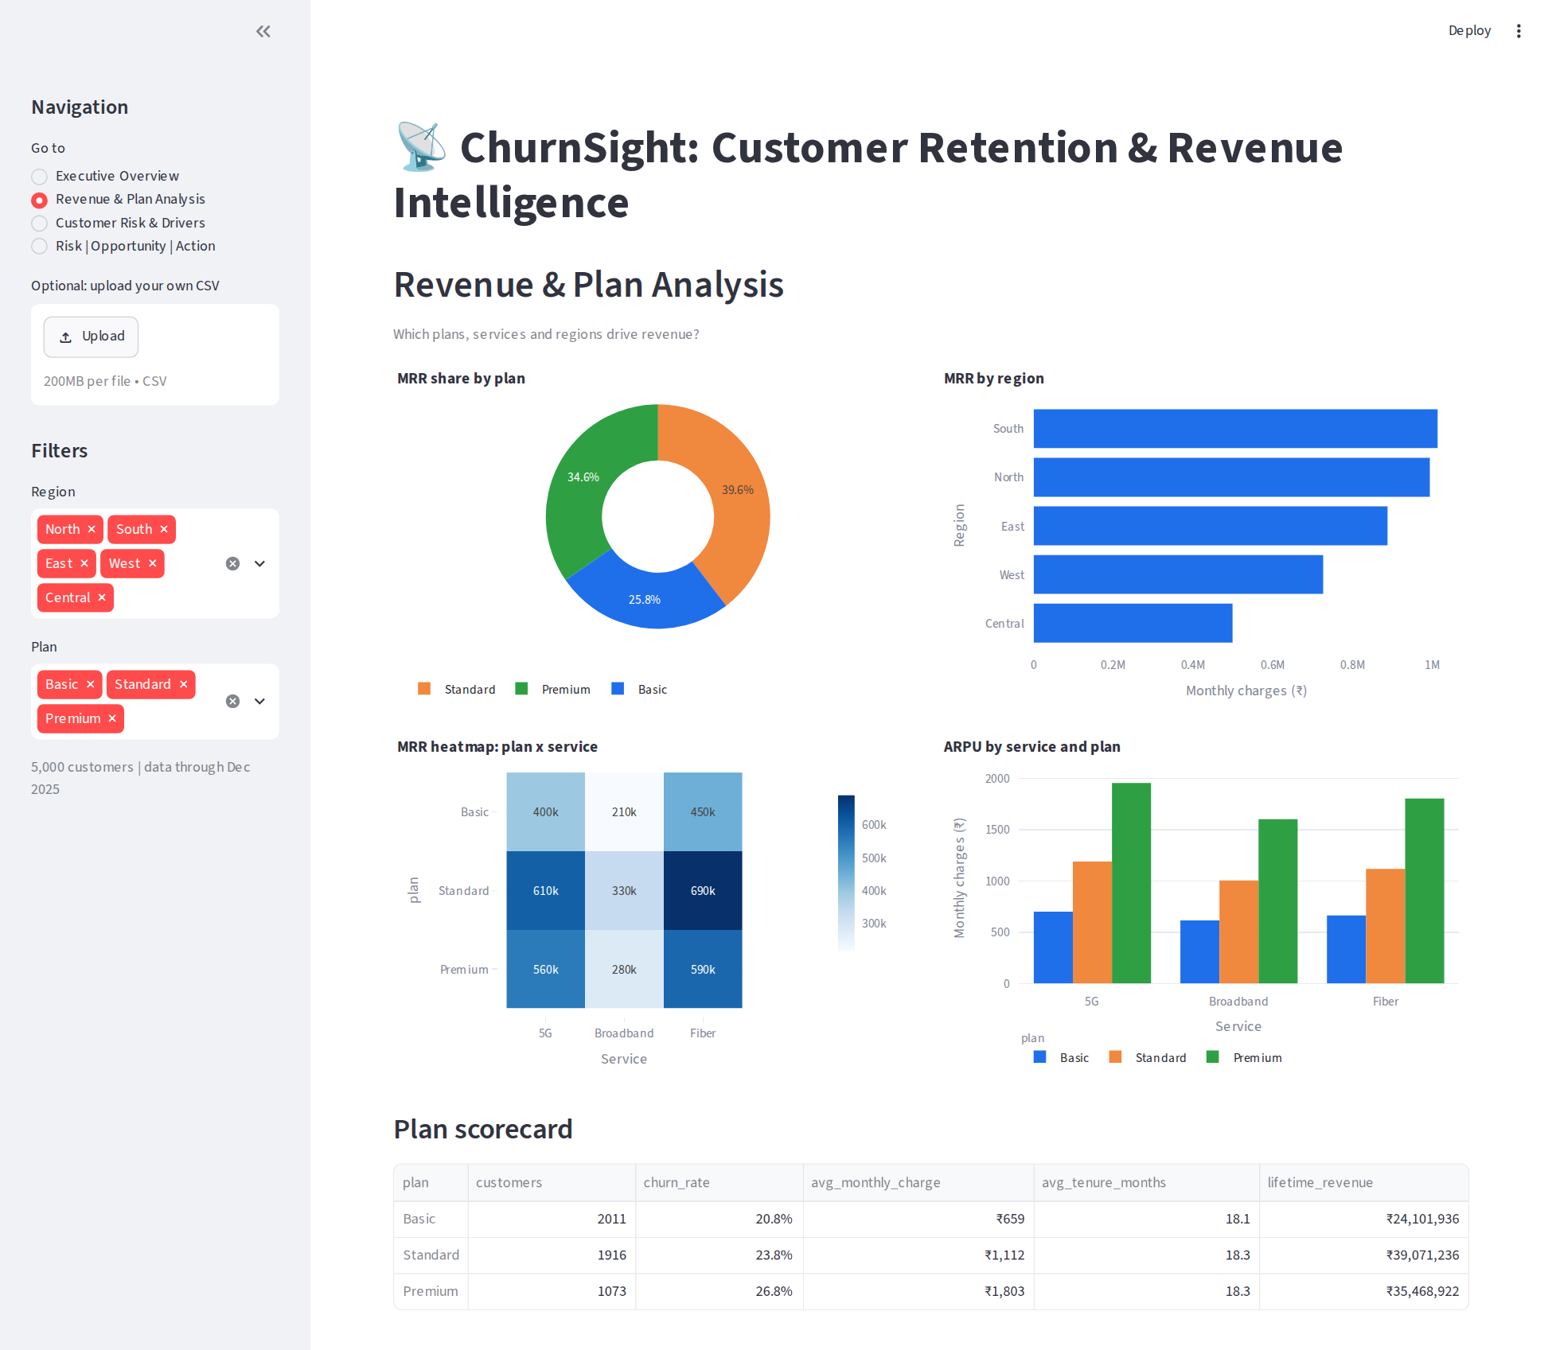
Figure 2. Revenue by plan, region and service, with a plan scorecard.

6.3 Customer Risk & Drivers
For the retention team: why customers leave and who is next. The model's most important drivers are contract type, satisfaction and support tickets, followed by region.
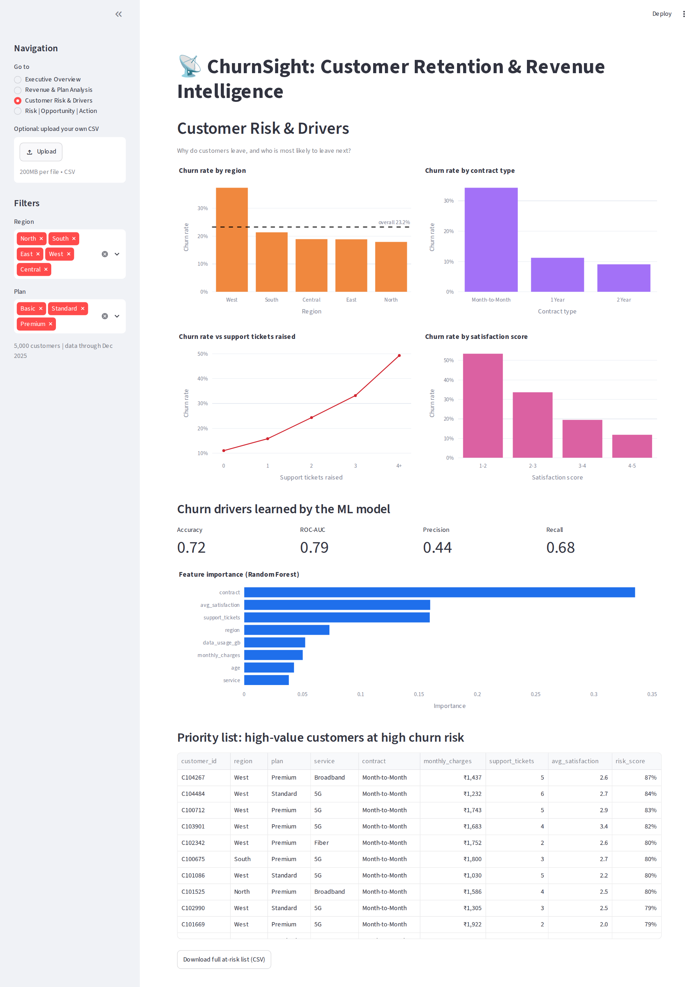
Figure 3. Churn by region, contract, tickets and satisfaction; model metrics; priority customer list.

6.4 Risk | Opportunity | Action
For management: facts turned into decisions, plus a simulator that estimates the payoff of a retention campaign.
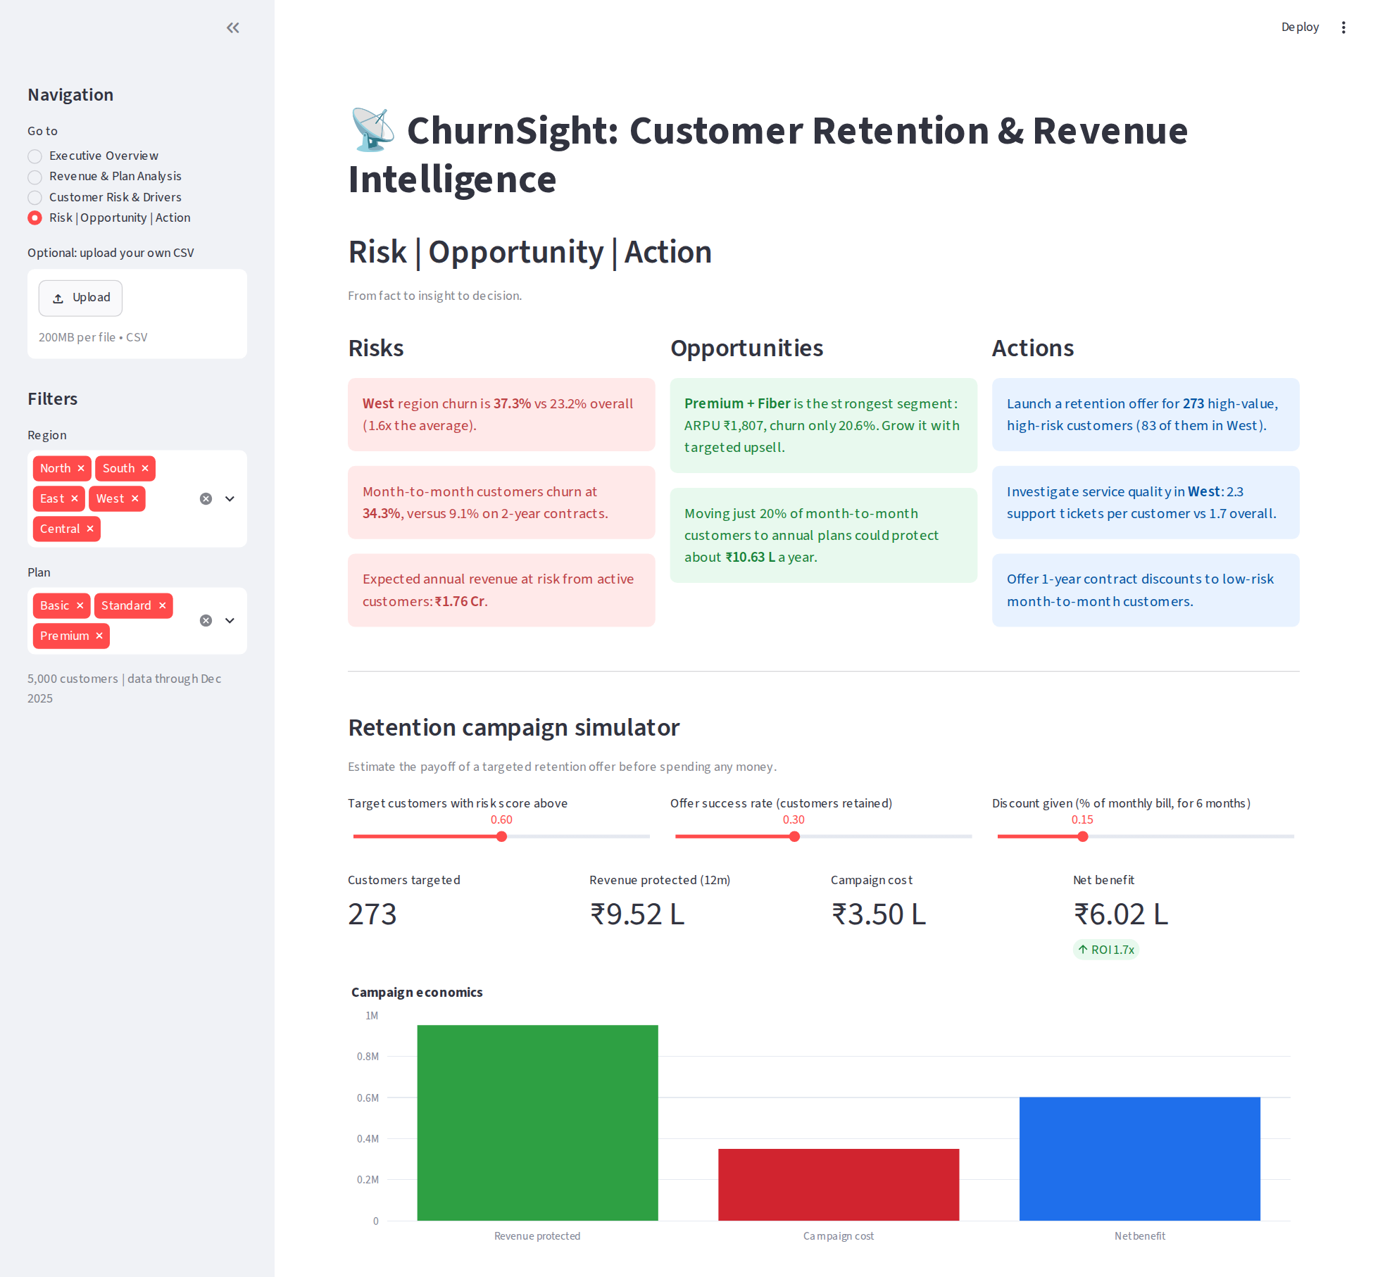
Figure 4. Auto-generated risks, opportunities, actions and the retention campaign simulator.

7. Key Findings
Finding | Evidence
West region is the biggest problem | Churn is 37.3% versus 23.2% overall (1.6x). Other regions range from 17.9% to 21.4%.
Contract length protects revenue | Month-to-month churn is 34.3%; 1-year is 11.2%; 2-year is 9.1%.
Poor service experience drives exits | Churn climbs from about 11% with no tickets to about 49% with four or more. Customers scoring 1–2 on satisfaction churn at over 50%.
Revenue is exposed | Expected annual revenue at risk is ₹1.76 Cr from 3,838 active customers; 273 are high-value and high-risk.
Growth has stalled | MRR is ₹41.18 L, down 1.1% month on month, as churn approaches the sign-up rate.

8. Recommendations
- Risk: launch a targeted retention offer for the 273 high-value, high-risk customers, starting with the 83 in the West region.
- Root cause: investigate service quality and support capacity in the West region, where customers raise 2.3 tickets on average versus 1.7 overall.
- Opportunity: move month-to-month customers to annual plans with a discount. Converting only 20% could protect about ₹10.6 L a year.
- Growth: grow the Premium + Fiber segment, which has the best mix of high ARPU (₹1,807) and low churn (20.6%).
Campaign economics (simulator defaults): targeting 273 customers with a 15% discount for 6 months and a 30% success rate protects about ₹9.52 L of revenue at a cost of ₹3.50 L, a net benefit of ₹6.02 L (ROI 1.7x).

9. Limitations and Future Work
- The data is synthetic. The method is real, but the findings should be re-validated on a company's own data.
- Revenue at risk assumes the model's probabilities are well calibrated; calibration and cross-validation would strengthen this.
- Future work: add explainability for individual customers (for example SHAP values), test gradient-boosting models, and connect the app to a live database.

10. Conclusion
ChurnSight shows that a simple, well-structured dashboard can be more useful than a complex one. By moving from KPIs to trends, drivers, risks and finally actions, it gives leadership a clear answer: retain high-value customers in the West region, encourage longer contracts, and invest in the Premium Fiber segment.

Appendix: How to Run
Install dependencies and start the dashboard:
pip install -r requirements.txt
streamlit run app.py

